OpenModelica Users Guide

Version 2012-03-29
for OpenModelica 1.8.1

March 2012

Peter Fritzson
Adrian Pop, Adeel Asghar, Willi Braun, Jens Frenkel,
Lennart Ochel, Martin Sjölund, Per Östlund, Peter Aronsson,
Mikael Axin, Bernhard Bachmann, Vasile Baluta, Robert Braun, David Broman, Stefan Brus, Francesco Casella, Filippo Donida, Anand Ganeson, Mahder Gebremedhin, Pavel Grozman, Daniel Hedberg, Michael Hanke, Alf Isaksson, Kim Jansson, Daniel Kanth, Tommi Karhela, Juha Kortelainen, Abhinn Kothari, Petter Krus, Alexey Lebedev, Oliver Lenord, Ariel Liebman, Rickard Lindberg, Håkan Lundvall, Abhi Raj Metkar, Eric Meyers, Tuomas Miettinen, Afshin Moghadam, Maroun Nemer, Hannu Niemistö, Peter Nordin, Kristoffer Norling, Karl Pettersson, Pavol Privitzer, Jhansi Reddy, Reino Ruusu, Per Sahlin,Wladimir Schamai, Gerhard Schmitz, Anton Sodja, Ingo Staack, Kristian Stavåker, Sonia Tariq, Mohsen Torabzadeh-Tari, Parham Vasaiely, Niklas Worschech, Robert Wotzlaw, Björn Zackrisson,
Azam Zia

Copyright by:

Open Source Modelica Consortium
Copyright © 1998-CurrentYear, Open Source Modelica Consortium (OSMC), c/o Linköpings universitet, Department of Computer and Information Science, SE-58183 Linköping, Sweden
All rights reserved.
THIS PROGRAM IS PROVIDED UNDER THE TERMS OF GPL VERSION 3 LICENSE OR THIS OSMC PUBLIC LICENSE (OSMC-PL). ANY USE, REPRODUCTION OR DISTRIBUTION OF THIS PROGRAM CONSTITUTES RECIPIENT'S ACCEPTANCE OF THE OSMC PUBLIC LICENSE OR THE GPL VERSION 3, ACCORDING TO RECIPIENTS CHOICE.
The OpenModelica software and the OSMC (Open Source Modelica Consortium) Public License (OSMC-PL) are obtained from OSMC, either from the above address, from the URLs: http://www.openmodelica.org or http://www.ida.liu.se/projects/OpenModelica, and in the OpenModelica distribution. GNU version 3 is obtained from: http://www.gnu.org/copyleft/gpl.html.
This program is distributed WITHOUT ANY WARRANTY; without even the implied warranty of MERCHANTABILITY or FITNESS FOR A PARTICULAR PURPOSE, EXCEPT AS EXPRESSLY SET FORTH IN THE BY RECIPIENT SELECTED SUBSIDIARY LICENSE CONDITIONS OF OSMC-PL.
See the full OSMC Public License conditions for more details.

This document is part of OpenModelica: http://www.openmodelica.org
Contact: OpenModelica@ida.liu.se

Modelica® is a registered trademark of the Modelica Association, http://www.Modelica.org
MathModelica® is a registered trademark of MathCore Engineering AB, www.mathcore.com
Mathematica® is a registered trademark of Wolfram Research Inc, www.wolfram.com

Table of Contents
Table of Contents 3
Preface 9
Chapter 1 Introduction 11
1.1 System Overview 12
1.2 Interactive Session with Examples 13
1.2.1 Starting the Interactive Session 13
1.2.2 Using Compiler Debug Trace Flags in Interactive Mode 14
1.2.3 Trying the Bubblesort Function 17
1.2.4 Trying the system and cd Commands 17
1.2.5 Modelica Library and DCMotor Model 18
1.2.6 The val() function 21
1.2.7 BouncingBall and Switch Models 21
1.2.8 Clear All Models 23
1.2.9 VanDerPol Model and Parametric Plot 23
1.2.10 Using Japanese or Chinese Characters 24
1.2.11 Scripting with For-Loops, While-Loops, and If-Statements 25
1.2.12 Variables, Functions, and Types of Variables 26
1.2.13 Getting Information about Error Cause 27
1.2.14 Alternative Simulation Output Formats 27
1.2.15 Using External Functions 27
1.2.16 Using Parallel Simulation via OpenMP Multi-Core Support 27
1.2.17 Loading Specific Library Version 28
1.2.18 Calling the Model Query and Manipulation API 28
1.2.19 Quit OpenModelica 29
1.2.20 Dump XML Representation 30
1.2.21 Dump Matlab Representation 30
1.3 Summary of Commands for the Interactive Session Handler 31
1.4 References 32
Chapter 2 OMEdit – The OpenModelica Connection Editor 33
2.1 Starting OMEdit 33
2.1.1 Microsoft Windows 33
2.1.2 Linux 34
2.1.3 Mac OS X 34
2.2 Introductory Modeling in OMEdit 35
2.2.1 Creating a New File 35
2.2.2 Adding Component Models 36
2.2.3 Making Connections 36
2.2.4 Simulating the Model 38
2.2.5 Plotting Variables from Simulated Models 39
2.3 How to Create User Defined Shapes – Icons 41
2.4 OMEdit Views 43
2.4.1 Modeling View 43
2.4.2 Plotting View 43
2.4.3 Interactive Simulation View 43
2.5 OMEdit Windows/Tabs 44
2.5.1 Library Window 44
2.5.2 Designer Window 45
2.5.3 Plot Variables Window 46
2.5.4 Messages Window 46
2.5.5 Documentation Window 46
2.5.6 Model Browser Window 47
2.6 Dialogs 48
2.6.1 New Model Dialog 48
2.6.2 Simulation Dialog 48
2.6.3 Model Properties Dialog 48
2.6.4 Model Attributes Dialog 49
2.7 Interactive Simulation in OMEdit 50
2.7.1 Invoking Interactive Simulation 50
2.7.2 Interactive Simulation View 50
Chapter 3 2D Plotting and 3D Animation 52
3.1 Enhanced Qt-based 2D Plot Functionality 52
3.2 Simple 2D Plot 53
3.2.1 Plot Functions and Their Options 57
3.2.2 Zooming 59
3.2.3 Plotting all variables of a model 60
3.2.4 Plotting During Simulation 61
3.2.5 Programmable Drawing of 2D Graphics 61
3.2.6 Plotting of Table Data 62
3.3 Java-based PtPlot 2D plotting 63
3.4 3D Animation 64
3.4.1 Object Based Visualization 64
3.4.2 BouncingBall 65
3.4.3 Pendulum 3D Example 67
3.5 References 70
Chapter 4 OMNotebook with DrModelica and DrControl 72
4.1 Interactive Notebooks with Literate Programming 72
4.1.1 Mathematica Notebooks 72
4.1.2 OMNotebook 72
4.2 DrModelica Tutoring System – an Application of OMNotebook 73
4.3 DrControl Tutorial for Teaching Control Theory 79
4.3.1 Feedback Loop 79
4.3.2 Mathematical Modeling with Characteristic Equations 82
4.4 OpenModelica Notebook Commands 88
4.4.1 Cells 88
4.4.2 Cursors 88
4.4.3 Selection of Text or Cells 89
4.4.4 File Menu 89
4.4.5 Edit Menu 90
4.4.6 Cell Menu 90
4.4.7 Format Menu 91
4.4.8 Insert Menu 91
4.4.9 Window Menu 92
4.4.10 Help Menu 92
4.4.11 Additional Features 92
4.5 References 93
Chapter 5 Interactive Simulation 95
5.1 OpenModelica Interactive 95
5.1.1 Interactively Changeable Parameters 95
5.1.2 OpenModelica Interactive Components description 96
5.1.3 Communication Interface 96
5.1.4 Network configuration Settings 97
5.1.5 Interactive Simulation general Procedure 99
5.1.6 Interactive Simulation Example 99
5.2 OPC and OPC UA Interfaces 102
5.2.1 Introduction to the OPC Interfaces 102
5.2.2 Implemented Features 102
5.2.3 Test clients 105
5.2.4 References 105
Chapter 6 Model Import and Export with FMI 1.0 107
6.1 FMI Import 107
6.2 FMI Export 108
Chapter 7 OMOptim – Optimization with OpenModelica 110
7.1 Introduction 110
7.2 Preparing the Model 110
7.2.1 Parameters 110
7.2.2 Constraints 110
7.2.3 Objectives 111
7.3 Set problem in OMOptim 111
7.3.1 Launch OMOptim 111
7.3.2 Create a new project 111
7.3.3 Load models 111
7.3.4 Create a new optimization problem 112
7.3.5 Select Optimized Variables 113
7.3.6 Select objectives 114
7.3.7 Select and configure algorithm 114
7.3.8 Launch 115
7.3.9 Stopping Optimization 115
7.4 Results 115
7.4.1 Obtaining all Variable Values 115
7.5 Window Regions in OMOptim GUI 116
Chapter 8 MDT – The OpenModelica Development Tooling Eclipse Plugin 117
8.1 Introduction 117
8.2 Installation 117
8.3 Getting Started 118
8.3.1 Configuring the OpenModelica Compiler 118
8.3.2 Using the Modelica Perspective 118
8.3.3 Selecting a Workspace Folder 118
8.3.4 Creating one or more Modelica Projects 118
8.3.5 Building and Running a Project 118
8.3.6 Switching to Another Perspective 119
8.3.7 Creating a Package 120
8.3.8 Creating a Class 120
8.3.9 Syntax Checking 121
8.3.10 Automatic Indentation Support 122
8.3.11 Code Completion 122
8.3.12 Code Assistance on Identifiers when Hovering 123
8.3.13 Go to Definition Support 123
8.3.14 Code Assistance on Writing Records 123
8.3.15 Using the MDT Console for Plotting 124
Chapter 9 Modelica Performance Analyzer 126
9.1 Example Report Generated for the A Model 127
9.1.1 Information 127
9.1.2 Settings 127
9.1.3 Summary 127
9.1.4 Global Steps 128
9.1.5 Measured Function Calls 128
9.1.6 Measured Blocks 128
9.1.7 Genenerated XML for the Example 129
Chapter 10 Modelica Algorithmic Subset Debugger 131
10.1 The Eclipse-based Debugging Environment 131
10.2 Starting the Modelica Debugging Perspective 132
10.2.1 Create mos file 132
10.2.2 Setting the debug configuration 133
10.2.3 Setting/Deleting Breakpoints 134
10.2.4 Starting the debugging session and enabling the debug perspective 135
10.3 Debugging OpenModelica 136
10.4 The Debugging Perspective 136
Chapter 11 Interoperability – C, Java, and Python 139
11.1 Calling External C functions 139
11.2 Calling External Java Functions 140
11.3 Python Interoperability 141
Chapter 12 OMPython – OpenModelica Python Interface 143
12.1 About OMPython 143
12.2 Features of OMPython 143
12.3 Using OMPython 143
12.3.1 Test Commands 144
12.3.2 Import As Library 144
12.3.3 Retrieve results from nested dictionaries 144
12.3.4 Set values to nested dictionaries 145
12.3.5 Example 146
12.4 Implementation 147
12.4.1 Client 147
12.4.2 Parser 147
12.4.3 The Simulation Results 149
12.4.4 Record Construction 150
12.5 Examples 151
12.5.1 Import As Library 151
12.5.2 Test Commands 153
12.6 List of Commands 153
Chapter 13 Frequently Asked Questions (FAQ) 175
13.1 OpenModelica General 175
13.2 OMNotebook 175
13.3 OMDev - OpenModelica Development Environment 176
Index 197

Preface
This users guide provides documentation and examples on how to use the OpenModelica system, both for the Modelica beginners and advanced users.

Introduction
The OpenModelica system described in this document has both short-term and long-term goals:
- The short-term goal is to develop an efficient interactive computational environment for the Modelica language, as well as a rather complete implementation of the language. It turns out that with support of appropriate tools and libraries, Modelica is very well suited as a computational language for development and execution of both low level and high level numerical algorithms, e.g. for control system design, solving nonlinear equation systems, or to develop optimization algorithms that are applied to complex applications.
- The longer-term goal is to have a complete reference implementation of the Modelica language, including simulation of equation based models and additional facilities in the programming environment, as well as convenient facilities for research and experimentation in language design or other research activities. However, our goal is not to reach the level of performance and quality provided by current commercial Modelica environments that can handle large models requiring advanced analysis and optimization by the Modelica compiler.
The long-term research related goals and issues of the OpenModelica open source implementation of a Modelica environment include but are not limited to the following:
- Development of a complete formal specification of Modelica, including both static and dynamic semantics. Such a specification can be used to assist current and future Modelica implementers by providing a semantic reference, as a kind of reference implementation.
- Language design, e.g. to further extend the scope of the language, e.g. for use in diagnosis, structural analysis, system identification, etc., as well as modeling problems that require extensions such as partial differential equations, enlarged scope for discrete modeling and simulation, etc.
- Language design to improve abstract properties such as expressiveness, orthogonality, declarativity, reuse, configurability, architectural properties, etc.
- Improved implementation techniques, e.g. to enhance the performance of compiled Modelica code by generating code for parallel hardware.
- Improved debugging support for equation based languages such as Modelica, to make them even easier to use.
- Easy-to-use specialized high-level (graphical) user interfaces for certain application domains.
- Visualization and animation techniques for interpretation and presentation of results.
- Application usage and model library development by researchers in various application areas.
The OpenModelica environment provides a test bench for language design ideas that, if successful, can be submitted to the Modelica Association for consideration regarding possible inclusion in the official Modelica standard.
The current version of the OpenModelica environment allows most of the expression, algorithm, and function parts of Modelica to be executed interactively, as well as equation models and Modelica functions to be compiled into efficient C code. The generated C code is combined with a library of utility functions, a run-time library, and a numerical DAE solver.

System Overview
The OpenModelica environment consists of several interconnected subsystems, as depicted in Figure 1-1-1 below.

- 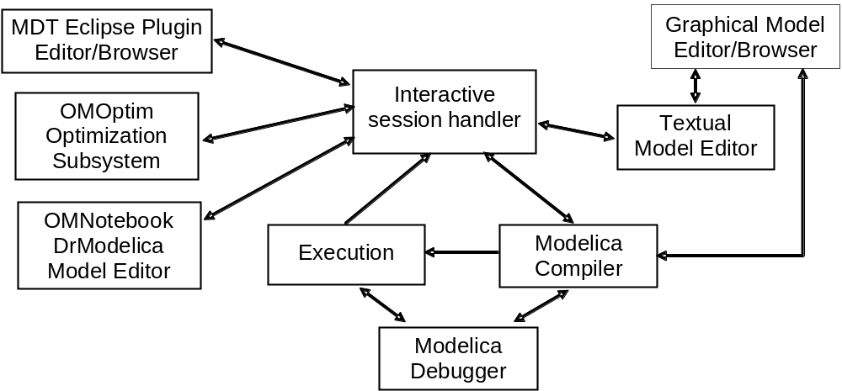
Figure 1-1-1. The architecture of the OpenModelica environment. Arrows denote data and control flow. The interactive session handler receives commands and shows results from evaluating commands and expressions that are translated and executed. Several subsystems provide different forms of browsing and textual editing of Modelica code. The debugger currently provides debugging of an extended algorithmic subset of Modelica
The following subsystems are currently integrated in the OpenModelica environment:
- An interactive session handler, that parses and interprets commands and Modelica expressions for evaluation, simulation, plotting, etc. The session handler also contains simple history facilities, and completion of file names and certain identifiers in commands.
- A Modelica compiler subsystem, translating Modelica to C code, with a symbol table containing definitions of classes, functions, and variables. Such definitions can be predefined, user-defined, or obtained from libraries. The compiler also includes a Modelica interpreter for interactive usage and constant expression evaluation. The subsystem also includes facilities for building simulation executables linked with selected numerical ODE or DAE solvers.
- An execution and run-time module. This module currently executes compiled binary code from translated expressions and functions, as well as simulation code from equation based models, linked with numerical solvers. In the near future event handling facilities will be included for the discrete and hybrid parts of the Modelica language.
- Eclipse plugin editor/browser. The Eclipse plugin called MDT (Modelica Development Tooling) provides file and class hierarchy browsing and text editing capabilities, rather analogous to previously described Emacs editor/browser. Some syntax highlighting facilities are also included. The Eclipse framework has the advantage of making it easier to add future extensions such as refactoring and cross referencing support.
- OMNotebook DrModelica model editor. This subsystem provides a lightweight notebook editor, compared to the more advanced Mathematica notebooks available in MathModelica. This basic functionality still allows essentially the whole DrModelica tutorial to be handled. Hierarchical text documents with chapters and sections can be represented and edited, including basic formatting. Cells can contain ordinary text or Modelica models and expressions, which can be evaluated and simulated. However, no mathematical typesetting facilities are yet available in the cells of this notebook editor.
- Graphical model editor/browser OMEdit.. This is a graphical connection editor, for component based model design by connecting instances of Modelica classes, and browsing Modelica model libraries for reading and picking component models. The graphical model editor also includes a textual editor for editing model class definitions, and a window for interactive Modelica command evaluation.
- Optimization subsystem OMEdit.. This is an optimization subsystem for OpenModelica, currently for design optimization choosing an optimal set of design parameters for a model. The current version has a graphical user interface, provides genetic optimization algorithms and Pareto front optimizaiton, works integrated with the simulators and automatically accesses variables and design parameters from the Modelica model.
- Modelica debugger. The current implementation of debugger provides debugging for an extended algorithmic subset of Modelica, excluding equation-based models and some other features, but including some meta-programming and model transformation extensions to Modelica. This is conventional full-feature debugger, using Eclipse for displaying the source code during stepping, setting breakpoints, etc. Various back-trace and inspection commands are available. The debugger also includes a data-view browser for browsing hierarchical data such as tree- or list structures in extended Modelica.

Interactive Session with Examples
The following is an interactive session using the interactive session handler in the OpenModelica environment, called OMShell – the OpenModelica Shell). Most of these examples are also available in the OpenModelica notebook UsersGuideExamples.onb in the testmodels (C:/OpenModelica/share/doc/omc/ testmodels/) directory, see also Chapter 4.

Starting the Interactive Session
The Windows version which at installation is made available in the start menu as OpenModelica->OpenModelica Shell which responds with an interaction window:
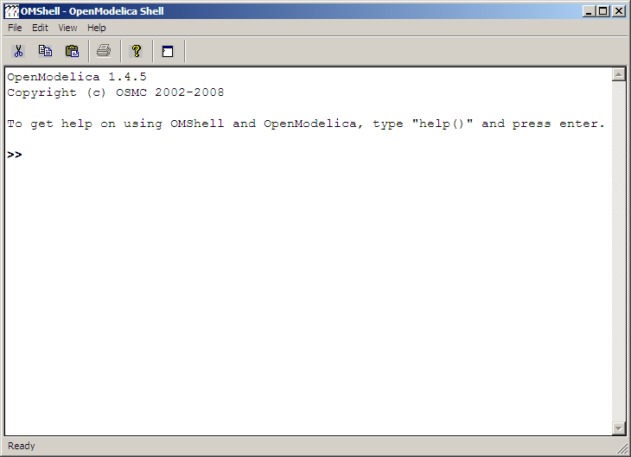
We enter an assignment of a vector expression, created by the range construction expression 1:12, to be stored in the variable x. The value of the expression is returned.
>> x := 1:12
{1, 2, 3, 4, 5, 6, 7, 8, 9, 10, 11, 12}

Using Compiler Debug Trace Flags in Interactive Mode
When running OMC in interactive mode (for instance using OMShell) one can make use of some of the compiler debug trace flags defined in section 2.1.2 in the System Documentation. Here we give a few example sessions.

Example Session 1

OpenModelica 1.8.0
Copyright (c) OSMC 2002-2011
To get help on using OMShell and OpenModelica, type "help()" and press enter.

>> setDebugFlags("failtrace")
true

>> model A Integer t = 1.5; end A; //The type is Integer but 1.5 is of Real Type
{A}

>> instantiateModel(A)
"/*- CevalScript.cevalGenerateFunctionDAEs failed( instantiateModel )*/
/*- CevalScript.cevalGenerateFunction failed(instantiateModel)*/
- Inst.makeBinding failed
- Inst.instElement failed: COMPONENT(t in/out: mod: = 1.5 tp: Integer var :VAR, baseClass: <nothing>)
Scope: A
- Inst.instClassdef failed
class :A
- Inst.instClass: A failed
Inst.instClassInProgram failed
"
Error: Type mismatch in modifier, expected type Integer, got modifier =1.5 of type Real
Error: Error occured while flattening model A
Error: Type mismatch in modifier, expected type Integer, got modifier =1.5 of type Real
Error: Error occured while flattening model A

Example Session 2

OpenModelica 1.8.1
Copyright (c) OSMC 2002-2011
To get help on using OMShell and OpenModelica, type "help()" and press enter.

>> setDebugFlags("dump")
true
---DEBUG(dump)---
IEXP(Absyn.CALL(Absyn.CREF_IDENT("setDebugFlags", []), FUNCTIONARGS(Absyn.STRING("dump"), )))
---/DEBUG(dump)---
"
---DEBUG(dump)---
IEXP(Absyn.CALL(Absyn.CREF_IDENT("getErrorString", []), FUNCTIONARGS(, )))
---/DEBUG(dump)—

>> model B Integer k = 10; end B;
{B}
---DEBUG(dump)---
Absyn.PROGRAM([
Absyn.CLASS("B", false, false, false, Absyn.R_MODEL, Absyn.PARTS([Absyn.PUBLIC([Absyn.ELEMENTITEM(Absyn.ELEMENT(false, _, Absyn.UNSPECIFIED , "component", Absyn.COMPONENTS(Absyn.ATTR(false, false, Absyn.VAR, Absyn.BIDIR, []),Integer,[Absyn.COMPONENTITEM(Absyn.COMPONENT("k",[], SOME(Absyn.CLASSMOD([], SOME(Absyn.INTEGER(10))))), NONE())]), Absyn.INFO("", false, 1, 9, 1, 23)), NONE))])], NONE()), Absyn.INFO("", false, 1, 1, 1, 30))
],Absyn.TOP)
---/DEBUG(dump)---
"
---DEBUG(dump)---
IEXP(Absyn.CALL(Absyn.CREF_IDENT("getErrorString", []), FUNCTIONARGS(, )))
---/DEBUG(dump)—

>> instantiateModel(B)
"fclass B
Integer k = 10;
end B;
"
---DEBUG(dump)---
IEXP(Absyn.CALL(Absyn.CREF_IDENT("instantiateModel", []), FUNCTIONARGS(Absyn.CREF(Absyn.CREF_IDENT("B", [])), )))
---/DEBUG(dump)---
"
---DEBUG(dump)---
IEXP(Absyn.CALL(Absyn.CREF_IDENT("getErrorString", []), FUNCTIONARGS(, )))
---/DEBUG(dump)—

>> simulate(B, startTime=0, stopTime=1, numberOfIntervals=500, tolerance=1e-4)
record SimulationResult
resultFile = "B_res.plt"
end SimulationResult;
---DEBUG(dump)---
#ifdef __cplusplus
extern "C" {
#endif
#ifdef __cplusplus
}
#endif
IEXP(Absyn.CALL(Absyn.CREF_IDENT("simulate", []), FUNCTIONARGS(Absyn.CREF(Absyn.CREF_IDENT("B", [])), startTime = Absyn.INTEGER(0), stopTime = Absyn.INTEGER(1), numberOfIntervals = Absyn.INTEGER(500), tolerance = Absyn.REAL(0.0001))))
---/DEBUG(dump)---
"
---DEBUG(dump)---
IEXP(Absyn.CALL(Absyn.CREF_IDENT("getErrorString", []), FUNCTIONARGS(, )))
---/DEBUG(dump)--

Example Session 3

OpenModelica 1.8.1
Copyright (c) OSMC 2002-2011
To get help on using OMShell and OpenModelica, type "help()" and press enter.

>> setDebugFlags("failtrace")
true

>> model C Integer a; Real b; equation der(a) = b; der(b) = 12.0; end C;
{C}

>> instantiateModel(C)
"/*- CevalScript.cevalGenerateFunctionDAEs failed( instantiateModel )*/
/*- CevalScript.cevalGenerateFunction failed(instantiateModel)*/
- Static.elabCall failed
function: der posargs: a
- Static.elabExp failed: der(a)
Scope: C
- instEquationCommon failed for eqn: der(a) = b; in scope:C
- instEquation failed eqn:der(a) = b;
- Inst.instClassdef failed
class :C
- Inst.instClass: C failed
Inst.instClassInProgram failed
"
Error: Illegal derivative. der(a) where a is of type Integer, which is not a subtype of Real
Error: Wrong type or wrong number of arguments to der(a)'.
Error: Error occured while flattening model C
Error: Illegal derivative. der(a) where a is of type Integer, which is not a subtype of Real
Error: Wrong type or wrong number of arguments to der(a)'.
Error: Error occured while flattening model C

Trying the Bubblesort Function
Load the function bubblesort, either by using the pull-down menu File->Load Model, or by explicitly giving the command:
>> loadFile("C:/OpenModelica1.8.1/share/doc/omc/testmodels/bubblesort.mo")
true
The function bubblesort is called below to sort the vector x in descending order. The sorted result is returned together with its type. Note that the result vector is of type Real[:], instantiated as Real[12], since this is the declared type of the function result. The input Integer vector was automatically converted to a Real vector according to the Modelica type coercion rules. The function is automatically compiled when called if this has not been done before.
>> bubblesort(x)
{12.0,11.0,10.0,9.0,8.0,7.0,6.0,5.0,4.0,3.0,2.0,1.0}
Another call:
>> bubblesort({4,6,2,5,8})
{8.0,6.0,5.0,4.0,2.0}
It is also possible to give operating system commands via the system utility function. A command is provided as a string argument. The example below shows the system utility applied to the UNIX command cat, which here outputs the contents of the file bubblesort.mo to the output stream. However, the cat command does not boldface Modelica keywords – this improvement has been done by hand for readability.
>> cd("C:/OpenModelica1.8.1/share/doc/omc/testmodels/")
>> system("cat bubblesort.mo")
function bubblesort
input Real[:] x;
output Real[size(x,1)] y;
protected
Real t;
algorithm
y := x;
for i in 1:size(x,1) loop
for j in 1:size(x,1) loop
if y[i] > y[j] then
t := y[i];
y[i] := y[j];
y[j] := t;
end if;
end for;
end for;
end bubblesort;

Trying the system and cd Commands
Note: Under Windows the output emitted into stdout by system commands is put into the winmosh console windows, not into the winmosh interaction windows. Thus the text emitted by the above cat command would not be returned. Only a success code (0 = success, 1 = failure) is returned to the winmosh window. For example:
>> system("dir")
0
>> system("Non-existing command")
1
Another built-in command is cd, the change current directory command. The resulting current directory is returned as a string.
>> cd()
" C:/OpenModelica1.8.1/share/doc/omc/testmodels/"

>> cd("..")
" C:/OpenModelica1.8.1/share/doc/omc/"

>> cd("C:/OpenModelica1.8.1/share/doc/omc/testmodels/")
" C:/OpenModelica1.8.1/share/doc/omc/testmodels/"

Modelica Library and DCMotor Model
We load a model, here the whole Modelica standard library, which also can be done through the File->Load Modelica Library menu item:
>> loadModel(Modelica)
true
We also load a file containing the dcmotor model:
>> loadFile("C:/OpenModelica1.8.1/share/doc/omc/testmodels/dcmotor.mo")
true
It is simulated:
>> simulate(dcmotor,startTime=0.0,stopTime=10.0)
record
resultFile = "dcmotor_res.plt"
end record
We list the source code of the model:
>> list(dcmotor)
"model dcmotor
Modelica.Electrical.Analog.Basic.Resistor r1(R=10);
Modelica.Electrical.Analog.Basic.Inductor i1;
Modelica.Electrical.Analog.Basic.EMF emf1;
Modelica.Mechanics.Rotational.Inertia load;
Modelica.Electrical.Analog.Basic.Ground g;
Modelica.Electrical.Analog.Sources.ConstantVoltage v;

equation
connect(v.p,r1.p);
connect(v.n,g.p);
connect(r1.n,i1.p);
connect(i1.n,emf1.p);
connect(emf1.n,g.p);
connect(emf1.flange_b,load.flange_a);
end dcmotor;
"
We test code instantiation of the model to flat code:
>> instantiateModel(dcmotor)
"fclass dcmotor
Real r1.v "Voltage drop between the two pins (= p.v - n.v)";
Real r1.i "Current flowing from pin p to pin n";
Real r1.p.v "Potential at the pin";
Real r1.p.i "Current flowing into the pin";
Real r1.n.v "Potential at the pin";
Real r1.n.i "Current flowing into the pin";
parameter Real r1.R = 10 "Resistance";
Real i1.v "Voltage drop between the two pins (= p.v - n.v)";
Real i1.i "Current flowing from pin p to pin n";
Real i1.p.v "Potential at the pin";
Real i1.p.i "Current flowing into the pin";
Real i1.n.v "Potential at the pin";
Real i1.n.i "Current flowing into the pin";
parameter Real i1.L = 1 "Inductance";
parameter Real emf1.k = 1 "Transformation coefficient";
Real emf1.v "Voltage drop between the two pins";
Real emf1.i "Current flowing from positive to negative pin";
Real emf1.w "Angular velocity of flange_b";
Real emf1.p.v "Potential at the pin";
Real emf1.p.i "Current flowing into the pin";
Real emf1.n.v "Potential at the pin";
Real emf1.n.i "Current flowing into the pin";
Real emf1.flange_b.phi "Absolute rotation angle of flange";
Real emf1.flange_b.tau "Cut torque in the flange";
Real load.phi "Absolute rotation angle of component (= flange_a.phi = flange_b.phi)";
Real load.flange_a.phi "Absolute rotation angle of flange";
Real load.flange_a.tau "Cut torque in the flange";
Real load.flange_b.phi "Absolute rotation angle of flange";
Real load.flange_b.tau "Cut torque in the flange";
parameter Real load.J = 1 "Moment of inertia";
Real load.w "Absolute angular velocity of component";
Real load.a "Absolute angular acceleration of component";
Real g.p.v "Potential at the pin";
Real g.p.i "Current flowing into the pin";
Real v.v "Voltage drop between the two pins (= p.v - n.v)";
Real v.i "Current flowing from pin p to pin n";
Real v.p.v "Potential at the pin";
Real v.p.i "Current flowing into the pin";
Real v.n.v "Potential at the pin";
Real v.n.i "Current flowing into the pin";
parameter Real v.V = 1 "Value of constant voltage";
equation
r1.R * r1.i = r1.v;
r1.v = r1.p.v - r1.n.v;
0.0 = r1.p.i + r1.n.i;
r1.i = r1.p.i;
i1.L * der(i1.i) = i1.v;
i1.v = i1.p.v - i1.n.v;
0.0 = i1.p.i + i1.n.i;
i1.i = i1.p.i;
emf1.v = emf1.p.v - emf1.n.v;
0.0 = emf1.p.i + emf1.n.i;
emf1.i = emf1.p.i;
emf1.w = der(emf1.flange_b.phi);
emf1.k * emf1.w = emf1.v;
emf1.flange_b.tau = -(emf1.k * emf1.i);
load.w = der(load.phi);
load.a = der(load.w);
load.J * load.a = load.flange_a.tau + load.flange_b.tau;
load.flange_a.phi = load.phi;
load.flange_b.phi = load.phi;
g.p.v = 0.0;
v.v = v.V;
v.v = v.p.v - v.n.v;
0.0 = v.p.i + v.n.i;
v.i = v.p.i;
emf1.flange_b.tau + load.flange_a.tau = 0.0;
emf1.flange_b.phi = load.flange_a.phi;
emf1.n.i + v.n.i + g.p.i = 0.0;
emf1.n.v = v.n.v;
v.n.v = g.p.v;
i1.n.i + emf1.p.i = 0.0;
i1.n.v = emf1.p.v;
r1.n.i + i1.p.i = 0.0;
r1.n.v = i1.p.v;
v.p.i + r1.p.i = 0.0;
v.p.v = r1.p.v;
load.flange_b.tau = 0.0;
end dcmotor;
"
We plot part of the simulated result:
>> plot({load.w,load.phi})
true

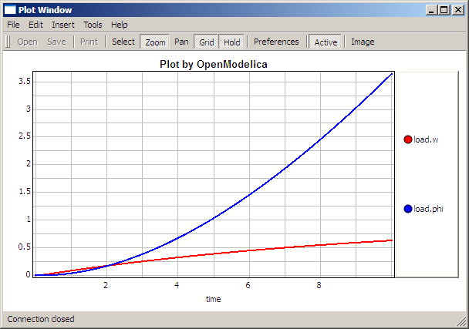

The val() function
The val(variableName,time) scription function can be used to retrieve the interpolated value of a simulation result variable at a certain point in the simulation time, see usage in the BouncingBall simulation below.

BouncingBall and Switch Models
We load and simulate the BouncingBall example containing when-equations and if-expressions (the Modelica key-words have been bold-faced by hand for better readability):
>> loadFile("C:/OpenModelica1.8.1/share/doc/omc/testmodels/BouncingBall.mo")
true
>> list(BouncingBall)
"model BouncingBall
parameter Real e=0.7 "coefficient of restitution";
parameter Real g=9.81 "gravity acceleration";
Real h(start=1) "height of ball";
Real v "velocity of ball";
Boolean flying(start=true) "true, if ball is flying";
Boolean impact;
Real v_new;
equation
impact=h <= 0.0;
der(v)=if flying then -g else 0;
der(h)=v;
when {h <= 0.0 and v <= 0.0,impact} then
v_new=if edge(impact) then -e*pre(v) else 0;
flying=v_new > 0;
reinit(v, v_new);
end when;
end BouncingBall;"
Instead of just giving a simulate and plot command, we perform a runScript command on a .mos (Modelica script) file sim_BouncingBall.mos that contains these commands:
loadFile("BouncingBall.mo");
simulate(BouncingBall, stopTime=3.0);
plot({h,flying});
The runScript command:
>> runScript("sim_BouncingBall.mos")
"true
record
resultFile = "BouncingBall_res.plt"
end record
true
true"
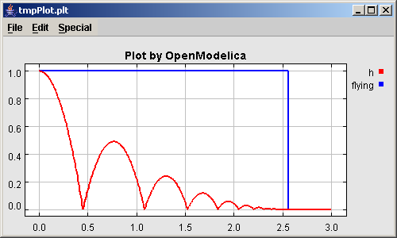
We enter a switch model, to test if-equations (e.g. copy and paste from another file and push enter):
>> model Switch
Real v;
Real i;
Real i1;
Real itot;
Boolean open;
equation
itot = i + i1;
if open then
v = 0;
else
i = 0;
end if;
1 - i1 = 0;
1 - v - i = 0;
open = time >= 0.5;
end Switch;
Ok
>> simulate(Switch, startTime=0, stopTime=1);
Retrieve the value of itot at time=0 using the val(variableName,time) function:
>> val(itot,0)
1
Plot itot and open:
>> plot({itot,open})
true

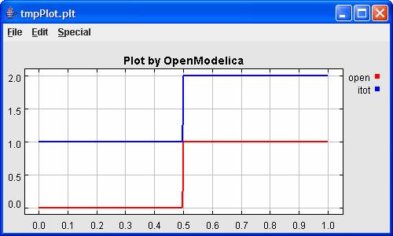
We note that the variable open switches from false (0) to true (1), causing itot to increase from 1.0 to 2.0.

Clear All Models
Now, first clear all loaded libraries and models:
>> clear()
true
List the loaded models – nothing left:
>> list()
""

VanDerPol Model and Parametric Plot
We load another model, the VanDerPol model (or via the menu File->Load Model):
>> loadFile("C:/OpenModelica1.8.1/share/doc/omc/testmodels/VanDerPol.mo"))
true
It is simulated:
>> simulate(VanDerPol)
record
resultFile = "VanDerPol_res.plt"
end record
It is plotted:
plotParametric(x,y);
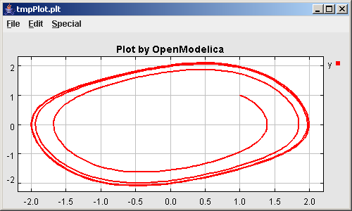
Perform code instantiation to flat forrm of the VanDerPol model:
>> instantiateModel(VanDerPol)
"fclass VanDerPol
Real x(start=1.0);
Real y(start=1.0);
parameter Real lambda = 0.3;
equation
der(x) = y;
der(y) = -x + lambda * (1.0 - x * x) * y;
end VanDerPol;
"

Using Japanese or Chinese Characters
Japenese, Chinese, and other kinds of UniCode characters can be used within quoted (single quote) identifiers, see for example the variable name to the right in the plot below:

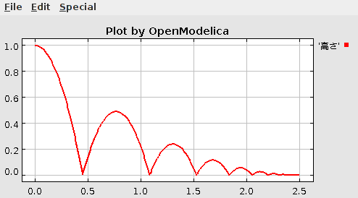

Scripting with For-Loops, While-Loops, and If-Statements
A simple summing integer loop (using multi-line input without evaluation at each line into OMShell requires copy-paste as one operation from another document):
>> k := 0;
for i in 1:1000 loop
k := k + i;
end for;
>> k
500500
A nested loop summing reals and integers::
>> g := 0.0;
h := 5;
for i in {23.0,77.12,88.23} loop
for j in i:0.5:(i+1) loop
g := g + j;
g := g + h / 2;
end for;
h := h + g;
end for;
By putting two (or more) variables or assignment statements separated by semicolon(s), ending with a variable, one can observe more than one variable value:
>> h;g
1997.45
1479.09
A for-loop with vector traversal and concatenation of string elements:
>> i:="";
lst := {"Here ", "are ","some ","strings."};
s := "";
for i in lst loop
s := s + i;
end for;
>> s
"Here are some strings."
Normal while-loop with concatenation of 10 "abc " strings:
>> s:="";
i:=1;
while i<=10 loop
s:="abc "+s;
i:=i+1;
end while;
>> s
"abc abc abc abc abc abc abc abc abc abc "
A simple if-statement. By putting the variable last, after the semicolon, its value is returned after evaluation:
>> if 5>2 then a := 77; end if; a
77
An if-then-else statement with elseif:
>> if false then
a := 5;
elseif a > 50 then
b:= "test"; a:= 100;
else
a:=34;
end if;
Take a look at the variables a and b:
>> a;b
100
"test"

Variables, Functions, and Types of Variables
Assign a vector to a variable:
>> a:=1:5
{1,2,3,4,5}
Type in a function:
>> function MySqr input Real x; output Real y; algorithm y:=x*x; end MySqr;
Ok
Call the function:
>> b:=MySqr(2)
4.0
Look at the value of variable a:
>> a
{1,2,3,4,5}
Look at the type of a:
>> typeOf(a)
"Integer[]"
Retrieve the type of b:
>> typeOf(b)
"Real"

What is the type of MySqr? Cannot currently be handled.
>> typeOf(MySqr)
Error evaluating expr.
List the available variables:
>> listVariables()
{currentSimulationResult, a, b}
Clear again:
>> clear()
true

Getting Information about Error Cause
Call the function getErrorString in order to get more information about the error cause after a simulation failure:
>> getErrorString()

Alternative Simulation Output Formats
There are several output format possibilities, with mat being the default. plt and mat are the only formats that allow you to use the val() or plot() functions after a simulation. Compared to the speed of plt, mat is roughly 5 times for small files, and scales better for larger files due to being a binary format. The csv format is roughly twice as fast as plt on data-heavy simulations. The plt format allocates all output data in RAM during simulation, which means that simulations may fail due applications only being able to address 4GB of memory on 32-bit platforms. Empty does no output at all and should be by far the fastest. The csv and plt formats are suitable when using an external scripts or tools like gnuplot to generate plots or process data. The mat format can be post-processed in MATLAB or Octave.
simulate(... , outputFormat="mat")
simulate(... , outputFormat="csv")
simulate(... , outputFormat="plt")
simulate(... , outputFormat="empty")
It is also possible to specify which variables should be present in the result-file. This is done by using POSIX Extended Regular Expressions. The given expression must match the full variable name (^ and $ symbols are automatically added to the given regular expression).
// Default, match everything
simulate(... , variableFilter=".*")
// match indices of variable myVar that only contain the numbers using combinations
// of the letters 1 through 3
simulate(... , variableFilter="myVar\\[[1-3]*\\]")
// match x or y z
simulate(... , variableFilter="x|y|z")

Using External Functions
See Chapter 11 for more information about calling functions in other programming languages.

Using Parallel Simulation via OpenMP Multi-Core Support
Faster simulations on multi-core computers can be obtained by using a new OpenModelica feature that automatically partitions the system of equations and schedules the parts for execution on different cores using shared-memory OpenMP based execution. The speedup obtained is dependent on the model structure, whether the system of equations can be partitioned well. This version in the OpenModelica 1.8 release is an experimental version without load balancing. The following command, not yet available from the OpenModelica GUI, will run a parallel simulation on a model:
omc +d=openmp model.mo

Loading Specific Library Version
There exists many different version of Modelica libraries which are not compatible. It is possible to keep multiple versions of the same library stored in the directory given by calling getModelicaPath(). By calling loadModel(Modelica,{"3.2"}), OpenModelica will search for a directory called "Modelica 3.2" or a file called "Modelica 3.2.mo". It is possible to give several library versions to search for, giving preference for a pre-release version of a library if it is installed. If the searched version is "default", the priority is: no version name (Modelica), main release version (Modelica 3.1), pre-release version (Modelica 3.1Beta 1) and unordered versions (Modelica Special Release).
The loadModel command will also look at the uses annotation of the top-level class after it has been loaded. Given the following package, Complex 1.0 and ModelicaServices 1.1 will also be loaded into the AST automatically.
package Modelica
annotation(uses(Complex(version="1.0"), ModelicaServices(version="1.1")))
end Modelica;

Calling the Model Query and Manipulation API
In the OpenModelica System Documentation, an external API (application programming interface) is described which returns information about models and/or allows manipulation of models. Calls to these functions can be done interactively as below, but more typically by program clients to the OpenModelica Compiler (OMC) server. Current examples or such clients are the OpenModelica MDT Eclipse plugin, OMNotebook, the OMEdit graphic model editor, etc. This API is untyped for performance reasons, i.e., no type checking and minimal error checking is done on the calls. The results of a call is returned as a text string in Modelica syntax form, which the client has to parse. An example parser in C++ is available in the OMNotebook source code, whereas another example parser in Java is available in the MDT Eclipse plugin.
Below we show a few calls on the previously simulated BouncingBall model. The full documentation on this API is available in the system documentation. First we load and list the model again to show its structure:
>>loadFile("C:/OpenModelica1.8.1/share/doc/omc/testmodels/BouncingBall.mo")
true
>>list(BouncingBall)
"model BouncingBall
parameter Real e=0.7 "coefficient of restitution";
parameter Real g=9.81 "gravity acceleration";
Real h(start=1) "height of ball";
Real v "velocity of ball";
Boolean flying(start=true) "true, if ball is flying";
Boolean impact;
Real v_new;
equation
impact=h <= 0.0;
der(v)=if flying then -g else 0;
der(h)=v;
when {h <= 0.0 and v <= 0.0,impact} then
v_new=if edge(impact) then -e*pre(v) else 0;
flying=v_new > 0;
reinit(v, v_new);
end when;
end BouncingBall;
"
Different kinds of calls with returned results:
>>getClassRestriction(BouncingBall)
"model"
>>getClassInformation(BouncingBall)
{"model","","",{false,false,false},{"writable",1,1,18,17}}
>>isFunction(BouncingBall)
false
>>existClass(BouncingBall)
true
>>getComponents(BouncingBall)
{{Real,e,"coefficient of restitution", "public", false, false, false,
"parameter", "none", "unspecified"},
{Real,g,"gravity acceleration",
"public", false, false, false, "parameter", "none", "unspecified"},
{Real,h,"height of ball", "public", false, false, false,
"unspecified", "none", "unspecified"},
{Real,v,"velocity of ball",
"public", false, false, false, "unspecified", "none", "unspecified"},
{Boolean,flying,"true, if ball is flying", "public", false, false,
false, "unspecified", "none", "unspecified"},
{Boolean,impact,"",
"public", false, false, false, "unspecified", "none", "unspecified"},
{Real,v_new,"", "public", false, false, false, "unspecified", "none",
"unspecified"}}
>>getConnectionCount(BouncingBall)
0
>>getInheritanceCount(BouncingBall)
0
>>getComponentModifierValue(BouncingBall,e)
0.7
>>getComponentModifierNames(BouncingBall,e)
{}
>>getClassRestriction(BouncingBall)
"model"
>>getVersion() // Version of the currently running OMC
"1.6"

Quit OpenModelica
Leave and quit OpenModelica:
>> quit()

Dump XML Representation
The command dumpXMLDAE dumps an XML representation of a model, according to several optional parameters.
dumpXMLDAE(modelname[,asInSimulationCode=<Boolean>] [,filePrefix=<String>] [,storeInTemp=<Boolean>] [,addMathMLCode =<Boolean>])
This command dumps the mathematical representation of a model using an XML representation, with optional parameters. In particular, asInSimulationCode defines where to stop in the translation process (before dumping the model), the other options are relative to the file storage: filePrefix for specifying a different name and storeInTemp to use the temporary directory. The optional parameter addMathMLCode gives the possibility to don't print the MathML code within the xml file, to make it more readable.Usage is trivial, just: addMathMLCode=true/false (default value is false).

Dump Matlab Representation
The command export dumps an XML representation of a model, according to several optional parameters.
exportDAEtoMatlab(modelname);
This command dumps the mathematical representation of a model using a Matlab representation. Example:
$ cat daequery.mos
loadFile("BouncingBall.mo");
exportDAEtoMatlab(BouncingBall);
readFile("BouncingBall_imatrix.m");

$ omc daequery.mos
true
"The equation system was dumped to Matlab file:BouncingBall_imatrix.m"
"
% Incidence Matrix
% ====================================
% number of rows: 6
IM={[3,-6],[1,{'if', 'true','==' {3},{},}],[2,{'if', 'edge(impact)' {3},{5},}],[4,2],[5,{'if', 'true','==' {4},{},}],[6,-5]};
VL = {'foo','v_new','impact','flying','v','h'};

EqStr = {'impact = h <= 0.0;','foo = if impact then 1 else 2;','when {h <= 0.0 AND v <= 0.0,impact} then v_new = if edge(impact) then (-e) * pre(v) else 0.0; end when;','when {h <= 0.0 AND v <= 0.0,impact} then flying = v_new > 0.0; end when;','der(v) = if flying then -g else 0.0;','der(h) = v;'};

OldEqStr={'fclass BouncingBall','parameter Real e = 0.7 "coefficient of restitution";','parameter Real g = 9.81 "gravity acceleration";','Real h(start = 1.0) "height of ball";','Real v "velocity of ball";','Boolean flying(start = true) "true, if ball is flying";','Boolean impact;','Real v_new;','Integer foo;','equation',' impact = h <= 0.0;',' foo = if impact then 1 else 2;',' der(v) = if flying then -g else 0.0;',' der(h) = v;',' when {h <= 0.0 AND v <= 0.0,impact} then',' v_new = if edge(impact) then (-e) * pre(v) else 0.0;',' flying = v_new > 0.0;',' reinit(v,v_new);',' end when;','end BouncingBall;',''};"

Summary of Commands for the Interactive Session Handler
The following is the complete list of commands currently available in the interactive session hander.
simulate(modelname) Translate a model named modelname and simulate it.
simulate(modelname[,startTime=<Real>][,stopTime=<Real>][,numberOfIntervals
=<Integer>][,outputInterval=<Real>][,method=<String>]
[,tolerance=<Real>][,fixedStepSize=<Real>]
[,outputFormat=<String>]) Translate and simulate a model, with optional start time, stop time, and optional number of simulation intervals or steps for which the simulation results will be computed. Many intervales will give higher time resolution, but occupy more space and take longer to compute. The default number of intervals is 500. It is possible to choose solving method, default is “dassl”, “euler” and “rungekutta” are also available. Output format “plt” is default and the only one that works with th val() command, “csv” (comma separated values) and “empty” (no output) are also available.
plot(vars) Plot the variables given as a vector or a scalar, e.g. plot({x1,x2}) or plot(x1).
plotParametric(var1, var2) Plot var2 relative to var1 from the most recently simulated model, e.g. plotParametric(x,y).
cd() Return the current directory.
cd(dir) Change directory to the directory given as string.
clear() Clear all loaded definitions.
clearVariables() Clear all defined variables.
dumpXMLDAE(modelname, ...) Dumps an XML representation of a model, according to several optional parameters.
exportDAEtoMatlab(name) Dumps an Matlab representation of a model.
instantiateModel(modelname)Performs code instantiation of a model/class and return a string containing the flat class definition.
list() Return a string containing all loaded class definitions.
list(modelname) Return a string containing the class definition of the named class.
listVariables() Return a vector of the names of the currently defined variables.
loadModel(classname) Load model or package of name classname from the path indicated by the environment variable OPENMODELICALIBRARY.
loadFile(str) Load Modelica file (.mo) with name given as string argument str.
readFile(str) Load file given as string str and return a string containing the file content.
runScript(str) Execute script file with file name given as string argument str.
system(str) Execute str as a system(shell) command in the operating system; return integer success value. Output into stdout from a shell command is put into the console window.
timing(expr) Evaluate expression expr and return the number of seconds (elapsed time) the evaluation took.
typeOf(variable) Return the type of the variable as a string.
saveModel(str,modelname) Save the model/class with name modelname in the file given by the string argument str.
val(variable,timePoint) Return the value of the variable at time timePoint.
help() Print this helptext (returned as a string).
quit() Leave and quit the OpenModelica environment

References
Peter Fritzson, Peter Aronsson, Håkan Lundvall, Kaj Nyström, Adrian Pop, Levon Saldamli, and David Broman. The OpenModelica Modeling, Simulation, and Software Development Environment. In Simulation News Europe, 44/45, December 2005. See also: http://www.openmodelica.org.
Peter Fritzson. Principles of Object-Oriented Modeling and Simulation with Modelica 2.1, 940 pp., ISBN 0-471-471631, Wiley-IEEE Press, 2004.
The Modelica Association. The Modelica Language Specification Version 3.0, Sept 2007. http://www.modelica.org.

OMEdit – The OpenModelica Connection Editor
OMEdit – the OpenModelica Connection Editor is the new Graphical User Interface for graphical model editing in OpenModelica. It is implemented in C++ using the Qt 4.7 graphical user interface library and supports the Modelica Standard Library version 3.1 that is included in the latest OpenModelica installation. This chapter gives a brief introduction to OMEdit and also demonstrates how to create a DCmotor model using the editor.
OMEdit provides several user friendly features for creating, browsing, editing, and simulating models:
- Modeling – Easy model creation for Modelica models.
- Pre-defined models – Browsing the Modelica Standard library to access the provided models.
- User defined models – Users can create their own models for immediate usage and later reuse.
- Component interfaces – Smart connection editing for drawing and editing connections between model interfaces.
- Simulation – Subsystem for running simulations and specifying simulation parameters start and stop time, etc.
- Plotting – Interface to plot variables from simulated models.

Starting OMEdit

Microsoft Windows
OMEdit can be launched using the executable placed in OpenModelicaInstallationDirectory/bin/OMEdit/OMEdit.exe. Alternately, choose OpenModelica > OpenModelica Connection Editor from the start menu in Windows. A splash screen similar to the one shown in Figure 2-2 will appear indicating that it is starting OMEdit. After the splash screen the main OMEdit window will appear; see Figure 2-3.

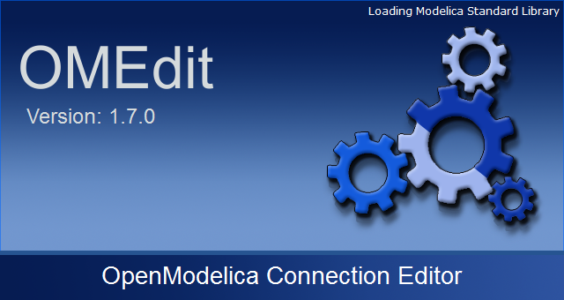
Figure 2-2: OMEdit Splash Screen.

Linux
?? fill in

Mac OS X
?? fill in

Introductory Modeling in OMEdit
In this section we will demonstrate how one can create Modelica models in OMEdit, e.g. a DCmotor.
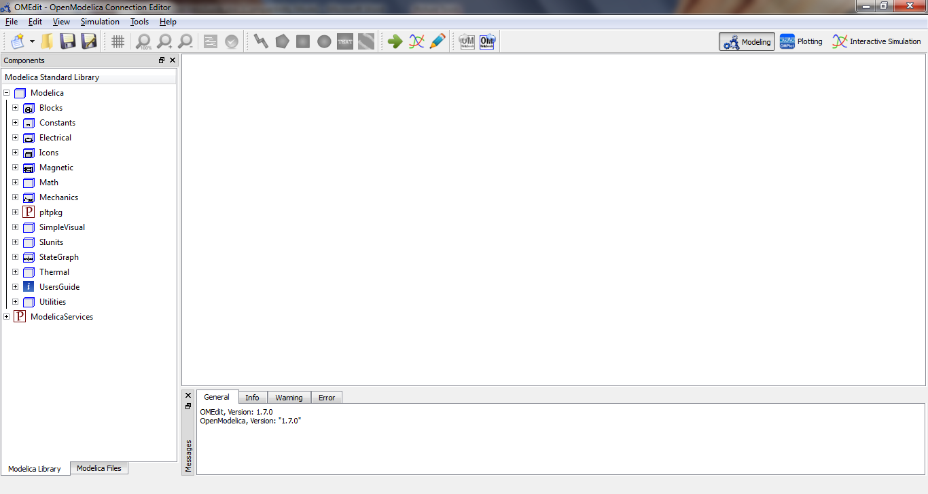
Figure 2-3: OMEdit Main Window.

Creating a New File
Creating a new file/model in OMEdit is rather straightforward. In OMEdit the new file can be of type model, class, connector, record, block, function and package. User can create any of the file types mentioned above by selecting File > New from the menu. Alternatively, you can also click on the drop down button beside new icon shown in toolbar right below the File menu. See Figure 2-5.
For this introductory example we will create a new model named DCmotor. By default the newly created model will open up in the tabbed view of OMEdit, also called Section 2.5.2), and become visible. The models are created in the OMC global scope unless you specify the parent package for it.
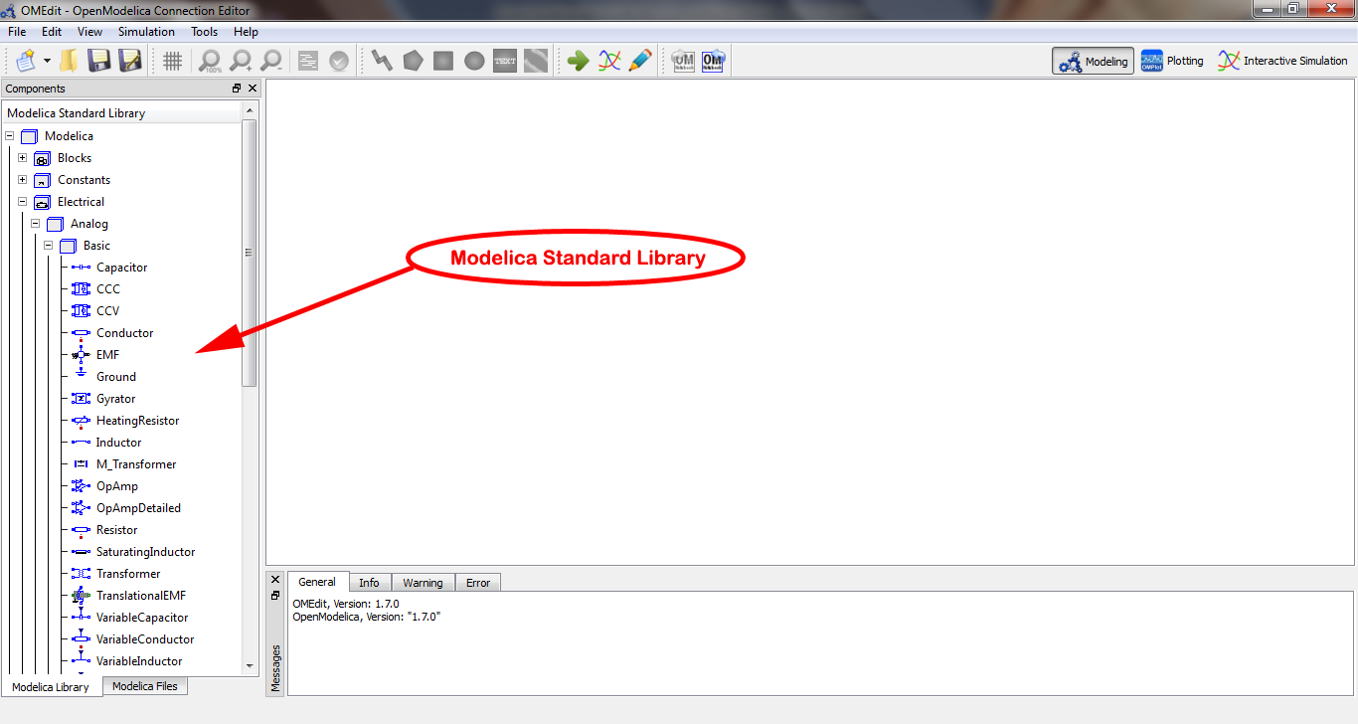
Figure 2-4: Modelica Standard Library.

Adding Component Models
The Modelica standard library is loaded automatically and is available in the left dock window. The library is retrieved through the loadModel(Modelica) API call and is loaded in the OMC symbol table and workspace after the command execution is completed. Component models available in the Modelica standard library are added to the models by doing a drag and drop from the Library Window (see Figure 2-4 and Section 2.5.1). Navigate to the component model in the library tree, click on it, drag it to the model you are building while pressing the mouse left button, and drop the component where you want to place it in the model.
Similarly, the component models present in the Modelica Tree View, i.e. the Custom Modelica Models also can be added into some other custom Modelica models by a similar drag and drop. The dropped component keeps getting updated as soon as we make any changes in the original model.
For this example we will add four components as instances of the models Ground, Resistor, Inductor and EMF from the Modelica.Electrical.Analog.Basic package, an instance of the model SignalVoltage from the Modelica.Electrical.Analog.Sources package, one instance of the model Inertia from the Modelica.Mechanics.Rotational.Components package and one last instance of the model Step from the Modelica.Blocks.Sources package.

Making Connections
In order to connect one component model to another the user simply clicks on any of the ports. Then it will start displaying a connection line. Then move the mouse to the target component where you want to finish the connection and click on the component port where the connection should end. You do not need to hold the mouse left button down for drawing connections.
In order to have a functioning DCmotor model, connect the Resistor to the Inductor and the SignalVoltage, EMF to Inductor and Inertia, Ground to SignalVoltage and EMF, and finally Step to SignalVoltage. Check Figure 2-8 to see how the DCmotor model looks like after connections.
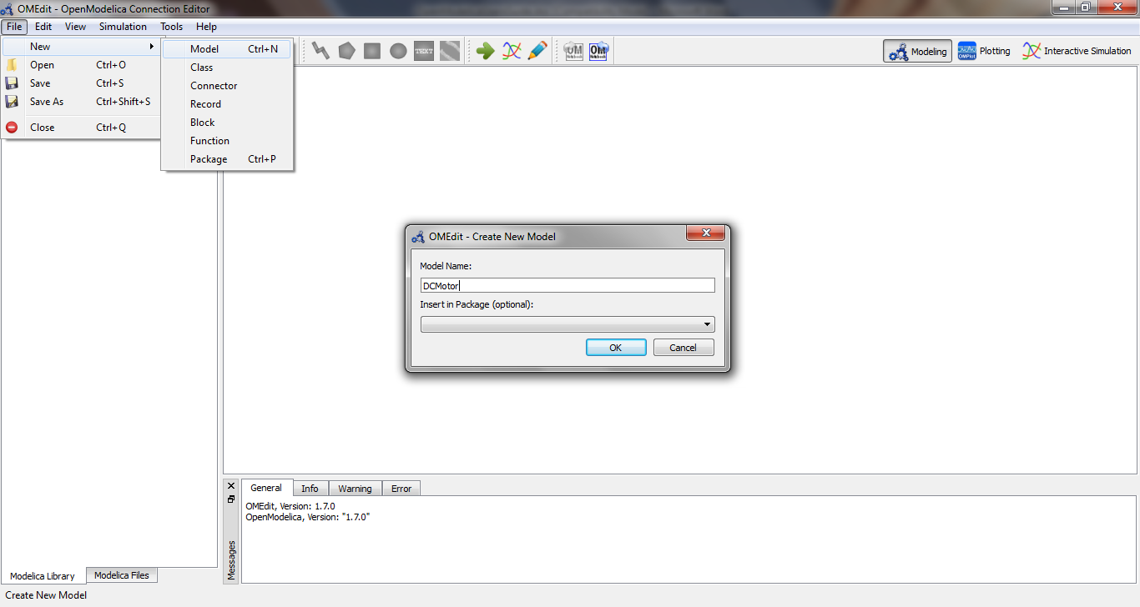
Figure 2-5: Creating a new model.
In order to connect one component model to another the user first enables the connect mode from the toolbar to make the connect mode active. See Figure 2-6.
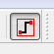
Figure 2-6: Connect mode button.
The different kinds of connections are:
- Connections for Models – If the connect mode is active then user then simply clicks on any of the ports.
- Connection for Connector Types – If the connect mode is active then we can also connect two components of connector types to each other if they are of the same type. Since, it is a connector type, to start or end a connection, you can just click anywhere on the component icon and it will start.
- Connection for Connector Array Type – If any of the start port or the end port of the connection is of an array type, the user also needs to add indices at which the connection is to be made. For this a dialog box will pop up, as soon as the user clicks on the end port of the connection asking the user for indices of the array for whichever port it is necessary. For example, let’s say, the user wants to connect, the x component instance of Modelica.Electrical.Digital.Converters.BooleanToLogic to the y component instance of Modelica.Blocks.Sources.BooleanConstant. Now since, Modelica.Electrical.Digital.Converters.BooleanToLogic.x is a connector array, as soon as the user clicks on the end port for this connection, a dialog box appears asking user the index of the start instance. See Figure 2-7.
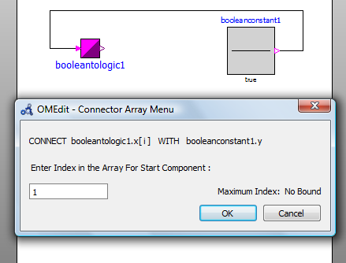
Figure 2-7: Connector Array Menu

Simulating the Model
The OMEdit Simulation dialog (see Figure 2-9, Section 2.6.2) can be launched either from Simulation > Simulate or by clicking the simulate icon from the toolbar. Once the user clicks on Simulate! button, OMEdit starts the simulation process, at the end of the simulation process the Plot Variables Window (Figure 2-10, Section 2.5.3) useful for plotting will appear at the right side. Figure 2-9 shows the simulation dialog.
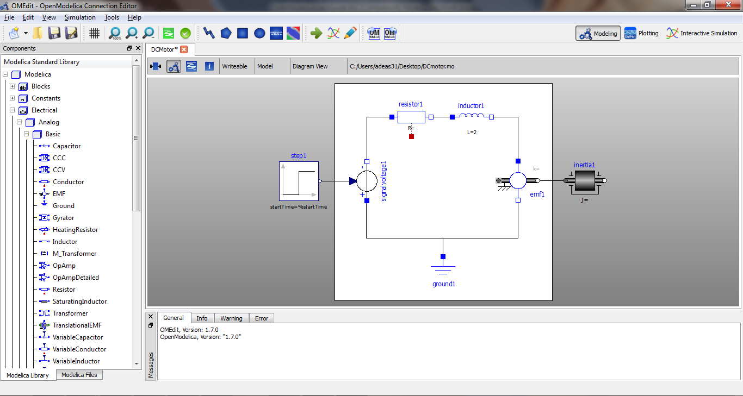
Figure 2-8: DCmotor model after connections.

Plotting Variables from Simulated Models
The instance variables that are candidate for plotting are shown in the right dock window. This window is automatically launched once the user simulates the model; the user can also launch this window manually either from Simulation > Plot Variables or by clicking on the plot icon from toolbar. It contains the list of variables that are possible to use in an OpenModelica plot. The plot variables window contains a tree structure of variables; there is a checkbox beside each variable. The user can launch the plotted graph window by clicking the checkbox.
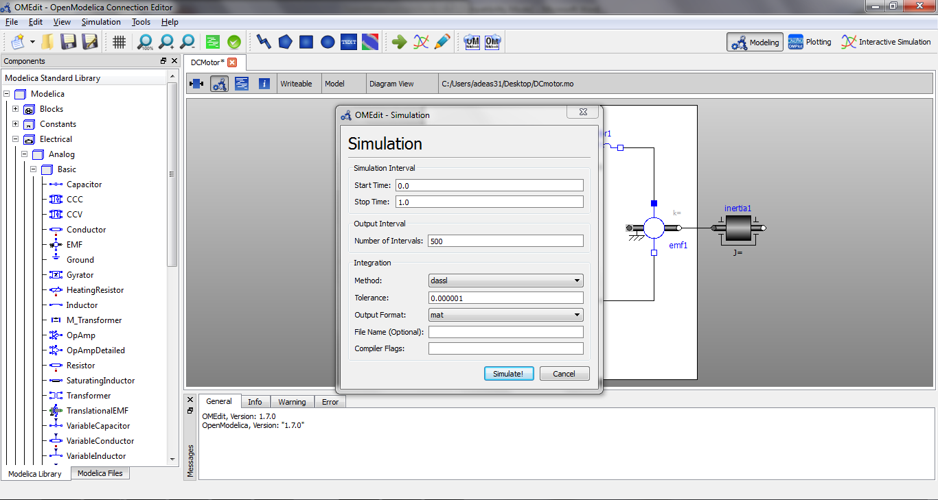
Figure 2-9: Simulation Dialog.
Figure 2-10 shows the complete DCmotor model along with the list of plot variables and an example plot window.
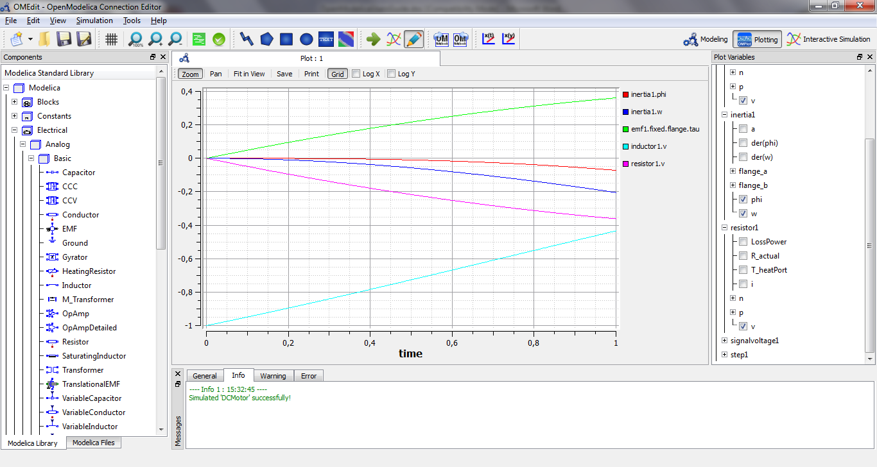
Figure 2-10: Plotted variables.

How to Create User Defined Shapes – Icons
Users can create shapes of their own by using the shape creation tools available in OMEdit.
- Line Tool – Draws a line. A line is created with a minimum of two points. In order to create a line, the user first selects the line tool from the toolbar and then click on the Designer Window; this will start creating a line. If a user clicks again on the Designer Window a new line point is created. In order to finish the line creation, user has to double click on the Designer Window.
- Polygon Tool – Draws a polygon. A polygon is created in a similar fashion as a line is created. The only difference between a line and a polygon is that, if a polygon contains two points it will look like a line and if a polygon contains more than two points it will become a closed polygon shape.
- Rectangle Tool – Draws a rectangle. The rectangle only contains two points where first point indicates the starting point and the second point indicates the ending the point. In order to create rectangle, the user has to select the rectangle tool from the toolbar and then click on the Designer Window, this click will become the first point of rectangle. In order to finish the rectangle creation, the user has to click again on the Designer Window where he/she wants to finish the rectangle. The second click will become the second point of rectangle.
- Ellipse Tool – Draws an ellipse. The ellipse is created in a similar way as a rectangle is created.
- Text Tool – Draws a text label.
- Bitmap Tool – Draws a bitmap container.
The shape tools are located at the top in the toolbar. See Figure 2-11.
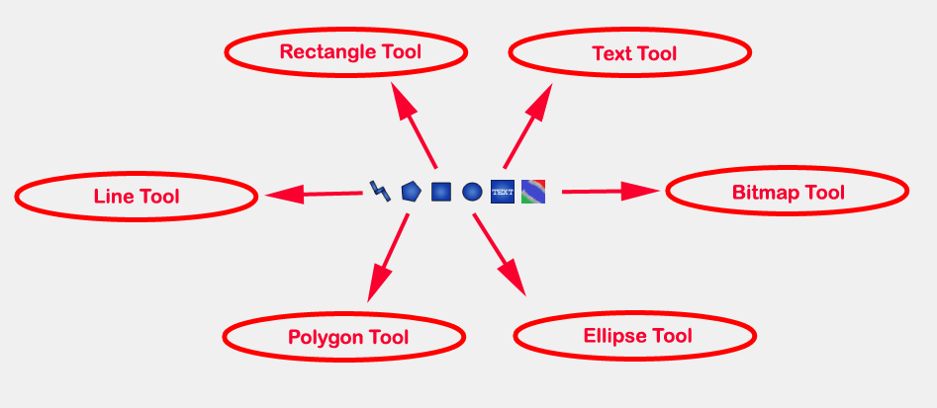
Figure 2-11: User defined shapes.
The user can select any of the shape tools and start drawing on the Designer Window. The shapes created on the Diagram View of Designer Window are part of the diagram and the shapes created on the Icon View will become the icon representative of the model.
For example, if a user creates a model with name testModel and add a rectangle using the rectangle tool and a polygon using the polygon tool, in the Icon View of the model. The model’s Modelica Text will appear as follows:
model testModel
annotation(Icon(graphics = {Rectangle(rotation = 0, lineColor = {0,0,255}, fillColor = {0,0,255}, pattern = LinePattern.Solid, fillPattern = FillPattern.None, lineThickness = 0.25, extent = {{ -64.5,88},{63, -22.5}}),Polygon(points = {{ -47.5, -29.5},{52.5, -29.5},{4.5, -86},{ -47.5, -29.5}}, rotation = 0, lineColor = {0,0,255}, fillColor = {0,0,255}, pattern = LinePattern.Solid, fillPattern = FillPattern.None, lineThickness = 0.25)}));
end testModel;
In the above code snippet of testModel, the rectangle and a polygon are added to the icon annotation of the model. Similarly, any user defined shape drawn on a Diagram View of the model will be added to the diagram annotation of the model.

OMEdit Views
OMEdit has three kinds of views.

Modeling View
This is the default view. This view shows the Designer Window and allows users to create their models.

Plotting View
This view is used for showing plot graphs. The user can launch this view anytime by using the views button in the tool bar. This view also becomes active automatically when user simulates the model successfully.

Interactive Simulation View
This view is quite similar to Plotting View. One of the primary differences is that Plotting View is used to show graphs of pre-built models that cannot be changed. However, in the Interactive Simulation View the user can change the values of variables and parameters of the model at runtime.

OMEdit Windows/Tabs
The OMEdit GUI contains several windows that shows different views to users:
- Library Window for the Modelica Standard Library.
- Drawing interface in the form of Designer Window.
- Plot Window contains the list of instance variables.
- Messages Window displays the informational, warning and error messages.
- Documentation Window displays the Modelica annotations based documentation in a QWebView.
- Model Browser Window displays the component hierarchy of the model.

Library Window
The Modelica Standard Library is automatically loaded in OMEdit and is located on the left dock window. Once a Modelica model has been created then the user can just drag and drop components into the model from the MSL, the Library Window. The available libraries in the MSL are:
- Blocks
- Constant
- Electric
- Icons
- Magnetic
- Math
- Mechanics
- SIunits
- Thermal
- UsersGuide
- Utilities
The Library Window consists of two tabs one shows the Modelica Standard Library and is selected by default the other tab shows the Modelica files that user creates in OMEdit.

Viewing Models Description
In order to view the model details, double click the component and details will be opened in Designer Window. Alternative way is to right click on the component and press Show Component, it will do the same.

Viewing Models Documentation
Right click the model in the Library Window and select View Documentation; it will launch the Documentation Window. See Figure 2-12.

How to Open an Existing Model?
- Go to File->Open. An Open Model Dialog Appears. The user can go to the required file location and click on it to open the model in OMEdit.
- The user can also drag any model from an outside window and drop it into the Main Window of OMEdit to open that model.

How to create a Copy of an Existing Model?
To copy a model, the user can simply right click on the model in the Library Window, and then select copy. To paste the copied model the user can click on any empty space in the Library Window and click on the paste Option. A copy of the model will be created initialized with a new name.

How to Check a Model?
Right click the component in the library window and select Check; it will launch the Check Dialog. See Figure 2-12.

How to Instantiate a Model?
Right click the component in the library window and select Instantiate Model; it will launch the Instantiate Model Dialog. See Figure 2-12.

How to Rename a Model?
Right click the model in the Library Window and select Rename; it will launch the Rename Dialog. See Figure 2-12.

How to Delete a Model?
Right click the model in the library window and select Delete; a popup will appear asking “Are you sure you want to delete?”
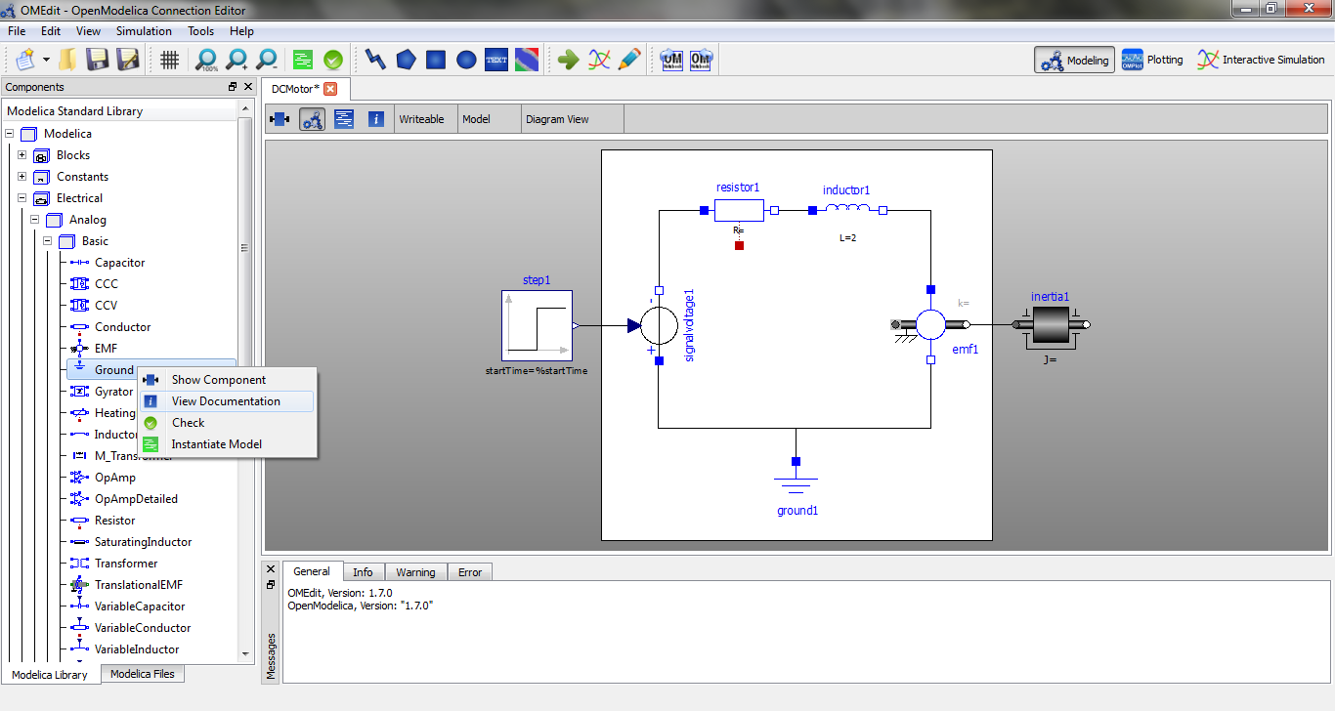
Figure 2-12: Context menu to view component model details.

Designer Window
The Designer Window is the main window of OMEdit. It consists of three views,
- Icon View - Shows the model icon view.
- Diagram View - Shows the diagram of the model created by the user.
- Modelica Text View - Shows the Modelica text of the model.

Plot Variables Window
The right dock window represents the Plot Variables Window. It consists of a tree containing the list of instance variables that are extracted from the simulation result. Each item of the tree has a checkbox beside it. The user can click on the check box to launch the plot graph window. The user can add/remove the variables from the plot graph window by marking/unmarking the checkbox beside the plot variable.

Messages Window
Messages Window is located at the bottom of the application. The Messages Window consists of 4 types of messages,
- General Messages – Shown in black color.
- Informational Messages – Shown in green color.
- Warning Messages – Shown in orange color.
- Error Messages – Shown in red color.

Documentation Window
This window is shown when a user right clicks the component in the library window and selects View Documentation. This shows the OpenModelica documentation of components in a web view. All externals links present in the documentation window are opened in the default browser of the user. All local links are opened in the same window. Figure 2-13 shows the Documentation Window view.
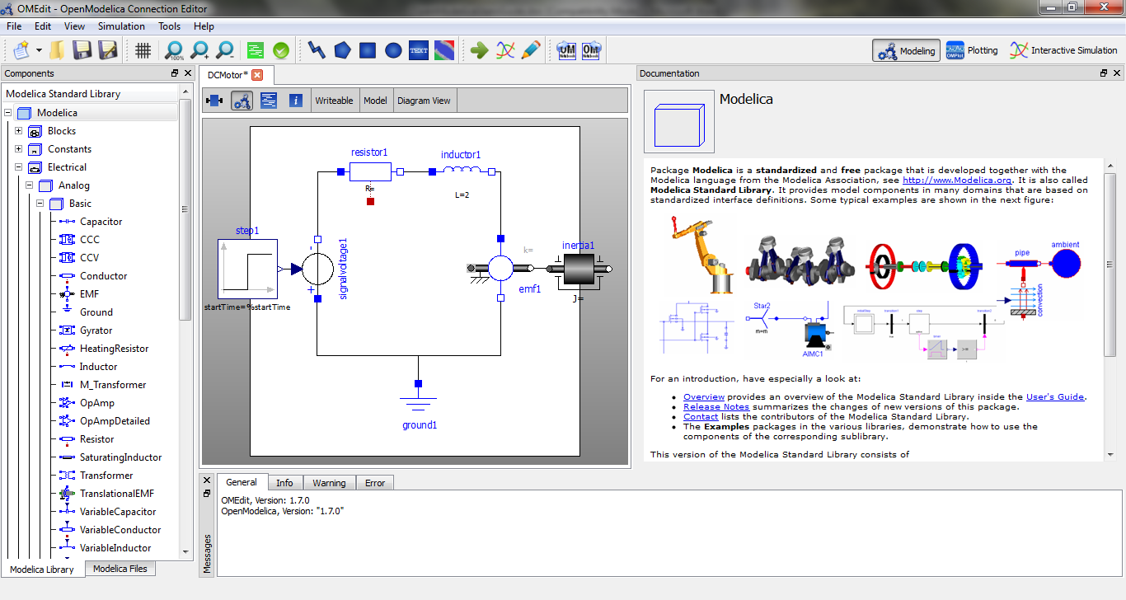
Figure 2-13: Documentation Window.

Model Browser Window
The Model Browser Window is located on the left bottom dock window below the Library Window. It lays the outline of the currently opened model and show all the component heirarchy in a tree format. See Figure 2-14.
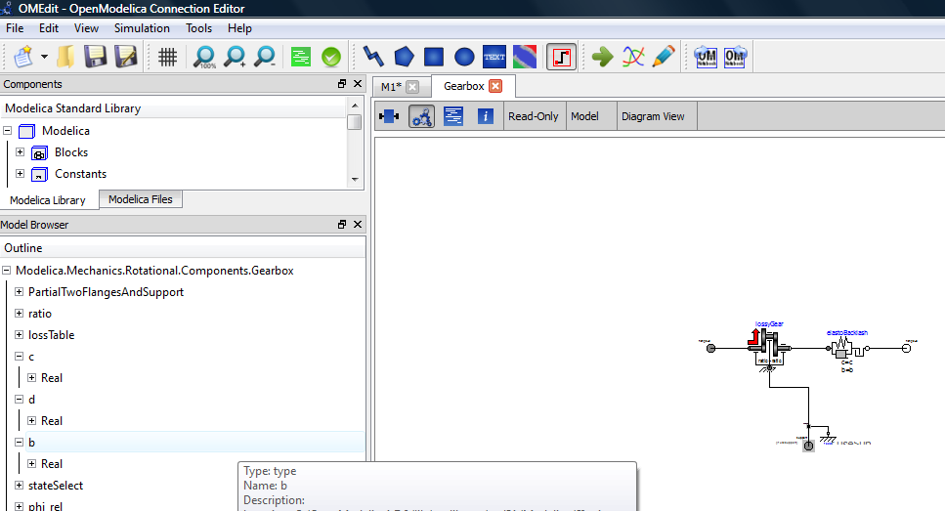
Figure 2-14: Model Browser Window.

Dialogs
Dialogs are a kind of window that is not visible by default. The user has to launch them or they will automatically appear due to some user action. The following dialogs are available:
- New Dialog for creating new Modelica models.
- Simulation Dialog for simulating Modelica models.
- Model Properties Dialog.
- Model Attributes Dialog.

New Model Dialog
The New Dialog can be launch from File > New > Model Type. Model type can be model, class, connector, record, function and package.

Simulation Dialog
Simulation Dialog can be launched either from Simulation > Simulate or by clicking on the Simulate! button in the toolbar. Figure 2-9 shows a simulation dialog. The simulation dialog consists of simulation variables. You can set the value of any variable, depending on the simulation requirement. Simulation variables are,
- Simulation Interval
- Start Time
- Stop Time
- Output Interval
- Number of Intervals
- Output Interval
- Integration
- Method
- Tolerance
- Fixed Step Size

Model Properties Dialog
The models that are placed in the Designer Window can be modified by changing the properties. In order to launch the Model Properties Dialog of a particular model right click the model and select Properties. See Figure 2-15. The properties dialog contains the name of the model, class name the model belongs to and the list of parameters of the component.
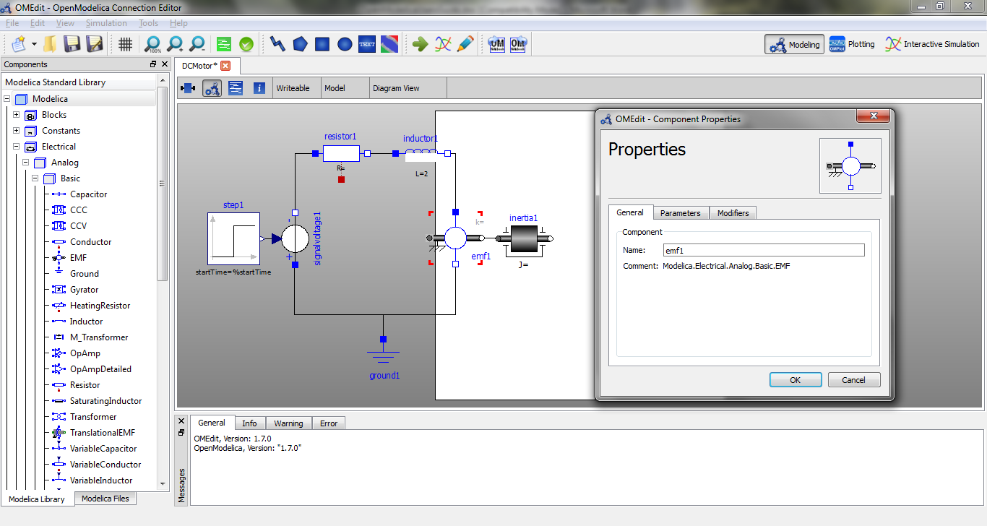
Figure 2-15: Properties Dialog.

Model Attributes Dialog
Right click the model placed in the Designer Window and select Attributes. It will launch the attributes dialog. Figure 2-16 shows the Model Attributes Dialog.
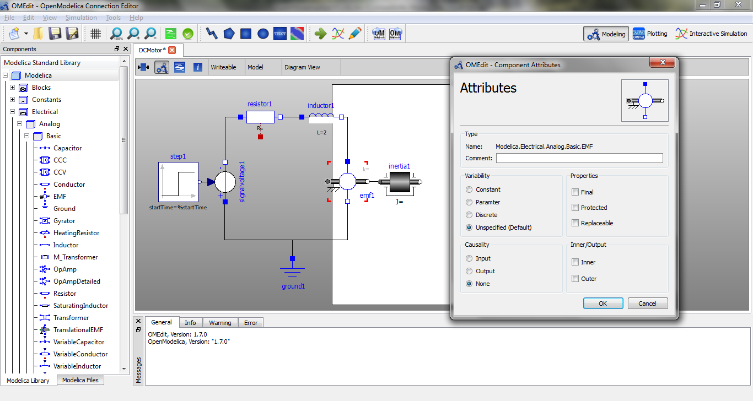
Figure 2-16: Attributes Dialog.

Interactive Simulation in OMEdit
OMEdit uses the OpenModelica Interactive (OMI) subsystem to perform the interactive plotting. The OMI uses the TCP/IP technique to transfer data back and forth. OMEdit connects with OMI through TCP sockets.

Invoking Interactive Simulation
Interactive Simulation Dialog can be launched either from Simulation > Interactive Simulation or by clicking on the Interactive Simulation! button in the toolbar. Interactive Simulation Dialog looks similar to the Simulation Dialog but it differs in functionality, instead of performing normal pre-built simulation it performs online interactive simulation where simulation responds in real-time to user input and changes to parameters.
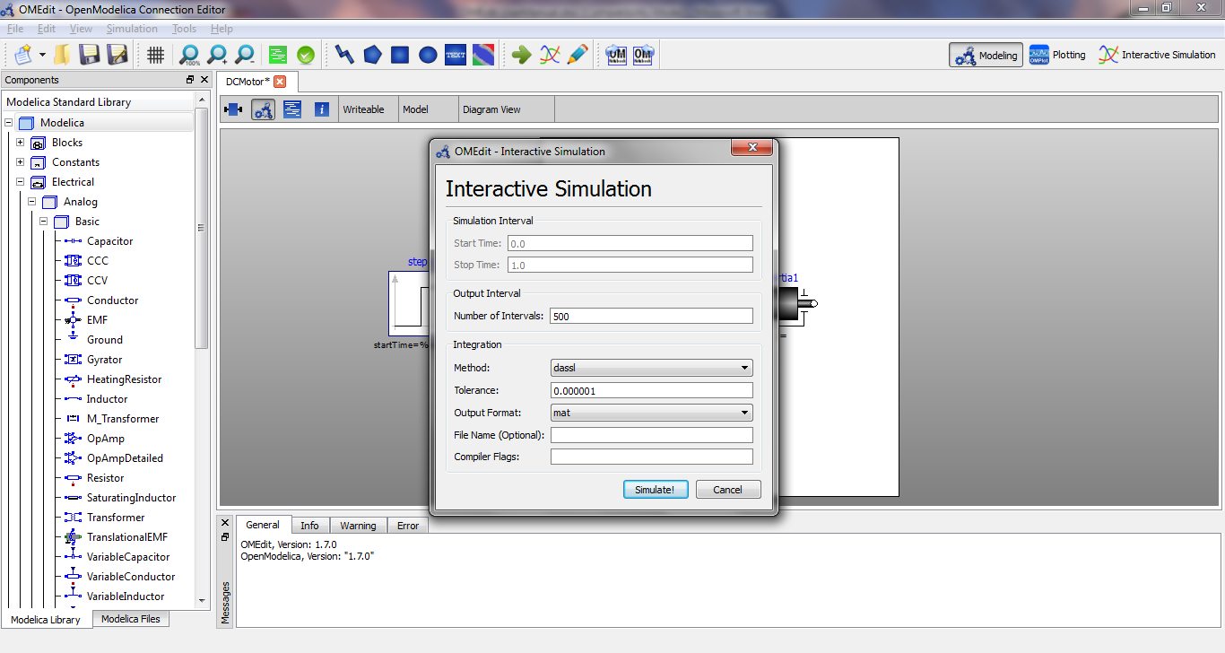
Figure 2-17: Interactive Simulation Dialog.

Interactive Simulation View
Once your model was successfully built using the Interactive Simulation Dialog, the Interactive Simulation View will become active automatically. Interactive Simulation View contains,
- Graph – It contains a graph which is used to display the values of selected variables over the time.
- Parameters – The parameters of the model are shown on the right top section with the default values.
- Variables – The right bottom section contains the list of variables that user can select for interactive plotting.
- Initialize Button – This button is used to send the information of changed parameters and checked variables to the OpenModelica Interactive subsystem.
- Start Button – Once the parameters and variables are initialized and sent to the OMI. Then the user can click on start button and start the interactive plotting.
- Pause Button – This button pauses the running interactive plotting.
- Stop Button – Clears everything but does not remove the connection with OMI. After clicking stop button user has to reinitialize everything and start the interactive plotting again.
- Shut Down Button – Disconnects from OMI and closes the interactive simulation session.
- Show OMI Log Button – Pops up a log window which displays the messages exchanged between OMEdit and OMI.
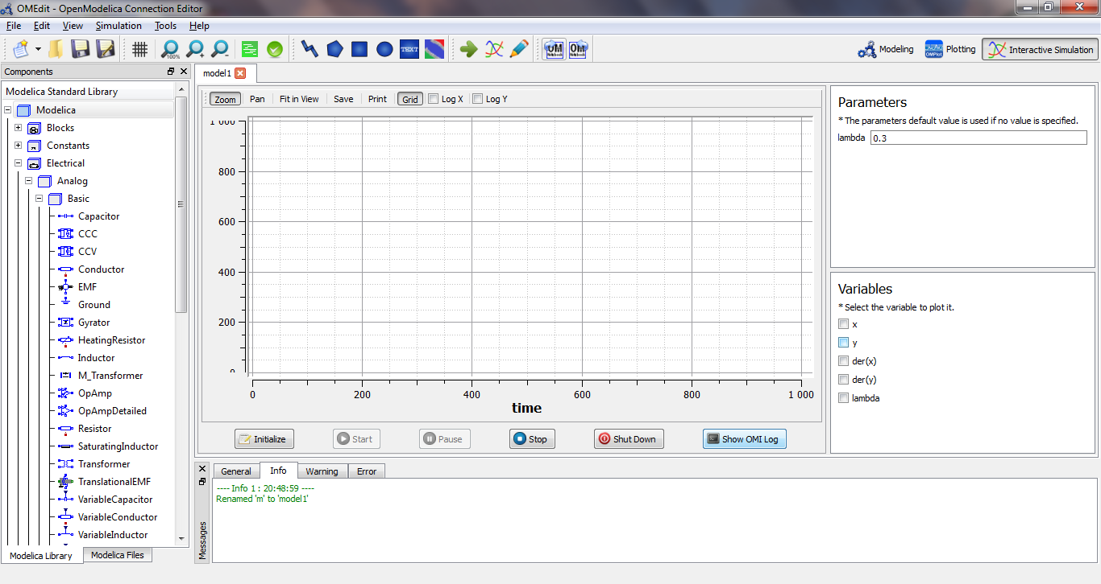
Figure 2-18: Interactive Simulation View.

2D Plotting and 3D Animation
This chapter covers 2D plotting available from OMNotebook, OMShell or programmable plotting from your own Modelica model. The 3D animation is currently turned off by default, but will be available in an enhanced version in a future release.

Enhanced Qt-based 2D Plot Functionality
Starting with OpenModelica 1.4.5, enhanced plotting functionality is available (Eriksson, 2008). The enhanced plotting is implemented based on a Qt-based (Trolltech, 2007) GUI package. This new plotting functionality has additional features compared to the old Java-based PtPlot plotting. The simulation data is sent directly to the plotting window in OMNotebook (or a popup window if called from OMShell), which handles the presentation (see Figure 3-20). As OMNotebook now has access to all source data it is now possible to manipulate diagrams, e.g. zoom or change scales.
To allow the use of graphics functions from within Modelica models a new Modelica API has been developed. This utilizes an external library to communicate with OMNotebook. In addition to this, a number of new functions that can be used for drawing geometric objects like circles, rectangles and lines have been added.
The following is a summary of the capabilities of the new 2D graphics package:
- Interaction with OMNotebook. The graphics package has been developed to be fully integrated with OMNotebook and allow modifications of diagrams that have been previously created.
- Usage without OMNotebook. If the functionality of the graphics package is used without OMNotebook, a new window should be opened to present the resulting graphics.
- Logarithmic scaling. Some applications of OpenModelica produce simulation data with large value ranges, which is hard to make good plots of. One solution to this problem is to scale the diagram logarithmically, and this is allowed by the graphics package.
- Zoom. To allow studying of small variations the user is allowed to zoom in and out in a diagram.
- Support for graphic programming. To allow creation of Modelica models that are able to draw illustrations, show diagrams and suchlike, it is possible to use the graphics package not only from the external API of OMC, but also from within Modelica models. To accomplish this a new Modelica interface for the graphics package has been created.
- Programmable Modelica API. The Modelica API is defined by a number of Modelica functions, located in the package Modelica.Graphics.Plot, which use external libraries to access functionality of the graphics package.
The programmable Modelica API functions include the following:
- plot(x). Draws a two-dimensional line diagram of x as a function of time.
- plotParametric(x,y). Draws a two-dimensional parametric diagram with y as a function of x.
- plotTable([x1, .., y1; .. ; xn, .., yn]). Draws a two-dimensional parametric diagram with y as a function of x.
- drawRect(x1, x2, y1, y2). Draws a rectangle with vertices in (x1, y1) and (x2, y2).
- drawEllipse(x1, x2, y1, y2). Draws an ellipse with the size of a rectangle with vertices in (x1, y1) and (x2, y2).
- drawLine(x1, x2, y1, y2). Draws a line from (x1, y1) to (x2, y2).
A faster and more stable plot implementation is available from the OpenModelica 1.7 release. Currently these commands can be used by giving the plot3(…) command instead of plot(…). In future releases the faster plot implementation will be the default.

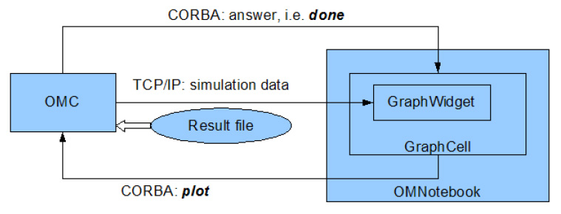
Figure 3-19. Plotting architecture with the new 2D graphics package.

Simple 2D Plot
To create a simple time plot the model HelloWorld defined in DrModelica is simulated. To reduce the amount of simulation data in this example the number of intervals is limited with the argument numberOfIntervals=10. The simulation is started with the command below.
simulate(HelloWorld, startTime=0, stopTime=4, numberOfIntervals=10);
When the simulation is finished the file HelloWorld res.plt contains the simulation data. The contents of the file is the following (some formatting has been applied).
0 1
4.440892098500626e-013 0.9999999999995559
0.4444444444444444 0.6411803884299349
0.8888888888888888 0.411112290507163
1.333333333333333 0.2635971381157249
1.777777777777778 0.1690133154060587
2.222222222222222 0.1083680232218813
2.666666666666667 0.06948345122279623
3.111111111111112 0.04455142624447787
3.555555555555556 0.02856550078454138
4 0.01831563888872685
Diagrams are now created with the new graphics package by using the following command.
plot(x);
seems to correspond well with the data.
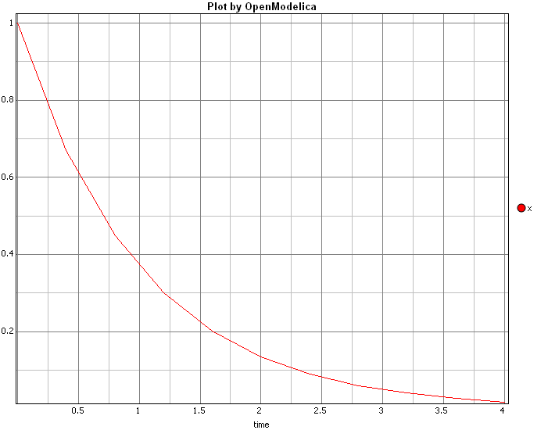
Figure 3-20. Simple 2D plot of the HelloWorld example.
By re-simulating and saving results at many more points, e.g. using the default 500 intervals, a much smoother plot can be obtained.
simulate(HelloWorld, startTime=0, stopTime=4, numberOfIntervals=500);
plot(x);
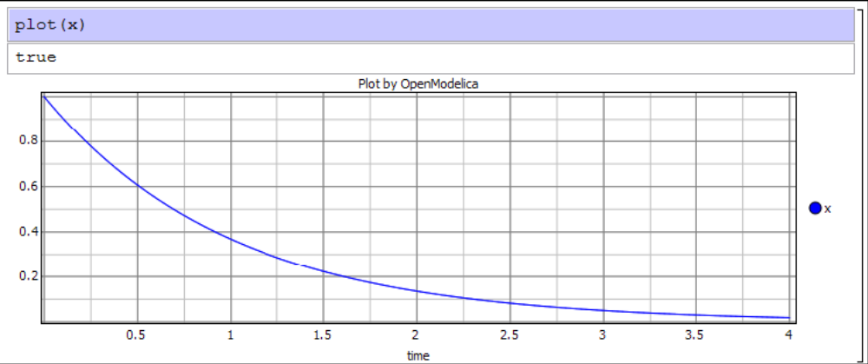
Figure 3-21. Simple 2D plot of the HelloWorld example with larger number of points.
Additional features of the new plotting are shown in Figure 3-22 and Figure 3-23.
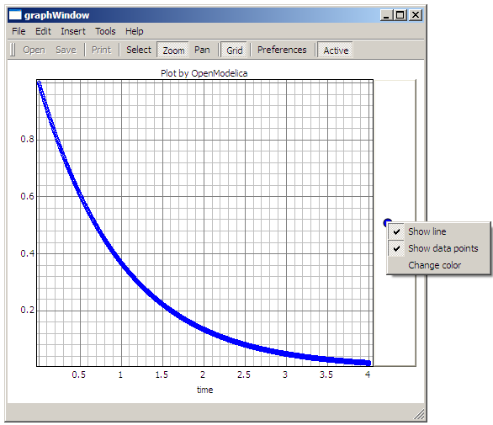
Figure 3-22. Features of the new Qt-based Plotting Package: Show data points, Change line colors, etc.
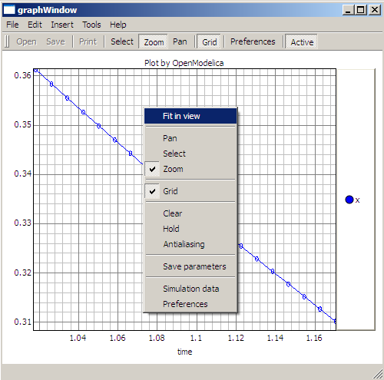
Figure 3-23. Features of the new Qt-based Plotting Package: Zoom, Fit in view, Grid, etc.

Plot Functions and Their Options
All plot functions are part of ModelicaBuiltin.mo , with additional explanation below.
All of these commands can have any number of optional arguments to further customize the the resulting diagram. The available options and their allowed values are listed below.
Command | Description
plot(x) | Creates a diagram with data from the last simulation that had a variable named x.
plot({x,y,..., z}) | Like the previous command, but with several variables.
plotParametric(x, y) | Creates a parametric diagram with data from the last simulated variables named x and y.
plotParametric(x, {y1,y2}) | Like the previous command, but with several variables.
plotAll() | Creates a diagram with all variables from the last simulated model as functions of time.

Option | Default value | Description
fileName | The result of the last simulation | The name of the result-file containing the variables to plot
grid | true | Determines whether or not a grid is shown in the diagram.
title | "Plot by OpenModelica" | This text will be used as the diagram title.
interpolation | linear | Determines if the simulation data should be interpolated to allow drawing of continuous lines in the diagram. "linear" results in linear interpolation between data points, "constant" keeps the value of the last known data point until a new one is found and "none" results in a diagram where only known data points are plotted.
legend | true | Determines whether or not the variable legend is shown.
points | true | Determines whether or not the data points should be indicated by a dot in the diagram.
logX | false | Determines whether or not the horizontal axis is logarithmically scaled.
logY | false | Determines whether or not the vertical axis is logarithmically scaled.
xRange | {0, 0} | Determines the horizontal interval that is visible in the diagram. {0, 0} will select a suitable range.
yRange | {0, 0} | Determines the vertical interval that is visible in the diagram. {0, 0} will select a suitable range.
antiAliasing | false | Determines whether or not antialiasing should be used in the diagram to improve the visual quality.
vTitle | “” | This text will be used as the vertical label in the diagram.
hTitle | “time” | This text will be used as the horizontal label in the diagram.

Zooming
The left mouse button can for instance be used for zooming in on interesting parts of the diagram.The same result can be achieved by using the optional parameters xRange and yRange. The plotParametric command would then look like the following.
plotParametric(x, y, xRange={0.9, 1.95}, yRange={-1.5, 1.35})
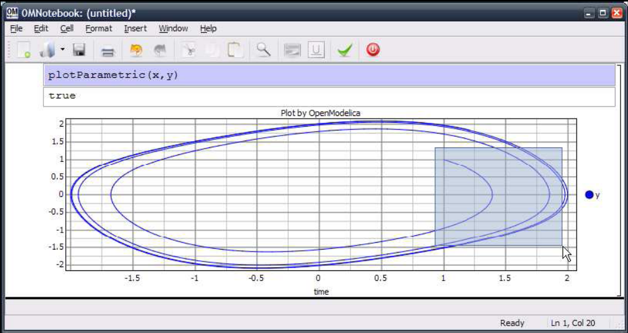
Figure 3-24. Zooming in an Input cell.

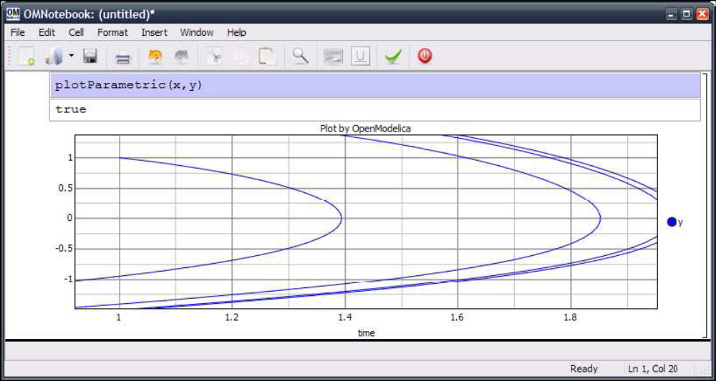
Figure 3-25. Magnified input cell.

Plotting all variables of a model
A command, plotAll, has been introduced to plot all the variables of a model. This can be useful if a model contains many interesting variables, as it might be easier to remove variables that are not important than to list all those who are. The command available for this is plotAll().The command below applies plotAll to the model HelloWorld. The result is shown in Figure 3-26. The simplest way to remove unimportant variables is to use the Remove command in the Legend menu.
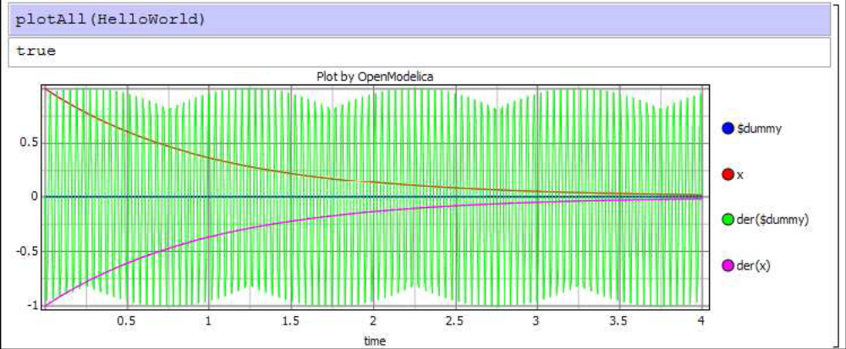
Figure 3-26. Result of the plotAll command.

Plotting During Simulation
When running long simulations, or if plotting without need for commands like plot or plotParametric is desired, the interface for transfer of simulation data during running simulations can be used. This is enabled by running the following command.
enableSendData(true)
The same command, but with the parameter false, is used to disable the interface. Enabling of the interface has some drawbacks though. The simulation time will be longer as the transfer of data will require some resources.
If the simulation data would have been plotted anyway, some of this time will be saved later however. To reduce the amount of data that has to be transferred, and thereby reduce the time needed to do so, the interesting variables in the model can be specified with the variableFilter option of the simulate command (see Section 1.2.14 for details). If for instance the model HelloWorld is to be simulated the following commands can be used.
class HelloWorld
Real x(start = 1);
parameter Real a = 1;
equation
der(x) = - a * x;
end HelloWorld;
enableSendData(true);
simulate(HelloWorld, startTime=0, stopTime=25, variableFilter="x");
When the simulation data has been transferred the button D will appear to the right of the input field. By pressing this dialog Simulation data will appear, where new curves can be created.

Programmable Drawing of 2D Graphics
The graphics package provides functions for drawing of basic geometrical objects in the graphics area. These can be used from Modelica models and are executed when the model is simulated. To avoid name conflicts, the functions have been put in the package Modelica.pltpkg. The functions of the Modelica programmable plotting interface are described below.
- plot(model, "x"). Creates a diagram with data from the variable x in the previously simulated model model.
- plot(model, "x, y"). Like the function above, but with more than one variable.
- plotParametric(model, "x", "y"). Creates a parametric diagram with data from the variables x and y in the previously simulated model model.
- plotTable([x1, y1, z1, ...; x2, y2, z2, ...;...]). Draws y and z as functions of x..
- clear().Clears the active GraphWidget.
- rect(x1, x2, y1, y2). Draws a rectangle with vertices in (x1, y1) and (x2, y2).
- ellipse(x1, x2, y1, y2). Draws an ellipse with the size of a rectangle with vertices in (x1, y1) and (x2, y2).
- line(x1, x2, y1, y2). Draws a line from (x1, y1) to (x2, y2).
- hold(Boolean on). Determines whether or not the active GraphWidget should be cleared before new graphics is drawn.
- wait(ms). Waits for (at least) ms milliseconds.
The following model shows how these functions can be used to draw ellipses, rectangles, and lines.

model testGeom
parameter Integer n=10;
protected
Boolean b[n,n];
equation
for x in 1:n loop
for y in 1:n loop
when initial() then
if((y == 1) or (y == 10) or (x == 1) or (x == 10)) then
b[x,y] = pltpkg.rect(x, y, x+1, y+1, fillColor = "blue",
color = "green");
else if(y >= 4 and y <= 5 and x >= 4 and x <= 5) then
b[x,y] = pltpkg.line(x, y, x+1, y+1, color = "red");
else
b[x,y] = pltpkg.ellipse(x, y, x+1, y+1, fillColor = "yellow",
color = "black");
end if;
end if;
end when;
end for;
end for;
end testGeom;
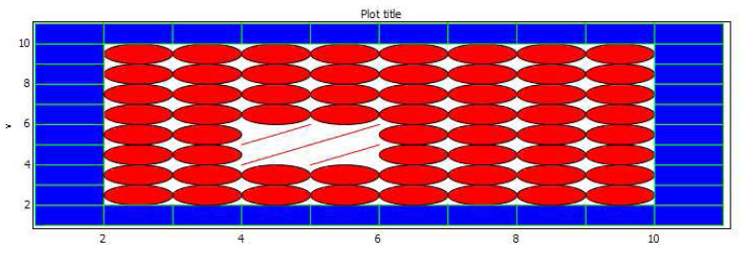
Figure 3-27. Programmable drawing of rectangles and ellipses.

Plotting of Table Data
Another way to visualize data provided by the graphics package is plotting of table data. This is done by using the command pltpkg.plotTable, which expects a matrix of Real values as a parameter. The rows of this matrix represent variable values. The first column is the time variable and the other columns contains values at these points in time. The names of the variables can be specified with the argument variableNames, which is a String list. The following model demonstrates how this command can be used.
model table
protected
Boolean b;
algorithm
b := pltpkg.pltTable([ 0, 0.95, 0.92, 20, 25;
10, 0.94, 0.92, 23, 28;
20, 0.94, 0.91, 32, 35;
30, 0.93, 0.90, 43, 46] );
end table;
The result is shown in Figure 3-28 below.
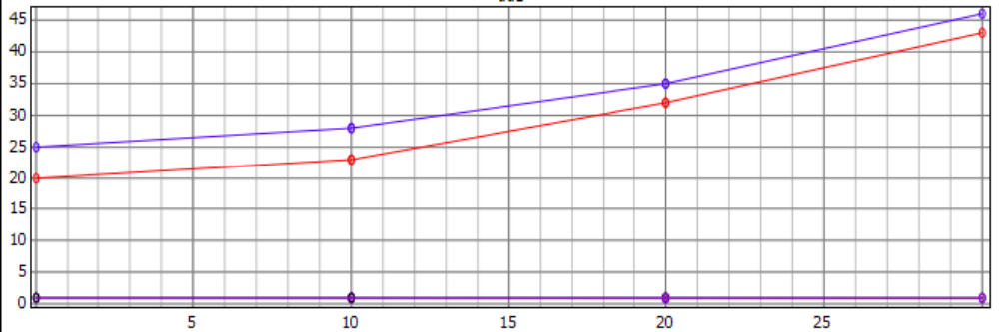
Figure 3-28. Plotting of table data.

Java-based PtPlot 2D plotting
The plot functionality in OpenModelica 1.4.4 and earlier was based on PtPlot (Lee, 2006), a Java-based plot package produced within the Ptolemy project. To plot one uses plot commands within input cells which it evaluates. Available plotting commands which call Java-based plotting are as follows, still available but renamed with a suffix 2:
// normal one variable plotting, time on the X axis
plot2( variable );
// normal multiple variable plotting, time on the X axis
plot2( {variable1, variable2, variable3, … variableN} );

// to plot dependent values
plotParametric2( variableX, variableY );

For example:
simulate(HelloWorld, startTime=9, stopTime=4);
plot(x);
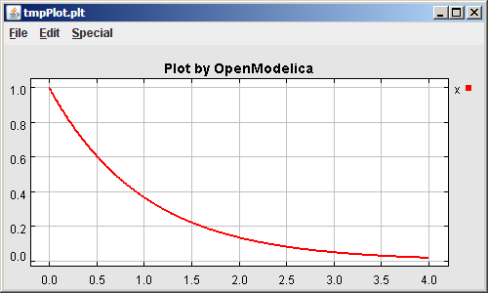
Figure 3-29. Java-based PtPlot plot window.

3D Animation
There are two main approaches to add 3D graphics information to Modelica objects:
- Graphical annotations
- Graphical objects
Both of these approaches were investigated, but the second was finally chosen.

Object Based Visualization
Since one important goal of this work is to come up with a system for visualization that might be used for simulations done with the Modelica MultiBody library (Otter, 2008), it follows that much can be learned from investigating currently available solutions. There are commercial software packages available that can visualize MultiBody simulations.
The MultiBody package is well suited for visualization. Entities in a MultiBody simulation correspond to physical entities in a real world and as such have many of the properties needed to correctly display them within a visualization of the simulation, such as position and rotation. Other properties such as color and shape can easily be added as properties or be decided based on the object type.
Instead of using annotations to encode information about how a certain object is supposed to look when visualized, object based visualization creates additional Modelica objects of a predetermined type that can be known to the client actually doing the visualization. These objects contain variables such as position, rotation and size that can be connected to the simulated variables using ordinary Modelica equations. When asked to visualize a model, the OpenModelica compiler can find variables in the model that are in the visualization package and only send only those datasets over to the client doing the visualization, in this case OMNotebook.
Taking inspiration from the MultiBody library, a small package has been designed that provides a minimal set of classes that can be connected to variables in the simulation. It is created as a Modelica package and can be included in the Modelica Library. The package is called SimpleVisual, and consists of a small hierarchy of classes that in increasing detail can describe properties of a visualized object. It is implemented on top of the Qt graphics package called Coin3D (Coin3D, 2008). More information is available in (Magnusson, 2008). A comprehensive earlier work on integrating and generating 3D graphics from Modelica models is reported in (Engelson, 2000).
This section gives a short introduction to how the SimpleVisual package is used.

BouncingBall
The bouncing ball model is a simple example to the Modelica language. Adding visualization of the bouncing ball using the SimpleVisual package is very straightforward.
model BouncingBall
parameter Real e=0.7 "coefficient of restitution";
parameter Real g=9.81 "gravity acceleration";
Real h(start=10) "height of ball";
Real v "velocity of ball";
Boolean flying(start=true) "true, if ball is flying";
Boolean impact;
Real v_new;
equation
impact=h <= 0.0;
der(v)=if flying then -g else 0;
der(h)=v;
when {h <= 0.0 and v <= 0.0,impact} then
v_new=if edge(impact) then -e*pre(v) else 0;
flying=v_new > 0;
reinit(v, v_new);
end when;
end BouncingBall;
To run a simulation of the bouncing ball, create a new InputCell and call the simulate command. The simulate command takes a model, start time, and an end time as arguments.
simulate(BouncingBall, startTime = 0, stopTime = 5);

Adding Visualization
The bouncing ball will be simulated with a red sphere. We will let the variable h control the y position of the sphere. Since the ball has a size and the model describes the bouncing movement of a point, we will use that size to translate the visualization slightly upwards. First, we must import the SimpleVisual package and create an object to visualize. That is done by adding a few lines to the beginning of the BouncingBall model, which we rename to BouncingBall3D to emphasize that we have made some changes:
model BouncingBall3D
import SimpleVisual.*
SimpleVisual.PositionSize ball "color=red;shape=sphere;";
...
The string "color=red;" is used to set the color parameter of the object and the shape parameter controls how we will display this object in the visualization.
The next step is to connect the position of the ball object to the simulation. Since Modelica is an equation based language, we must have the same number of variables as equations in the model. This means that even though the only aspect of the ball that is really interesting is its y-position, each variable in the ball object must be assigned to an equation. Setting a variable to be constant zero is a valid equation. The SimpleVisual library contains a number of generic objects which gives the user an increasing amount of control.
SimpleVisual.Position
SimpleVisual.PositionSize
SimpleVisual.PositionRotation
SimpleVisual.PositionRotationSize
SimpleVisual.PositionRotationSizeO_set
Since we are really only interested in the position of the ball, we could use SimpleVisual.Position, but to make it a little bit more interesting we use SimpleVisual.PositionSize and make the ball a little bigger.
obj.size[1]=5; obj.size[2]=5; obj.size[3]=5;
obj.frame_a[1]=0; obj.frame_a[2]=h+obj.size[2]/2; obj.frame_a[3]=0;
A SimpleVisual.PositionSize object has two properties; size and frame_a. All are three dimensional real numbers, or Real[3] in Modelica.
- size controls the size of the visual representation of the object.
- frame_a contains the position of the object.

Running the Simulation and Starting Visualization
To be able to simulate the model with the added visualization, OpenModelica must load the SimpleVisual package.
loadLibrary(SimpleVisual)
Now, call simulate once more. This time the simulation will generate values for the added SimpleVisual object that can be read by the visualization in OMNotebook.
simulate(BouncingBall3D, start=0, end=5s);
To display the visualization, create an input cell and call the visualize in the input part of the cell.
visualize(BouncingBall3D);
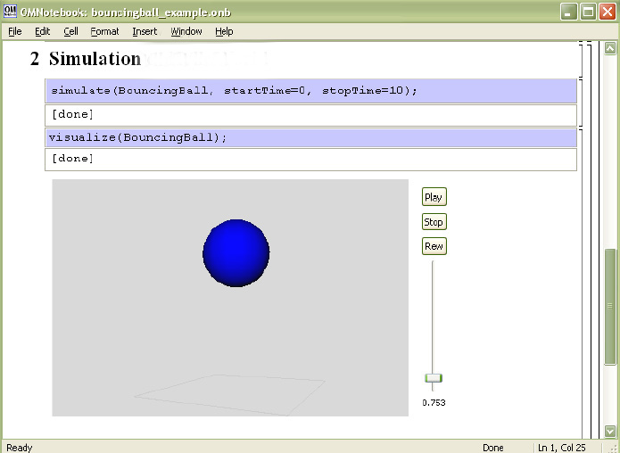
Figure 3-30. 3D animation of the bouncing ball model.

Pendulum 3D Example
This example explores a slightly more complex scenario where the visualization uses all the properties of a SimpleVisual object. The model used is a simple ideal 2D pendulum, not modeling properties like friction, air resistance etc.
class MyPendulum3D "Planar Pendulum"
constant Real PI=3.141592653589793;
parameter Real m=1, g=9.81, L=5;
Real F;
Real x(start=5),y(start=0);
Real vx,vy;
equation
m*der(vx)=-(x/L)*F;
m*der(vy)=-(y/L)*F-m*g;
der(x)=vx;
der(y)=vy;
x^2+y^2=L^2;
end MyPendulum3D;
Start by identifying the variables in the model that will be needed to create a visual representation of the simulation.
- Real x and Real y hold the current position of the pendulum.
- Real L is a parameter which holds the length of the pendulum.

Adding the Visualization
As before, to be able to use the SimpleVisual package we must import it.
class MyPendulum3D "Planar Pendulum"
import Modelica.SimpleVisual;
...
Adding a sphere to represent the weight of the pendulum is done in the same way the BouncingBall was visualized. The variables x and y hold the position.
...
Real vx,vy;
SimpleVisual.PositionSize ball "color=red;shape=ball;";
equation
ball.size[1]=1.5; ball.size[2]=1.5; ball.size[3]=1.5;
ball.frame_a[1]=x; ball.frame_a[2]=y; ball.frame_a[3]=0;
m*der(vx)=-(x/L)*F;
...
The next step is to create a visualization of the "thread" that holds the pendulum. It will be represented by a small elongated cube connected to the ball in one end and in the fixed center of the pendulum movement. We will want the object to rotate with the pendulum motion so create a SimpleVisual.‌PositionRotationSize object.
SimpleVisual.PositionRotationSize thread "shape=cube;"
To specify the rotation of an object, the visualization package uses two points. One is the position of the object, frame_a, that has been demonstrated earlier. The other position, frame_b, is interpreted as the end point of a vector from frame_a. This vector is used as the new up direction for the object. In this example, defining frame_b is simple. The cube that represents the thread will always be pointing to (0, 0, 0). We already know the length of the thread from the parameter L.
thread.size[1]=0.05; thread.size[2]=L; thread.size[3]=0.05;
thread.frame_a[1]=x; thread.frame_a[2]=y; thread.frame_a[3]=0;
thread.frame_b[1]=0; thread.frame_b[2]=0; thread.frame_b[3]=0;
Running this simulation and starting the visualization, we notice that everything is not quite right. The thread is centered around the pendulum. We could calculate a new position by translating the x and y coordinates along the rotation vector, but there is a better way. Change the object type to SimpleVisual.‌PositionRotationSizeOffset. The offset parameter is a translation within the local coordinate system of the object. To shift the center of the object to be at the bottom of the thread we add an offset of L/2 to the y component of offset.
thread.size[1]=0.05; thread.size[2]=L; thread.size[3]=0.05;
thread.frame_a[1]=x; thread.frame_a[2]=y; thread.frame_a[3]=0;
thread.frame_b[1]=0; thread.frame_b[2]=0; thread.frame_b[3]=0;
thread.offset[1]=0; thread.offset[2]=L/2; thread.offset[3]=0;
In the final model, a simple static fixture has also been added.
class MyPendulum3D "Planar Pendulum"
import Modelica.SimpleVisual;
constant Real PI=3.141592653589793;
parameter Real m=1, g=9.81, L=5;
Real F;
Real x(start=5),y(start=0);
Real vx,vy;
SimpleVisual.PositionSize ball "color=red;shape=ball;";
SimpleVisual.PositionSize fixture "shape=cube;";
SimpleVisual.PositionRotationSizeOffset thread "shape=cube;";
equation
fixture.size[1]=0.5; fixture.size[2]=0.1; fixture.size[3]=0.5;
fixture.frame_a[1]=0; fixture.frame_a[2]=0; fixture.frame_a[3]=0;
ball.size[1]=1.5; ball.size[2]=1.5; ball.size[3]=1.5;
ball.frame_a[1]=x; ball.frame_a[2]=y; ball.frame_a[3]=0;
thread.size[1]=0.05; thread.size[2]=L; thread.size[3]=0.05;
thread.frame_a[1]=x; thread.frame_a[2]=y; thread.frame_a[3]=0;
thread.frame_b[1]=0; thread.frame_b[2]=0; thread.frame_b[3]=0;
thread.offset[1]=0; thread.offset[2]=L/2; thread.offset[3]=0;
m*der(vx)=-(x/L)*F;
m*der(vy)=-(y/L)*F-m*g;
der(x)=vx;
der(y)=vy;
x^2+y^2=L^2;
end MyPendulum3D;
We simulate and visualize as previously:
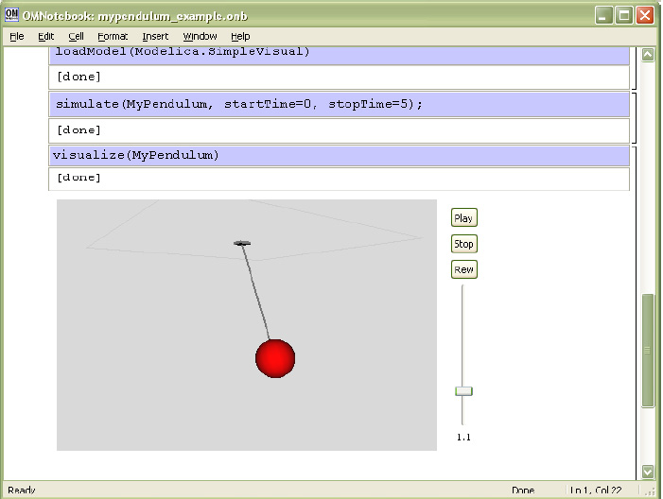
Figure 3-31. Visualization with animation of 3D pendulum.

References
Trolltech. Qt. http://www.trolltech.com/, accessed July 2007.
Coin3D. www.coin3d.org, accessed August 2008.
Henrik Eriksson. Advanced OpenModelica Plotting Package for Modelica. Master Thesis, LIU-IDA/LITH-EX-A-08/036-SE, Linköping University Electronic Press, www.ep.liu.se, June 22, 2008.
Henrik Magnusson. Integrated Generic 3D visualization of Modelica Models. Master Thesis, LIU-IDA/LITH-EX-A-08/035-SE, Linköping University Electronic Press, www.ep.liu.se, June 27, 2008.
Martin Otter. The Modelica MultiBody Library. http://www.modelica.org/libraries/Modelica, Modelica.Mechanics.MultiBody, accessed August 2008.
Vadim Engelson. Tools for Design, Interactive Simulation, and Visualization of Object-Oriented Models in Scientific Computing. Ph.D. Thesis. Linköping Studies in Science and Technology, Dissertation No. 627, http://www.ida.liu.se/~vaden/thesis/, 2000.
Edward Lee et al. The PtPlot package The Ptolemy Project. http://ptolemy.berkeley.edu/body.htm, accessed July 2007.

OMNotebook with DrModelica and DrControl
This chapter covers the OpenModelica electronic notebook subsystem, called OMNotebook, together with the DrModelica tutoring system for teaching Modelica, and DrControl for teaching control together with Modelica. Both are using such notebooks.

Interactive Notebooks with Literate Programming
Interactive Electronic Notebooks are active documents that may contain technical computations and text, as well as graphics. Hence, these documents are suitable to be used for teaching and experimentation, simulation scripting, model documentation and storage, etc.

Mathematica Notebooks
Literate Programming (Knuth 1984) is a form of programming where programs are integrated with documentation in the same document. Mathematica notebooks (Wolfram 1997) is one of the first WYSIWYG (What-You-See-Is-What-You-Get) systems that support Literate Programming. Such notebooks are used, e.g., in the MathModelica modeling and simulation environment, e.g. see Figure 4-32below and Chapter 19 in (Fritzson 2004)

OMNotebook
The OMNotebook software (Axelsson 2005, Fernström 2006) is a new open source free software that gives an interactive WYSIWYG (What-You-See-Is-What-You-Get) realization of Literate Programming, a form of programming where programs are integrated with documentation in the same document.
The OMNotebook facility is actually an interactive WYSIWYG (What-You-See-Is-What-You-Get) realization of Literate Programming, a form of programming where programs are integrated with documentation in the same document. OMNotebook is a simple open-source software tool for an electronic notebook supporting Modelica.
A more advanced electronic notebook tool, also supporting mathematical typesetting and many other facilities, is provided by Mathematica notebooks in the MathModelica environment, see Figure 4-32.
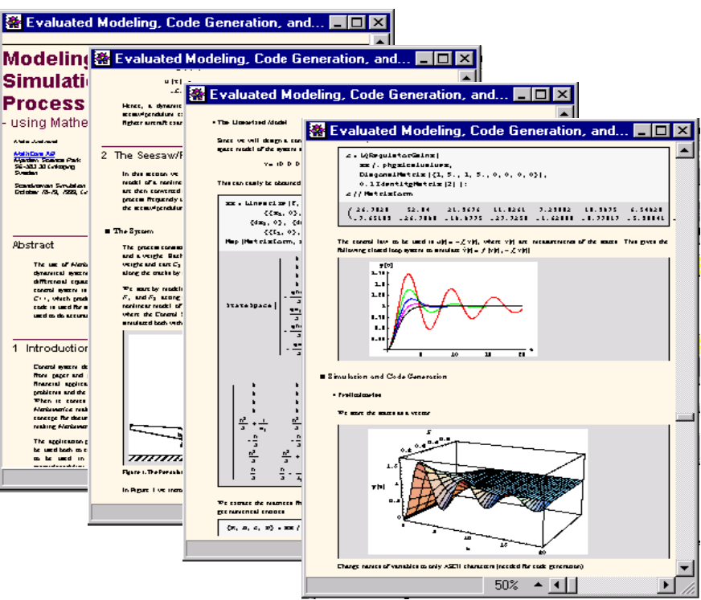
Figure 4-32. Examples of Mathematica notebooks in the MathModelica modeling and simulation environment.
Traditional documents, e.g. books and reports, essentially always have a hierarchical structure. They are divided into sections, subsections, paragraphs, etc. Both the document itself and its sections usually have headings as labels for easier navigation. This kind of structure is also reflected in electronic notebooks. Every notebook corresponds to one document (one file) and contains a tree structure of cells. A cell can have different kinds of contents, and can even contain other cells. The notebook hierarchy of cells thus reflects the hierarchy of sections and subsections in a traditional document such as a book.

DrModelica Tutoring System – an Application of OMNotebook
Understanding programs is hard, especially code written by someone else. For educational purposes it is essential to be able to show the source code and to give an explanation of it at the same time.
Moreover, it is important to show the result of the source code’s execution. In modeling and simulation it is also important to have the source code, the documentation about the source code, the execution results of the simulation model, and the documentation of the simulation results in the same document. The reason is that the problem solving process in computational simulation is an iterative process that often requires a modification of the original mathematical model and its software implementation after the interpretation and validation of the computed results corresponding to an initial model.
Most of the environments associated with equation-based modeling languages focus more on providing efficient numerical algorithms rather than giving attention to the aspects that should facilitate the learning and teaching of the language. There is a need for an environment facilitating the learning and understanding of Modelica. These are the reasons for developing the DrModelica teaching material for Modelica and for teaching modeling and simulation.
An earlier version of DrModelica was developed using the MathModelica environment. The rest of this chapter is concerned with the OMNotebook version of DrModelica and on the OMNotebook tool itself.
DrModelica has a hierarchical structure represented as notebooks. The front-page notebook is similar to a table of contents that holds all other notebooks together by providing links to them. This particular notebook is the first page the user will see (Figure 4-33).
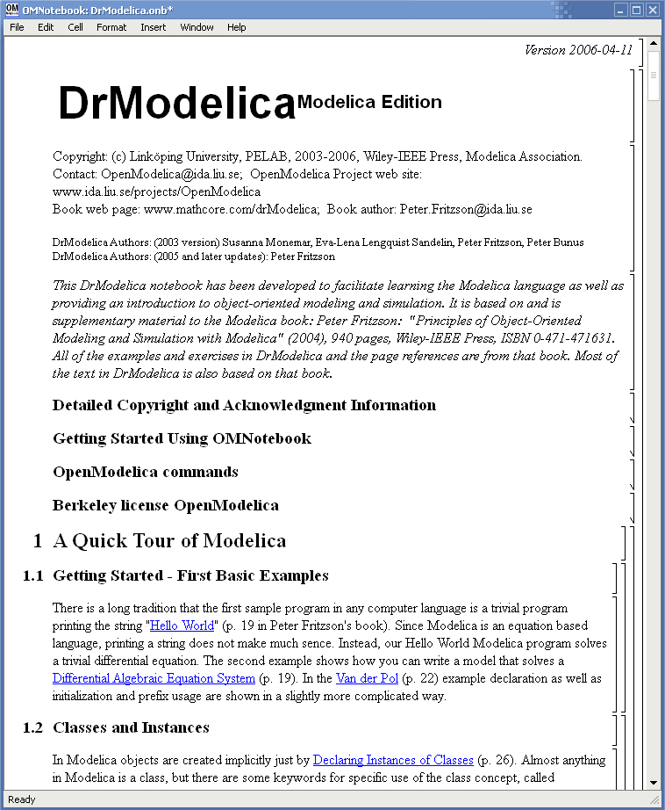
Figure 4-33. The front-page notebook of the OMNotebook version of the DrModelica tutoring system.
In each chapter of DrModelica the user is presented a short summary of the corresponding chapter of the book “Principles of Object-Oriented Modeling and Simulation with Modelica 2.1” by Peter Fritzson. The summary introduces some keywords, being hyperlinks that will lead the user to other notebooks describing the keywords in detail
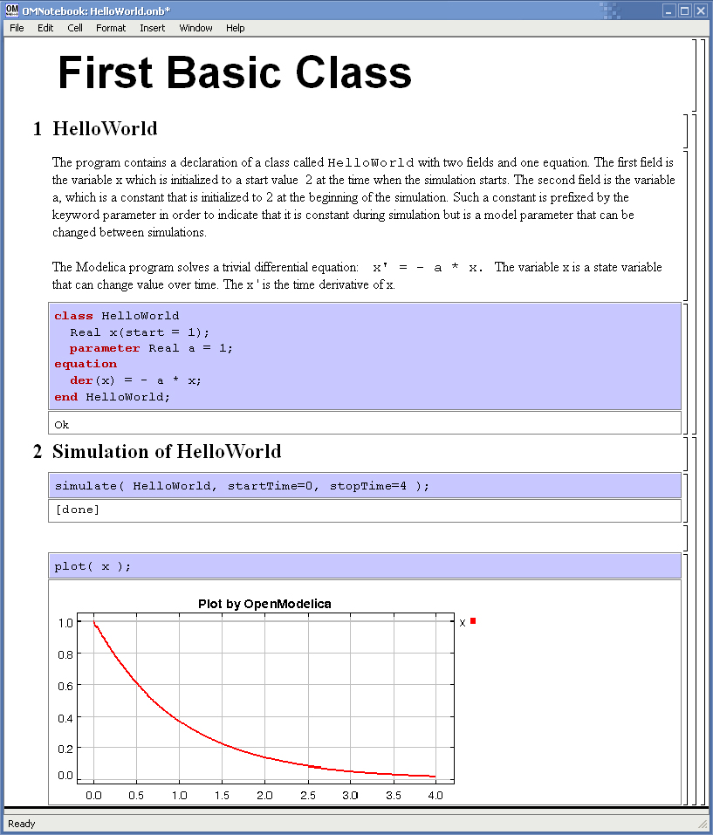
Figure 4-34. The HelloWorld class simulated and plotted using the OMNotebook version of DrModelica.
Now, let us consider that the link “HelloWorld” in DrModelica Section is clicked by the user. The new HelloWorld notebook (see Figure 4-34), to which the user is being linked, is not only a textual description but also contains one or more examples explaining the specific keyword. In this class, HelloWorld, a differential equation is specified.
No information in a notebook is fixed, which implies that the user can add, change, or remove anything in a notebook. Alternatively, the user can create an entirely new notebook in order to write his/her own programs or copy examples from other notebooks. This new notebook can be linked from existing notebooks.
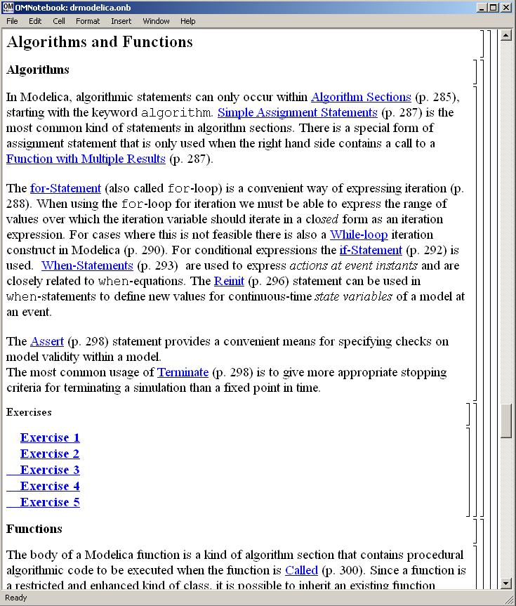
Figure 4-35. DrModelica Chapter on Algorithms and Functions in the main page of the OMNotebook version of DrModelica.
When a class has been successfully evaluated the user can simulate and plot the result, as previously depicted in Figure 4-34 for the simple HelloWorld example model.
After reading a chapter in DrModelica the user can immediately practice the newly acquired information by doing the exercises that concern the specific chapter. Exercises have been written in order to elucidate language constructs step by step based on the pedagogical assumption that a student learns better “using the strategy of learning by doing”. The exercises consist of either theoretical questions or practical programming assignments. All exercises provide answers in order to give the user immediate feedback.
Figure 4-35 shows part of Chapter 9 of the DrModelica teaching material. Here the user can read about language constructs, like algorithm sections, when-statements, and reinit equations, and then practice these constructs by solving the exercises corresponding to the recently studied section.

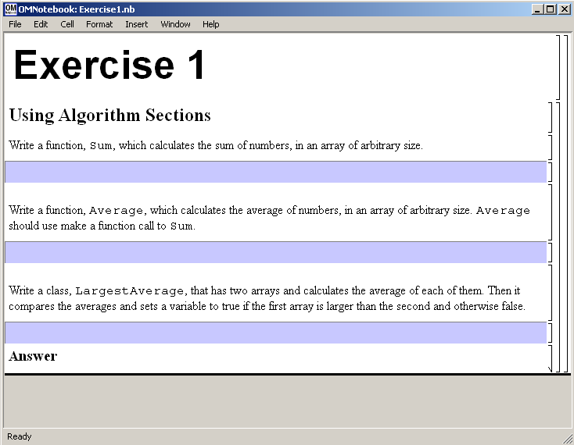
Figure 4-36. Exercise 1 in Chapter 9 of DrModelica
Exercise 1 from Chapter 9 is shown in . In this exercise the user has the opportunity to practice different language constructs and then compare the solution to the answer for the exercise. Notice that the answer is not visible until the Answer section is expanded. The answer is shown in

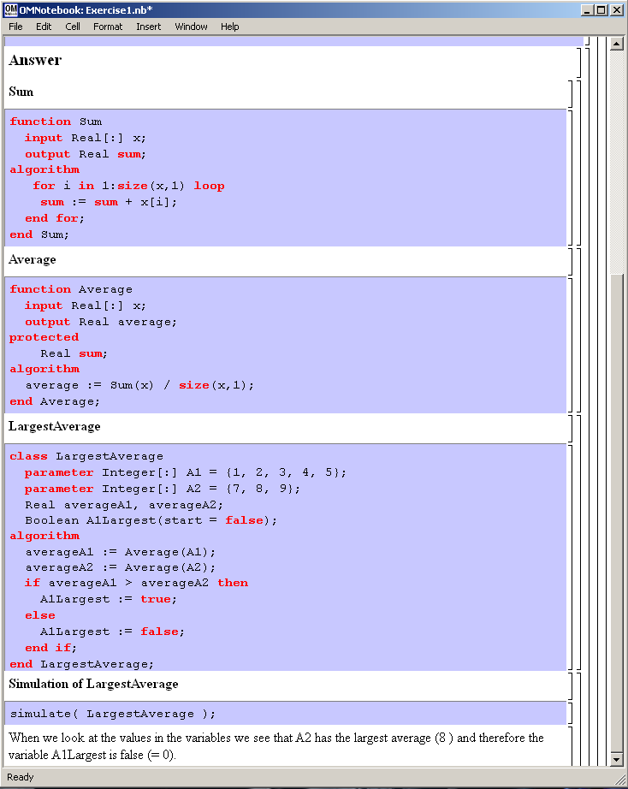
Figure 4-37. The answer section to Exercise 1 in Chapter 9 of DrModelica.

DrControl Tutorial for Teaching Control Theory
DrControl is an interactive OMNotebook document aimed at teaching control theory. It is included in the OpenModelica distribution and appears under the directory OpenModelica1.8.1/share/ omnotebook/drcontrol.
The front-page of DrControl resembles a linked table of content that can be used as a navigation center. The content list contains topics like:
- Getting started
- The control problem in ordinary life
- Feedback loop
- Mathematical modeling
- Transfer function
- Stability
- Example of controlling a DC-motor
- Feedforward compensation
- State-space form
- State observation
- Closed loop control system.
- Reconstructed system
- Linear quadratic optimization
- Linearization
Each entry in this list leads to a new notebook page where either the theory is explained with Modelica examples or an exercise with a solution is provided to illustrate the background theory. Below we show a few sections of DrControl.

Feedback Loop
One of the basic concepts of control theory is using feedback loops either for neutralizing the disturbances from the surroundings or a desire for a smoother output.
In Figure 4-38, control of a simple car model is illustrated where the car velocity on a road is controlled, first with an open loop control, and then compared to a closed loop system with a feedback loop. The car has a mass m, velocity y, and aerodynamic coefficient α. The θ is the road slope, which in this case can be regarded as noise.
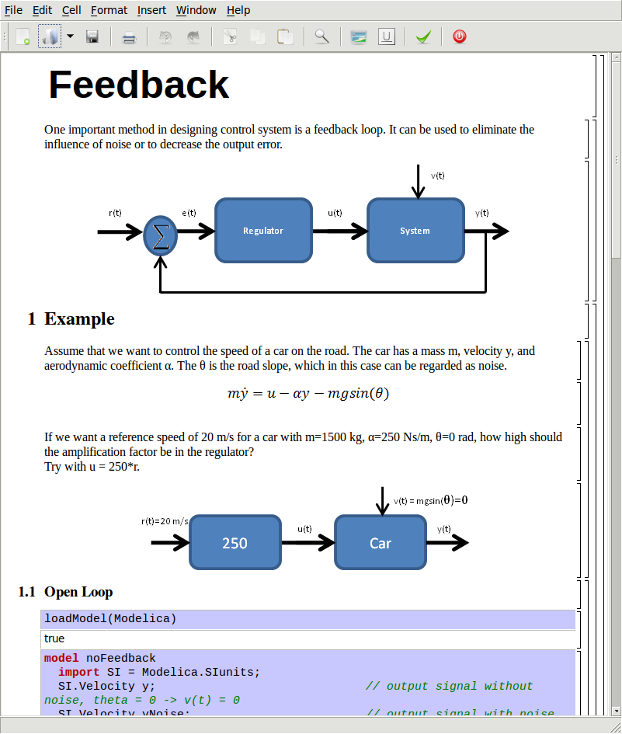
Figure 4-38. Feedback loop
Lets look at the Modelica model for the open loop controlled car:

model NoFeedback
import SI = Modelica.SIunits;
SI.Velocity y "No noise";
SI.Velocity yNoise "With noise";
parameter SI.Mass m = 1500;
parameter Real alpha = 200;
parameter SI. ngle theta = 5*3.14/180;
parameter SI.Acceleration g = 9.82;
SI.Force u;
SI.Velocity r = 20 "Reference signal";
equation
m*der(y)=u - alpha*y;
m*der(yNoise)= u - alpha*yNoise –
m*g*sin(theta);
u = 250A*r;
end NoFeedback;
By applying a road slope angle different from zero the car velocity is influenced which can be regarded as noise in this model. The output signal in Figure 4-39 is stable but an overshoot can be observed compared to the reference signal. Naturally the overshoot is not desired and the student will in the next exercise learn how to get rid of this undesired behavior of the system.

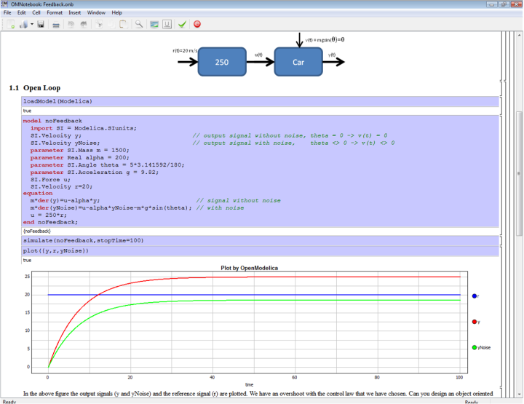
Figure 4-39. Open loop control example.
The closed car model with a proportional regulator is shown below:

model WithFeedback
import SI = Modelica.SIunits;
SI.Velocity y "Output, No noise";
SI.Velocity yNoise "Output With noise";
parameter SI.Mass m = 1500;
parameter Real alpha = 250;
parameter SI.Angle theta = 5*3.14/180;
parameter SI.Acceleration g = 9.82;
SI.Force u;
SI.Force uNoise;
SI.Velocity r = 20 "Reference signal";
equation
m*der(y) = u - alpha*y;
m*der(yNoise) = uNoise - alpha*yNois –
m*g*sin(theta);
u = 5000*(r - y);
uNoise = 5000*(r - yNoise);
end WithFeedback;
By using the information about the current level of the output signal and re-tune the regulator the output quantity can be controlled towards the reference signal smoothly and without an overshoot, as shown in Figure 4-40.
In the above simple example the flat modeling approach was adopted since it was the fastest one to quickly obtain a working model. However, one could use the object oriented approach and encapsulate the car and regulator models in separate classes with the Modelica connector mechanism in between.
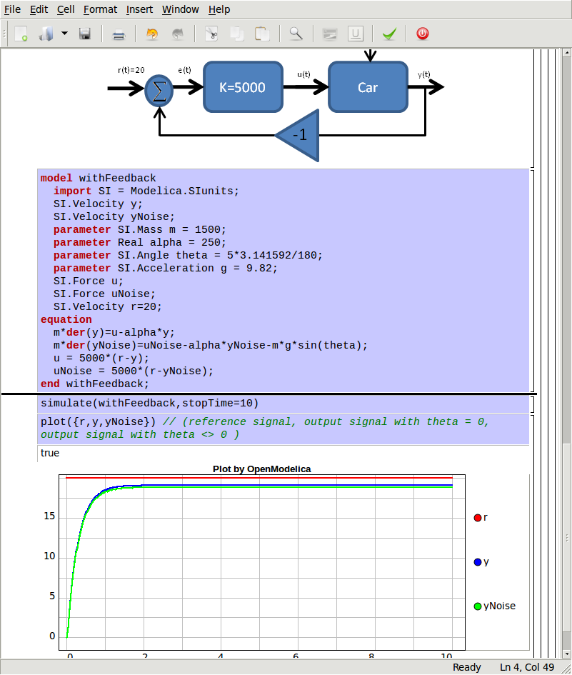
Figure 4-40. Closed loop control example.

Mathematical Modeling with Characteristic Equations
In most systems the relation between the inputs and outputs can be described by a linear differential equation. Tearing apart the solution of the differential equation into homogenous and particular parts is an important technique taught to the students in engineering courses, also illustrated in Figure 4-41.

Now let us examine a second order system:

model NegRoots
Real y;
Real der_y;
parameter Real a1 = 3;
parameter Real a2 = 2;
equation
der_y = der(y);
der(der_y) + a1*der_y + a2*y = 1;
end NegRoots;
Choosing different values for a₁ and a₂ leads to different behavior as shown in Figure 4-42 and Figure 4-43.

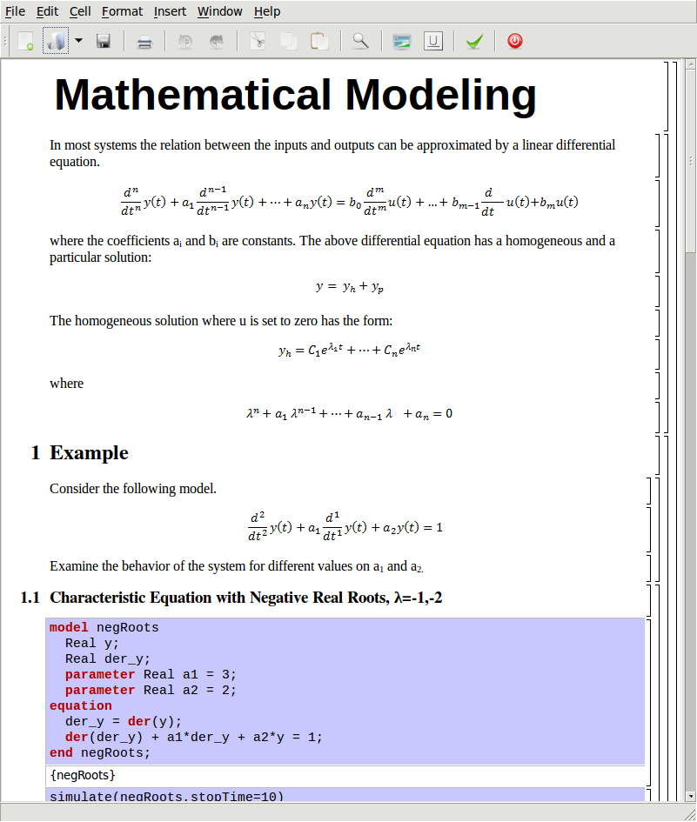
Figure 4-41. Mathematical modeling with characteristic equation.
In the first example the values of a₁ and a₂ are chosen in such way that the characteristic equation has negative real roots and thereby a stable output response, see Figure 4-42.

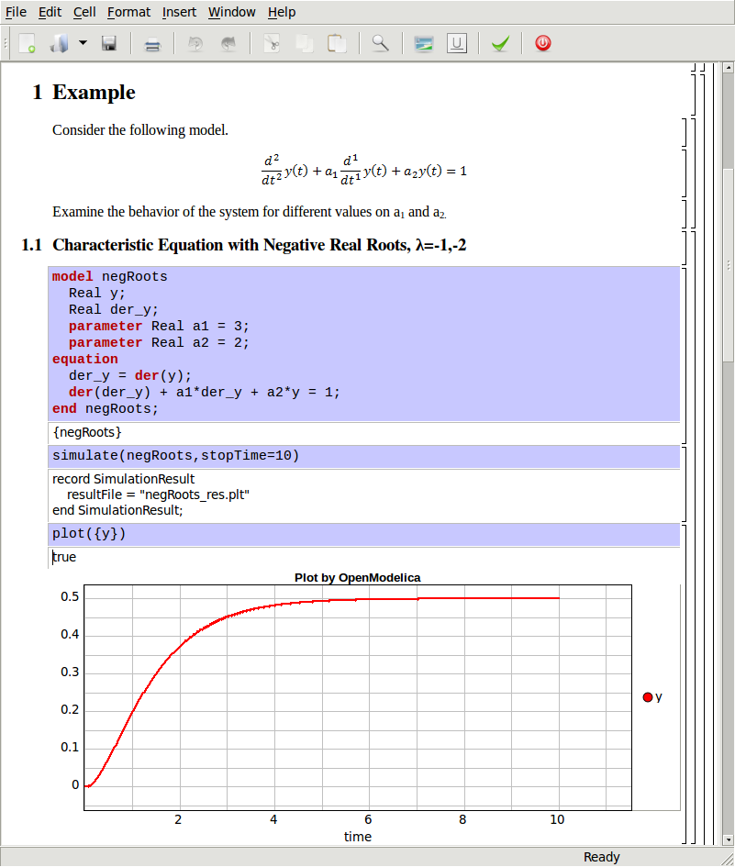
Figure 4-42. Characteristic eq. with real negative roots.
The importance of the sign of the roots in the characteristic equation is illustrated in Figure 4-42 and Figure 4-43, e.g., a stable system with negative real roots and an unstable system with positive imaginary roots resulting in oscillations.
model NegRoots
Real y;
Real der_y;
parameter Real a1 = -2;
parameter Real a2 = 10;
equation
der_y = der(y);
der(der_y) + a1*der_y + a2*y = 1;
end NegRoots;

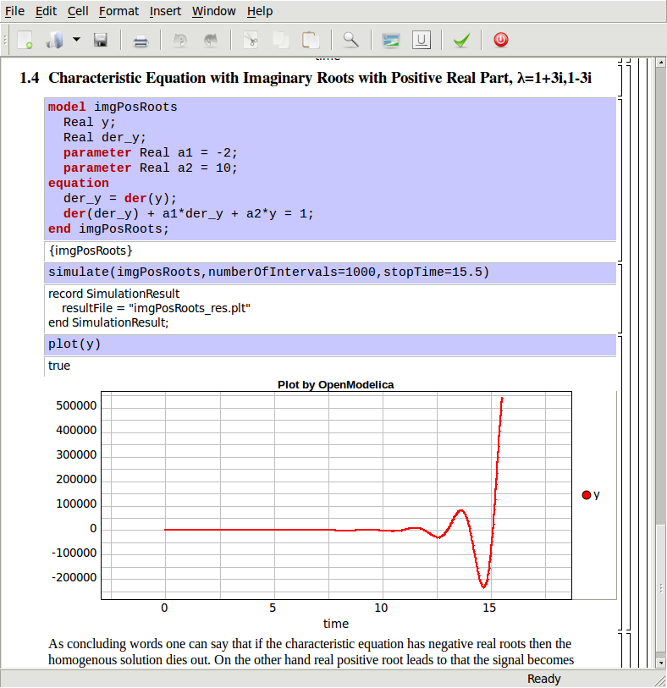
Figure 4-43. Characteristic eq. with positive imaginary roots.
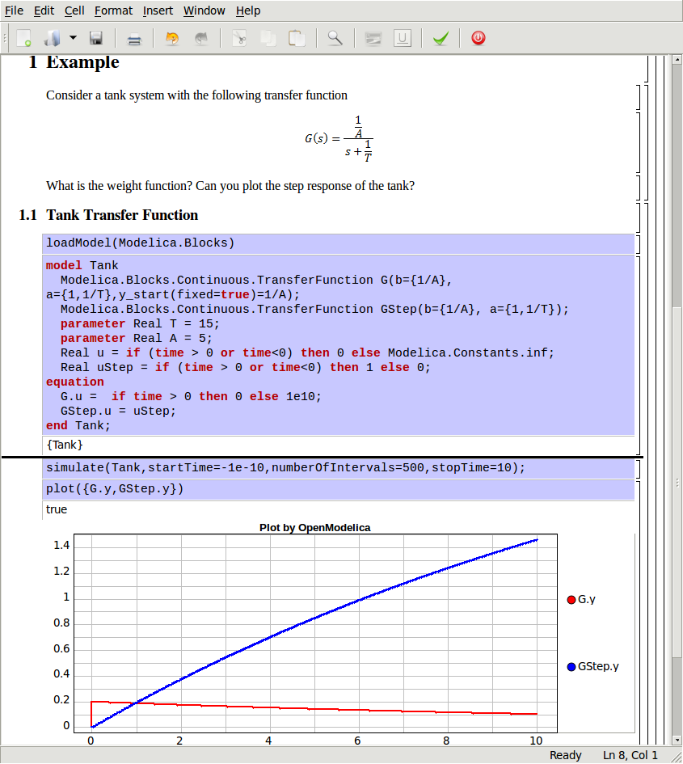
Figure 4-44. Step and pulse (weight function) response.

The theory and application of Kalman filters is also explained in the interactive course material.

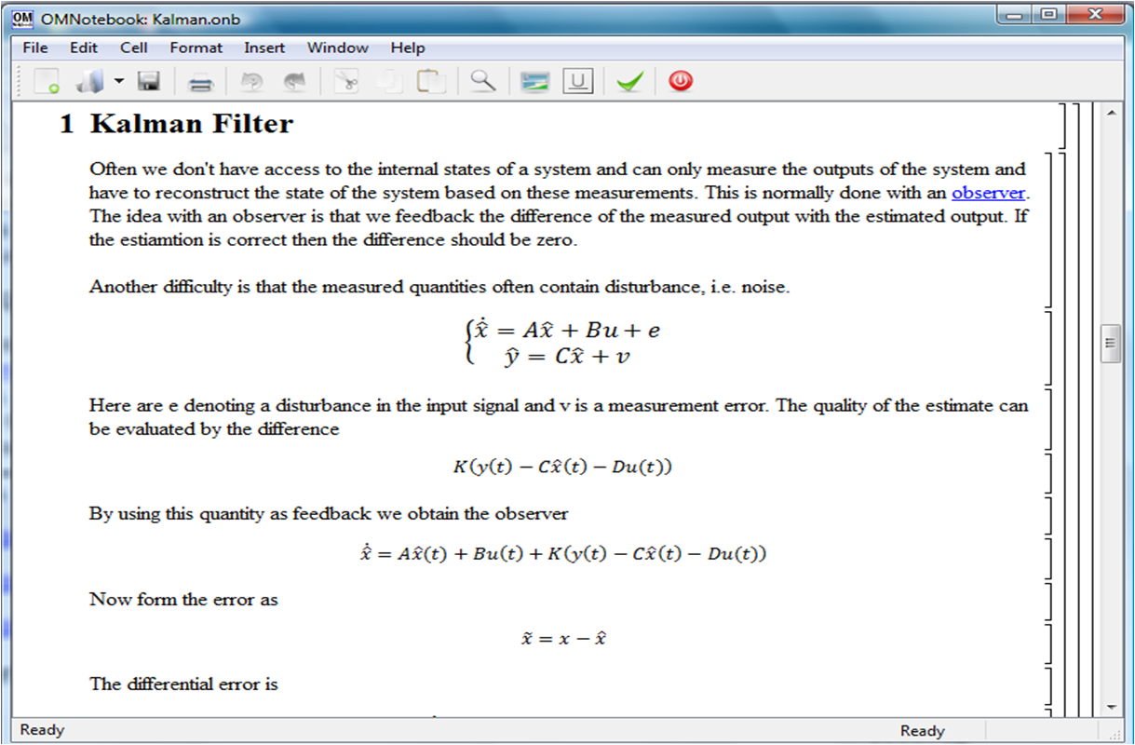
Figure 4-45. Theory background about Kalman filter.
In reality noise is present in almost every physical system under study and therefore the concept of noise is also introduced in the course material, which is purely Modelica based.

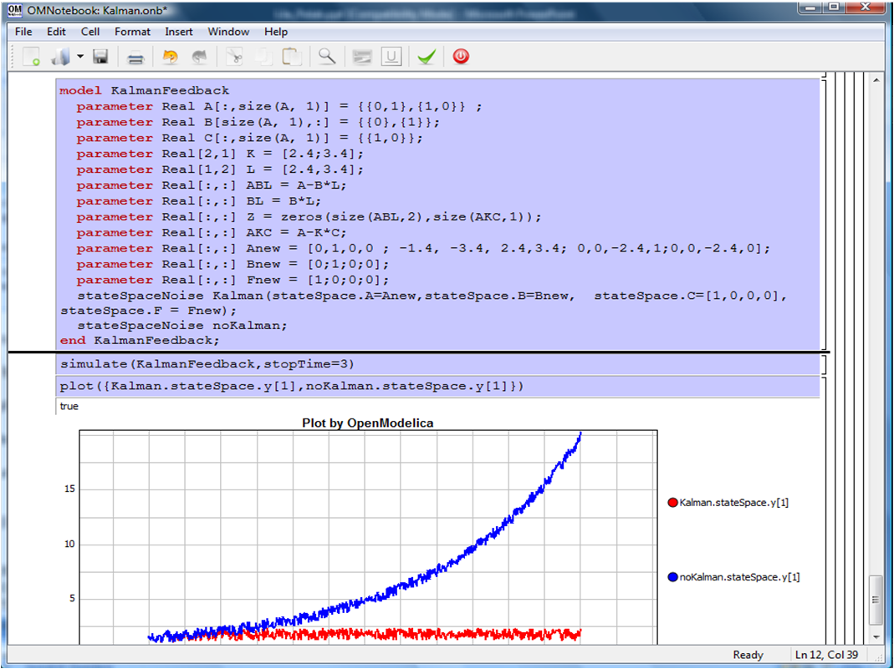
Figure 4-46. Comparison of a noisy system with feedback link in DrControl.

OpenModelica Notebook Commands
OMNotebook currently supports the commands and concepts that are described in this section.

Cells
Everything inside an OMNotebook document is made out of cells. A cell basically contains a chunk of data. That data can be text, images, or other cells. OMNotebook has four types of cells: headercell, textcell, inputcell, and groupcell. Cells are ordered in a tree structure, where one cell can be a parent to one or more additional cells. A tree view is available close to the right border in the notebook window to display the relation between the cells.
- Textcell – This cell type are used to display ordinary text and images. Each textcell has a style that specifies how text is displayed. The cell´s style can be changed in the menu Format->Styles, example of different styles are: Text, Title, and Subtitle. The Textcell type also has support for following links to other notebook documents.
- Inputcell – This cell type has support for syntax highlighting and evaluation. It is intended to be used for writing program code, e.g. Modelica code. Evaluation is done by pressing the key combination Shift+Return or Shift+Enter. All the text in the cell is sent to OMC (OpenModelica Compiler/interpreter), where the text is evaluated and the result is displayed below the inputcell. By double-clicking on the cell marker in the tree view, the inputcell can be collapsed causing the result to be hidden.
- Groupcell – This cell type is used to group together other cell. A groupcell can be opened or closed. When a groupcell is opened all the cells inside the groupcell are visible, but when the groupcell is closed only the first cell inside the groupcell is visible. The state of the groupcell is changed by the user double-clicking on the cell marker in the tree view. When the groupcell is closed the marker is changed and the marker has an arrow at the bottom.

Cursors
An OMNotebook document contains cells which in turn contain text. Thus, two kinds of cursors are needed for positioning, text cursor and cell cursor:
- Textcursor – A cursor between characters in a cell, appearing as a small vertical line. Position the cursor by clicking on the text or using the arrow buttons.
- Cellcursor – This cursor shows which cell currently has the input focus. It consists of two parts. The main cellcursor is basically just a thin black horizontal line below the cell with input focus. The cellcursor is positioned by clicking on a cell, clicking between cells, or using the menu item Cell->Next Cell or Cell->Previous Cell. The cursor can also be moved with the key combination Ctrl+Up or Ctrl+Down. The dynamic cellcursor is a short blinking horisontal line. To make this visible, you must click once more on the main cellcursor (the long horizontal line). NOTE: In order to paste cells at the cellcursor, the dynamic cellcursor must be made active by clicking on the main cellcursor (the horisontal line).

Selection of Text or Cells
To perform operations on text or cells we often need to select a range of characters or cells.
- Select characters – There are several ways of selecting characters, e.g. double-clicking on a word, clicking and dragging the mouse, or click followed by a shift-click at an adjacent positioin selects the text between the previous click and the position of the most recent shift-click.
- Select cells – Cells can be selected by clicking on them. Holding done Ctrl and clicking on the cell markers in the tree view allows several cells to be selected, one at a time. Several cells can be selected at once in the tree view by holding down the Shift key. Holding down Shift selects all cells between last selected cell and the cell clicked on. This only works if both cells belong to the same groupcell.

File Menu
The following file related operations are available in the file menu:
- Create a new notebook – A new notebook can be created using the menu File->New or the key combination Ctrl+N. A new document window will then open, with a new document inside.
- Open a notebook – To open a notebook use File->Open in the menu or the key combination Ctrl+O. Only files of the type .onb or .nb can be opened. If a file does not follow the OMNotebook format or the FullForm Mathematica Notebook format, a message box is displayed telling the user what is wrong. Mathematica Notebooks must be converted to fullform before they can be opened in OMNotebook.
- Save a notebook – To save a notebook use the menu item File->Save or File->Save As. If the notebook has not been saved before the save as dialog is shown and a filename can be selected. OMNotebook can only save in xml format and the saved file is not compatible with Mathematica. Key combination for save is Ctrl+S and for save as Ctrl+Shift+S. The saved file by default obtains the file extension .onb.
- Print – Printing a document to a printer is done by pressing the key combination Ctrl+P or using the menu item File->Print. A normal print dialog is displayed where the usually properties can be changed.
- Import old document – Old documents, saved with the old version of OMNotebook where a different file format was used, can be opened using the menu item File->Import->Old OMNotebook file. Old documents have the extension .xml.
- Export text – The text inside a document can be exported to a text document. The text is exported to this document without almost any structure saved. The only structure that is saved is the cell structure. Each paragraph in the text document will contain text from one cell. To use the export function, use menu item File->Export->Pure Text.
- Close a notebook window – A notebook window can be closed using the menu item File->Close or the key combination Ctrl+F4. Any unsaved changes in the document are lost when the notebook window is closed.
- Quitting OMNotebook – To quit OMNotebook, use menu item File->Quit or the key combination Crtl+Q. This closes all notebook windows; users will have the option of closing OMC also. OMC will not automatically shutdown because other programs may still use it. Evaluating the command quit() has the same result as exiting OMNotebook.

Edit Menu
- Editing cell text – Cells have a set of of basic editing functions. The key combination for these are: Undo (Ctrl+Z), Redo (Ctrl+Y), Cut (Ctrl+X), Copy (Ctrl+C) and Paste (Ctrl+V). These functions can also be accessed from the edit menu; Undo (Edit->Undo), Redo (Edit->Redo), Cut (Edit->Cut), Copy (Edit->Copy) and Paste (Edit->Paste). Selection of text is done in the usual way by double-clicking, triple-clicking (select a paragraph), dragging the mouse, or using (Ctrl+A) to select all text within the cell.
- Cut cell – Cells can be cut from a document with the menu item Edit->Cut or the key combination Ctrl+X. The cut function will always cut cells if cells have been selected in the tree view, otherwise the cut function cuts text.
- Copy cell – Cells can be copied from a document with the menu item Edit->Copy or the key combination Ctrl+C. The copy function will always copy cells if cells have been selected in the tree view, otherwise the copy function copy text.
- Paste cell – To paste copied or cut cells the cell cursor must be selected in the location where the cells should be pasted. This is done by clicking on the cell cursor. Pasteing cells is done from the menu Edit->Paste or the key combination Ctrl+V. If the cell cursor is selected the paste function will always paste cells. OMNotebook share the same application-wide clipboard. Therefore cells that have been copied from one document can be pasted into another document. Only pointers to the copied or cut cells are added to the clipboard, thus the cell that should be pasted must still exist. Consequently a cell can not be pasted from a document that has been closed.
- Find – Find text string in the current notebook, with the options match full word, match cell, search within closed cells. Short command Ctrl+F.
- Replace – Find and replace text string in the current notebook, with the options match full word, match cell, search+replace within closed cells. Short command Ctrl+H.
- View expression – Text in a cell is stored internally as a subset of HTML code and the menu item Edit->View Expression let the user switch between viewing the text or the internal HTML representation. Changes made to the HTML code will affect how the text is displayed.

Cell Menu
- Add textcell – A new textcell is added with the menu item Cell->Add Cell (previous cell style) or the key combination Alt+Enter. The new textcell gets the same style as the previous selected cell had.
- Add inputcell – A new inputcell is added with the menu item Cell->Add Inputcell or the key combination Ctrl+Shift+I.
- Add groupcell – A new groupcell is inserted with the menu item Cell->Groupcell or the key combination Ctrl+Shift+G. The selected cell will then become the first cell inside the groupcell.
- Ungroup groupcell – A groupcell can be ungrouped by selecting it in the tree view and using the menu item Cell->Ungroup Groupcell or by using the key combination Ctrl+Shift+U. Only one groupcell at a time can be ungrouped.
- Split cell – Spliting a cell is done with the menu item Cell->Split cell or the key combination Ctrl+Shift+P. The cell is splited at the position of the text cursor.
- Delete cell – The menu item Cell->Delete Cell will delete all cells that have been selected in the tree view. If no cell is selected this action will delete the cell that have been selected by the cellcursor. This action can also be called with the key combination Ctrl+Shift+D or the key Del (only works when cells have been selected in the tree view).
- Cellcursor – This cell type is a special type that shows which cell that currently has the focus. The cell is basically just a thin black line. The cellcursor is moved by clicking on a cell or using the menu item Cell->Next Cell or Cell->Previous Cell. The cursor can also be moved with the key combination Ctrl+Up or Ctrl+Down.

Format Menu
- Textcell – This cell type is used to display ordinary text and images. Each textcell has a style that specifies how text is displayed. The cells style can be changed in the menu Format->Styles, examples of different styles are: Text, Title, and Subtitle. The Textcell type also have support for following links to other notebook documents.
- Text manipulation – There are a number of different text manipulations that can be done to change the appearance of the text. These manipulations include operations like: changing font, changing color and make text bold, but also operations like: changing the alignment of the text and the margin inside the cell. All text manipulations inside a cell can be done on single letters, words or the entire text. Text settings are found in the Format menu. The following text manipulations are available in OMNotebook:
> Font family
> Font face (Plain, Bold, Italic, Underline)
> Font size
> Font stretch
> Font color
> Text horizontal alignment
> Text vertical alignment
> Border thickness
> Margin (outside the border)
> Padding (inside the border)

Insert Menu
- Insert image – Images are added to a document with the menu item Insert->Image or the key combination Ctrl+Shift+M. After an image has been selected a dialog appears, where the size of the image can be chosen. The images actual size is the default value of the image. OMNotebook stretches the image accordantly to the selected size. All images are saved in the same file as the rest of the document.
- Insert link – A document can contain links to other OMNotebook file or Mathematica notebook and to add a new link a piece of text must first be selected. The selected text make up the part of the link that the user can click on. Inserting a link is done from the menu Insert->Link or with the key combination Ctrl+Shift+L. A dialog window, much like the one used to open documents, allows the user to choose the file that the link refers to. All links are saved in the document with a relative file path so documents that belong together easily can be moved from one place to another without the links failing.

Window Menu
- Change window – Each opened document has its own document window. To switch between those use the Window menu. The window menu lists all titles of the open documents, in the same order as they were opened. To switch to another document, simple click on the title of that document.

Help Menu
- About OMNotebook – Accessing the about message box for OMNotebook is done from the menu Help->About OMNotebook.
- About Qt – To access the message box for Qt, use the menu Help->About Qt.
- Help Text – Opening the help text (document OMNotebookHelp.onb) for OMNotebook can be done in the same way as any OMNotebook document is opened or with the menu Help->Help Text. The menu item can also be triggered with the key F1.

Additional Features
- Links – By clicking on a link, OMNotebook will open the document that is referred to in the link.
- Update link – All links are stored with relative file path. Therefore OMNotebook has functions that automatically updating links if a document is resaved in another folder. Every time a document is saved, OMNotebook checks if the document is saved in the same folder as last time. If the folder has changed, the links are updated.
- Evaluate several cells – Several inputcells can be evaluated at the same time by selecting them in the treeview and then pressing the key combination Shift+Enter or Shift+Return. The cells are evaluated in the same order as they have been selected. If a groupcell is selected all inputcells in that groupcell are evaluated, in the order they are located in the groupcell.
- Command completion – Inputcells have command completion support, which checks if the user is typing a command (or any keyword defined in the file commands.xml) and finish the command. If the user types the first two or three letters in a command, the command completion function fills in the rest. To use command completion, press the key combination Ctrl+Space or Shift+Tab. The first command that matches the letters written will then appear. Holding down Shift and pressing Tab (alternative holding down Ctrl and pressing Space) again will display the second command that matches. Repeated request to use command completion will loop through all commands that match the letters written. When a command is displayed by the command completion functionality any field inside the command that should be edited by the user is automatically selected. Some commands can have several of these fields and by pressing the key combination Ctrl+Tab, the next field will be selected inside the command.
> Active Command completion: Ctrl+Space / Shift+Tab
> Next command: Ctrl+Space / Shift+Tab
> Next field in command: Ctrl+Tab’
- Generated plot – When plotting a simulation result, OMC uses the program Ptplot to create a plot. From Ptplot OMNotebook gets an image of the plot and automatically adds that image to the output part of an inputcell. Like all other images in a document, the plot is saved in the document file when the document is saved.
- Stylesheet –OMNotebook follows the style settings defined in stylesheet.xml and the correct style is applied to a cell when the cell is created.
- Automatic Chapter Numbering – OMNotebook automatically numbers different chapter, subchapter, section and other styles. The user can specify which styles should have chapter numbers and which level the style should have. This is done in the stylesheet.xml file. Every style can have a <chapterLevel> tag that specifies the chapter level. Level 0 or no tag at all, means that the style should not have any chapter numbering.
- Scrollarea – Scrolling through a document can be done by using the mouse wheel. A document can also be scrolled by moving the cell cursor up or down.
- Syntax highlighter – The syntax highlighter runs in a separated thread which speeds up the loading of large document that contains many Modelica code cells. The syntax highlighter only highlights when letters are added, not when they are removed. The color settings for the different types of keywords are stored in the file modelicacolors.xml. Besides defining the text color and background color of keywords, whether or not the keywords should be bold or/and italic can be defined.
- Change indicator – A star (*) will appear behind the filename in the title of notebook window if the document has been changed and needs saving. When the user closes a document that has some unsaved change, OMNotebook asks the user if he/she wants to save the document before closing. If the document never has been saved before, the save-as dialog appears so that a filename can be choosen for the new document.
- Update menus – All menus are constantly updated so that only menu items that are linked to actions that can be performed on the currently selected cell is enabled. All other menu items will be disabled. When a textcell is selected the Format menu is updated so that it indicates the text settings for the text, in the current cursor position.

References
Eric Allen, Robert Cartwright, Brian Stoler. DrJava: A lightweight pedagogic environment for Java. In Proceedings of the 33rd ACM Technical Symposium on Computer Science Education (SIGCSE 2002) (Northern Kentucky – The Southern Side of Cincinnati, USA, February 27 – March 3, 2002).
Ingemar Axelsson. OpenModelica Notebook for Interactive Structured Modelica Documents. Final thesis, LITH-IDA-EX–05/080–SE, Linköping University, Linköping, Sweden, October 21, 2005.
Anders Fernström, Ingemar Axelsson, Peter Fritzson, Anders Sandholm, Adrian Pop. OMNotebook – Interactive WYSIWYG Book Software for Teaching Programming. In Proc. of the Workshop on Developing Computer Science Education – How Can It Be Done?. Linköping University, Dept. Computer & Inf. Science, Linköping, Sweden, March 10, 2006.
Anders Fernström. Extending OMNotebook – An Interactive Notebook for Structured Modelica Documents. Final thesis, LITH-IDA-EX--06/057—SE, Dept. Computer and Information Science, Linköping University, Sweden, September 4, 2006.
Peter Fritzson. Principles of Object Oriented Modeling and Simulation with Modelica 2.1, 940 pages, ISBN 0-471-471631, Wiley-IEEE Press. Feb. 2004.
Knuth, Donald E. Literate Programming. The Computer Journal, NO27(2), pp. 97–111, May 1984.
Eva-Lena Lengquist-Sandelin, Susanna Monemar, Peter Fritzson, and Peter Bunus. DrModelica – A Web-Based Teaching Environment for Modelica. In Proceedings of the 44th Scandinavian Conference on Simulation and Modeling (SIMS’2003), available at www.scan-sims.org. Västerås, Sweden. September 18-19, 2003.
The Modelica Association. The Modelica Language Specification Version 3.0, Sept 2007. http://www.modelica.org.
Stephen Wolfram. The Mathematica Book. Wolfram Media Inc, 1997.

Interactive Simulation
In order to offer a user-interactive and time synchronous simulation, OpenModelica has an additional subsystem to fulfill general requirements on such simulations.
This module is part of the simulation runtime core and is called “OpenModelica Interactive” (OMI). OMI will result in an executable simulation application, such as the non interactive simulation. The executable file will be generated by the OMC, which contains the full Modelica model as C/C++ code with all required equations, conditions and different solvers to simulate a whole system or a single system component. This executable file offers a non-interactive and an interactive simulation runtime.
The following are some general functionalities of an interactive simulation runtime:
- The user will be able to stimulate the system during a running system simulation and to observe its’ reaction immediately.
- Simulation runtime behavior will be controllable and adaptable to offer an interaction with a user.
- A user will receive simulation results during a simulation synchronous to the real-time. Since network process time and some other factors like scheduling of processes from the operation system this is not given at any time.
- In order to offer a stable simulation, a runtime will inform a user interface of errors and consequential simulation aborts.
- Simulation results will not under-run or exceed a tolerance compared to a thoroughly reliable value, for a correct simulation.
- Communication between a simulation runtime and a user interface will use a well defined interface and be base on a common technology, in this case network communication.
Note that OMI is available in an easy-to-use way from OMEdit, see Section 2.7.

OpenModelica Interactive

Interactively Changeable Parameters
An important modification/addition to the semantics of the Modelica language during interactive simulation is the fact that parameters are changeable while simulating interactively using OMI. All properties using the prefix “parameter” can be changed during an interactive simulation. The fully qualified name is used as a unique identifier, so a parameter value can be found and changed regardless of its hierarchical position in the model.

OpenModelica Interactive Components description
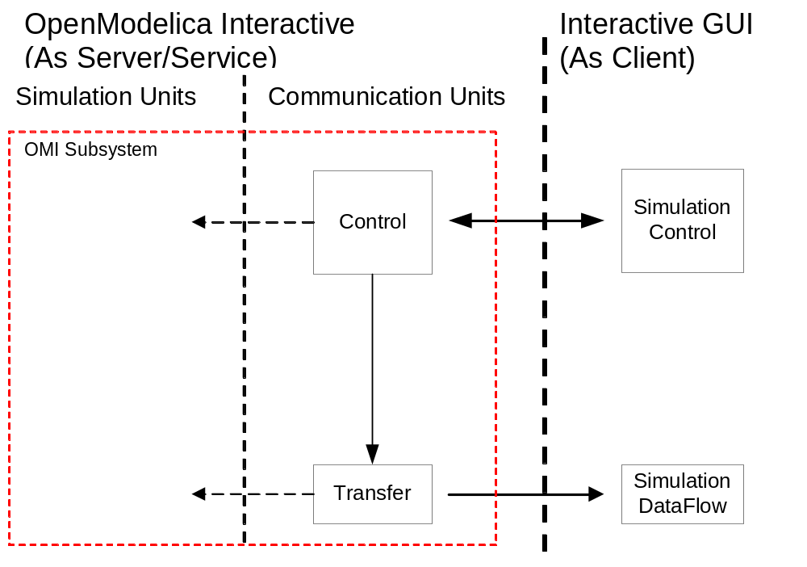
Figure 5-47. OpenModelica interactive communication architecture..
The OpenModelica Interactive subsystem is also separated into different modules, following are important for the user to communicate with:
- Control: The “Control” module is the interface between OMI and a UI. It is implemented as a single thread to support parallel tasks and independent reactivity. As the main controlling and communication instance at simulation initialization phase and while simulation is running it manages simulation properties and also behavior. A client can permanently send operations as messages to the “Control” unit, it can react at any time to feedback from the other internal OMI components and it also sends messages to a client, for example error or status messages.
- Transfer: Similar to a consumer, the “Transfer” thread tries to get simulation results from a result manager and sends them to the UI immediately after starting a simulation. If the communication takes longer than a calculation step, it is also possible to create more than one consumer. The “Transfer” uses a property filter mask containing all property names whose result values are important for the UI. The UI must set this mask using the “setfilter” operation from chapter 2.1.3.2, otherwise the transfer sends only the actual simulation time. This is very useful for increasing the communication speed while sending results to the UI.

Communication Interface
The network communication technology “TCP/IPv4” (later IPv6) will be used to send and receive messages. Each system has its own server and client implementations to receive and send messages respectively. The Control and Transfer are the OMI components which are designated for a communication over TCP/IP.

Network configuration Settings
Name | Description | URL
Control Server | Waits for requests from the UI | By Default, waits for connection on: 127.0.0.1:10501
Control Client | Replies to the UI and sends other synchronization messages to it | By Default, tries to connect on:  127.0.0.1:10500
Transfer Client | Sends simulation results to a UI | By Default, tries to connect on:  127.0.0.1:10502
OMI server and client components: Communication behaviour and configuration by default

Name | Description | URL
Control Client | Requests to the OMI Control Server | By Default, tries to connect on:  127.0.0.1:10501
Control Server | Waits for information from the OMI Control Client | By Default, waits for connection on: 127.0.0.1:10500
Transfer Server | Waits for simulation results from the OMI Transfer Client | By Default, waits for connection on: 127.0.0.1:10502
UI server and client components: Suggested configuration by default

Operation Messages
To use messages parsing there is a need to specify a communications protocol.
A string message begins with a specified prefix and ends with a specified suffix.
The prefix describes the request type, for example an operation. Depending on the request type, some additional information and parameters can append on it. The suffix is to check if the message has been received correctly and if the sender has created it correctly. All parts should be separated with “#”.
A sequence number is helpful to manage operation request and reply, a UI has to send a sequence number combined with an operation.
The following are all available message strings between a UI and the OMI system:

Request from UI to Control

UI Request | Description | OMI::Control Reply
start#SEQ#end | Starts or continues the simulation | done#SEQ#end
pause#SEQ#end | Pauses the running simulation | done#SEQ#end
stop#SEQ#end | Stops the running simulation and resets all values to the beginning | done#SEQ#end
shutdown#SEQ#end | Shuts the simulation down | done#SEQ#end
setfilter#SEQ#  var1:var2#  par1:par2#  end | Sets the filter for variables and parameters which should send from OMI to the client UI | done#SEQ#end
useindex#SEQ#end | Uses indexes as attribute names. The index will be used at transmitting results to a client. This will cause much less data to transmit. (??Not implemented yet) | done#SEQ#end
setcontrolclienturl#SEQ#  ip#port#  end | Changes the IP and port of the Control Server. Otherwise the default configuration will be used. | done#SEQ#end
settransferclienturl#SEQ#  ip#port#  end | Changes the IP and port of the Control Server. Otherwise the default configuration will be used. | done#SEQ#end
changetime#SEQ#Tn#end | Changes the simulation time and goes back to a specific time step | done#SEQ#end
changevalue#SEQ#Tn#  par1=2.3:par2=33.3#  end | Changes the value of the appended parameters and stets the simulation time back to the point where the user clicked in the UI | done#SEQ#end
error#TYPE#end | Error handling not implemented yet | Error: *
Table 5-1 Available messages from a UI to OMI (Request-Reply)

Messages from Control to UI

OMI::Control | Description | UI
Error: MESSAGE | If an error occurs the OMI::Control generates an error messages and sends the messages with the prefix “Error:” to the UI (not implemented yet) | Up to the UI developers
Table 5-2 Available messages from OMI::Control to UI

Messages from Transfer to UI

OMI::Transfer | Description | UI
result#ID#Tn#  var1=Val:var2=Val#  par1=Val:par2=Val#  end | Sends the simulation result for a time step Tn to the client UI, using the property names as identifier. Maybe a result ID is important to identify the results which are obsolete (not implemented yet). | None
result#ID#Tn#  1=Val:2=Val#  1=Val:2=Val#  end | Sends the simulation result for a time step Tn to the client UI, using an index as identifier. This requires a convention about the used index mask. Transfer optimization.  NOTE: Operation from UI needed, Mask creation using the standard array index is recommended.  Maybe a result ID is important to identify the results which are obsolete (not implemented yet). | None
Table 5-3 Available messages from OMI::Transfer to UI

Interactive Simulation general Procedure
Note that OMI is available in an easy-to-use way from OMEdit, see Section 2.7, as an alternative to the procedure described below.

Initialize an Interactive Simulation Session
Start the OpenModelica Shell or OMNotebook which is available in the start menu as
OpenModelica->OpenModelica Shell or OpenModelica->OMNotebook.

1. Load a model or file.
Optional: You can check if your model or file has been loaded correctly with the operation “list()”
2. Build the model using the operation “buildModel(…)” with the following parameters:
a) Model main class name: Name of the main class of your model.
b) numberOfIntervals: Number of output values in an interval of one second. For Example: “numberOfIntervall=5” means that 5 results will be put out every one second (0s, 0.2s, 0.4s, 0.6s, 0.8s, 1.0s…).
c) Note: You can use all parameters which are accepted from the operation “buildModel” except the parameters “Start” and “Stop”. These parameters are unnecessary because an interactive simulation always starts at the time “0s” and runs as long as it won’t be stopped or aborted.
3. Execute the created simulation runtime with the parameter “-interactive” and with a port for the control server optionally “-port xxxxx”. After starting the runtime it will wait until a client connects to its control server port. Now you can enter the operations mentioned above.

Interactive Simulation Example
In this chapter we will explain how to simulate a Modelica system interactively. This procedure should be a default step by step procedure for using OMI with a UI.

How to get an example Modelica Model
The application sample for Windows is present in C:\OpenModelica1.8.1\share\doc\omc\interactive-simulation. Also read C:\OpenModelica1.8.0\share\doc\omc\interactive-simulation\README.txt.
The source code for the client is in the Subversion repository: trunk/c_runtime/interactive.
An application test is in the Subversion repository here: trunk/testsuite/interactive-simulation.
See here how to get the code: https://www.openmodelica.org/index.php/developer/source-code

Create the simulation runtime
We will use an example system based on a demonstration model which is given in the Modelica book by Peter Fritzson [[2], Page 386].
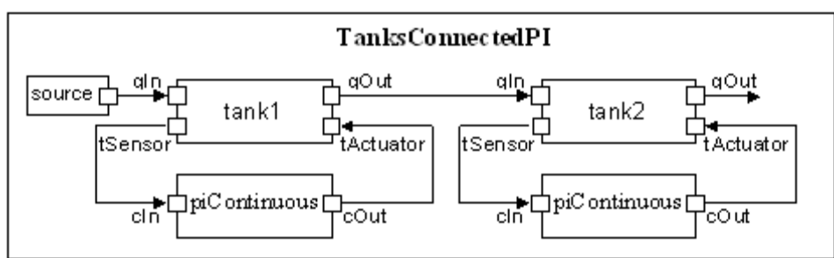
Figure 5-48. TanksConnectedPI structure diagram.
Please follow the steps to create an executable simulation runtime file.
1. Start OMShell “Start->OpenModelica->OpenModelica Shell”
2. Enter the operation “loadModel(TwoTanks)”
NOTE: We assume that the TwoTanks model is in the ModelicaLibary OM installation folder (…\OpenModelica1.8.1\ModelicaLibrary\TwoTanks) otherwise please load the file from its location (…\OpenModelica1.8.1\share\doc\omc\interactive-simulation\*.zip).
3. Use the “buildModel” operation with the following parameters to build the TwoTanks model:
buildModel(TwoTanks.TanksConnectedPI, numberOfIntervals=5)
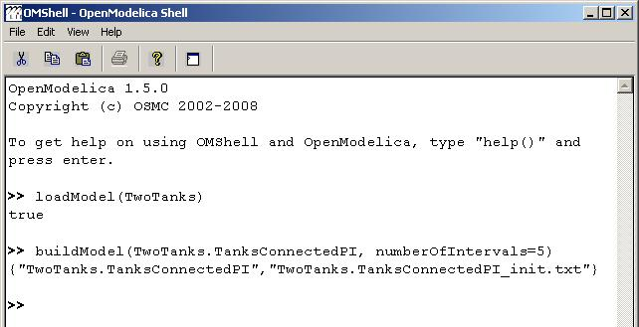

Start an interactive Simulation Session
Start the created simulation runtime it should be located in the “tmp” folder of the OM installation folder (…\OpenModelica1.8.1\tmp\TwoTanks.TanksConnectedPI.exe)
Use the b “-interactive –port xxxxx”. NOTE: If the default port (10501) should be used ignore the parameter “–port”. Now the simulation runtime will be waiting until a UI client has been connected on its port.
Start the client: “client.exe”.
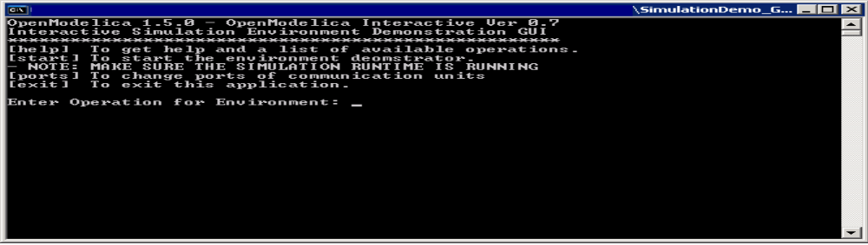

(Deprecated: Now enter “start” into the console and wait until the client is successfully connected.)

Enter following operation for the simulation runtime:
setcontrolclienturl#1#127.0.0.1#10500#end
settransferclienturl#2#127.0.0.1#10502#end
setfilter#3#tank1.h#source.flowLevel#end

Start the simulation with: start#4#end
NOTE: After starting the simulation your keyboard entries and the results will be displayed in the same console and you can’t see what you are typing. Please pause the simulation first than enter a longer operation string.

Pause the simulation with: pause#5#end

Change a Value with: changevalue#6#xx.x#source.flowLevel=0.04#end.
For example if time is higher than 60 and lower than 200 enter →
changevalue#6#60.0#source.flowLevel=0.0004#end

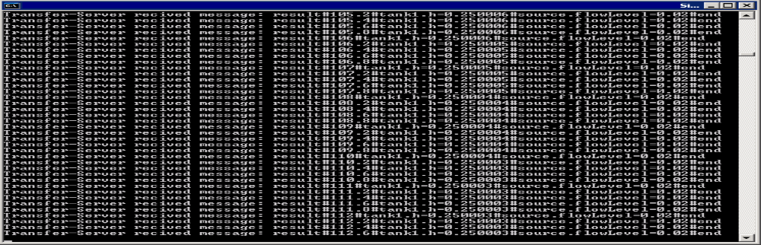

Shutdown the simulation runtime and the environment with: shutdown#7#end

OPC and OPC UA Interfaces
In addition to OMI, OpenModelica can also be stimulated through the OPC interface. At the moment OPC DA and OPC UA interfaces are supported. As OPC UA is seen as the technology that will replace the regular OPC in the future, the OPC UA implementation is concentrated on more than OPC DA.

Introduction to the OPC Interfaces
In this chapter, the basics of OPC are explained. In addition, a literature survey [OPC_1] has been made for the project “OPC Interfaces in OpenModelica”. In that survey, OPC is explained on a higher level generally as well as from the viewpoint of OpenModelica.
OPC is a set of specifications which defines a common interface for communication between software packages and hardware devices of different kinds. The most used of the OPC interfaces, OPC DA (3.00) specification [OPC_2], defines how to get and set data in real time devices using client-server communication paradigm and Ethernet based communication. OPC DA uses Microsoft COM (Component Object Model) technology.
The next generation of OPC specifications is OPC Unified Architecture. It combines the different OPC interfaces under one specification. The basic idea behind OPC UA is the same even though the technology behind is different. Unlike the regular OPC specification, OPC UA is platform independent and has new features, such as method calls, included. A binary transfer protocol is provided for a better performance, as well as the XML based one. The OPC UA specification is defined in a 13-part specification downloadable in OPC Foundation homepage [OPC_3].
Since OPC and OPC UA are rather large specifications, their usage cannot be discussed here in detail. For a deeper understanding of the technology behind OPC and OPC UA the reader should get familiar with the interface specifications above. However, for both of the interfaces there exist test clients which can be used to utilize the interfaces in a quick and easy manner. A couple of test clients are introduced in section 5.2.3.

Implemented Features
Both the OPC UA and the OPC DA interface (combined with the Simulation Control (SC) interface) provide a very similar functionality. Thus only OPC UA is discussed extensively here. In subsection 5.2.2.2 the most noteworthy differences in features between OPC UA and OPC are discussed.
To utilize either of the OPC interfaces, the OPC branch needs to be merged to c_runtime. UA Server is linked to the simulation executable by adding -lOPCregistry -lua_server at the end of the compiling script. OPC DA server is linked to the simulation executable by adding -lOPCregistry -lOPCKit at the end of the compiling script. At the moment there is no option in the OMC to do this automatically.

OPC UA
After an OPC UA client has established a connection to an OpenModelica simulation, the following features can be utilized. In Figure 5-49 UA Expert connected to an OpenModelica simulation (‘dcmotor’) with the OPC UA server included, a view of the UA Expert test client is shown. The client is connected to an example OpenModelica simulation, namely the ‘dcmotor’ [OPC_4]. In the following, all the examples use Figure 5-49 UA Expert connected to an OpenModelica simulation (‘dcmotor’) with the OPC UA server included to explain the concepts.

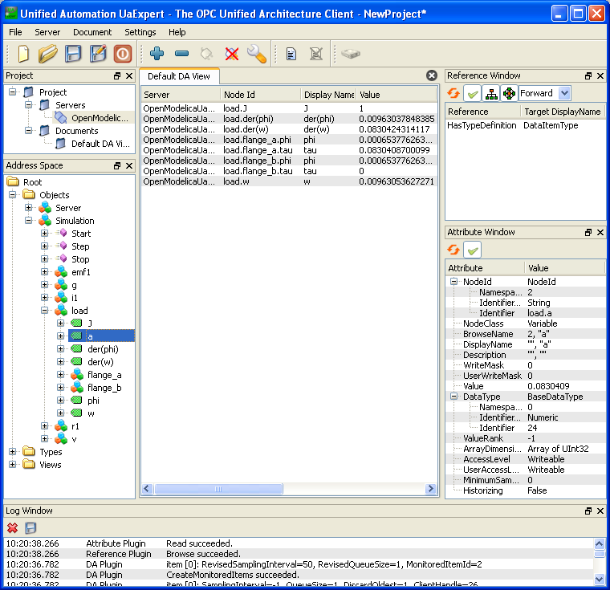
Figure 5-49 UA Expert connected to an OpenModelica simulation (‘dcmotor’) with the OPC UA server included
Browse
The data structure (in OPC UA terminology: address space) of the OpenModelica simulation can be browsed. The address space consists of nodes and references between them. The part of the address space in which all the elements of the simulation are is a tree under the ‘Simulation’ node. This is shown in the left plane in Figure 5-49. In addition, the three methods are there as nodes as well; these methods are discussed later.
Read
Values of variables and parameters can be read through OPC UA after each simulation step. In addition to that, OPC UA offers some metadata, the majority of which is not utilized, though. The value and the metadata can be found on the right plane in Figure 5-49.
Write
Values of attributes and parameters can also be altered during the simulation between the simulation steps. When a value has been changed, the simulation is initialized with the new values and continued. This is needed if variables are wished to be changed, however a parameter change would not require this. Hence the implementation should be fixed on this matter.
Subscribe
Variable (and parameter) values can be subscribed. There are two alternative types of subscription: The first option is that the OPC UA server sends the value of the subscribed variable to the client each time after a defined time interval has passed (real time). The other one is that the value is sent to the client after each simulation step. In UA Expert, variables can be subscribed by dragging them to the middle plane.
Start, Stop, Step
The simulation can be controlled by the three methods: start(), stop(), and step(). With the OPC UA server included, the OpenModelica simulation starts in a stopped state. With start() and stop() methods this state can be changed. The simulation can also be run one step at a time with step().

OPC DA and Simulation Control (SC)
The OPC DA server offers roughly the same functionality than the OPC UA server. The biggest conceptual difference between the two specifications is groups: Before variables and parameters can be used in any way they have to be grouped. A group is an entity consisting of items. A group can contain any variables and parameters as items. The other major differences between the two interfaces are described in the following.
Browse
The data structure of OPC DA is a tree consisting of branches and leaves. The leaves correspond to variables and parameters whereas the branches form the tree-like structure (e.g. ‘load’ and ‘flange_a’ are shown as branches in the dcmotor example).
Read
Reading values doesn’t differ much from OPC UA, except that the items read have to be grouped. There is also almost no metadata available through the OPC DA.
Write
There are no major differences.
Subscribe
The biggest difference in OPC DA is that single items cannot be subscribed. Instead, a subscription can be made for a group.
Start, Stop, Step
OPC DA interface doesn’t enable methods as such. Thus a proprietary interface, Simulation Control (SC), is used. In practice this means that in addition to the OPC DA client an SC client must be run alongside.

Test clients
There are free test clients available in the Internet to test the OPC and OPC UA interfaces. One test client for each interface is shortly presented below. In addition, a test client for the SC interface is published as part of OpenModelica.
UA Expert by Unified Automation is an OPC UA test client with a GUI. It supports all the functionalities provided by the OPC UA in OpenModelica. The latest version of UA Expert can be downloaded for free from the Unified Automation homepage [OPC_5].
For OPC DA there are numerous test clients available. The one which was most used for testing the OPC server is MatrikonOPC Explorer. It supports all the OPC DA functionalities needed to access data in OpenModelica. As well as UA Expert, this test client has a graphical user interface. The latest version of MatrikonOPC Explorer can be downloaded for free from the MatrikonOPC homepage [OPC_6].
As the SC interface is a non-standard interface, there are no clients for it in the Internet. SimpleOPCClient is a small test client for OPC and SC interfaces published with OpenModelica. Besides some basic OPC features, this test client allows the simulation to be controlled, i.e. start(), stop(), and step() functions can be used with it. Unlike the commercial products above, SimpleOPCClient is published in source code format.

References
- OPC Interfaces in OpenModelica – Technical Specification (Task 5.3); Online: https://openmodelica.org/svn/OpenModelica/trunk/doc/opc/
OPC_Interfaces_in_OpenModelica.pdf (Accessed 10 June 2011).
- OPC DA 3.00 Specification; Online: http://opcfoundation.org/DownloadFile.aspx?CM=3&RI=67&CN=KEY&CI=283&CU=6 (Accessed 9 June 2011).
- The OPC Foundation – The Interoperability Standard for a Connected World; Online: http://opcfoundation.org/ (Accessed 8 June 2011).
- OpenModelica: DC Motor model; Online: https://openmodelica.ida.liu.se/svn/
OpenModelica/tags/OPENMODELICA_1_5_0/Examples/dcmotor.mo (Accessed 10 June 2011).
- Unified Automation GmbH | OPC UA Clients; Online: http://www.unified-automation.com/opc-ua-clients/ (Accessed 9 June 2011).
- MatrikonOPC: Free OPC Downloads; Online: http://www.matrikonopc.com/downloads/ (Accessed 9 June 2011).

Model Import and Export with FMI 1.0
The new standard for model exchange with Functional Mockup Interface (FMI) 1.0 allows export of pre-compiled models, i.e., C-code or binary code, from a tool for import in another tool, and vice versa. The FMI model exchange standard is Modelica independent. Import and export works both between different Modelica tools, or between certain non-Modelica tools and Modelica tools. OpenModelica supports FMI 1.0 import as well as FMI 1.0 export.

FMI Import
To import the FMU package use the OpenModelica command importFMU(“fmufile”, “outputdirectory”) from command line interface, OMShell, OMNotebook or MDT. The importFMU command is also integrated with OMEdit. Select FMI > Import FMI the FMU package is extracted in the directory specified by outputdirectory, since the outputdirectory parameter is optional so if its not specified then the current directory of omc is used. You can use the cd() command to see the current location.
The FMI Import is currently a prototype. It was implemented on the Windows 7 x64 platform under the MinGW environment. The prototype has been tested in OpenModelica 1.8.1 (revision-10129) with several examples. A more fullfleged version for FMI Import will be released in the near future. The present version can be used as a stand-alone FMU import for Modelica simulators.

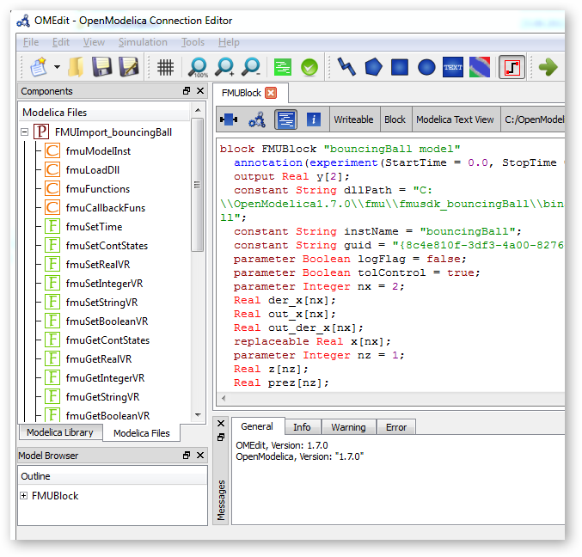
Figure 6-50: Example of FMU Import in OpenModelica where a bouncing ball model is imported.

FMI Export
To export the FMU use the OpenModelica command translateModelFMU(ModelName) from command line interface, OMShell, OMNotebook or MDT. The export FMU command is also integrated with OMEdit. Select FMI > Export FMI the FMU package is generated in the current directory of omc. You can use the cd() command to see the current location.
After the command execution is complete you will see that a file ModelName.fmu has been created. As depicted in Figure 6-2, we first changed the current directory to C:/OpenModelica1.7.0/bin , then we loaded a Modelica file with BouncingBall example model and finally created an FMU for it using the translateModelFMU call.
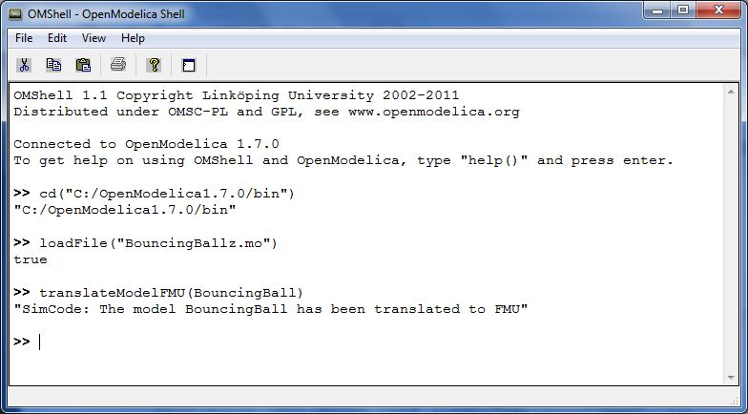
Figure 6-51: OMShell screenshot for creating an FMU
A log file for FMU creation is also generated named ModelName_FMU.log. If there are some errors while creating FMU they will be shown in the command line window and logged in this log file as well.

OMOptim – Optimization with OpenModelica

Introduction
OMOptim is a tool dedicated to optimization of Modelica models. By optimization, one should understand a procedure which minimizes/maximizes one or more objectives by adjusting one or more parameters.
OMOptim 0.9 contains meta-heuristic optimization algorithms which allow optimizing all sorts of models with following functionalities:
- One or several objectives optimized simultaneously
- One or several parameters (integer or real variables)
However, the user must be aware of the large number of simulations an optimization might require.

Preparing the Model
Before launching OMOptim, one must prepare the model in order to optimize it.

Parameters
An optimization parameter is picked up from all model variables. The choice of parameters can be done using the OMOptim interface.
For all intended parameters, please note that:
- The corresponding variable is constant during all simulations. The OMOptim optimization in version 0.9 only concerns static parameters’ optimization i.e. values found for these parameters will be constant during all simulation time.
- The corresponding variable should play an input role in the model i.e. its modification influences model simulation results.

Constraints
If some constraints should be respected during optimization, they must be defined in the Modelica model itself.
For instance, if mechanical stress must be less than 5 N.m⁻², one should write in the model:
assert( mechanicalStress < 5, “Mechanical stress too high”);
If during simulation, the variable mechanicalStress exceeds 5 N.m⁻², the simulation will stop and be considered as a failure.

Objectives
As parameters, objectives are picked up from model variables. Objectives’ values are considered by the optimizer at the final time.

Set problem in OMOptim

Launch OMOptim
OMOptim can be launched using the executable placed in OpenModelicaInstallationDirectory/bin/ OMOptim/OMOptim.exe. Alternately, choose OpenModelica > OMOptim from the start menu.

Create a new project
To create a new project, click on menu File -> New project
Then set a name to the project and save it in a dedicated folder. The created file created has a .min extension. It will contain information regarding model, problems, and results loaded.

Load models
First, you need to load the model(s) you want to optimize. To do so, click on Add .mo button on main window or select menu Model -> Load Mo file…
When selecting a model, the file will be loaded in OpenModelica which runs in the background.
While OpenModelica is loading the model, you could have a frozen interface. This is due to multi-threading limitation but the delay should be short (few seconds).
You can load as many models as you want.
If an error occurs (indicated in log window), this might be because:
- Dependencies have not been loaded before (e.g. modelica library)
- Model use syntax incompatible with OpenModelica.

Dependencies
OMOptim should detect dependencies and load corresponding files. However, it some errors occur, please load by yourself dependencies. You can also load Modelica library using Model->Load Modelica library.
When the model correctly loaded, you should see a window similar to Figure 7-52.
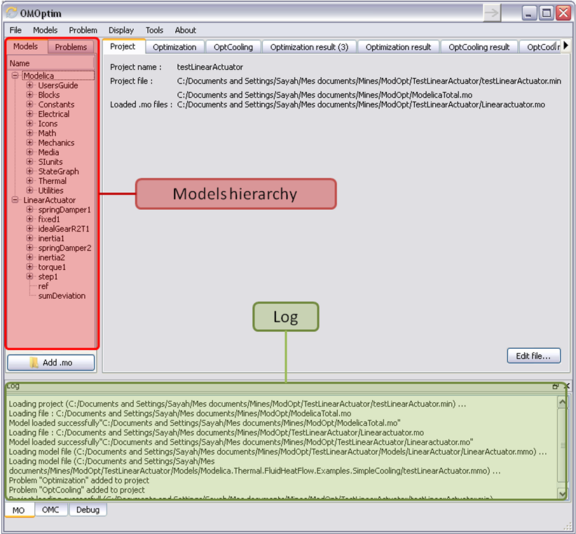
Figure 7-52. OMOptim window after having loaded model.

Create a new optimization problem
Problem->Add Problem->Optimization
A dialog should appear. Select the model you want to optimize. Only Model can be selected (no Package, Component, Block…).
A new form will be displayed. This form has two tabs. One is called Variables, the other is called Optimization.

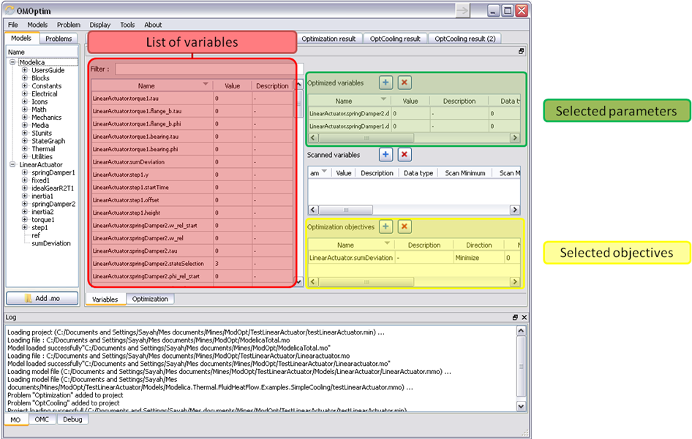
Figure 7-53. Forms for defining a new optimization problem.

List of Variables is Empty
If variables are not displayed, right click on model name in model hierarchy, and select Read variables.

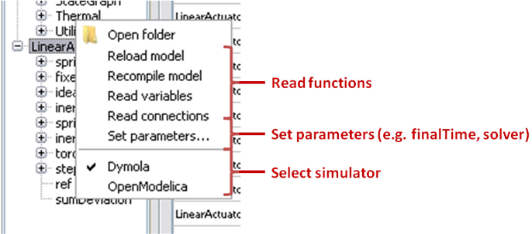
Figure 7-54. Selecting read variables, set parameters, and selecting simulator.

Select Optimized Variables
To set optimization, we first have to define the variables the optimizer will consider as free i.e. those that it should find best values of. To do this, select in the left list, the variables concerned. Then, add them to Optimized variables by clicking on corresponding button ().
For each variable, you must set minimum and maximum values it can take. This can be done in the Optimized variables table.

Select objectives
Objectives correspond to the final values of chosen variables. To select these last, select in left list variables concerned and click button of Optimization objectives table.
For each objective, you must:
- Set minimum and maximum values it can take. If a configuration does not respect these values, this configuration won’t be considered. You also can set minimum and maximum equals to “-“ : it will then
- Define whether objective should be minimized or maximized.
This can be done in the Optimized variables table.

Select and configure algorithm
After having selected variables and objectives, you should now select and configure optimization algorithm. To do this, click on Optimization tab.
Here, you can select optimization algorithm you want to use. In version 0.9, OMOptim offers three different genetic algorithms. Let’s for example choose SPEA2Adapt which is an auto-adaptative genetic algorithm.
By clicking on parameters… button, a dialog is opened allowing defining parameters. These are:
- Population size: this is the number of configurations kept after a generation. If it is set to 50, your final result can’t contain more than 50 different points.
- Off spring rate: this is the number of children per adult obtained after combination process. If it is set to 3, each generation will contain 150 individual (considering population size is 50).
- Max generations: this number defines the number of generations after which optimization should stop. In our case, each generation corresponds to 150 simulations. Note that you can still stop optimization while it is running by clicking on stop button (which will appear once optimization is launched). Therefore, you can set a really high number and still stop optimization when you want without losing results obtained until there.
- Save frequency: during optimization, best configurations can be regularly saved. It allows to analyze evolution of best configurations but also to restart an optimization from previously obtained results. A Save Frequency parameter set to 3 means that after three generations, a file is automatically created containing best configurations. These files are named iteraion1.sav, iteration2.sav and are store in Temp directory, and moved to SolvedProblems directory when optimization is finished.
- ReinitStdDev: this is a specific parameter of EAAdapt1. It defines whether standard deviation of variables should be reinitialized. It is used only if you start optimization from previously obtained configurations (using Use start file option). Setting it to yes (1) will, in most of cases, lead to a spread research of optimized configurations, forgetting parameters’ variations’ reduction obtained in previous optimization.

Use start file
As indicated before, it is possible to pursue an optimization finished or stopped. To do this, you must enable Use start file option and select file from which optimization should be started. This file is an iteration_.sav file created in previous optimization. It is stored in corresponding SolvedProblems folder (iteration10.sav corresponds to the tenth generation of previous optimization).
Note that this functionality can only work with same variables and objectives. However, minimum, maximum of variables and objectives can be changed before pursuing an optimization.

Launch
You can now launch Optimization by clicking Launch button.

Stopping Optimization
Optimization will be stopped when the generation counter will reach the generation number defined in parameters. However, you can still stop the optimization while it is running without loosing obtained results. To do this, click on Stop button. Note that this will not immediately stop optimization: it will first finish the current generation.
This stop function is especially useful when optimum points do not vary any more between generations. This can be easily observed since at each generation, the optimum objectives values and corresponding parameters are displayed in log window.

Results
The result tab appear when the optimization is finished. It consists of two parts: a table where variables are displayed and a plot region.

Obtaining all Variable Values
During optimization, the values of optimized variables and objectives are memorized. The others are not. To get these last, you must recomputed corresponding points. To achieve this, select one or several points in point’s list region and click on recompute.
For each point, it will simulate model setting input parameters to point corresponding values. All values of this point (including those which are not optimization parameters neither objectives).

Window Regions in OMOptim GUI
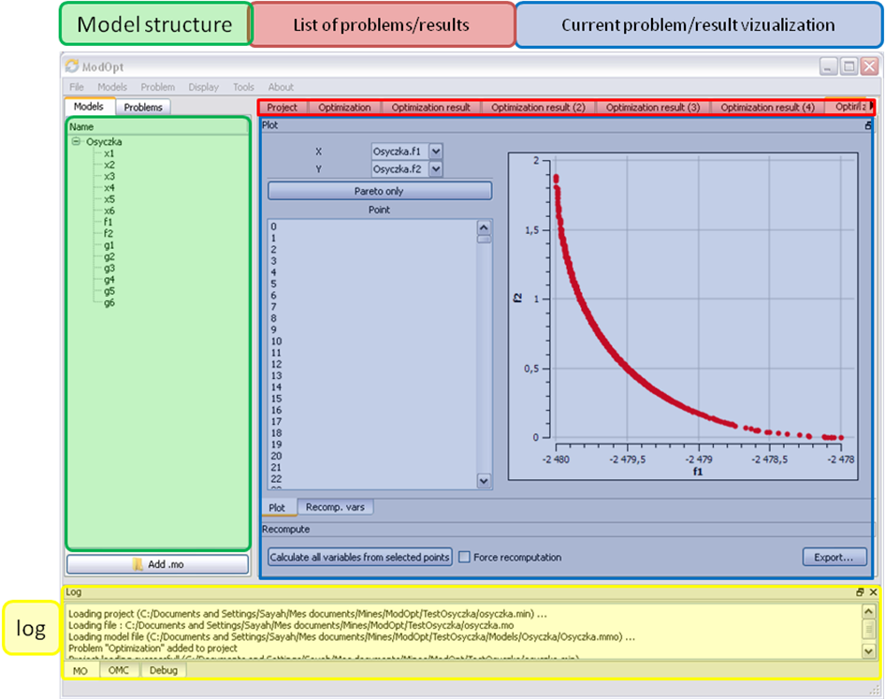
Figure 7-55. Window regions in OMOptim GUI.

MDT – The OpenModelica Development Tooling Eclipse Plugin

Introduction
The Modelica Development Tooling (MDT) Eclipse Plug-In as part of OMDev – The OpenModelica Development Environment integrates the OpenModelica compiler with Eclipse. MDT, together with the OpenModelica compiler, provides an environment for working with Modelica development projects.
The following features are available:
- Browsing support for Modelica projects, packages, and classes
- Wizards for creating Modelica projects, packages, and classes
- Syntax color highlighting
- Syntax checking
- Browsing of the Modelica Standard Library or other libraries
- Code completion for class names and function argument lists.
- Goto definition for classes, types, and functions.
- Displaying type information when hovering the mouse over an identifier.

Installation
The installation of MDT is accomplished by following the below installation instructions. These instructions assume that you have successfully downloaded and installed Eclipse (http://www.eclipse.org).
- Start Eclipse
- Select Help->Software Updates->Find and Install... from the menu
- Select ‘Search for new features to install’ and click ‘Next’
- Select ‘New Remote Site...’
- Enter ‘MDT’ as name and ‘http://www.ida.liu.se/labs/pelab/modelica/OpenModelica/MDT’ as URL and click ‘OK’
- Make sure ‘MDT’ is selected and click ‘Finish’
- In the updates dialog select the ‘MDT’ feature and click ‘Next’
- Read through the license agreement, select ‘I accept...’ and click ‘Next’
- Click ‘Finish’ to install MDT

Getting Started

Configuring the OpenModelica Compiler
MDT needs to be able to locate the binary of the compiler. It uses the environment variable OPENMODELICAHOME to do so.
If you have problems using MDT, make sure that OPENMODELICAHOME is pointing to the folder where the Open Modelica Compiler is installed. In other words, OPENMODELICAHOME must point to the folder that contains the Open Modelica Compiler (OMC) binary. On the Windows platform it’s called omc.exe and on Unix platforms it’s called omc.

Using the Modelica Perspective
The most convenient way to work with Modelica projects is to use to the Modelica perspective. To switch to the Modelica perspective, choose the Window menu item, pick Open Perspective followed by Other... Select the Modelica option from the dialog presented and click OK..

Selecting a Workspace Folder
Eclipse stores your projects in a folder called a workspace. You need to choose a workspace folder for this session, see Figure 5-8-56

Figure 5-8-56. Eclipse Setup – Switching Workspace.

Creating one or more Modelica Projects
To start a new project, use the New Modelica Project Wizard. It is accessible through File->New-> Modelica Project or by right-clicking in the Modelica Projects view and selecting New->Modelica Project.

Figure 5-8-57. Eclipse Setup – creating a Modelica project in the workspace.
You need to disable automatic build for the project(s) (Figure 5-8-58).

Figure 5-8-58. Eclipse Setup – disable automatic build for the projects.
Repeat the procedure for all the projects you need, e.g. for the exercises described in the MetaModelica users guide: 01_experiment, 02a_exp1, 02b_exp2, 03_assignment, 04a_assigntwotype, etc.
NOTE: Leave open only the projects you are working on! Close all the others!

Building and Running a Project
After having created a project, you eventually need to build the project (Figure 8-59).
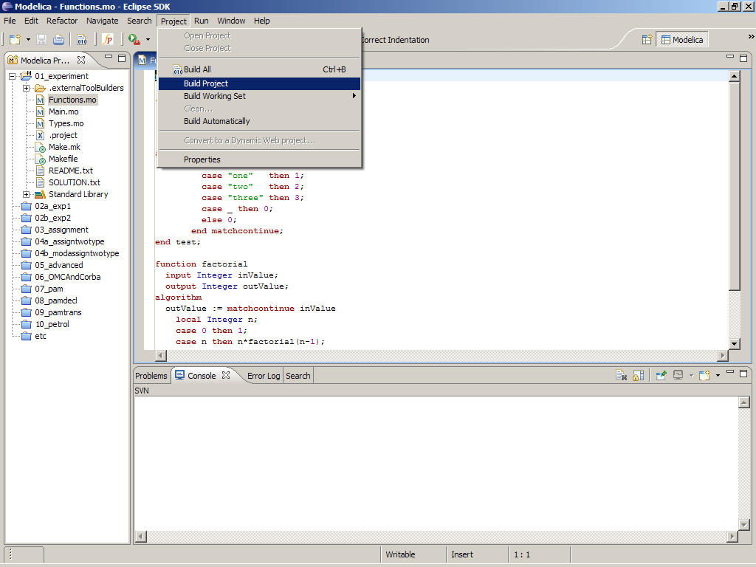
Figure 8-59. Eclipse MDT – Building a project.
There are several options: building, building from scratch (clean), running, see Figure 8-60.
??missing figure
Figure 8-60. Eclipse – building and running a project.
You may also open additional views, e.g as in Figure 8-61.
??missing figure
Figure 8-61. Eclipse – Opening views.

Switching to Another Perspective
If you need, you can (temporarily) switch to another perspective, e.g. to the Java perspective for working with an OpenModelica Java client as in Figure 8-62.
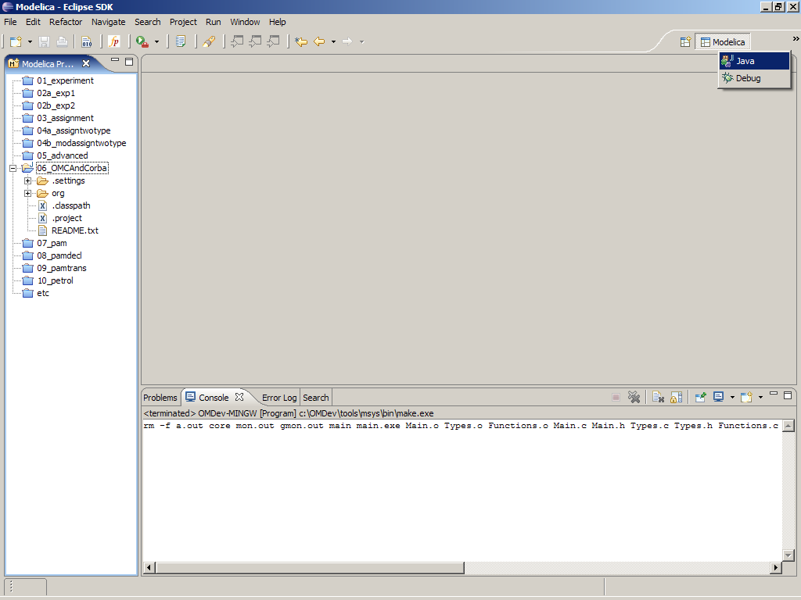
Figure 8-62. Eclipse – Switching to another perspective – e.g. the Java Perspective.

Creating a Package
To create a new package inside a Modelica project, select File->New->Modelica Package. Enter the desired name of the package and a description of what it contains. Note: for the exercises we already have existing packages.
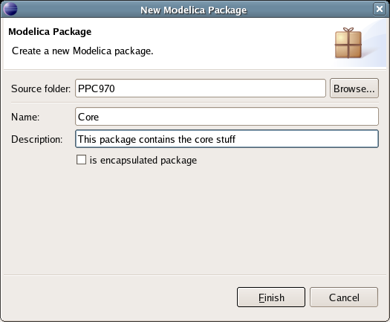
Figure 8-63. Creating a new Modelica package.

Creating a Class
To create a new Modelica class, select where in the hierarchy that you want to add your new class and select File->New->Modelica Class. When creating a Modelica class you can add different restrictions on what the class can contain. These can for example be model, connector, block, record, or function. When you have selected your desired class type, you can select modifiers that add code blocks to the generated code. ‘Include initial code block’ will for example add the line ‘initial equation’ to the class.
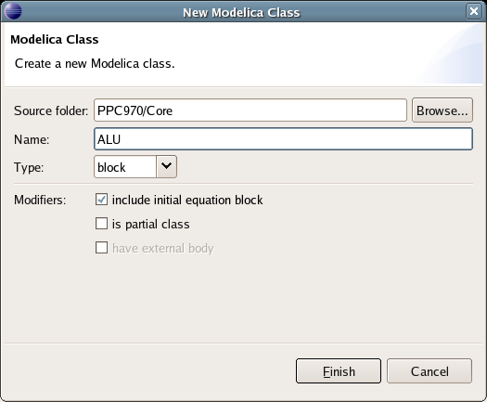
Figure 8-64. Creating a new Modelica class.

Syntax Checking
Whenever a build command is given to the MDT environment, modified and saved Modelica (.mo) files are checked for syntactical errors. Any errors that are found are added to the Problems view and also marked in the source code editor. Errors are marked in the editor as a red circle with a white cross, a squiggly red line under the problematic construct, and as a red marker in the right-hand side of the editor. If you want to reach the problem, you can either click the item in the Problems view or select the red box in the right-hand side of the editor.

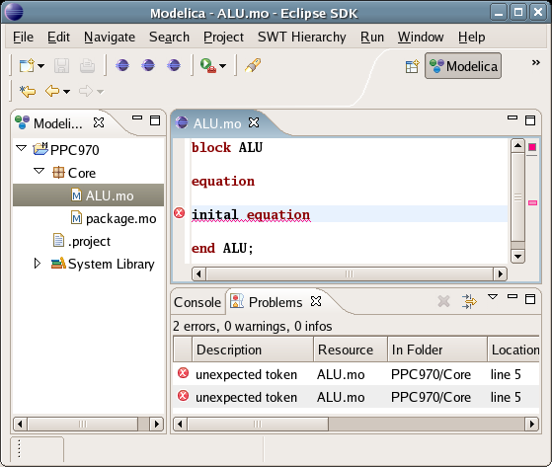
Figure 8-65. Syntax checking.

Automatic Indentation Support
MDT currently has support for automatic indentation. When typing the Return (Enter) key, the next line is indented correctly. You can also correct indentation of the current line or a range selection using CTRL+I or “Correct Indentation” action on the toolbar or in the Edit menu.

Code Completion
MDT supports Code Completion in two variants. The first variant, code completion when typing a dot after a class (package) name, shows alternatives in a menu. Besides the alternatives, Modelica documentation from comments is shown if is available. This makes the selection easyer.
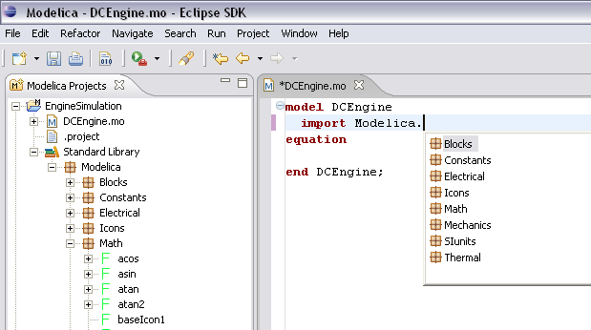
Figure 8-66. Code completion when typing a dot.
The second variant is useful when typing a call to a function. It shows the function signature (formal parameter names and types) in a popup when typing the parenthesis after the function name, here the signature Real sin(SI.Angle u) of the sin function:

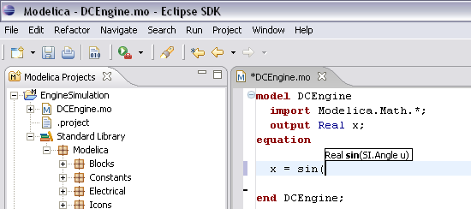
Figure 8-67. Code completion at a function call when typing left parenthesis.

Code Assistance on Identifiers when Hovering
When hovering with the mouse over an identifier a popup with information about the identifier is displayed. If the text is too long, the user can press F2 to focus the popup dialog and scroll up and down to examine all the text. As one can see the information in the popup dialog is syntax-highlighted.
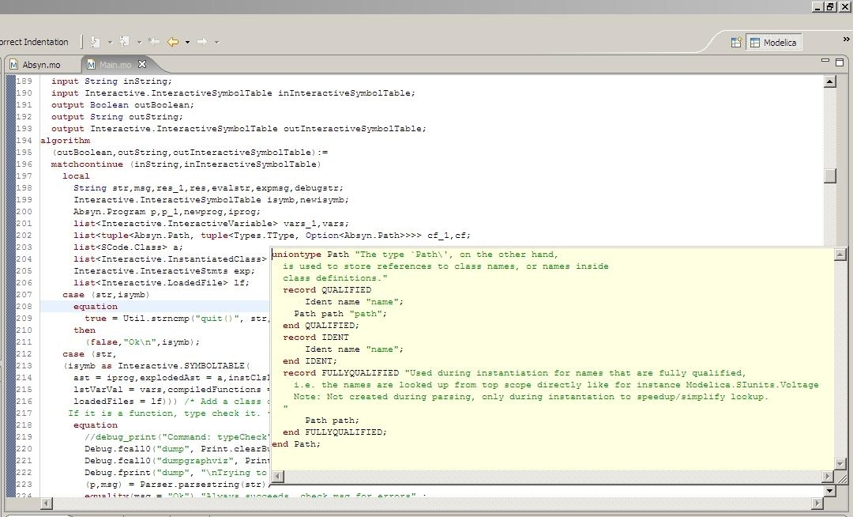
Figure 8-68. Displaying information for identifiers on hovering

Go to Definition Support
Besides hovering information the user can press CTRL+click to go to the definition of the identifier. When pressing CTRL the identifier will be presented as a link and when pressing mouse click the editor will go to the definition of the identifier.

Code Assistance on Writing Records
When writing records, the same functionality as for function calls is used. This is useful especially in MetaModelica when writing cases in match constructs.
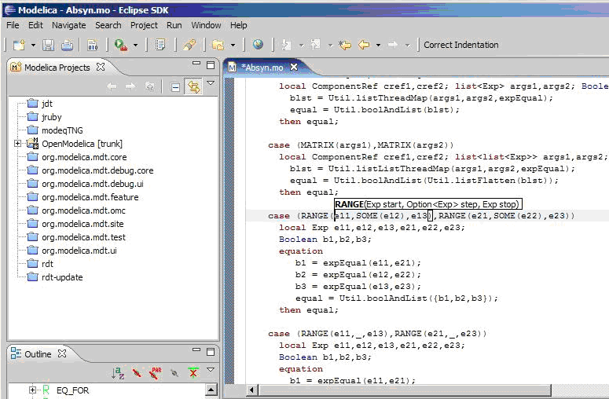
Figure 8-69. Code assistance when writing cases with records in MetaModelica.

Using the MDT Console for Plotting
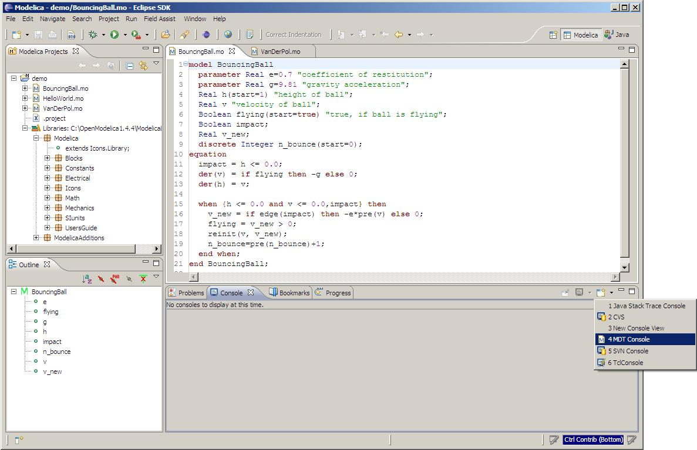
Figure 8-70. Activate the MDT Console
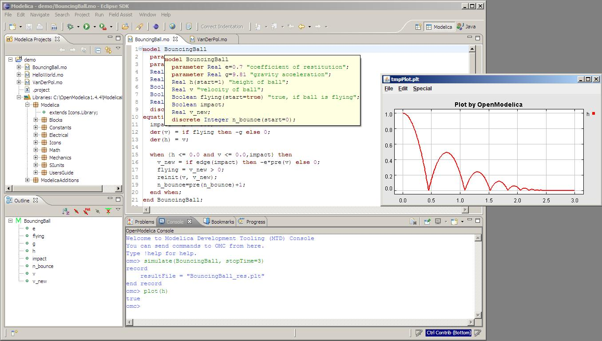
Figure 8-71. Simulation from MDT Console

Modelica Performance Analyzer
A common problem when simulating models in an equation-based language like Modelica is that the model may contain non-linear equation systems. These are solved in each time-step by extrapolating an initial guess and running a non-linear system solver. If the simulation takes too long to simulate, it is useful to run the performance analysis tool. The tool has around 5~25% overhead, which is very low compared to instruction-level profilers (30x-100x overhead). Due to being based on a single simulation run, the report may contain spikes in the charts.
When running a simulation for performance analysis, execution times of user-defined functions as well as linear, non-linear and mixed equation systems are recorded.
To start a simulation in this mode, just use the measureTime flag of the simulate command.
simulate(modelname, measureTime = true)
The generated report is in HTML format (with images in the SVG format), stored in a file modelname_prof.html, but the XML database and measured times that generated the report and graphs are also available if you want to customize the report for comparison with other tools.
Below we use the performance profiler on the simple model A:
model A
function f
input Real r;
output Real o := sin(r);
end f;
String s = "abc";
Real x = f(x) "This is x";
Real y(start=1);
Real z1 = cos(z2);
Real z2 = sin(z1);
equation
der(y) = time;
end A;
We simulate as usual, but set measureTime=true to activate the profiling:
simulate(A, measureTime = true)

// // record SimulationResult
// resultFile = "A_res.mat",
// messages = "Time measurements are stored in A_prof.html (human-readable) and A_prof.xml (for XSL transforms or more details)"
// end SimulationResult;

Example Report Generated for the A Model

Information
All times are measured using a real-time wall clock. This means context switching produces bad worst-case execution times (max times) for blocks. If you want better results, use a CPU-time clock or run the command using real-time priviliges (avoiding context switches).
Note that for blocks where the individual execution time is close to the accuracy of the real-time clock, the maximum measured time may deviate a lot from the average.
For more details, see the generated file A_prof.xml, shown in Section 9.1.7 below.

Settings
The settings for the simulation are summarized in the table below:

Name | Value
Integration method | euler
Output format | mat
Output name | A_res.mat
Output size | 24.0 kB
Profiling data | A_prof.data
Profiling size | 27.3 kB

Summary
Execution times for different activities:

Task | Time | Fraction
Pre-Initialization | 0.000401 | 19.17%
Initialization | 0.000046 | 2.20%
Event-handling | 0.000036 | 1.72%
Creating output file | 0.000264 | 12.62%
Linearization | 0.000000 | 0.00%
Time steps | 0.001067 | 51.00%
Overhead | 0.000273 | 13.05%
Unknown | 0.000406 | 0.24%
Total simulation time | 0.002092 | 100.00%

Global Steps
 | Steps | Total Time | Fraction | Average Time | Max Time | Deviation
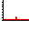 | 499 | 0.001067 | 51.00% | 2.13827655310621e-06 | 0.000006611 | 2.09x

Measured Function Calls
 | Name | Calls | Time | Fraction | Max Time | Deviation
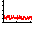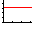 | A.f | 1506 | 0.000092990 | 4.45% | 0.000000448 | 6.26x

Measured Blocks
 | Name | Calls | Time | Fraction | Max Time | Deviation
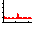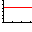 | residualFunc3 | 2018 | 0.000521137 | 24.91% | 0.000035456 | 136.30x
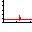 | residualFunc1 | 1506 | 0.000393709 | 18.82% | 0.000002735 | 9.46x

Equations
Name | Variables
SES_ALGORITHM 0
SES_SIMPLE_ASSIGN 1 | der(y)
residualFunc3 | z2, z1
residualFunc1 | x

Variables
Name | Comment
y
der(y)
x | This is x
z1
z2
s

Genenerated XML for the Example

<!DOCTYPE doc (View Source for full doctype...)>
- <simulation>
- <modelinfo>
<name>A</name>
<prefix>A</prefix>
<date>2011-03-07 12:55:53</date>
<method>euler</method>
<outputFormat>mat</outputFormat>
<outputFilename>A_res.mat</outputFilename>
<outputFilesize>24617</outputFilesize>
<overheadTime>0.000273</overheadTime>
<preinitTime>0.000401</preinitTime>
<initTime>0.000046</initTime>
<eventTime>0.000036</eventTime>
<outputTime>0.000264</outputTime>
<linearizeTime>0.000000</linearizeTime>
<totalTime>0.002092</totalTime>
<totalStepsTime>0.001067</totalStepsTime>
<numStep>499</numStep>
<maxTime>0.000006611</maxTime>
</modelinfo>
- <profilingdataheader>
<filename>A_prof.data</filename>
<filesize>28000</filesize>
- <format>
<uint32>step</uint32>
<double>time</double>
<double>cpu time</double>
<uint32>A.f (calls)</uint32>
<uint32>residualFunc3 (calls)</uint32>
<uint32>residualFunc1 (calls)</uint32>
<double>A.f (cpu time)</double>
<double>residualFunc3 (cpu time)</double>
<double>residualFunc1 (cpu time)</double>
</format>
</profilingdataheader>
- <variables>
- <variable id="1000" name="y" comment="">
<info filename="a.mo" startline="8" startcol="3" endline="8" endcol="18" readonly="writable" />
</variable>
- <variable id="1001" name="der(y)" comment="">
<info filename="a.mo" startline="8" startcol="3" endline="8" endcol="18" readonly="writable" />
</variable>
- <variable id="1002" name="x" comment="This is x">
<info filename="a.mo" startline="7" startcol="3" endline="7" endcol="28" readonly="writable" />
</variable>
- <variable id="1003" name="z1" comment="">
<info filename="a.mo" startline="9" startcol="3" endline="9" endcol="20" readonly="writable" />
</variable>
- <variable id="1004" name="z2" comment="">
<info filename="a.mo" startline="10" startcol="3" endline="10" endcol="20" readonly="writable" />
</variable>
- <variable id="1005" name="s" comment="">
<info filename="a.mo" startline="6" startcol="3" endline="6" endcol="19" readonly="writable" />
</variable>
</variables>
- <functions>
- <function id="1006">
<name>A.f</name>
<ncall>1506</ncall>
<time>0.000092990</time>
<maxTime>0.000000448</maxTime>
<info filename="a.mo" startline="2" startcol="3" endline="5" endcol="8" readonly="writable" />
</function>
</functions>
- <equations>
- <equation id="1007" name="SES_ALGORITHM 0">
<refs />
</equation>
- <equation id="1008" name="SES_SIMPLE_ASSIGN 1">
- <refs>
<ref refid="1001" />
</refs>
</equation>
- <equation id="1009" name="residualFunc3">
- <refs>
<ref refid="1004" />
<ref refid="1003" />
</refs>
</equation>
- <equation id="1010" name="residualFunc1">
- <refs>
<ref refid="1002" />
</refs>
</equation>
</equations>
- <profileblocks>
- <profileblock>
<ref refid="1009" />
<ncall>2018</ncall>
<time>0.000521137</time>
<maxTime>0.000035456</maxTime>
</profileblock>
- <profileblock>
<ref refid="1010" />
<ncall>1506</ncall>
<time>0.000393709</time>
<maxTime>0.000002735</maxTime>
</profileblock>
</profileblocks>
</simulation>

Modelica Algorithmic Subset Debugger
This chapter presents a comprehensive Modelica debugger for an extended algorithmic subset of the Modelica language called MetaModelica. This replaces debugging of algorithmic code using primitive means such as print statements or asserts which is complex, time-consuming and error- prone.
The debugger is portable since it is based on transparent source code instrumentation techniques that are independent of the implementation platform.
The usual debugging functionality found in debuggers for procedural or traditional object-oriented languages is supported, such as setting and removing breakpoints, stepping, inspecting variables, etc. The debugger is integrated with Eclipse.

The Eclipse-based Debugging Environment
The debugging framework is based on the Eclipse environment and is implememented as a set of plugins which are available from Modelica Development Tooling (MDT) environment. Some of the debugger functionality is presented below. In the right part a variable value is explored. In the top-left part the stack trace is presented. In the middle-left part the execution point is presented.
The debugger provides the following general functionalities:
- Adding/Removing breakpoints.
- Step Over – moves to the next line, skipping the function calls.
- Step In – takes the user into the function call.
- Step Return – complete the execution of the function and takes the user back to the point from where the function is called.
- Suspend – interrupts the running program.
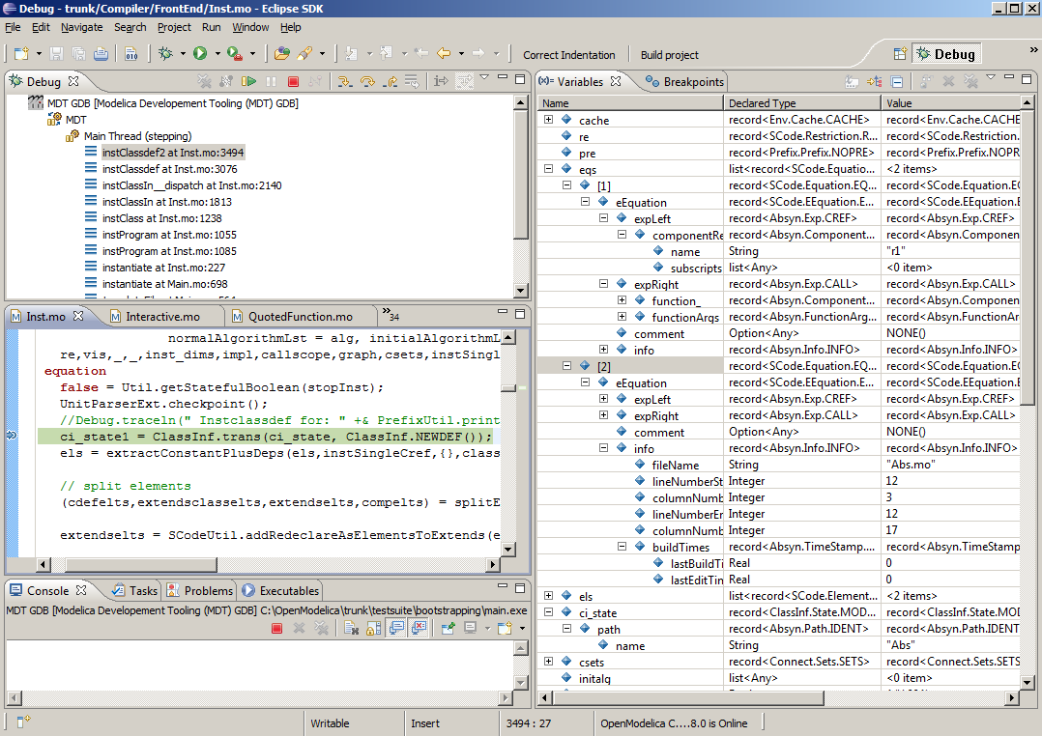
Figure 10-72. Debugging functionality.

Starting the Modelica Debugging Perspective
To be able to run in debug mode, one has to go through the following steps:
- create a mos file
- setting the debug configuration
- setting breakpoints
- running the debug configuration
All these steps are presented below using images.

Create mos file
In order to debug Modelica code we need to load the Modelica files into the OpenModelica Compiler. For this we can write a small script file like this,

setCommandLineOptions({"+d=rml,noevalfunc","+g=MetaModelica"});
setEnvironmentVar("MODELICAUSERCFLAGS","-g");
loadFile("HelloWorld.mo");
getErrorString();
HelloWorld(120.0);
getErrorString();
So lets say that we want to debug HelloWorld.mo. For that we must load it into the compiler using the script file. Put all the Modelica files there in the script file to be loaded. We should also initiate the debugger by calling the starting function, in the above code HelloWorld(120.0);

Setting the debug configuration
While the Modelica perspective is activated the user should click on the bug icon on the toolbar and select Debug in order to access the dialog for building debug configurations.
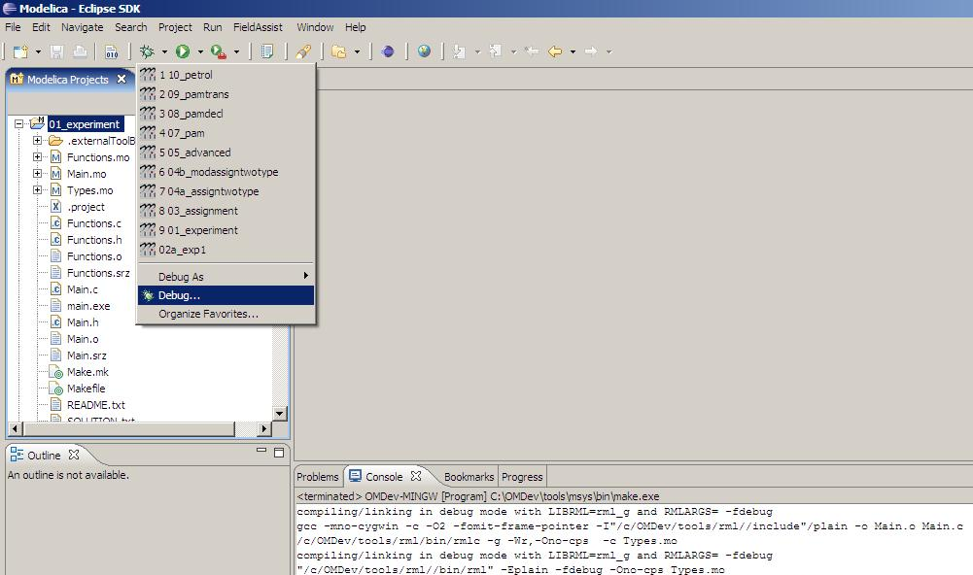
Figure 10-73. Accessing the debug configuration dialog.
To create the debug configuration, right click on the classification Modelica Development Tooling (MDT) GDB and select New as in figure below. Then give a name to the configuration, select the debugging executable to be executed and give it command line parameters. There are several tabs in which the user can select additional debug configuration settings like the environment in which the executable should be run.
Note that we require Gnu Debugger (GDB) for debugging session. We must specify the GDB location, also we must pass our script file as an argument to OMC.
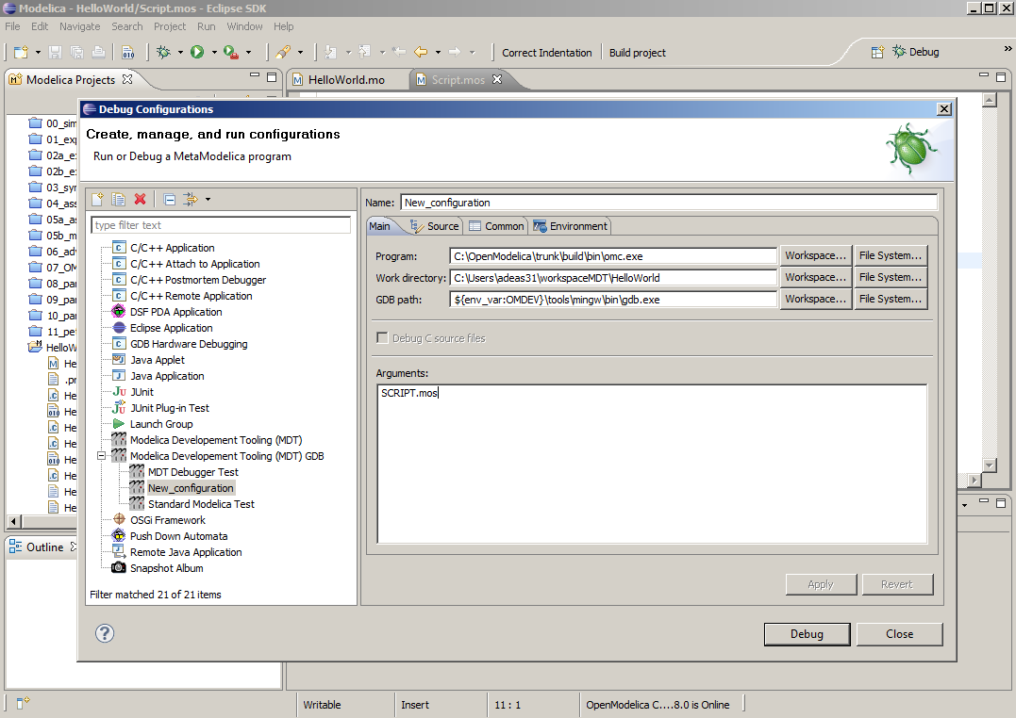
Figure 10-74. Creating the Debug Configuration.

Setting/Deleting Breakpoints
The Eclipse interface allows to add/remove breakpoints. At the moment only line number based breakpoints are supported. Other alternative to set the breakpoints is; function breakpoints.
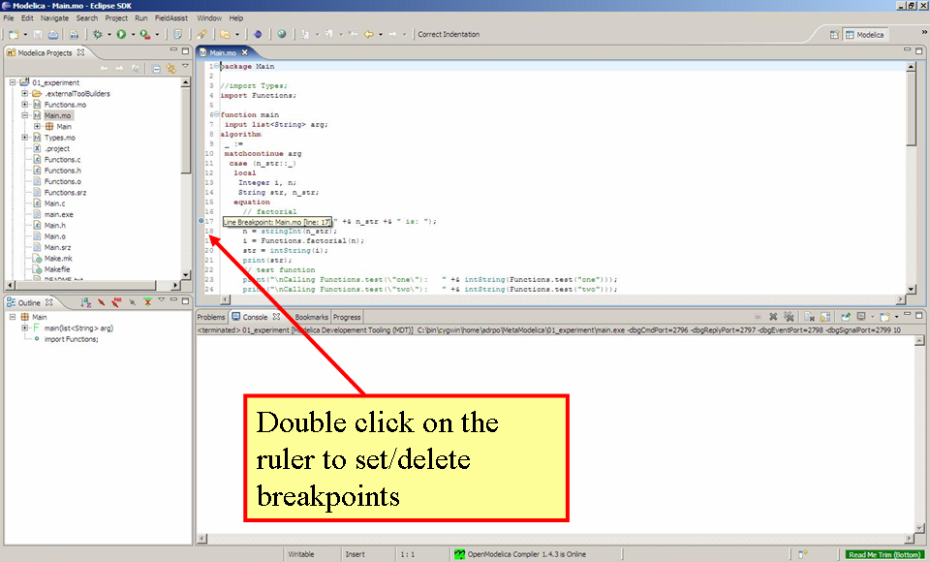
Figure 10-75. Setting/deleting breakpoints.

Starting the debugging session and enabling the debug perspective
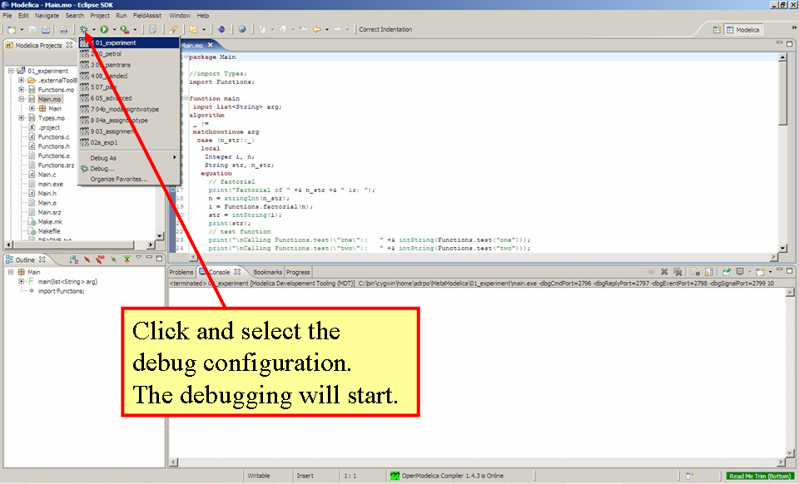
Figure 10-76. Starting the debugging session.

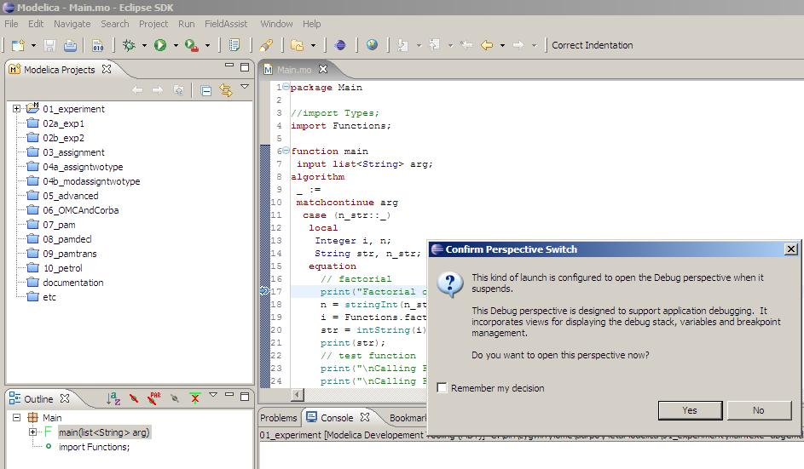
Figure 10-77. Eclipse will ask if the user wants to switch to the debugging perspective.

Debugging OpenModelica
- Compile and create OpenModelica executable as usual.
- Go to /trunk/testsuite/bootstrapping and run command ../../build/bin/omc.exe MainTest.mos
- Now run make –f LinkMain.makefile.mingw (choose the right make file depending on your platform), this will create main.exe in the same directory.
- Now in the debug configuration as explained in Section 10.2.2 choose main.exe as the program.

The Debugging Perspective
The debug view primarily consists of two main views:
- Stack Frames View
- Variables View
The stack frame view, shown in the figure below, shows a list of frames that indicates how the flow had moved from one function to another or from one file to another. This allows backtracing of the code. It is very much possible to select the previous frame in the stack and inspect the values of the variables in that frame. However, it is not possible to select any of the previous frame and start debugging from there. Each frame is shown as <function_name at file_name:line_number>.
The Variables view shows the list of variables at a certain point in the program, containing four colums:
- Name – the variable name.
- Declared Type – the Modelica type of the variable.
- Value – the variable value.
- Actual Type – the mapped C type.
By preserving the stack frames and variables it is possible to keep track of the variables values. If the value of any variable is changed while stepping then that variable will be highlighted yellow (the standard Eclipse way of showing the change).
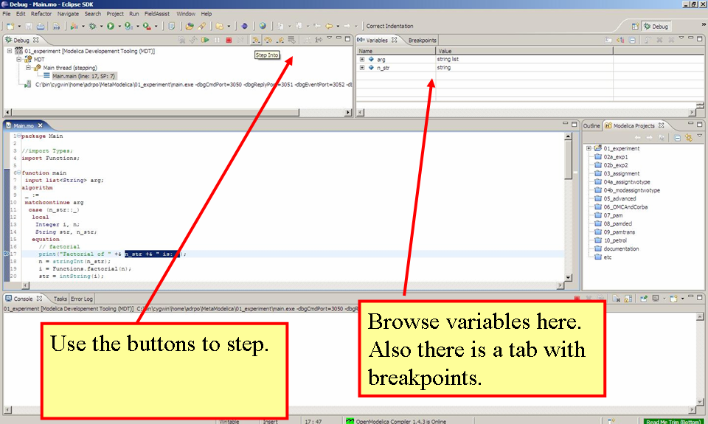
Figure 10-78. The debugging perspective.
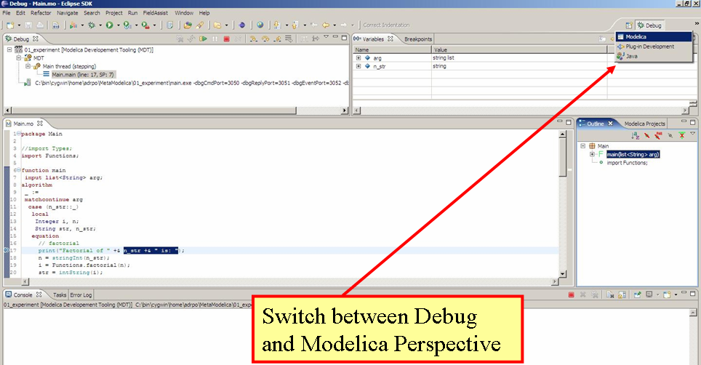
Figure 10-79. Switching between perspectives.

Interoperability – C, Java, and Python
Below is information and examples about the OpenModelica external C and Java interfaces, as well as examples of Python interoperability.

Calling External C functions
The following is a small example (ExternalLibraries.mo) to show the use of external C functions:

model ExternalLibraries
Real x(start=1.0),y(start=2.0);
equation
der(x)=-ExternalFunc1(x);
der(y)=-ExternalFunc2(y);
end ExternalLibraries;
function ExternalFunc1
input Real x;
output Real y;
external
y=ExternalFunc1_ext(x) annotation(Library="libExternalFunc1_ext.o",
Include="#include \"ExternalFunc1_ext.h\"");
end ExternalFunc1;

function ExternalFunc2
input Real x;
output Real y;
external "C" annotation(Library="libExternalFunc2.a",
Include="#include \"ExternalFunc2.h\"");
end ExternalFunc2;
These C (.c) files and header files (.h) are needed:
/* file: ExternalFunc1.c */
double ExternalFunc1_ext(double x)
{
double res;
res = x+2.0*x*x;
return res;
}

/* Header file ExternalFunc1_ext.h for ExternalFunc1 function */
double ExternalFunc1_ext(double);

/* file: ExternalFunc2.c */
double ExternalFunc2(double x)
{
double res;
res = (x-1.0)*(x+2.0);
return res;
}

/* Header file ExternalFunc2.h for ExternalFunc2 */
double ExternalFunc2(double);
The following script file ExternalLibraries.mos will perform everything that is needed, provided you have gcc installed in your path:
loadFile("ExternalLibraries.mo");
system("gcc -c -o libExternalFunc1_ext.o ExternalFunc1.c");
system("gcc -c -o libExternalFunc2.a ExternalFunc2.c");
simulate(ExternalLibraries);
We run the script:
>> runScript("ExternalLibraries.mos");
and plot the results:
>> plot({x,y});
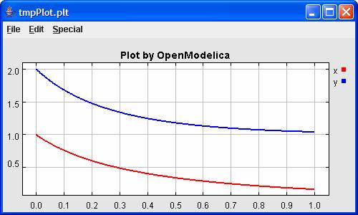

Calling External Java Functions
There exists a bidirectional OpenModelica-Java CORBA interface, which is capable of passing both standard Modelica data types, as well as abstract syntax trees and list structures to and from Java and process them in either Java or the OpenModelica Compiler.
The following is a small example (ExternalJavaLib.mo) to show the use of external Java function calls in Modelica, i.e., only the case calling Java from Modelica:

model ExternalJavaLib
Real x(start=1.0);
equation
der(x)=- ExternalJavaLog(x);
end ExternalJavaLib;

function ExternalJavaLog
input Real x;
output Real y;
external "Java" y=’java.lang.Math.log’(x) annotation(JavaMapping = "simple");
end ExternalJavaLog;

The datatypes are mapped according to the tables below. There is one mapping for interacting with existing Java code (simple), and a default mapping that handles all OpenModelica datatypes. The definitions of the default datatypes exist in the Java package org.openmodelica (see $OPENMODELICAHOME/share/java/modelica_java.jar).
For more complete examples on how to use the Java interface, download the OpenModelica source code and view the examples in testsuite/java.

Modelica | Default Mapping | JavaMapping = "simple"
Real | ModelicaReal | double
Integer | ModelicaInteger | int
Boolean | ModelicaBoolean | bool
String | ModelicaString | String
Record | ModelicaRecord
T[:] | ModelicaArray<T>

MetaModelica | Default Mapping
list<T> | ModelicaArray<T>
tuple<T1, ... , Tn> | ModelicaTuple
Option<T> | ModelicaOption<T>
Uniontype | IModelicaRecord

Python Interoperability
The interaction with Python can be perfomed in four different ways whereas one is illustrated below. Assume that we have the following Modelica code (CalledbyPython.mo):
model CalledbyPython
Real x(start=1.0),y(start=2.0);
parameter Real b = 2.0;
equation
der(x) = -b*y;
der(y) = x;
end CalledbyPython;
In the following Python (.py) files the above Modelica model is simulated via the OpenModelica scripting interface.
# file: PythonCaller.py
#!/usr/bin/python
import sys,os
global newb = 0.5
os.chdir(r'C:\Users\Documents\python')
execfile('CreateMosFile.py')
os.popen(r"C:\OpenModelica1.4.5\bin\omc.exe CalledbyPython.mos").read()
execfile('RetrResult.py')

# file: CreateMosFile.py
#!/usr/bin/python
mos_file = open('CalledbyPython.mos',’w’,1)
mos_file.write("loadFile(\"CalledbyPython.mo\");\n")
mos_file.write("setComponentModifierValue(CalledbyPython,b,Code(="+str(newb)+")
);\n")
mos_file.write("simulate(CalledbyPython,stopTime=10);\n")
mos_file.close()

# file: RetrResult.py
#!/usr/bin/python
def zeros(n): #
vec = [0.0]
for i in range(int(n)-1): vec = vec + [0.0]
return vec
res_file = open("CalledbyPython_res.plt",'r',1)
line = res_file.readline()
size = int(res_file.readline().split('=')[1])
time = zeros(size)
y = zeros(size)
while line != ['DataSet: time\n']: line = res_file.readline().split(',')[0:1]
for j in range(int(size)): time[j]=float(res_file.readline().split(',')[0])
while line != ['DataSet: y\n']: line=res_file.readline().split(',')[0:1]
for j in range(int(size)): y[j]=float(res_file.readline().split(',')[1])
res_file.close()
A second option of simulating the above Modelica model is to use the command buildModel instead of the simulate command and setting the parameter value in the initial parameter file, CalledbyPython_init.txt instead of using the command setComponentModifierValue. Then the file CalledbyPython.exe is just executed.
The third option is to use the Corba interface for invoking the compiler and then just use the scripting interface to send commands to the compiler via this interface.
The fourth variant is to use external function calls to directly communicate with the executing simulation process.

OMPython – OpenModelica Python Interface

About OMPython
OMPython – OpenModelica Python API is a free, open source, highly portable Python based interactive session handler for Modelica scripting. It provides the modeler with components for creating a complete Modelica modeling, compilation and simulation environment based on the latest OpenModelica library standard available. OMPython is architectured to combine both the solving strategy and model building. So domain experts (people writing the models) and computational engineers (people writing the solver code) can work on one unified tool that is industrially viable for optimization of Modelica models, while offering a flexible platform for algorithm development and research. OMPython v1.0 is not a standalone package, it depends upon the OpenModelica installation.
OMPython v1.0 is implemented in Python using the OmniORB and OmniORBpy – high performance CORBA ORBs for Python and it supports the Modelica Standard Library version 3.2 that is included in the latest OpenModelica (version 1.8.1) installation.

Features of OMPython
OMPython provides user friendly features like,
- Interactive session handling, parsing, interpretation of commands and Modelica expressions for evaluation, simulation, plotting, etc.
- Interface to the latest OpenModelica API calls.
- Optimized parser results that give control over every element of the output.
- Helper functions to allow manipulation on Nested dictionaries.
- Easy access to the library and testing of OpenModelica commands.

Using OMPython
The third party library of OMPython can be created by changing directory to,
OpenModelicaInstallationDirectory/share/omc/scripts/PythonInterface/
And running the command,
python setup.py install
This will install the OMPython library into your Python’s third party libraries directory. Now OMPython can be imported and used within Python.

Test Commands
To test the command outputs, simply import the OMPython library from Python and execute the run() method of OMPython. The module allows you to interactively send commands to the OMC server and display their output.
For example:
C:\>python
>>> import OMPython
>>> OMPython.run()
Full example:
C:\>python
>>> import OMPython
>>> OMPython.run()
>>loadModel(Modelica)
True

Import As Library
To use the module from within another python program, simply import OMPython from within the using program. Make use of the execute() function of the OMPython library to send commands to the OMC server.
For example:
answer = OMPython.execute(cmd)
Full example:
# test.py
import OMPython
cmds =
["loadModel(Modelica)",
"model test end test;",
"loadFile(\"C:/OpenModelica1.8.1/testmodels/BouncingBall.mo\")",
"getIconAnnotation(Modelica.Electrical.Analog.Basic.Resistor)",
"getElementsInfo(Modelica.Electrical.Analog.Basic.Resistor)",
"simulate(BouncingBall)",
"plot(h)"]
for cmd in cmds:
answer = OMPython.execute(cmd)
print "\nResult:\n%s"%answer

Retrieve results from nested dictionaries
Once the result is available from the OMPython.execute(), the OMPython.get() method can be used to retrieve and use specific values inside the dictionaries by simply querying the result dictionary with a string of nested dictionary names (keys).
The query should define the complete nested structure of the dictionary starting from its root.
Syntax:
OMPython.get(dict, "dotted.dict.structure")
For example:
OMPython.execute("loadModel(Modelica)")
result= OMPython.execute("getIconAnnotation(Modelica.Electrical.Analog.Basic.Resistor)")
inner = OMPython.get(result,'SET2.Elements.Line1.Properties')
Full example:
#test.py
import OMPython
OMPython.execute("loadModel(Modelica)")
result= OMPython.execute("getIconAnnotation(Modelica.Electrical.Analog.Basic.Resistor)")
inner = OMPython.get(result,'SET2.Elements.Line1.Properties')
print "result of get is \n%s" %inner

Set values to nested dictionaries
New dictionaries can be added to the existing nested dictionary by using the OMPyhton.set() method.
Syntax:
OMPython.set(dict,"new.dotted.dict.structure", new_value)
Note: new_value can be any of the Python supported datatypes.
For example:
OMPython.execute("loadModel(Modelica)")
result= OMPython.execute("getIconAnnotation(Modelica.Electrical.Analog.Basic.Resistor)")
value = OMPython.set(result,"SET2.Elements.Line1.Properties.NEW", 1e-05)
The OMPython.set() method does not append dictionaries to the existing nest but creates new ones inside the existing. Design your query such that you don't overwrite the dictionaries if you don’t intend to.
Full example:
#test.py
import OMPython
OMPython.execute("loadModel(Modelica)")
result = OMPython.execute("getIconAnnotation(Modelica.Electrical.Analog.Basic.Resistor)")
inner = OMPython.get(result,'SET2.Elements.Line1.Properties')
print "result of get is \n%s" %inner
value = OMPython.set(result,"SET2.Elements.Line1.Properties.NEW", [1,2,3])
print "Result:: \n%s" % OMPython.get(value,'SET2.Elements.Line1.Properties.NEW')

Example
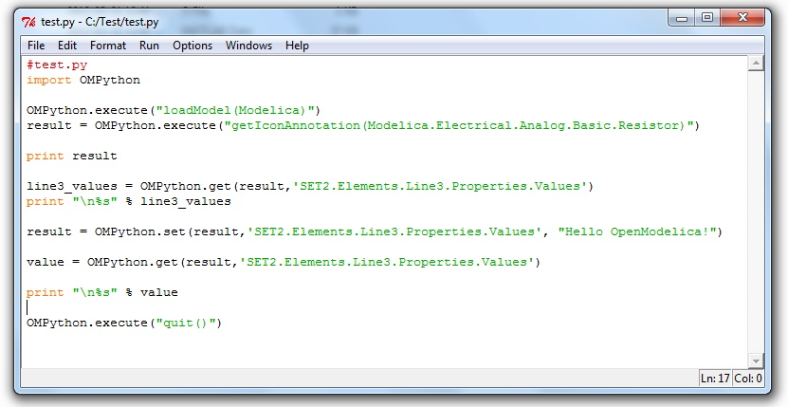
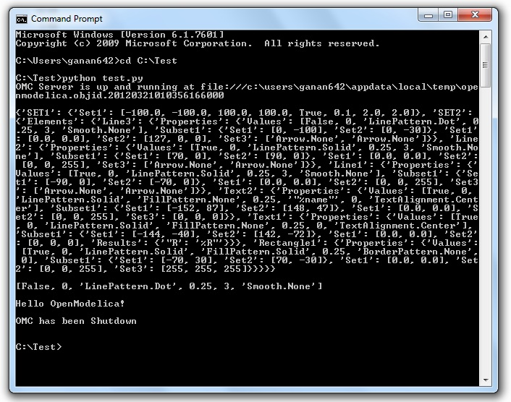

Implementation

Client
The OpenModelica Python API Interface – OMPython, attempts to mimic the OMShell's style of operations.
OMPython is designed to,
- Initialize the CORBA communication.
- Send commands to the Omc server via the CORBA interface.
- Receive the string results.
- Use the Parser module to format the results.
- Return or display the results.

Parser
Since the results of OMC are retrieved in a String format over CORBA, some housekeeping has to be done to make sure the results are usable in Python easily.
The Parser is designed to do the following,

- Analyze the result string for categorical data.
- Group each category under a category name.
- Type cast the data within these categories.
- Build a suitable data structure to hold these data so that the results can be easily accessed and used.

Understanding the Parsed output
Each command in OpenModelica produces a result that can be categorized according to the statistics of the pattern of data presented in the text. Grammar based parsers were found to be tedious to use because of the complexity of the patterns of data.
The parser just type casts the data without "curly brackets" to the appropriate data type and displays it as the result.
For example:
>> getVectorizationLimit()
<< 20
>> getNthInheritedClass(Modelica.Electrical.Analog.Basic.Resistor,1)
<< Modelica.Electrical.Analog.Interfaces.OnePort
However, multiple data types packed within a pair of quotations is always treated as a full string.
For example:
>> getModelicaPath()
<< "C:/OpenModelica1.8.0/lib/omlibrary"

The Dictionary data type in Python
Dictionaries are found to be a useful datatype to pack data with different datatypes. Dictionaries in Python are indexed by Keys unlike the sequences, which are indexed by a range of numbers.
It is best to think of dictionaries as an unordered set of key:value pairs, with the requirement that the keys are always unique. The common operation on dictionaries is to store a value associated with a key and retrieve the value using the key. This provides us the flexibility of creating keys at runtime and accessing these values using their keys later. All data within the dictionary are stored inside a named dictionary. An empty dictionary is represented by a pair of braces {}.
From the reply of the OMC, the complicated result strings are usually the ones found within the curly braces, in order to make a meaningful categorization of the data within these brackets and to avoid the potential complexities due to creating Dynamic variables, we introduce the following notations that can be used within dictionaries,
- SET
- Set
- Subset
- Element
- Results
- Values

SET
A SET (note the capital letters) is used to group data that belong to the first set of balanced curly brackets. According to the needed semantics of the results, a SET can contain Sets, Subsets, Elements, Values and Results. A SET can also be empty, denoted by {}. The SETs are named with an increasing index starting from 1(one). This feature was planned to eliminate the need for dynamic variable creation and having duplicate Keys. The SET belongs within the dictionary, result.
For example:
>> strtok("abcbdef","b")
<< {'SET1': {'Values': ['"a","c","def"']}}
The command strtok tokenizes the string "abcbdef" at every occurrence of b and produces a SET with values "a", "c", "def".

Set
A set is used to group all data within the a SET that is enclosed within a pair of balanced {}s. A Set can contain only Values and Elements. A set can also be empty, it can be depicted as {{}}, the outer brackets compose a SET, the inner brackets are the Set within the SET.

Subset
A Subset is a two-level deep set that is found within a SET. A subset can contain multiple Sets within its enclosure.
For example:
{SET1 {Subset1{Set1},{Set2},{Set3}}}

Element
Elements are the data which are grouped within a pair of Parenthesis ( ). As observed from the results string, elements have an element name that describes the data within them, so elements can be grouped by their names. Also, many elements have the same names, so they are indexed by increasing numbers starting from 1(one). Elements have the special property of having one or more Sets and Subsets within them. However, they are in turn enclosed within the SET.
For example:
>> getClassAttributes(test.mymodel)
<< {'SET1': {'Elements': {'rec1': {'Properties': {'Results': {'comment': None, 'res
triction': 'MODEL', 'startLine': 1, 'partial': False, 'name': '"mymodel"', 'enca
psulated': False, 'startColumn': 14, 'readonly': '"writable"', 'endColumn': 69,
'file': '"<interactive>"', 'endLine': 1, 'final': False}}}}}}
The result contains, a SET with a Element named rec1 which has Properties which are Results (see below) of the element.

Results
Data that is related by the assignment operator "=", within the SETs are denoted as Results. These assignments cannot be assigned to their actual values unless they are related by a Name = Value relationship. So, they form the sub-dictionary called Results within the Element (for example). Then these values can be related by the key:value pair relationship.
For example:
>> getClassAttributes(test.mymodel)
<< {'SET1': {'Elements': {'rec1': {'Properties': {'Results': {'comment': None, 'res
triction': 'MODEL', 'startLine': 1, 'partial': False, 'name': '"mymodel"', 'enca
psulated': False, 'startColumn': 14, 'readonly': '"writable"', 'endColumn': 69,
'file': '"<interactive>"', 'endLine': 1, 'final': False}}}}}}

Values
Data within any or all of SETs, Sets, Elements and Subsets that are not assignments and separated by commas are grouped together into a list called "Values". The Values list may also be empty, due to Python's representation of a null string "" as {}. Although a Null string is still a Null value, sometimes it is possible to observe data grouped into Values to look like Sets within the Values list.
For example:
>> getNthConnection(Modelica.Electrical.Analog.Examples.ChuaCircuit,2)
<< {'SET1': {'Set1': ['G.n', 'Nr.p', {}]}}

The Simulation Results
The simulate() command produces output that has no SET or Set data in it. Instead, for simplicity, it has two dictionaries namely, SimulationResults and SimulationOptions within the result dictionary.
For example:
OMPython.execute("simulate(BouncingBall)")
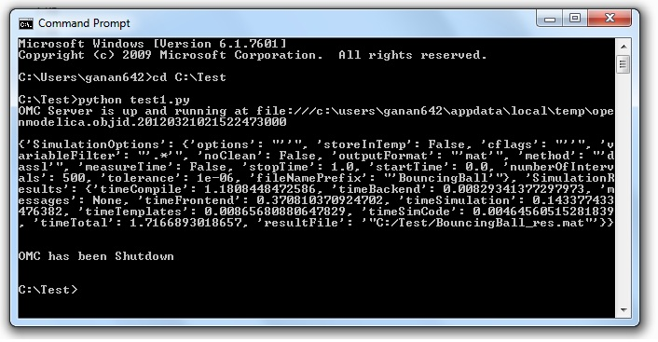

Record Construction
The OpenModelica commands that produce output with Record constructs also do not have SET or Set data within them. The results of the output are packed within the RecordResults dictionary.
For example:
OMPython.execute("checkSettings()")

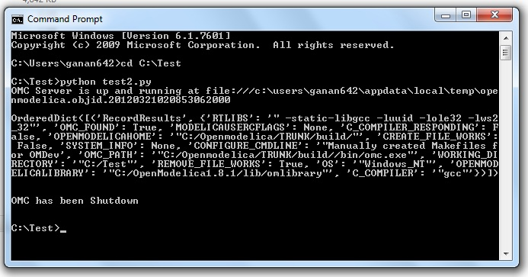
  - Examples

Import As Library
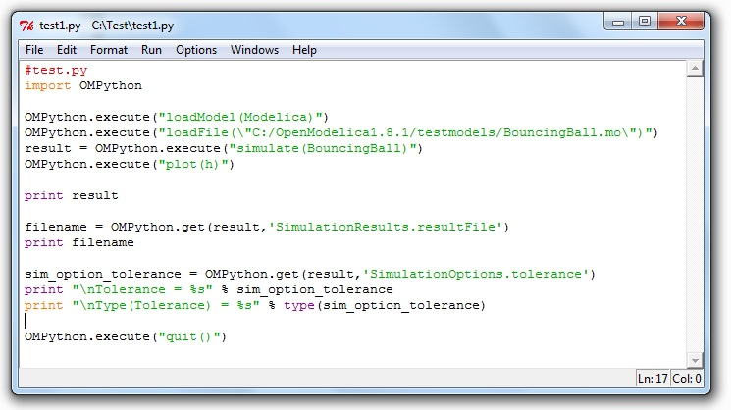
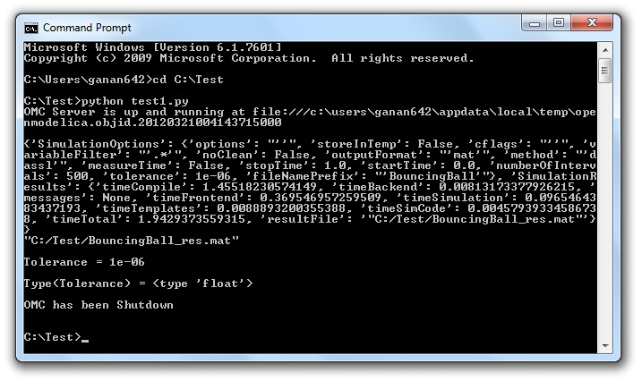
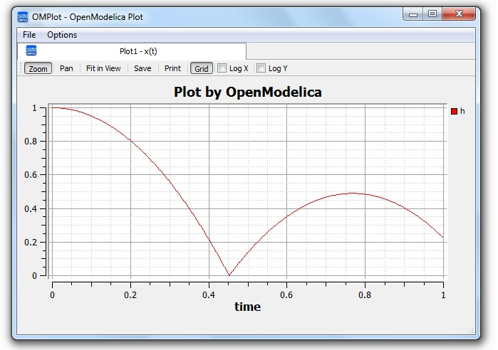

Test Commands
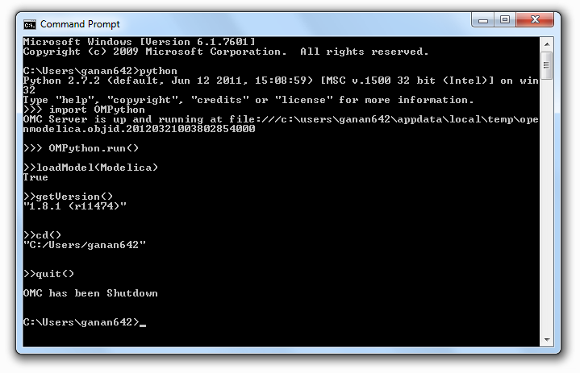
  - List of Commands
The following table contains brief descriptions about the commands that are available in the OpenModelica environment.

Command | Description
simulate | Simulates a model.  Interface:  function simulate  input TypeName className;  input Real startTime=0;  input Real stopTime=1;  input Integer numberOfIntervals=500;  input Real tolerance=1e-4;  input String method=”dassl”; {euler, rungekutta, dopri5, inline-euler, inline-rungekutta}  input String outputFormat=”mat”; {mat, plt, csv, empty}  input String fileNamePrefix=””;  input String variableFilter=””;  input String cflags=””;  input String simflags=””;  ouput SimulationResult simRes;  end simulate;  SimulationResult:  Record SimulationResult  String resultFile;  String simulationOptions;  String messages;  Real timeFrontend;  Real timeBackend;  Real timeSimCode;  Real timeTemplates;  Real timeCompile;  Real timeSimulation;  Real timeTotal;  End SimulationResult;
appendEnvironmentVar | Appends a variable to the environment variables list.  Interface:  function appendEnvironmentVar  input String var;  input String value;  output String result "returns \"error\" if the variable could not be appended";  end appendEnvironmentVar;
basename | Returns the base name (file part) of a file path. Similar to basename(3), but with the safety of Modelica strings.  Interface:  function basename  input String path;  output String basename;  end basename;
cd | change directory to the given path (which may be either relative or absolute) returns the new working directory on success or a message on failure if the given path is the empty string, the function simply returns the current working directory.  Interface:  function cd  input String newWorkingDirectory = "";  output String workingDirectory;  end cd;
checkAllModelsRecursive | Checks all models recursively and returns number of variables and equations.  Interface:  function checkAllModelsRecursive  input TypeName className;  input Boolean checkProtected = false "Checks also protected classes if true";  output String result;  end checkAllModelsRecursive;
checkModel | Checks a model and returns number of variables and equations.  Interface:  function checkModel  input TypeName className;  output String result;  end checkModel;
checkSettings | Display some diagnostics.  Interface:  function checkSettings  output CheckSettingsResult result;  end checkSettings;  CheckSettingsResult:  String OPENMODELICAHOME,OPENMODELICALIBRARY,OMC_PATH;  Boolean OMC_FOUND;  String MODELICAUSERCFLAGS,WORKING_DIRECTORY;  Boolean CREATE_FILE_WORKS,REMOVE_FILE_WORKS;  String OS, SYSTEM_INFO,SENDDATALIBS,C_COMPILER;  Boolean C_COMPILER_RESPONDING;  String CONFIGURE_CMDLINE;  end CheckSettingsResult;
clear | Clears everything: symboltable and variables.  Interface:  function clear  output Boolean success;  end clear;
clearMessages | Clears the error buffer.  Interface:  function clearMessages  output Boolean success;  end clearMessages;
clearVariables | Clear all user defined variables.  Interface:  function clearVariables  output Boolean success;  end clearVariables;
closeSimulationResultFile | Closes the current simulation result file. Only needed by Windows. Windows cannot handle reading and writing to the same file from different processes. To allow OMEdit to make successful simulation again on the same file we must close the file after reading the Simulation Result Variables. Even OMEdit only use this API for Windows.  Interface:  function closeSimulationResultFile  output Boolean success;  end closeSimulationResultFile;
codeToString | Interface:  function codeToString  input Code className;  output String string;  end codeToString;
compareSimulationResults | Compares simulation results.  Interface:  function compareSimulationResults  input String filename;  input String reffilename;  input String logfilename;  input Real refTol;  input Real absTol;  input String[:] vars;  output String result;  end compareSimulationResults;
deleteFile | Deletes a file with the given name.  Interface:  function deleteFile  input String fileName;  output Boolean success;  end deleteFile;
dirname | Returns the directory name of a file path. Similar to dirname(3), but with the safety of Modelica strings.  Interface:  function dirname  input String path;  output String dirname;  end dirname;
dumpXMLDAE | Outputs the DAE system corresponding to a specific model.  Interface:  function dumpXMLDAE  input TypeName className;  input String translationLevel = "flat";  input Boolean addOriginalIncidenceMatrix = false;  input Boolean addSolvingInfo = false;  input Boolean addMathMLCode = false;  input Boolean dumpResiduals = false;  input String fileNamePrefix = "<default>" "this is the className in string form by default";  input Boolean storeInTemp = false;  output String result[2] "Contents, Message/Filename; why is this an array and not 2 output arguments?";  end dumpXMLDAE;
echo | echo(false) disables Interactive output, echo(true) enables it again.  Interface:  function echo  input Boolean setEcho;  output Boolean newEcho;  end echo;
generateCode | The input is a function name for which C-code is generated and compiled into a dll/so.  Interface:  function generateCode  input TypeName className;  output Boolean success;  end generateCode;
generateHeader | Interface:  function generateHeader  input String fileName;  output Boolean success;  end generateHeader;
generateSeparateCode | Interface:  function generateSeparateCode  output Boolean success;  end generateSeparateCode;
getAlgorithmCount | Counts the number of Algorithm sections in a class.  Interface:  function getAlgorithmCount  input TypeName class_;  output Integer count;  end getAlgorithmCount;
getAlgorithmItemsCount | Counts the number of Algorithm items in a class.  Interface:  function getAlgorithmItemsCount  input TypeName class_;  output Integer count;  end getAlgorithmItemsCount;
getAnnotationCount | Counts the number of Annotation sections in a class.  Interface:  function getAnnotationCount  input TypeName class_;  output Integer count;  end getAnnotationCount;
getAnnotationVersion | Returns the current annotation version.  Interface:  function getAnnotationVersion  output String annotationVersion;  end getAnnotationVersion;
getAstAsCorbaString | Print the whole AST on the CORBA format for records, e.g.  record Absyn.PROGRAM  classes = ...,  within_ = ...,  globalBuildTimes = ...  end Absyn.PROGRAM;  Interface:  function getAstAsCorbaString  input String fileName = "<interactive>";  output String result "returns the string if fileName is interactive; else it returns ok or error depending on if writing the file succeeded";  end getAstAsCorbaString;
getClassComment | Returns the class comment.  Interface:  function getClassComment  input TypeName cl;  output String comment;  end getClassComment;
getClassNames | Returns the list of class names defined in the class.  Interface:  function getClassNames  input TypeName class_ = Code(AllLoadedClasses);  input Boolean recursive = false;  input Boolean qualified = false;  input Boolean sort = false;  input Boolean builtin = false "List also builtin classes if true";  input Boolean showProtected = false "List also protected classes if true";  output TypeName classNames[:];  end getClassNames;
getClassesInModelicaPath | Interface:  function getClassesInModelicaPath  output String classesInModelicaPath;  end getClassesInModelicaPath;
getCompileCommand | Interface:  function getCompileCommand  output String compileCommand;  end getCompileCommand;
getDocumentationAnnotation | Returns the documentaiton annotation defined in the class.  Interface:  function getDocumentationAnnotation  input TypeName cl;  output String out[2] "{info,revision}";  end getDocumentationAnnotation;
getEnvironmentVar | Returns the value of the environment variable.  Interface:  function getEnvironmentVar  input String var;  output String value "returns empty string on failure";  end getEnvironmentVar;
getEquationCount | Counts the number of Equation sections in a class.  Interface:  function getEquationCount  input TypeName class_;  output Integer count;  end getEquationCount;
getEquationItemsCount | Counts the number of Equation items in a class.  Interface:  function getEquationItemsCount  input TypeName class_;  output Integer count;  end getEquationItemsCount;
getErrorString | Returns the current error message. [file.mo:n:n-n:n:b] Error: message  Interface:  function getErrorString  output String errorString;  end getErrorString;
getImportCount | Counts the number of Import sections in a class.  Interface:  function getImportCount  input TypeName class_;  output Integer count;  end getImportCount;
getInitialAlgorithmCount | Counts the number of Initial Algorithm sections in a class.  Interface:  function getInitialAlgorithmCount  input TypeName class_;  output Integer count;  end getInitialAlgorithmCount;
getInitialAlgorithmItemsCount | Counts the number of Initial Algorithm items in a class.  Interface:  function getInitialAlgorithmItemsCount  input TypeName class_;  output Integer count;  end getInitialAlgorithmItemsCount;
getInitialEquationCount | Counts the number of Initial Equation sections in a class.  Interface:  function getInitialEquationCount  input TypeName class_;  output Integer count;  end getInitialEquationCount;
getInitialEquationItemsCount | Counts the number of Initial Equation items in a class.  Interface:  function getInitialEquationItemsCount  input TypeName class_;  output Integer count;  end getInitialEquationItemsCount;
getInstallationDirectoryPath | This returns OPENMODELICAHOME if it is set; on some platforms the default path is returned if it is not set.  Interface:  function getInstallationDirectoryPath  output String installationDirectoryPath;  end getInstallationDirectoryPath;
getLanguageStandard | Returns the current Modelica Language Standard in use.  Interface:  function getLanguageStandard  output String outVersion;  end getLanguageStandard;
getMessagesString | see getErrorString()  Interface:  function getMessagesString  output String messagesString;  end getMessagesString;
getMessagesStringInternal | {{[file.mo:n:n-n:n:b] Error: message, TRANSLATION, Error, code}}  Interface:  function getMessagesStringInternal  output ErrorMessage[:] messagesString;  end getMessagesStringInternal;
getModelicaPath | Get the Modelica Library Path.  Interface:  function getModelicaPath  output String modelicaPath;  end getModelicaPath;
getNoSimplify | Returns true if noSimplify flag is set.  Interface:  function getNoSimplify  output Boolean noSimplify;  end getNoSimplify;
getNthAlgorithm | Returns the Nth Algorithm section.  Interface:  function getNthAlgorithm  input TypeName class_;  input Integer index;  output String result;  end getNthAlgorithm;
getNthAlgorithmItem | Returns the Nth Algorithm Item.  Interface:  function getNthAlgorithmItem  input TypeName class_;  input Integer index;  output String result;  end getNthAlgorithmItem;
getNthAnnotationString | Returns the Nth Annotation section as string.  Interface:  function getNthAnnotationString  input TypeName class_;  input Integer index;  output String result;  end getNthAnnotationString;
getNthEquation | Returns the Nth Equation section.  Interface:  function getNthEquation  input TypeName class_;  input Integer index;  output String result;  end getNthEquation;
getNthEquationItem | Returns the Nth Equation Item.  Interface:  function getNthEquationItem  input TypeName class_;  input Integer index;  output String result;  end getNthEquationItem;
getNthImport | Returns the Nth Import as string.  Interface:  function getNthImport  input TypeName class_;  input Integer index;  output String out[3] "{\"Path\",\"Id\",\"Kind\"}";  end getNthImport;
getNthInitialAlgorithm | Returns the Nth Initial Algorithm section.  Interface:  function getNthInitialAlgorithm  input TypeName class_;  input Integer index;  output String result;  end getNthInitialAlgorithm;
getNthInitialAlgorithmItem | Returns the Nth Initial Algorithm Item.  Interface:  function getNthInitialAlgorithmItem  input TypeName class_;  input Integer index;  output String result;  end getNthInitialAlgorithmItem;
getNthInitialEquation | Returns the Nth Initial Equation section.  Interface:  function getNthInitialEquation  input TypeName class_;  input Integer index;  output String result;  end getNthInitialEquation;
getNthInitialEquationItem | Returns the Nth Initial Equation Item.  Interface:  function getNthInitialEquationItem  input TypeName class_;  input Integer index;  output String result;  end getNthInitialEquationItem;
getOrderConnections | Returns true if orderConnections flag is set.  Interface:  function getOrderConnections  output Boolean orderConnections;  end getOrderConnections;
getPackages | Returns the list of packages defined in the class.  Interface:  function getPackages  input TypeName class_ = Code(AllLoadedClasses);  output TypeName classNames[:];  end getPackages;
getPlotSilent | Returns true if plotSilent flag is set.  Interface:  function getPlotSilent  output Boolean plotSilent;  end getPlotSilent;
getSettings | Interface:  function getSettings  output String settings;  end getSettings;
getShowAnnotations | Interface:  function getShowAnnotations  output Boolean show;  end getShowAnnotations;
getSourceFile | Returns the filename of the class.  Interface:  function getSourceFile  input TypeName class_;  output String filename "empty on failure";  end getSourceFile;
getTempDirectoryPath | Returns the current user temporary directory location.  Interface:  function getTempDirectoryPath  output String tempDirectoryPath;  end getTempDirectoryPath;
getVectorizationLimit | Interface:  function getVectorizationLimit  output Integer vectorizationLimit;  end getVectorizationLimit;
getVersion | Returns the version of the Modelica compiler.  Interface:  function getVersion  input TypeName cl = Code(OpenModelica);  output String version;  end getVersion;
help | Display the OpenModelica help text.  Interface:  function help  output String helpText;  end help;
iconv | The iconv() function converts one multibyte characters from one character  set to another.  See man(3) iconv for more information.  Interface:  function iconv  input String string;  input String from;  input String to = "UTF-8";  output String result;  end iconv;
importFMU | Imports the Functional Mockup Unit.  Example command:  importFMU("A.fmu");  Interface:  function importFMU  input String filename "the fmu file name";  input String workdir = "./" "The output directory for imported FMU files. <default> will put the files to current working directory.";  output Boolean success "Returns true on success";  end importFMU;
instantiateModel | Instantiates the class and returns the flat Modelica code.  Interface:  function instantiateModel  input TypeName className;  output String result;  end instantiateModel;
isModel | Returns true if the given class has restriction model.  Interface:  function isModel  input TypeName cl;  output Boolean b;  end isModel;
isPackage | Returns true if the given class is a package.  Interface:  function isPackage  input TypeName cl;  output Boolean b;  end isPackage;
isPartial | Returns true if the given class is partial.  Interface:  function isPartial  input TypeName cl;  output Boolean b;  end isPartial;
list | Lists the contents of the given class, or all loaded classes.  Pretty-prints a class definition.  Syntax  list(Modelica.Math.sin)  list(Modelica.Math.sin,interfaceOnly=true)  Interface:  function list  input TypeName class_ = Code(AllLoadedClasses);  input Boolean interfaceOnly = false;  input Boolean shortOnly = false "only short class definitions";  output String contents;  end list;
listVariables | Lists the names of the active variables in the scripting environment.  Interface:  function listVariables  output TypeName variables[:];  end listVariables;
loadFile | load file (*.mo) and merge it with the loaded AST.  Interface:  function loadFile  input String fileName;  output Boolean success;  end loadFile;
loadFileInteractive | Interface:  function loadFileInteractive  input String filename;  output TypeName names[:];  end loadFileInteractive;
loadFileInteractiveQualified | Interface:  function loadFileInteractiveQualified  input String filename;  output TypeName names[:];  end loadFileInteractiveQualified;
loadModel | Loads a Modelica library.  Syntax  loadModel(Modelica)  loadModel(Modelica,{"3.2"})  Interface:  function loadModel  input TypeName className;  input String[:] priorityVersion = {"default"};  output Boolean success;  end loadModel;
loadString | Parses the data and merges the resulting AST with the loaded AST. If a filename is given, it is used to provide error-messages as if the string was read in binary format from a file with the same name. The file is converted to UTF-8 from the given character set.  Interface:  function loadString  input String data;  input String filename = "<interactive>";  input String encoding = "UTF-8";  output Boolean success;  end loadString;
parseFile | Interface:  function parseFile  input String filename;  output TypeName names[:];  end parseFile;
parseString | Interface:  function parseString  input String data;  input String filename = "<interactive>";  output TypeName names[:];  end parseString;
plot | Launches a plot window using OMPlot. Returns true on success. Don't require sendData support.  Example command sequences:  simulate(A);plot({x,y,z});  simulate(A);plot(x, externalWindow=true);  simulate(A,fileNamePrefix="B");  simulate(C);plot(z,"B.mat",legend=false);  Interface:  function plot  input VariableNames vars "The variables you want to plot";  input Boolean externalWindow = false "Opens the plot in a new plot window";  input String fileName = "<default>" "The filename containing the variables. <default> will read the last simulation result";  input String title = "Plot by OpenModelica" "This text will be used as the diagram title.";  input Boolean legend = true "Determines whether or not the variable legend is shown.";  input Boolean grid = true "Determines whether or not a grid is shown in the diagram.";  input Boolean logX = false "Determines whether or not the horizontal axis is logarithmically scaled.";  input Boolean logY = false "Determines whether or not the vertical axis is logarithmically scaled.";  input String xLabel = "time" "This text will be used as the horizontal label in the diagram.";  input String yLabel = "" "This text will be used as the vertical label in the diagram.";  input Real xRange[2] = {0.0,0.0} "Determines the horizontal interval that is visible in the diagram. {0,0} will select a suitable range.";  input Real yRange[2] = {0.0,0.0} "Determines the vertical interval that is visible in the diagram. {0,0} will select a suitable range.";  output Boolean success "Returns true on success";  output String[:] result "Returns list i.e {\"_omc_PlotResult\", \"<fileName>\", \"<title>\", \"<legend>\", \"<grid>\", \"<PlotType>\", \"<logX>\", \"<logY>\", \"<xLabel>\", \"<yLabel>\", \"<xRange>\", \"<yRange>\", \"<PlotVariables>\"}";  end plot;
plot2 | Uses the Java-based plot window (ptplot.jar) to launch a plot, similar to the plot() command. This command accepts fewer options, but works even when OpenModelica was not compiled with sendData support.  Example command sequences:  simulate(A);plot2({x,y});  simulate(A,fileNamePrefix="B");  simulate(C);plot2(x,"B.mat");  Interface:  function plot2  input VariableNames vars;  input String fileName = "<default>";  output Boolean success "Returns true on success";  end plot2;
plotAll | Works in the same way as plot(), but does not accept any variable names as input. Instead, all variables are part of the plot window.  Example command sequences:  simulate(A);  plotAll();  simulate(A);  plotAll(externalWindow=true);  simulate(A,fileNamePrefix="B");  simulate(C);  plotAll(x,"B.mat");  Interface:  function plotAll  input Boolean externalWindow = false "Opens the plot in a new plot window";  input String fileName = "<default>" "The filename containing the variables. <default> will read the last simulation result";  input String title = "Plot by OpenModelica" "This text will be used as the diagram title.";  input Boolean legend = true "Determines whether or not the variable legend is shown.";  input Boolean grid = true "Determines whether or not a grid is shown in the diagram.";  input Boolean logX = false "Determines whether or not the horizontal axis is logarithmically scaled.";  input Boolean logY = false "Determines whether or not the vertical axis is logarithmically scaled.";  input String xLabel = "time" "This text will be used as the horizontal label in the diagram.";  input String yLabel = "" "This text will be used as the vertical label in the diagram.";  input Real xRange[2] = {0.0,0.0} "Determines the horizontal interval that is visible in the diagram. {0,0} will select a suitable range.";  input Real yRange[2] = {0.0,0.0} "Determines the vertical interval that is visible in the diagram. {0,0} will select a suitable range.";  output Boolean success "Returns true on success";  output String[:] result "Returns list i.e {\"_omc_PlotResult\", \"<fileName>\", \"<title>\", \"<legend>\", \"<grid>\", \"<PlotType>\", \"<logX>\", \"<logY>\", \"<xLabel>\", \"<yLabel>\", \"<xRange>\", \"<yRange>\", \"<PlotVariables>\"}";  end plotAll;
plotParametric | Launches a plotParametric window using OMPlot. Returns true on success.  Example command sequences:  simulate(A);plotParametric2(x,y);  simulate(A);plotParametric2(x,y, externalWindow=true);  Interface:  function plotParametric  input VariableName xVariable;  input VariableName yVariable;  input Boolean externalWindow = false "Opens the plot in a new plot window";  input String fileName = "<default>" "The filename containing the variables. <default> will read the last simulation result";  input String title = "Plot by OpenModelica" "This text will be used as the diagram title.";  input Boolean legend = true "Determines whether or not the variable legend is shown.";  input Boolean grid = true "Determines whether or not a grid is shown in the diagram.";  input Boolean logX = false "Determines whether or not the horizontal axis is logarithmically scaled.";  input Boolean logY = false "Determines whether or not the vertical axis is logarithmically scaled.";  input String xLabel = "time" "This text will be used as the horizontal label in the diagram.";  input String yLabel = "" "This text will be used as the vertical label in the diagram.";  input Real xRange[2] = {0.0,0.0} "Determines the horizontal interval that is visible in the diagram. {0,0} will select a suitable range.";  input Real yRange[2] = {0.0,0.0} "Determines the vertical interval that is visible in the diagram. {0,0} will select a suitable range.";  output Boolean success "Returns true on success";  output String[:] result "Returns list i.e {\"_omc_PlotResult\", \"<fileName>\", \"<title>\", \"<legend>\", \"<grid>\", \"<PlotType>\", \"<logX>\", \"<logY>\", \"<xLabel>\", \"<yLabel>\", \"<xRange>\", \"<yRange>\", \"<PlotVariables>\"}";  end plotParametric;
plotParametric2 | Plots the y-variables as a function of the x-variable.  Example command sequences:  simulate(A);  plotParametric2(x,y);  simulate(A,fileNamePrefix="B");  simulate(C);  plotParametric2(x,{y1,y2,y3},"B.mat");  Interface:  function plotParametric2  input VariableName xVariable;  input VariableNames yVariables;  input String fileName = "<default>";  output Boolean success "Returns true on success";  end plotParametric2;
readFile | The contents of the given file are returned. Note that if the function fails, the error message is returned as a string instead of multiple output or similar.  Interface:  function readFile  input String fileName;  output String contents;  end readFile;
readFileNoNumeric | Returns the contents of the file, with anything resembling a (real) number stripped out, and at the end adding:  Filter count from number domain: n.  This should probably be changed to multiple outputs; the filtered string and an integer.  Does anyone use this API call?  Interface:  function readFileNoNumeric  input String fileName;  output String contents;  end readFileNoNumeric;
readFilePostprocessLineDirective | Searches lines for the #modelicaLine directive. If it is found, all lines up until the next #modelicaLine or #endModelicaLine are put on a single file, following a #line linenumber "filename" line. This causes GCC to output an executable that we can set breakpoints in and debug.  Note: You could use a stack to keep track of start/end of #modelicaLine and match them up. But this is not really desirable since that will cause extra breakpoints for the same line (you would get breakpoints before and after each case if you break on a match-expression, etc).  Interface:  function readFilePostprocessLineDirective  input String fileName;  output String out;  end readFilePostprocessLineDirective;
readFileShowLineNumbers | Prefixes each line in the file with <n>:, where n is the line number.  Note: Scales O(n^2)  Interface:  function readFileShowLineNumbers  input String fileName;  output String out;  end readFileShowLineNumbers;
readSimulationResult | Reads a result file, returning a matrix corresponding to the variables and size given.  Interface:  function readSimulationResult  input String filename;  input VariableNames variables;  input Integer size = 0 "0=read any size... If the size is not the same as the result-file, this function fails";  output Real result[:,:];  end readSimulationResult;
readSimulationResultSize | The number of intervals that are present in the output file.  Interface:  function readSimulationResultSize  input String fileName;  output Integer sz;  end readSimulationResultSize;
readSimulationResultVars | Returns the variables in the simulation file; you can use val() and plot() commands using these names.  Interface:  function readSimulationResultVars  input String fileName;  output String[:] vars;  end readSimulationResultVars;
Regex | Sets the error buffer and returns -1 if the regex does not compile.  The returned result is the same as POSIX regex():  The first value is the complete matched string  The rest are the substrings that you wanted.  For example:  regex(lorem," \([A-Za-z]*\) \([A-Za-z]*\) ",maxMatches=3)  => {" ipsum dolor ","ipsum","dolor"}  This means if you have n groups, you want maxMatches=n+1  Interface:  function regex  input String str;  input String re;  input Integer maxMatches = 1 "The maximum number of matches that will be returned";  input Boolean extended = true "Use POSIX extended or regular syntax";  input Boolean caseInsensitive = false;  output Integer numMatches "-1 is an error, 0 means no match, else returns a number 1..maxMatches";  output String matchedSubstrings[maxMatches] "unmatched strings are returned as empty";  end regex;
regexBool | Returns true if the string matches the regular expression.  Interface:  function regexBool  input String str;  input String re;  input Boolean extended = true "Use POSIX extended or regular syntax";  input Boolean caseInsensitive = false;  output Boolean matches;  end regexBool;
regularFileExists | The contents of the given file are returned.  Note that if the function fails, the error message is returned as a string instead of multiple output or similar.  Interface:  function regularFileExists  input String fileName;  output Boolean exists;  end regularFileExists;
reopenStandardStream | Interface:  function reopenStandardStream  input StandardStream _stream;  input String filename;  output Boolean success;  end reopenStandardStream;
runScript | Runs the mos-script specified by the filename.  Interface:  function runScript  input String fileName "*.mos";  output String result;  end runScript;
Save | Interface:  function save  input TypeName className;  output Boolean success;  end save;
saveAll | Save the entire loaded AST to file.  Interface:  function saveAll  input String fileName;  output Boolean success;  end saveAll;
saveModel | Save class definition in a file.  Interface:  function saveModel  input String fileName;  input TypeName className;  output Boolean success;  end saveModel;
saveTotalModel | Save total class definition into file of a class.  Inputs: String fileName; TypeName className  Outputs: Boolean res;  Interface:  function saveTotalModel  input String fileName;  input TypeName className;  output Boolean success;  end saveTotalModel;
saveTotalSCode | Interface:  function saveTotalSCode  input String fileName;  input TypeName className;  output Boolean success;  end saveTotalSCode;
setAnnotationVersion | Sets the annotation version.  Interface:  function setAnnotationVersion  input String annotationVersion;  output Boolean success;  end setAnnotationVersion;
setCXXCompiler | Interface:  function setCXXCompiler  input String compiler;  output Boolean success;  end setCXXCompiler;
setClassComment | Sets the class comment.  Interface:  function setClassComment  input TypeName class_;  input String filename;  output Boolean success;  end setClassComment;
setCommandLineOptions | The input is a regular command-line flag given to OMC, e.g. +d=failtrace or +g=MetaModelica.  Interface:  function setCommandLineOptions  input String option;  output Boolean success;  end setCommandLineOptions;
setCompileCommand | Interface:  function setCompileCommand  input String compileCommand;  output Boolean success;  end setCompileCommand;
setCompiler | Interface:  function setCompiler  input String compiler;  output Boolean success;  end setCompiler;
setCompilerFlags | Interface:  function setCompilerFlags  input String compilerFlags;  output Boolean success;  end setCompilerFlags;
setCompilerPath | Interface:  function setCompilerPath  input String compilerPath;  output Boolean success;  end setCompilerPath;
setDebugFlags | example input: failtrace,-noevalfunc  Interface:  function setDebugFlags  input String debugFlags;  output Boolean success;  end setDebugFlags;
setEnvironmentVar | Interface:  function setEnvironmentVar  input String var;  input String value;  output Boolean success;  end setEnvironmentVar;
setIndexReductionMethod | example input: dummyDerivative  Interface:  function setIndexReductionMethod  input String method;  output Boolean success;  end setIndexReductionMethod;
setInstallationDirectoryPath | Sets the OPENMODELICAHOME environment variable. Use this method instead of setEnvironmentVar.  Interface:  function setInstallationDirectoryPath  input String installationDirectoryPath;  output Boolean success;  end setInstallationDirectoryPath;
setLanguageStandard | Sets the Modelica Language Standard.  Interface:  function setLanguageStandard  input String inVersion;  output Boolean success;  end setLanguageStandard;
setLinker | Interface:  function setLinker  input String linker;  output Boolean success;  end setLinker;
setLinkerFlags | Interface:  function setLinkerFlags  input String linkerFlags;  output Boolean success;  end setLinkerFlags;
setModelicaPath | See loadModel() for a description of what the MODELICAPATH is used for.  Interface:  function setModelicaPath  input String modelicaPath;  output Boolean success;  end setModelicaPath;
setNoSimplify | Sets the noSimplify flag.  Interface:  function setNoSimplify  input Boolean noSimplify;  output Boolean success;  end setNoSimplify;
setOrderConnections | Sets the orderConnection flag.  Interface:  function setOrderConnections  input Boolean orderConnections;  output Boolean success;  end setOrderConnections;
setPastOptModules | example input: lateInline,inlineArrayEqn,removeSimpleEquations  Interface:  function setPastOptModules  input String modules;  output Boolean success;  end setPastOptModules;
setPlotCommand | Interface:  function setPlotCommand  input String plotCommand;  output Boolean success;  end setPlotCommand;
setPlotSilent | Sets the plotSilent flag.  Interface:  function setPlotSilent  input Boolean silent;  output Boolean success;  end setPlotSilent;
setPreOptModules | example input: removeFinalParameters,removeSimpleEquations,expandDerOperator  Interface:  function setPreOptModules  input String modules;  output Boolean success;  end setPreOptModules;
setShowAnnotations | Interface:  function setShowAnnotations  input Boolean show;  output Boolean success;  end setShowAnnotations;
setSourceFile | Interface:  function setSourceFile  input TypeName class_;  input String filename;  output Boolean success;  end setSourceFile;
setTempDirectoryPath | Interface:  function setTempDirectoryPath  input String tempDirectoryPath;  output Boolean success;  end setTempDirectoryPath;
setVectorizationLimit | Interface:  function setVectorizationLimit  input Integer vectorizationLimit;  output Boolean success;  end setVectorizationLimit;
solveLinearSystem | Solve A*X = B, using dgesv or lp_solve (if any variable in X is integer). Returns for solver dgesv: info>0: Singular for element i. info<0: Bad input.  Interface:  function solveLinearSystem  input Real[size(B, 1),size(B, 1)] A;  input Real[:] B;  input LinearSystemSolver solver = LinearSystemSolver.dgesv;  input Integer[:] isInt = {-1} "list of indices that are integers";  output Real[size(B, 1)] X;  output Integer info;  end solveLinearSystem;
strictRMLCheck | Checks if any loaded function.  Interface:  function strictRMLCheck  output String message "empty if there was no problem";  end strictRMLCheck;
stringReplace | Interface:  function stringReplace  input String str;  input String source;  input String target;  output String res;  end stringReplace;
Strtok | Splits the strings at the places given by the token, for example:  strtok("abcbdef","b") => {"a","c","def"}  Interface:  function strtok  input String string;  input String token;  output String[:] strings;  end strtok;
System | Similar to system(3). Executes the given command in the system shell.  Interface:  function system  input String callStr "String to call: bash -c $callStr";  output Integer retval "Return value of the system call; usually 0 on success";  end system;
translateGraphics | Interface:  function translateGraphics  input TypeName className;  output String result;  end translateGraphics;
typeNameString | Interface:  function typeNameString  input TypeName cl;  output String out;  end typeNameString;
typeNameStrings | Interface:  function typeNameStrings  input TypeName cl;  output String out[:];  end typeNameStrings;
typeOf | Interface:  function typeOf  input VariableName variableName;  output String result;  end typeOf;
uriToFilename | Handles modelica:// and file:// URI's. The result is an absolute path on the local system. The result depends on the current MODELICAPATH. Returns the empty string on failure.  Interface:  function uriToFilename  input String uri;  output String filename;  end uriToFilename;
val | Works on the filename pointed to by the scripting variable currentSimulationResult. The result is the value of the variable at a certain time point. For parameters, any time may be given. For variables the startTime<=time<=stopTime needs to hold. On error, nan (Not a Number) is returned and the error buffer contains the message.  Interface:  function val  input VariableName var;  input Real time;  output Real valAtTime;  end val;
verifyCompiler | Interface:  function verifyCompiler  output Boolean compilerWorks;  end verifyCompiler;
visualize | Uses the 3D visualization package, SimpleVisual.mo, to visualize the model. See chapter 3.4 (3D Animation) of the OpenModelica System Documentation for more details. Writes the visulizations objects into the file "model_name.visualize".  Example command sequence:  simulate(A,outputFormat="mat");  visualize(A);  visualize(A,"B.mat");  visualize(A,"B.mat", true);  Interface:  function visualize  input TypeName className;  input Boolean externalWindow = false "Opens the visualize in a new window";  input String fileName = "<default>" "The filename containing the variables. <default> will read the last simulation result";  output Boolean success "Returns true on success";  end visualize;
writeFile | Write the data to file. Returns true on success.  Interface:  function writeFile  input String fileName;  input String data;  input Boolean append = false;  output Boolean success;  end writeFile;

Frequently Asked Questions (FAQ)
Below are some frequently asked questions in three areas, with associated answers.

OpenModelica General
- Q: Why are not the Media and Fluid libraries included in the OpenModelica distribution.
- A: These libraries need special features in the Modelica language which are not yet implemented in OpenModelica. We are working on it, but it will take some time.
- Q: OpenModelica does not read the MODELICAPATH environment variable, even though this is part of the Modelica Language Specification.
- A: Use the OPENMODELICALIBRARY environment variable instead. We have temporarily switched to this variable, in order not to interfere with other Modelica tools which might be installed on the same system. In the future, we might switch to a solution with a settings file, that also allows the user to turn on the MODELICAPATH functionality if desired.
- Q: How do I enter multi-line models into OMShell since it evaluates when typing the Enter/Return key?
- A: There are basically three methods: 1) load the model from a file using the pull-down menu or the loadModel command. 2) Enter the model/function as one (possibly long) line. 3) Type in the model in another editor, where using multiple lines is no problem, and copy/paste the model into OMShell as one operation, then push Enter. Another option is to use OMNotebook instead to enter and evaluate models.

OMNotebook
- Q: OMNotebook hangs, what to do?
- A: It is probably waiting for the omc.exe (compiler) process. (Under windows): Kill the processes omc.exe, g++.exe (C-compiler), as.exe (assembler), if present. If OMNotebook then asks whether to restart OMC, answer yes. If not, kill the process OMNotebook.exe and restart manually.
- Q: I always get simulation failed, and plotting does not work..
- A: This is cause by problems compiling and linking the generated simulation code with the MINGW (Gnu) C compiler under Windows. You probably have some Logitech software installed that prevents Corba communication to start the compilation. There is a known bug/incompatibility in Logitech products. For example, if lvprcsrv.exe is running, kill it and/or prevent it to start again at reboot; it does not do anything really useful, not needed for operation of web cameras or mice.

- Q: After a previous session, when starting OMNotebook again, I get a strange message.
- A: You probably quit the previous OpenModelica session in the wrong way, which left the process omc.exe running. Kill that process, and try starting OMNotebook again.
- Q: I copy and paste a graphic figure from Word or some other application into OMNotebook, but the graphic does not appear. What is wrong?
- A: OMNotebook supports the graphic picture formats supported by Qt 4, including the .png, .bmp (bitmap) formats, but not for example the gif format. Try to convert your picture into one of the supported formats, (e.g. in Word, first do paste as bitmap format), and then copy the converted version into a text cell in OMNotebook.
- Q: Plotting does not work in OMNotebook.
- A: You probably have an old version of Java installed. Update your installation, and try again. (Another known problem, soon to be fixed, is that plotting of parameters and constants does not yet work).
- Q: I select a cell, copy it (e.g. Ctrl-C), and try to paste it at another place in the notebook. However, this does not work. Instead some other text that I earlier put on the clipboard is pasted into the nearest text cell.
- A: The problem is wrong choice of cursor mode, which can be text insertion or cell insertion. If you click inside a cell, the cursor become vertical, and OMNotebook expects you to paste text inside the cell. To paste a cell, you must be in cell insertion mode, i.e., click between two cells (or after a cell), you will get a vertical line. Place the cursor carefully on that vertical line until you see a small horizontal cursor. Then you should past the cell.
- Q: I am trying to click in cells to place the vertical character cursor, but it does not seem to react.
- A: This seems to be a Qt feature. You have probably made a selection (e.g. for copying) in the output section of an evaluation cell. This seems to block cursor position. Click again in the output section to disable the selection. After that it will work normally.
- Q: I have copied a text cell and start writing at the beginning of the cell. Strangely enough, the font becomes much smaller than it should be.
- A: This seems to be a Qt feature. Keep some of the old text and start writing the new stuff inside the text, i.e., at least one character position to the right. Afterwards, delete the old text at the beginning of the cell.

OMDev - OpenModelica Development Environment
- Q: I get problems compiling and linking some files when using OMDev with the MINGW (Gnu) C compiler under Windows.
- A: You probably have some Logitech software installed. There is a known bug/incompatibility in Logitech products. For example, if lvprcsrv.exe is running, kill it and/or prevent it to start again at reboot; it does not do anything really useful, not needed for operation of web cameras or mice.

- Major OpenModelica Releases
This Appendix lists the most important OpenModelica releases and a brief description of their contents. Right now the versions from 1.3.1 to 1.8.1 are described.

  - OpenModelica 1.8.1, March 2012
The OpenModelica 1.8.1 release has a faster and more stable OMC model compiler. It flattens and simulates more models than the previous 1.8.0 version. Significant flattening speedup of the compiler has been achieved for certain large models. It also contains a New ModelicaML version with support for value bindings in requirements-driven modeling and importing Modelica library models into ModelicaML models. A beta version of the new OpenModelica Python scripting is also included.
    - OpenModelica Compiler (OMC)
This release includes bug fixes and improvements of the flattening frontend part of the OpenModelica Compiler (OMC) and several improvements of the backend, including, but not restricted to:
- A faster and more stable OMC model compiler. The 1.8.1 version flattens and simulates more models than the previous 1.8.0 version.
- Support for operator overloading (except Complex numbers).
- New ModelicaML version with support for value bindings in requirements-driven modeling and importing Modelica library models into ModelicaML models.
- Faster plotting in OMNotebook. The feature sendData has been removed from OpenModelica. As a result, the kernel no longer depends on Qt. The plot3() family of functions have now replaced to plot(), which in turn have been removed. The non-standard visualize() command has been removed in favour of more recent alternatives.
- Store OpenModelica documentation as Modelica Documentation annotations.
- Re-implementation of the simulation runtime using C instead of C++ (this was needed to export FMI source-based packages).
- FMI import/export bug fixes.
- Changed the internal representation of various structures to share more memory. This significantly improved the performance for very large models that use records.
- Faster model flattening, Improved simulation, some graphical API bug fixes.
- More robust and general initialization, but currently time-consuming.
- New initialization flags to omc and options to simulate(), to control whether fast or robust initialization is selected, or initialization from an external (.mat) data file.
- New options to API calls list, loadFile, and more.
- Enforce the restriction that input arguments of functions may not be assigned to.
- Improved the scripting environment. cl := $TypeName(Modelica);getClassComment(cl); now works as expected. As does looping over lists of typenames and using reduction expressions.
- Beta version of Python scripting.
- Various bugfixes.
- NOTE: interactive simulation is not operational in this release. It will be put back again in the near future, first available as a nightly build. It is also available in the previous 1.8.0 release.
    - OpenModelica Notebook (OMNotebook)
Faster and more stable plottning.
    - OpenModelica Shell (OMShell)
No changes.
    - OpenModelica Eclipse Plug-in (MDT)
Small fixes and improvements.
    - OpenModelica Development Environment (OMDev)
No changes.
    - Graphic Editor OMEdit
Bug fixes.
    - New OMOptim Optimization Subsystem
Bug fixes.
    - FMI Support
Bug fixes.

  - OpenModelica 1.8, November 2011
The OpenModelica 1.8 release contains OMC flattening improvements for the Media library – it now flattens the whole library and simulates about 20% of its example models. Moreover, about half of the Fluid library models also flatten. This release also includes two new tool functionalities – the FMI for model exchange import and export, and a new efficient Eclipse-based debugger for Modelica/MetaModelica algorithmic code.
    - OpenModelica Compiler (OMC)
This release includes bug fixes and improvements of the flattening frontend part of the OpenModelica Compiler (OMC) and several improvements of the backend, including, but not restricted to:
- A faster and more stable OMC model compiler. The 1.8.1 version flattens and simulates more models than the previous 1.7.0 version.
- Flattening of the whole Media library, and about half of the Fluid library. Simulation of approximately 20% of the Media library example models.
- Functional Mockup Interface FMI 1.0 for model exchange, export and import, for the Windows platform.
- Bug fixes in the OpenModelica graphical model connection editor OMEdit, supporting easy-to-use graphical drag-and-drop modeling and MSL 3.1.
- Bug fixes in the OMOptim optimization subsystem.
- Beta version of compiler support for a new Eclipse-based very efficient algorithmic code debugger for functions in MetaModelica/Modelica, available in the development environment when using the bootstrapped OpenModelica compiler.
- Improvements in initialization of simulations.
- Improved index reduction with dynamic state selection, which improves simulation.
- Better error messages from several parts of the compiler, including a new API call for giving better error messages.
- Automatic partitioning of equation systems and multi-core parallel simulation of independent parts based on the shared-memory OpenMP model. This version is a preliminary experimental version without load balancing.
    - OpenModelica Notebook (OMNotebook)
No changes.
    - OpenModelica Shell (OMShell)
Small performance improvements.
    - OpenModelica Eclipse Plug-in (MDT)
Small fixes and improvements. MDT now also includes a beta version of a new Eclipse-based very efficient algorithmic code debugger for functions in MetaModelica/Modelica.
    - OpenModelica Development Environment (OMDev)
Third party binaries, including Qt libraries and executable Qt clients, are now part of the OMDev package. Also, now uses GCC 4.4.0 instead of the earlier GCC 3.4.5.
    - Graphic Editor OMEdit
Bug fixes. Access to FMI Import/Export through a pull-down menu. Improved configuration of library loading. A function to go to a specific line number. A button to cancel an on-going simulation. Support for some updated OMC API calls.
    - New OMOptim Optimization Subsystem
Bug fixes, especially in the Linux version.
    - FMI Support
The Functional Mockup Interface FMI 1.0 for model exchange import and export is supported by this release. The functionality is accessible via API calls as well as via pull-down menu commands in OMEdit.

  - OpenModelica 1.7, April 2011
The OpenModelica 1.7 release contains OMC flattening improvements for the Media library, better and faster event handling and simulation, and fast MetaModelica support in the compiler, enabling it to compiler itself. This release also includes two interesting new tools – the OMOpttim optimization subsystem, and a new performance profiler for equation-based Modelica models.
    - OpenModelica Compiler (OMC)
This release includes bug fixes and performance improvements of the flattening frontend part of the OpenModelica Compiler (OMC) and several improvements of the backend, including, but not restricted to:
- Flattening of the whole Modelica Standard Library 3.1 (MSL 3.1), except Media and Fluid.
- Progress in supporting the Media library, some models now flatten.
- Much faster simulation of many models through more efficient handling of alias variables, binary output format, and faster event handling.
- Faster and more stable simulation through new improved event handling, which is now default.
- Simulation result storage in binary .mat files, and plotting from such files.
- Support for Unicode characters in quoted Modelica identifiers, including Japanese and Chinese.
- Preliminary MetaModelica 2.0 support. (use setCommandLineOptions({"+g=MetaModelica"}) ). Execution is as fast as MetaModelica 1.0, except for garbage collection.
- Preliminary bootstrapped OpenModelica compiler: OMC now compiles itself, and the bootstrapped compiler passes the test suite. A garbage collector is still missing.
- Many bug fixes.
    - OpenModelica Notebook (OMNotebook)
Improved much faster and more stable 2D plotting through the new OMPlot module. Plotting from binary .mat files. Better integration between OMEdit and OMNotebook, copy/paste between them.
    - OpenModelica Shell (OMShell)
Same as previously, except the improved 2D plotting through OMPlot.
    - OpenModelica Eclipse Plug-in (MDT)
Same as previously.
    - OpenModelica Development Environment (OMDev)
No changes.
    - Graphic Editor OMEdit
Several enhancements of OMEdit are included in this release. Support for Icon editing is now available. There is also an improved much faster 2D plotting through the new OMPlot module. Better integration between OMEdit and OMNotebook, with copy/paste between them. Interactive on-line simulation is available in an easy-to-use way.
    - New OMOptim Optimization Subsystem
A new optimization subsystem called OMOptim has been added to OpenModelica. Currently, parameter optimization using genetic algorithms is supported in this version 0.9. Pareto front optimization is also supported.
    - New Performance Profiler
A new, low overhead, performance profiler for Modelica models has been developed.
  - OpenModelica 1.6, November 2010
The OpenModelica 1.6 release primarily contains flattening, simulation, and performance improvements regarding Modelica Standard Library 3.1 support, but also has an interesting new tool – the OMEdit graphic connection editor, and a new educational material called DrControl, and an improved ModelicaML UML/Modelica profile with better support for modeling and requirement handling.
    - OpenModelica Compiler (OMC)
This release includes bug fix and performance improvemetns of the flattening frontend part of the OpenModelica Compiler (OMC) and some improvements of the backend, including, but not restricted to:
- Flattening of the whole Modelica Standard Library 3.1 (MSL 3.1), except Media and Fluid.
- Improved flattening speed of a factor of 5-20 compared to OpenModelica 1.5 for a number of models, especially in the MultiBody library.
- Reduced memory consumption by the OpenModelica compiler frontend, for certain large models a reduction of a factor 50.
- Reorganized, more modular OpenModelica compiler backend, can now handle approximately 30 000 equations, compared to previously approximately 10 000 equations.
- Better error messages from the compiler, especially regarding functions.
- Improved simulation coverage of MSL 3.1. Many models that did not simulate before are now simulating. However, there are still many models in certain sublibraries that do not simulate.
- Progress in supporting the Media library, but simulation is not yet possible.
- Improved support for enumerations, both in the frontend and the backend.
- Implementation of stream connectors.
- Support for linearization through symbolic Jacobians.
- Many bug fixes.
    - OpenModelica Notebook (OMNotebook)
A new DrControl electronic notebook for teaching control and modeling with Modelica.
    - OpenModelica Shell (OMShell)
Same as previously.
    - OpenModelica Eclipse Plug-in (MDT)
Same as previously.
    - OpenModelica Development Environment (OMDev)
Several enhancements. Support for match-expressions in addition to matchcontinue. Support for real if-then-else. Support for if-then without else-branches. Modelica Development Tooling 0.7.7 with small improvements such as more settings, improved error detection in console, etc.
    - New Graphic Editor OMEdit
A new improved open source graphic model connection editor called OMEdit, supporting 3.1 graphical annotations, which makes it possible to move models back and forth to other tools without problems. The editor has been implemented by students at Linköping University and is based on the C++ Qt library.
  - OpenModelica 1.5, July 2010
This OpenModelica 1.5 release has major improvements in the OpenModelica compiler frontend and some in the backend. A major improvement of this release is full flattening support for the MultiBody library as well as limited simulation support for MultiBody. Interesting new facilities are the interactive simulation and the integrated UML-Modelica modeling with ModelicaML. Approximately 4 person-years of additional effort have been invested in the compiler compared to the 1.4.5 version, e.g., in order to have a more complete coverage of Modelica 3.0, mainly focusing on improved flattening in the compiler frontend.
    - OpenModelica Compiler (OMC)
This release includes major improvements of the flattening frontend part of the OpenModelica Compiler (OMC) and some improvements of the backend, including, but not restricted to:
- Improved flattening speed of at least a factor of 10 or more compared to the 1.4.5 release, primarily for larger models with inner-outer, but also speedup for other models, e.g. the robot model flattens in approximately 2 seconds.
- Flattening of all MultiBody models, including all elementary models, breaking connection graphs, world object, etc. Moreover, simulation is now possible for at least five MultiBody models: Pendulum, DoublePendulum, InitSpringConstant, World, PointGravityWithPointMasses.
- Progress in supporting the Media library, but simulation is not yet possible.
- Support for enumerations, both in the frontend and the backend.
- Support for expandable connectors.
- Support for the inline and late inline annotations in functions.
- Complete support for record constructors, also for records containing other records.
- Full support for iterators, including nested ones.
- Support for inferred iterator and for-loop ranges.
- Support for the function derivative annotation.
- Prototype of interactive simulation.
- Prototype of integrated UML-Modelica modeling and simulation with ModelicaML.
- A new bidirectional external Java interface for calling external Java functions, or for calling Modelica functions from Java.
- Complete implementation of replaceable model extends.
- Fixed problems involving arrays of unknown dimensions.
- Limited support for tearing.
- Improved error handling at division by zero.
- Support for Modelica 3.1 annotations.
- Support for all MetaModelica language constructs inside OpenModelica.
- OpenModelica works also under 64-bit Linux and Mac 64-bit OSX.
- Parallel builds and running test suites in parallel on multi-core platforms.
- New OpenModelica text template language for easier implementation of code generators, XML generators, etc.
- New OpenModelica code generators to C and C# using the text template language.
- Faster simulation result data file output optionally as comma-separated values.
- Many bug fixes.
It is now possible to graphically edit models using parts from the Modelica Standard Library 3.1, since the simForge graphical editor (from Politecnico di Milano) that is used together with OpenModelica has been updated to version 0.9.0 with a important new functionality, including support for Modelica 3.1 and 3.0 annotations. The 1.6 and 2.2.1 Modelica graphical annotation versions are still supported.
    - OpenModelica Notebook (OMNotebook)
Improvements in platform availability.
- Support for 64-bit Linux.
- Support for Windows 7.
- Better support for MacOS, including 64-bit OSX.
    - OpenModelica Shell (OMShell)
Same as previously.
    - OpenModelica Eclipse Plug-in (MDT)
Minor bug fixes.
    - OpenModelica Development Environment (OMDev)
Minor bug fixes.
  - OpenModelica 1.4.5, January 2009
This release has several improvements, especially platform availability, less compiler memory usage, and supporting more aspects of Modelica 3.0.
    - OpenModelica Compiler (OMC)
This release includes small improvements and some bugfixes of the OpenModelica Compiler (OMC):
- Less memory consumption and better memory management over time. This also includes a better API supporting automatic memory management when calling C functions from within the compiler.
- Modelica 3.0 parsing support.
- Export of DAE to XML and MATLAB.
- Support for several platforms Linux, MacOS, Windows (2000, Xp, Vista).
- Support for record and strings as function arguments.
- Many bug fixes.
- (Not part of OMC): Additional free graphic editor SimForge can be used with OpenModelica.
    - OpenModelica Notebook (OMNotebook)
A number of improvements, primarily in the plotting functionality and platform availability.
- A number of improvements in the plotting functionality: scalable plots, zooming, logarithmic plots, grids, etc.
- Programmable plotting accessible through a Modelica API.
- Simple 3D visualization.
- Support for several platforms Linux, MacOS, Windows (2000, Xp, Vista).
    - OpenModelica Shell (OMShell)
Same as previously.
    - OpenModelica Eclipse Plug-in (MDT)
Minor bug fixes.
    - OpenModelica Development Environment (OMDev)
Same as previously.
  - OpenModelica 1.4.4, Feb 2008
This release is primarily a bug fix release, except for a preliminary version of new plotting functionality available both from the OMNotebook and separately through a Modelica API. This is also the first release under the open source license OSMC-PL (Open Source Modelica Consortium Public License), with support from the recently created Open Source Modelica Consortium. An integrated version handler, bug-, and issue tracker has also been added.
    - OpenModelica Compiler (OMC)
This release includes small improvements and some bugfixes of the OpenModelica Compiler (OMC):
- Better support for if-equations, also inside when.
- Better support for calling functions in parameter expressions and interactively through dynamic loading of functions.
- Less memory consumtion during compilation and interactive evaluation.
- A number of bug-fixes.
    - OpenModelica Notebook (OMNotebook)
Test release of improvements, primarily in the plotting functionality and platform availability.
- Preliminary version of improvements in the plotting functionality: scalable plots, zooming, logarithmic plots, grids, etc., currently available in a preliminary version through the plot2 function.
- Programmable plotting accessible through a Modelica API.
    - OpenModelica Shell (OMShell)
Same as previously.
    - OpenModelica Eclipse Plug-in (MDT)
This release includes minor bugfixes of MDT and the associated MetaModelica debugger:
    - OpenModelica Development Environment (OMDev)
Extended test suite with a better structure. Version handling, bug tracking, issue tracking, etc. now available under the integrated Codebeamer
  - OpenModelica 1.4.3, June 2007
This release has a number of significant improvements of the OMC compiler, OMNotebook, the MDT plugin and the OMDev. Increased platform availability now also for Linux and Macintosh, in addition to Windows. OMShell is the same as previously, but now ported to Linux and Mac.
    - OpenModelica Compiler (OMC)
This release includes a number of improvements of the OpenModelica Compiler (OMC):
- Significantly increased compilation speed, especially with large models and many packages.
- Now available also for Linux and Macintosh platforms.
- Support for when-equations in algorithm sections, including elsewhen.
- Support for inner/outer prefixes of components (but without type error checking).
- Improved solution of nonlinear systems.
- Added ability to compile generated simulation code using Visual Studio compiler.
- Added "smart setting of fixed attribute to false. If initial equations, OMC instead has fixed=true as default for states due to allowing overdetermined initial equation systems.
- Better state select heuristics.
- New function getIncidenceMatrix(ClassName) for dumping the incidence matrix.
- Builtin functions String(), product(), ndims(), implemented.
- Support for terminate() and assert() in equations.
- In emitted flat form: protected variables are now prefixed with protected when printing flat class.
- Some support for tables, using omcTableTimeIni instead of dymTableTimeIni2.
- Better support for empty arrays, and support for matrix operations like a*[1,2;3,4].
- Improved val() function can now evaluate array elements and record fields, e.g. val(x[n]), val(x.y) .
- Support for reinit in algorithm sections.
- String support in external functions.
- Double precision floating point precision now also for interpreted expressions
- Better simulation error messages.
- Support for der(expressions).
- Support for iterator expressions such as {3*i for i in 1..10}.
- More test cases in the test suite.
- A number of bug fixes, including sample and event handling bugs.
    - OpenModelica Notebook (OMNotebook)
A number of improvements, primarily in the platform availability.
- Available on the Linux and Macintosh platforms, in addition to Windows.
- Fixed cell copying bugs, plotting of derivatives now works, etc.
    - OpenModelica Shell (OMShell)
Now available also on the Macintosh platform.
    - OpenModelica Eclipse Plug-in (MDT)
This release includes major improvements of MDT and the associated MetaModelica debugger:
- Greatly improved browsing and code completion works both for standard Modelica and for MetaModelica.
- Hovering over identifiers displays type information.
- A new and greatly improved implementation of the debugger for MetaModelica algorithmic code, operational in Eclipse. Greatly improved performance – only approx 10% speed reduction even for 100 000 line programs. Greatly improved single stepping, step over, data structure browsing, etc.
- Many bug fixes.
    - OpenModelica Development Environment (OMDev)
Increased compilation speed for MetaModelica. Better if-expression support in MetaModelica.
  - OpenModelica 1.4.2, October 2006
This release has improvements and bug fixes of the OMC compiler, OMNotebook, the MDT plugin and the OMDev. OMShell is the same as previously.
    - OpenModelica Compiler (OMC)
This release includes further improvements of the OpenModelica Compiler (OMC):
- Improved initialization and index reduction.
- Support for integer arrays is now largely implemented.
- The val(variable,time) scripting function for accessing the value of a simulation result variable at a certain point in the simulated time.
- Interactive evalution of for-loops, while-loops, if-statements, if-expressions, in the interactive scripting mode.
- Improved documentation and examples of calling the Model Query and Manipulation API.
- Many bug fixes.
    - OpenModelica Notebook (OMNotebook)
Search and replace functions have been added. The DrModelica tutorial (all files) has been updated, obsolete sections removed, and models which are not supported by the current implementation marked clearly. Automatic recognition of the .onb suffix (e.g. when double-clicking) in Windows makes it even more convenient to use.
    - OpenModelica Eclipse Plug-in (MDT)
Two major improvements are added in this release:
- Browsing and code completion works both for standard Modelica and for MetaModelica.
- The debugger for algorithmic code is now available and operational in Eclipse for debugging of MetaModelica programs.
    - OpenModelica Development Environment (OMDev)
Mostly the same as previously.
  - OpenModelica 1.4.1, June 2006
This release has only improvements and bug fixes of the OMC compiler, the MDT plugin and the OMDev components. The OMShell and OMNotebook are the same.
    - OpenModelica Compiler (OMC)
This release includes further improvements of the OpenModelica Compiler (OMC):
- Support for external objects.
- OMC now reports the version number (via command line switches or CORBA API getVersion()).
- Implemented caching for faster instantiation of large models.
- Many bug fixes.
    - OpenModelica Eclipse Plug-in (MDT)
Improvements of the error reporting when building the OMC compiler. The errors are now added to the problems view. The latest MDT release is version 0.6.6 (2006-06-06).
    - OpenModelica Development Environment (OMDev)
Small fixes in the MetaModelica compiler. MetaModelica Users Guide is now part of the OMDev release. The latest OMDev was release in 2006-06-06.
  - OpenModelica 1.4.0, May 2006
This release has a number of improvements described below. The most significant change is probably that OMC has now been translated to an extended subset of Modelica (MetaModelica), and that all development of the compiler is now done in this version..
    - OpenModelica Compiler (OMC)
This release includes further improvements of the OpenModelica Compiler (OMC):
- Partial support for mixed system of equations.
- New initialization routine, based on optimization (minimizing residuals of initial equations).
- Symbolic simplification of builtin operators for vectors and matrices.
- Improved code generation in simulation code to support e.g. Modelica functions.
- Support for classes extending basic types, e.g. connectors (support for MSL 2.2 block connectors).
- Support for parametric plotting via the plotParametric command.
- Many bug fixes.
    - OpenModelica Shell (OMShell)
Essentially the same OMShell as in 1.3.1. One difference is that now all error messages are sent to the command window instead of to a separate log window.
    - OpenModelica Notebook (OMNotebook)
Many significant improvements and bug fixes. This version supports graphic plots within the cells in the notebook. Improved cell handling and Modelica code syntax highlighting. Command completion of the most common OMC commands is now supported. The notebook has been used in several courses.
    - OpenModelica Eclipse Plug-in (MDT)
This is the first really useful version of MDT. Full browsing of Modelica code, e.g. the MSL 2.2, is now supported. (MetaModelica browsing is not yet fully supported). Full support for automatic indentation of Modelica code, including the MetaModelica extensions. Many bug fixes. The Eclipse plug-in is now in use for OpenModelica development at PELAB and MathCore Engineering AB since approximately one month.
    - OpenModelica Development Environment (OMDev)
The following mechanisms have been put in place to support OpenModelica development.
- A separate web page for OMDev (OpenModelica Development Environment).
- A pre-packaged OMDev zip-file with precompiled binaries for development under Windows using the mingw Gnu compiler from the Eclipse MDT plug-in. (Development is also possible using Visual Studio).
- All source code of the OpenModelica compiler has recently been translated to an extended subset of Modelica, currently called MetaModelica. The current size of OMC is approximately 100 000 lines All development is now done in this version.
- A new tutorial and users guide for development in MetaModelica.
- Successful builds and tests of OMC under Linux and Solaris.

  - OpenModelica 1.3.1, November 2005
This release has several important highlights.
This is also the first release for which the New BSD (Berkeley) open-source license applies to the source code, including the whole compiler and run-time system. This makes is possible to use OpenModelica for both academic and commercial purposes without restrictions.
    - OpenModelica Compiler (OMC)
This release includes a significantly improved OpenModelica Compiler (OMC):
- Support for hybrid and discrete-event simulation (if-equations, if-expressions, when-equations; not yet if-statements and when-statements).
- Parsing of full Modelica 2.2
- Improved support for external functions.
- Vectorization of function arguments; each-modifiers, better implementation of replaceable, better handling of structural parameters, better support for vector and array operations, and many other improvements.
- Flattening of the Modelica Block library version 1.5 (except a few models), and simulation of most of these.
- Automatic index reduction (present also in previous release).
- Updated User's Guide including examples of hybrid simulation and external functions.
    - OpenModelica Shell (OMShell)
An improved window-based interactive command shell, now including command completion and better editing and font size support.
    - OpenModelica Notebook (OMNotebook)
A free implementation of an OpenModelica notebook (OMNOtebook), for electronic books with course material, including the DrModelica interactive course material. It is possible to simulate and plot from this notebook.
    - OpenModelica Eclipse Plug-in (MDT)
An early alpha version of the first Eclipse plug-in (called MDT for Modelica Development Tooling) for Modelica Development. This version gives compilation support and partial support for browsing Modelica package hierarchies and classes.
    - OpenModelica Development Environment (OMDev)
The following mechanisms have been put in place to support OpenModelica development.
- Bugzilla support for OpenModelica bug tracking, accessible to anybody.
- A system for automatic regression testing of the compiler and simulator, (+ other system parts) usually run at check in time.
- Version handling is done using SVN, which is better than the previously used CVS system. For example, name change of modules is now possible within the version handling system.

- Contributors to OpenModelica
This Appendix lists the individuals who have made significant contributions to OpenModelica, in the form of software development, design, documentation, project leadership, tutorial material, promotion, etc. The individuals are listed for each year, from 1998 to the current year: the project leader and main author/editor of this document followed by main contributors followed by contributors in alphabetical order.
  - OpenModelica Contributors 2012
Peter Fritzson, PELAB, Linköping University, Linköping, Sweden.
Adrian Pop, PELAB, Linköping University, Linköping, Sweden.
Adeel Asghar, PELAB, Linköping University, Linköping, Sweden.
Willi Braun, Fachhochschule Bielefeld, Bielefeld, Germany.
Jens Frenkel, TU Dresden, Dresden, Germany.
Lennart Ochel, Fachhochschule Bielefeld, Bielefeld, Germany.
Martin Sjölund, PELAB, Linköping University, Linköping, Sweden.
Per Östlund, PELAB, Linköping University, Linköping, Sweden.
Peter Aronsson, MathCore Engineering AB, Linköping, Sweden.
Adeel Asghar, PELAB, Linköping University, Linköping, Sweden.
David Akhvlediani, PELAB, Linköping University, Linköping, Sweden.
Mikael Axin, IEI, Linköping University, Linköping, Sweden.
Bernhard Bachmann, Fachhochschule Bielefeld, Bielefeld, Germany.
Vasile Baluta, PELAB, Linköping University, Linköping, Sweden.
Robert Braun, IEI, Linköping University, Linköping, Sweden.
David Broman, PELAB, Linköping University, Linköping, Sweden.
Stefan Brus, PELAB, Linköping University, Linköping, Sweden.
Francesco Casella, Politecnico di Milano, Milan, Italy.
Filippo Donida, Politecnico di Milano, Milan, Italy.
Mahder Gebremedhin, PELAB, Linköping University, Linköping, Sweden.
Pavel Grozman, Equa AB, Stockholm, Sweden.
Michael Hanke, NADA, KTH, Stockholm.
Daniel Hedberg, MathCore Engineering AB, Linköping, Sweden.
Zoheb Hossain, PELAB, Linköping University, Linköping, Sweden.
Alf Isaksson, ABB Corporate Research, Västerås, Sweden.
Kim Jansson, PELAB, Linköping University, Linköping, Sweden.
Daniel Kanth, Bosch-Rexroth, Lohr am Main, Germany.
Tommi Karhela, VTT, Espoo, Finland.
Joel Klinghed, PELAB, Linköping University, Linköping, Sweden.
Petter Krus, IEI, Linköping University, Linköping, Sweden.
Juha Kortelainen, VTT, Espoo, Finland.
Abhinn Kothari, PELAB, Linköping University, Linköping, Sweden.
Alexey Lebedev, Equa Simulation AB, Stockholm, Sweden.
Oliver Lenord, Siemens PLM, California, USA.
Ariel Liebman, Energy Users Association of Australia, Victoria, Australia.
Rickard Lindberg, PELAB, Linköping University, Linköping, Sweden
Håkan Lundvall, PELAB, Linköping University, Linköping, Sweden.
Henrik Magnusson, Linköping, Sweden.
Abhi Raj Metkar, CDAC, Trivandrum, Kerala, India.
Eric Meyers, Pratt & Whitney Rocketdyne, Palm City, Florida, USA.
Tuomas Miettinen, VTT, Espoo, Finland.
Afshin Moghadam, PELAB, Linköping University, Linköping, Sweden.
Maroun Nemer, CEP Paristech, Ecole des Mines, Paris, France.
Hannu Niemistö, VTT, Espoo, Finland.
Peter Nordin, IEI, Linköping University, Linköping, Sweden.
Kristoffer Norling, PELAB, Linköping University, Linköping, Sweden.
Karl Pettersson, IEI, Linköping University, Linköping, Sweden.
Pavol Privitzer, Institute of Pathological Physiology, Praha, Czech Republic.
Jhansi Remala, PELAB, Linköping University, Linköping, Sweden.
Reino Ruusu, VTT, Espoo, Finland.
Per Sahlin, Equa Simulation AB, Stockholm, Sweden.
Wladimir Schamai, EADS, Hamburg, Germany.
Gerhard Schmitz, University of Hamburg, Hamburg, Germany.
Klas Sjöholm, PELAB, Linköping University, Linköping, Sweden.
Anton Sodja, University of Ljubljana, Ljubljana, Slovenia
Ingo Staack, IEI, Linköping University, Linköping, Sweden.
Kristian Stavåker, PELAB, Linköping University, Linköping, Sweden.
Sonia Tariq, PELAB, Linköping University, Linköping, Sweden.
Hubert Thierot, CEP Paristech, Ecole des Mines, Paris, France.
Mohsen Torabzadeh-Tari, PELAB, Linköping University, Linköping, Sweden.
Parham Vasaiely, EADS, Hamburg, Germany.
Niklas Worschech, Bosch-Rexroth, Lohr am Main, Germany.
Robert Wotzlaw, Goettingen, Germany.
Björn Zachrisson, MathCore Engineering AB, Linköping, Sweden.
Azam Zia, PELAB, Linköping University, Linköping, Sweden.
  - OpenModelica Contributors 2011
Peter Fritzson, PELAB, Linköping University, Linköping, Sweden.
Adrian Pop, PELAB, Linköping University, Linköping, Sweden.
Willi Braun, Fachhochschule Bielefeld, Bielefeld, Germany.
Jens Frenkel, TU Dresden, Dresden, Germany.
Martin Sjölund, PELAB, Linköping University, Linköping, Sweden.
Per Östlund, PELAB, Linköping University, Linköping, Sweden.
Peter Aronsson, MathCore Engineering AB, Linköping, Sweden.
David Akhvlediani, PELAB, Linköping University, Linköping, Sweden.
Mikael Axin, IEI, Linköping University, Linköping, Sweden.
Bernhard Bachmann, Fachhochschule Bielefeld, Bielefeld, Germany.
Vasile Baluta, PELAB, Linköping University, Linköping, Sweden.
Robert Braun, IEI, Linköping University, Linköping, Sweden.
David Broman, PELAB, Linköping University, Linköping, Sweden.
Stefan Brus, PELAB, Linköping University, Linköping, Sweden.
Francesco Casella, Politecnico di Milano, Milan, Italy.
Filippo Donida, Politecnico di Milano, Milan, Italy.
Anand Ganeson, PELAB, Linköping University, Linköping, Sweden.
Mahder Gebremedhin, PELAB, Linköping University, Linköping, Sweden.
Pavel Grozman, Equa AB, Stockholm, Sweden.
Michael Hanke, NADA, KTH, Stockholm.
Daniel Hedberg, MathCore Engineering AB, Linköping, Sweden.
Zoheb Hossain, PELAB, Linköping University, Linköping, Sweden.
Alf Isaksson, ABB Corporate Research, Västerås, Sweden.
Kim Jansson, PELAB, Linköping University, Linköping, Sweden.
Daniel Kanth, Bosch-Rexroth, Lohr am Main, Germany.
Tommi Karhela, VTT, Espoo, Finland.
Joel Klinghed, PELAB, Linköping University, Linköping, Sweden.
Petter Krus, IEI, Linköping University, Linköping, Sweden.
Juha Kortelainen, VTT, Espoo, Finland.
Abhinn Kothari, PELAB, Linköping University, Linköping, Sweden.
Alexey Lebedev, Equa Simulation AB, Stockholm, Sweden.
Oliver Lenord, Siemens PLM, California, USA.
Ariel Liebman, Energy Users Association of Australia, Victoria, Australia.
Rickard Lindberg, PELAB, Linköping University, Linköping, Sweden
Håkan Lundvall, PELAB, Linköping University, Linköping, Sweden.
Henrik Magnusson, Linköping, Sweden.
Abhi Raj Metkar, CDAC, Trivandrum, Kerala, India.
Eric Meyers, Pratt & Whitney Rocketdyne, Palm City, Florida, USA.
Tuomas Miettinen, VTT, Espoo, Finland.
Afshin Moghadam, PELAB, Linköping University, Linköping, Sweden.
Maroun Nemer, CEP Paristech, Ecole des Mines, Paris, France.
Hannu Niemistö, VTT, Espoo, Finland.
Peter Nordin, IEI, Linköping University, Linköping, Sweden.
Kristoffer Norling, PELAB, Linköping University, Linköping, Sweden.
Lennart Ochel, Fachhochschule Bielefeld, Bielefeld, Germany.
Karl Pettersson, IEI, Linköping University, Linköping, Sweden.
Pavol Privitzer, Institute of Pathological Physiology, Praha, Czech Republic.
Reino Ruusu, VTT, Espoo, Finland.
Per Sahlin, Equa Simulation AB, Stockholm, Sweden.
Wladimir Schamai, EADS, Hamburg, Germany.
Gerhard Schmitz, University of Hamburg, Hamburg, Germany.
Klas Sjöholm, PELAB, Linköping University, Linköping, Sweden.
Anton Sodja, University of Ljubljana, Ljubljana, Slovenia
Ingo Staack, IEI, Linköping University, Linköping, Sweden.
Kristian Stavåker, PELAB, Linköping University, Linköping, Sweden.
Sonia Tariq, PELAB, Linköping University, Linköping, Sweden.
Hubert Thierot, CEP Paristech, Ecole des Mines, Paris, France.
Mohsen Torabzadeh-Tari, PELAB, Linköping University, Linköping, Sweden.
Parham Vasaiely, EADS, Hamburg, Germany.
Niklas Worschech, Bosch-Rexroth, Lohr am Main, Germany.
Robert Wotzlaw, Goettingen, Germany.
Björn Zachrisson, MathCore Engineering AB, Linköping, Sweden.
Azam Zia, PELAB, Linköping University, Linköping, Sweden.
  - OpenModelica Contributors 2010
Peter Fritzson, PELAB, Linköping University, Linköping, Sweden.
Adrian Pop, PELAB, Linköping University, Linköping, Sweden.
Martin Sjölund, PELAB, Linköping University, Linköping, Sweden.
Per Östlund, PELAB, Linköping University, Linköping, Sweden.
Peter Aronsson, MathCore Engineering AB, Linköping, Sweden.
Adeel Asghar, PELAB, Linköping University, Linköping, Sweden.
David Akhvlediani, PELAB, Linköping University, Linköping, Sweden.
Bernhard Bachmann, Fachhochschule Bielefeld, Bielefeld, Germany.
Vasile Baluta, PELAB, Linköping University, Linköping, Sweden.
Simon Björklén, PELAB, Linköping University, Linköping, Sweden.
Mikael Blom, PELAB, Linköping University, Linköping, Sweden.
Robert Braun, IEI, Linköping University, Linköping, Sweden.
Willi Braun, Fachhochschule Bielefeld, Bielefeld, Germany.
David Broman, PELAB, Linköping University, Linköping, Sweden.
Stefan Brus, PELAB, Linköping University, Linköping, Sweden.
Francesco Casella, Politecnico di Milano, Milan, Italy.
Filippo Donida, Politecnico di Milano, Milan, Italy.
Henrik Eriksson, PELAB, Linköping University, Linköping, Sweden.
Anders Fernström, PELAB, Linköping University, Linköping, Sweden.
Jens Frenkel, TU Dresden, Dresden, Germany.
Pavel Grozman, Equa AB, Stockholm, Sweden.
Michael Hanke, NADA, KTH, Stockholm.
Daniel Hedberg, MathCore Engineering AB, Linköping, Sweden.
Alf Isaksson, ABB Corporate Research, Västerås, Sweden.
Kim Jansson, PELAB, Linköping University, Linköping, Sweden.
Daniel Kanth, Bosch-Rexroth, Lohr am Main, Germany.
Tommi Karhela, VTT, Espoo, Finland.
Joel Klinghed, PELAB, Linköping University, Linköping, Sweden.
Petter Krus, IEI, Linköping University, Linköping, Sweden.
Juha Kortelainen, VTT, Espoo, Finland.
Alexey Lebedev, Equa Simulation AB, Stockholm, Sweden.
Magnus Leksell, Linköping, Sweden.
Oliver Lenord, Bosch-Rexroth, Lohr am Main, Germany.
Ariel Liebman, Energy Users Association of Australia, Victoria, Australia.
Rickard Lindberg, PELAB, Linköping University, Linköping, Sweden
Håkan Lundvall, PELAB, Linköping University, Linköping, Sweden.
Henrik Magnusson, Linköping, Sweden.
Eric Meyers, Pratt & Whitney Rocketdyne, Palm City, Florida, USA.
Hannu Niemistö, VTT, Espoo, Finland.
Peter Nordin, IEI, Linköping University, Linköping, Sweden.
Kristoffer Norling, PELAB, Linköping University, Linköping, Sweden.
Lennart Ochel, Fachhochschule Bielefeld, Bielefeld, Germany.
Atanas Pavlov, Munich, Germany.
Karl Pettersson, IEI, Linköping University, Linköping, Sweden.
Pavol Privitzer, Institute of Pathological Physiology, Praha, Czech Republic.
Reino Ruusu, VTT, Espoo, Finland.
Per Sahlin, Equa Simulation AB, Stockholm, Sweden.
Wladimir Schamai, EADS, Hamburg, Germany.
Gerhard Schmitz, University of Hamburg, Hamburg, Germany.
Klas Sjöholm, PELAB, Linköping University, Linköping, Sweden.
Anton Sodja, University of Ljubljana, Ljubljana, Slovenia
Ingo Staack, IEI, Linköping University, Linköping, Sweden.
Kristian Stavåker, PELAB, Linköping University, Linköping, Sweden.
Sonia Tariq, PELAB, Linköping University, Linköping, Sweden.
Mohsen Torabzadeh-Tari, PELAB, Linköping University, Linköping, Sweden.
Niklas Worschech, Bosch-Rexroth, Lohr am Main, Germany.
Robert Wotzlaw, Goettingen, Germany.
Björn Zachrisson, MathCore Engineering AB, Linköping, Sweden.
  - OpenModelica Contributors 2009
Peter Fritzson, PELAB, Linköping University, Linköping, Sweden.
Adrian Pop, PELAB, Linköping University, Linköping, Sweden.
Peter Aronsson, MathCore Engineering AB, Linköping, Sweden.
David Akhvlediani, PELAB, Linköping University, Linköping, Sweden.
Bernhard Bachmann, Fachhochschule Bielefeld, Bielefeld, Germany.
Vasile Baluta, PELAB, Linköping University, Linköping, Sweden.
Constantin Belyaev, Bashpromavtomatika Ltd., Ufa, Russia
Simon Björklén, PELAB, Linköping University, Linköping, Sweden.
Mikael Blom, PELAB, Linköping University, Linköping, Sweden.
Willi Braun, Fachhochschule Bielefeld, Bielefeld, Germany.
David Broman, PELAB, Linköping University, Linköping, Sweden.
Stefan Brus, PELAB, Linköping University, Linköping, Sweden.
Francesco Casella, Politecnico di Milano, Milan, Italy
Filippo Donida, Politecnico di Milano, Milan, Italy
Henrik Eriksson, PELAB, Linköping University, Linköping, Sweden.
Anders Fernström, PELAB, Linköping University, Linköping, Sweden.
Jens Frenkel, TU Dresden, Dresden, Germany.
Pavel Grozman, Equa AB, Stockholm, Sweden.
Michael Hanke, NADA, KTH, Stockholm
Daniel Hedberg, MathCore Engineering AB, Linköping, Sweden.
Alf Isaksson, ABB Corporate Research, Västerås, Sweden
Kim Jansson, PELAB, Linköping University, Linköping, Sweden.
Daniel Kanth, Bosch-Rexroth, Lohr am Main, Germany
Tommi Karhela, VTT, Espoo, Finland.
Joel Klinghed, PELAB, Linköping University, Linköping, Sweden.
Juha Kortelainen, VTT, Espoo, Finland
Alexey Lebedev, Equa Simulation AB, Stockholm, Sweden
Magnus Leksell, Linköping, Sweden
Oliver Lenord, Bosch-Rexroth, Lohr am Main, Germany
Håkan Lundvall, PELAB, Linköping University, Linköping, Sweden.
Henrik Magnusson, Linköping, Sweden
Eric Meyers, Pratt & Whitney Rocketdyne, Palm City, Florida, USA.
Hannu Niemistö, VTT, Espoo, Finland
Kristoffer Norling, PELAB, Linköping University, Linköping, Sweden.
Atanas Pavlov, Munich, Germany.
Pavol Privitzer, Institute of Pathological Physiology, Praha, Czech Republic.
Per Sahlin, Equa Simulation AB, Stockholm, Sweden.
Gerhard Schmitz, University of Hamburg, Hamburg, Germany
Klas Sjöholm, PELAB, Linköping University, Linköping, Sweden.
Martin Sjölund, PELAB, Linköping University, Linköping, Sweden.
Kristian Stavåker, PELAB, Linköping University, Linköping, Sweden.
Mohsen Torabzadeh-Tari, PELAB, Linköping University, Linköping, Sweden.
Niklas Worschech, Bosch-Rexroth, Lohr am Main, Germany
Robert Wotzlaw, Goettingen, Germany
Björn Zachrisson, MathCore Engineering AB, Linköping, Sweden
  - OpenModelica Contributors 2008
Peter Fritzson, PELAB, Linköping University, Linköping, Sweden.

Adrian Pop, PELAB, Linköping University, Linköping, Sweden.
Peter Aronsson, MathCore Engineering AB, Linköping, Sweden.
David Akhvlediani, PELAB, Linköping University, Linköping, Sweden.
Bernhard Bachmann, Fachhochschule Bielefeld, Bielefeld, Germany.
Vasile Baluta, PELAB, Linköping University, Linköping, Sweden.
Mikael Blom, PELAB, Linköping University, Linköping, Sweden.
David Broman, PELAB, Linköping University, Linköping, Sweden.
Henrik Eriksson, PELAB, Linköping University, Linköping, Sweden.
Anders Fernström, PELAB, Linköping University, Linköping, Sweden.
Pavel Grozman, Equa AB, Stockholm, Sweden.
Daniel Hedberg, MathCore Engineering AB, Linköping, Sweden.
Kim Jansson, PELAB, Linköping University, Linköping, Sweden.
Joel Klinghed, PELAB, Linköping University, Linköping, Sweden.
Håkan Lundvall, PELAB, Linköping University, Linköping, Sweden.
Eric Meyers, Pratt & Whitney Rocketdyne, Palm City, Florida, USA.
Kristoffer Norling, PELAB, Linköping University, Linköping, Sweden.
Anders Sandholm, PELAB, Linköping University, Linköping, Sweden.
Klas Sjöholm, PELAB, Linköping University, Linköping, Sweden.
Kristian Stavåker, PELAB, Linköping University, Linköping, Sweden.
Simon Bjorklén, PELAB, Linköping University, Linköping, Sweden.
Constantin Belyaev, Bashpromavtomatika Ltd., Ufa, Russia
  - OpenModelica Contributors 2007
Peter Fritzson, PELAB, Linköping University, Linköping, Sweden.

Adrian Pop, PELAB, Linköping University, Linköping, Sweden.
Peter Aronsson, MathCore Engineering AB, Linköping, Sweden.
David Akhvlediani, PELAB, Linköping University, Linköping, Sweden.
Bernhard Bachmann, Fachhochschule Bielefeld, Bielefeld, Germany.
David Broman, PELAB, Linköping University, Linköping, Sweden.
Henrik Eriksson, PELAB, Linköping University, Linköping, Sweden.
Anders Fernström, PELAB, Linköping University, Linköping, Sweden.
Pavel Grozman, Equa AB, Stockholm, Sweden.
Daniel Hedberg, MathCore Engineering AB, Linköping, Sweden.
Ola Leifler, IDA, Linköping University, Linköping, Sweden.
Håkan Lundvall, PELAB, Linköping University, Linköping, Sweden.
Eric Meyers, Pratt & Whitney Rocketdyne, Palm City, Florida, USA.
Kristoffer Norling, PELAB, Linköping University, Linköping, Sweden.
Anders Sandholm, PELAB, Linköping University, Linköping, Sweden.
Klas Sjöholm, PELAB, Linköping University, Linköping, Sweden.
William Spinelli, Politecnico di Milano, Milano, Italy
Kristian Stavåker, PELAB, Linköping University, Linköping, Sweden.
Stefan Vorkoetter, MapleSoft, Waterloo, Canada.
Björn Zachrisson, MathCore Engineering AB, Linköping, Sweden.
Constantin Belyaev, Bashpromavtomatika Ltd., Ufa, Russia
  - OpenModelica Contributors 2006
Peter Fritzson, PELAB, Linköping University, Linköping, Sweden.
Peter Aronsson, MathCore Engineering AB, Linköping, Sweden.
Adrian Pop, PELAB, Linköping University, Linköping, Sweden.
David Akhvlediani, PELAB, Linköping University, Linköping, Sweden.
Bernhard Bachmann, Fachhochschule Bielefeld, Bielefeld, Germany.
David Broman, PELAB, Linköping University, Linköping, Sweden.
Anders Fernström, PELAB, Linköping University, Linköping, Sweden.
Elmir Jagudin, PELAB, Linköping University, Linköping, Sweden.
Håkan Lundvall, PELAB, Linköping University, Linköping, Sweden.
Kaj Nyström, PELAB, Linköping University, Linköping, Sweden.
Lucian Popescu, MathCore Engineering AB, Linköping, Sweden.
Andreas Remar, PELAB, Linköping University, Linköping, Sweden.
Anders Sandholm, PELAB, Linköping University, Linköping, Sweden.
  - OpenModelica Contributors 2005
Peter Fritzson, PELAB, Linköping University, Linköping, Sweden.
Peter Aronsson, PELAB, Linköping University and MathCore Engineering AB, Linköping, Sweden.
Adrian Pop, PELAB, Linköping University, Linköping, Sweden.
Håkan Lundvall, PELAB, Linköping University, Linköping, Sweden.
Ingemar Axelsson, PELAB, Linköping University, Linköping, Sweden.
David Broman, PELAB, Linköping University, Linköping, Sweden.
Daniel Hedberg, MathCore Engineering AB, Linköping, Sweden.
Håkan Lundvall, PELAB, Linköping University, Linköping, Sweden.
Kaj Nyström, PELAB, Linköping University, Linköping, Sweden.
Lucian Popescu, MathCore Engineering AB, Linköping, Sweden.
Levon Saldamli, PELAB, Linköping University, Linköping, Sweden.
  - OpenModelica Contributors 2004
Peter Fritzson, PELAB, Linköping University, Linköping, Sweden.
Peter Aronsson, Linköping University, Linköping, Sweden.
Bernhard Bachmann, Fachhochschule Bielefeld, Bielefeld, Germany.
Peter Bunus, PELAB, Linköping University, Linköping, Sweden.
Daniel Hedberg, MathCore Engineering AB, Linköping, Sweden.
Håkan Lundvall, PELAB, Linköping University, Linköping, Sweden.
Emma Larsdotter Nilsson, PELAB, Linköping University, Linköping, Sweden.
Kaj Nyström, PELAB, Linköping University, Linköping, Sweden.
Adrian Pop, PELAB, Linköping University, Linköping, Sweden.
Lucian Popescu, MathCore Engineering AB, Linköping, Sweden.
Levon Saldamli, PELAB, Linköping University, Linköping, Sweden.
  - OpenModelica Contributors 2003
Peter Fritzson, PELAB, Linköping University, Linköping, Sweden.
Peter Aronsson, Linköping University, Linköping, Sweden.
Levon Saldamli, PELAB, Linköping University, Linköping, Sweden.
Peter Bunus, PELAB, Linköping University, Linköping, Sweden.
Vadim Engelson, PELAB, Linköping University, Linköping, Sweden.
Daniel Hedberg, Linköping University, Linköping, Sweden.
Eva-Lena Lengquist-Sandelin, PELAB, Linköping University, Linköping, Sweden.
Susanna Monemar, PELAB, Linköping University, Linköping, Sweden.
Adrian Pop, PELAB, Linköping University, Linköping, Sweden.
Erik Svensson, MathCore Engineering AB, Linköping, Sweden.
  - OpenModelica Contributors 2002
Peter Fritzson, PELAB, Linköping University, Linköping, Sweden.
Levon Saldamli, PELAB, Linköping University, Linköping, Sweden.
Peter Aronsson, Linköping University, Linköping, Sweden.
Daniel Hedberg, Linköping University, Linköping, Sweden.
Henrik Johansson, PELAB, Linköping University, Linköping, Sweden
Andreas Karström, PELAB, Linköping University, Linköping, Sweden
  - OpenModelica Contributors 2001
Peter Fritzson, PELAB, Linköping University, Linköping, Sweden.
Levon Saldamli, PELAB, Linköping University, Linköping, Sweden.
Peter Aronsson, Linköping University, Linköping, Sweden.
  - OpenModelica Contributors 2000
Peter Fritzson, PELAB, Linköping University, Linköping, Sweden.
  - OpenModelica Contributors 1999
Peter Fritzson, PELAB, Linköping University, Linköping, Sweden
–
Peter Rönnquist, PELAB, Linköping University, Linköping, Sweden.
  - OpenModelica Contributors 1998
Peter Fritzson, PELAB, Linköping University, Linköping, Sweden.
David Kågedal, PELAB, Linköping University, Linköping, Sweden.
Vadim Engelson, PELAB, Linköping University, Linköping, Sweden.

Index

literate programming 70

http://www.mathworks.com/products/matlab/
http://www.gnu.org/software/octave/
http://en.wikipedia.org/wiki/Regular_expression
OPENMODELICAHOME/lib/omc/ModelicaBuiltin.mo

