United States Department of Agriculture



USDA Online Course Style Guide
Final
August 15, 2006

Prepared By
Table of Contents
1.0 Introduction 1
1.1 Purpose 1
1.2 Audience 1
1.3 Style Guide Overview 1
2.0 Instructional Design Standards 2
2.1 Instructional Design Model 2
2.1.1 Systematic Process 2
2.2 Instructional Design Phases 3
2.2.1 Analysis Phase 3
2.2.2 Design Phase 4
2.2.3 Development Phase 5
2.2.4 Implementation Phase 6
2.2.5 Evaluation Phase 6
2.3 References 6
3.0 Course Structure 8
3.1 Course Hierarchy 8
3.1.1 Learning Objectives 8
3.1.2 Customized Course Hierarchy 9
3.1.3 Module Components 9
3.1.4 Lesson Components 10
3.1.5 Topic Components 10
3.2 SCORM 10
3.2.1 Sharable Content Objects (SCOs) 10
4.0 Interactivity Guidelines and Strategies 11
4.1 Interactivity Strategy Levels 11
4.1.1 Interactivity and Learning Objectives 11
4.1.2 Guidelines for Interactivity 12
4.2 Course Assessment Strategies 12
4.3 Practice Exercise and Assessment Item Types and Guidelines 13
4.3.1 True and False Items 13
4.3.2 Multiple Choice Questions 13
4.3.3 Fill-in-the-Blank Items 14
4.3.4 Matching Items 14
4.3.5 Scenarios 14
4.3.6 Simulations 14
5.0 Courseware Design Specifications 15
5.1 Screen Types 15
5.1.1 Main Menu Template 16
5.1.2 Introduction Screen 16
5.1.3 Content Screens 17
5.1.4 Practice and Assessment Screens 21
5.2 Interface Design 22
5.3 Interface Specifications 23
5.3.1 Global Interface Elements 23
5.4 Interface Components 25
5.4.1 Navigational Elements 25
5.4.2 Content Elements 26
5.4.3 Indicator Elements 28
6.0 Production and Technical Specifications 29
6.1 Host Platform Specifications 29
6.2 End-User Platform Specifications 29
6.2.1 Operating Systems 29
6.2.2 Hardware 29
6.2.3 Software 29
6.3 Screen Development 29
6.3.1 Text Layout and Appearance 30
6.3.2 Graphic Development 30
6.3.3 Animation Development 31
6.4 Programming and Development 31
6.5 Section 508 Requirements 31
6.5.1 Evaluating Courseware for Accessibility 31
6.5.2 Accessibility Assessment Tools 33
6.6 SCORM Requirements 34
6.6.1 USDA Templates and SCORM 34
6.7 Tools for the Creation of SCORM Content 35
6.8 Configuration Management 36
6.9 Directory Naming Conventions 37
6.10 File Naming Conventions 38
6.10.1 Content files 38
6.10.2 Screen Numbers 39
6.11 Course Migration Practices 39
7.0 Content Integration and Implementation 40
7.1 Content Standards 40
7.1.1 Content Types 40
7.1.2 Content within AgLearn 40
7.1.3 AICC and SCORM Standards Testing 41
7.1.4 Vendors and Authoring Tools 42
7.2 AgLearn Environment 42
7.2.1 AgLearn Training Server 43
7.2.2 AgLearn STAGING Server 43
7.2.3 AgLearn LIVE (Production) Server 43
7.3 Online Courseware Test Procedures 43
7.3.1 Step 1: Content Submission 44
7.3.2 Step 2: Content Upload 46
7.3.3 Step 3: Manifest Import and File Migration 47
7.3.4 Step 4: Component Configuration 47
7.3.5 Step 5: Test Student Assignment 48
7.3.6 Step 6: Telecommunications Impact Assessment and Content Testing 48
7.3.7 Step 7: Test Results Reporting 49
7.3.8 Step 8: Course Approval 50
7.3.9 Step 9: Content Migration to Production 50
7.3.10 Step 10: Course Availability Announcements 50

Table of Figures
Figure 1: USDA Instructional Design Model 2
Figure 2: Course Structure with Modules 9
Figure 3: Menu Template 16
Figure 4: Text Only Screen 17
Figure 5: Content Template with Portrait Graphic on Right 18
Figure 6: Content Template with Landscape Graphic on Top 19
Figure 7: Content Template with Right Portrait Flash Window 20

Tables
Table 1: Analysis Types 3
Table 2: Analysis Deliverables 4
Table 3: Design Deliverables 4
Table 4: Development Deliverables 5
Table 5: Implementation Deliverables 6
Table 6: Evaluation Deliverables 6
Table 7: Course Hierarchy Components 8
Table 8: Levels of Interactivity 11
Table 9: Level of Objective and Recommended Interactivity Level 11
Table 10: Guidelines for Interactivity 12
Table 11: Global Element Descriptions 24
Table 12: Navigation Element Descriptions 26
Table 13: Content Elements 27
Table 14: Examples of Indicator Elements 28
Table 15: Meta-Data Elements 35
Table 16: Testing a Custom AICC Course 41
Table 17: Testing a Custom SCORM Course 41
Table 18: Step 1 Procedure 44
Table 19: Content Submission Form Description 44
Table 20: Step 2 Procedure 46
Table 21: Step 3 Procedures 47
Table 22: Step 4 Procedures 47
Table 23: Step 5 Procedures 48
Table 24: Step 6a Procedures 48
Table 25: Step 6b Procedures 49
Table 26: Step 7 Procedures 49
Table 27: Step 8 Procedures 50
Table 28: Step 9 Procedures 50
Table 29: Step 10 Procedures 50

Appendix
Appendix A Section 508 Guidelines and Best Practices 51
Appendix B Content Submission Form 57
Appendix C Content Testing Form 58
Appendix D Course Approval Form 70

Introduction
The USDA Online Course Style Guide provides a well-defined set of standards and guidelines for courseware design, development and production. It documents the instructional design standards; course structure and interactivity guidelines; production and technical specifications and content integration and implementation guidelines for USDA online courseware.

Purpose
The purpose of this style guide is to establish standards and guidelines for designing and developing online courseware at USDA. The use of a unified set of standards and guidelines ensures that all courseware developed for USDA will meet required specifications and function properly in the USDA environment.

Audience
The intended audience for this style guide is all USDA Agencies and Agency employees currently involved in the design and development of online courseware for USDA. Users include program managers, project managers, instructional systems designers (ISDs), graphic artists, programmers and subject matter experts (SMEs).

Style Guide Overview
This document includes comprehensive standards and guidelines for online courseware based on industry standards and best practices. The style guide includes the following elements:
- Instructional Design Standards
- Course Structure Guidelines
- Interactivity Guidelines and Strategies
- Courseware Design Specifications
- Production and Technical Specifications
- Content Integration and Implementation Guidelines

Instructional Design Standards
The USDA recommends that courseware development follow an orderly, systematic approach tailored to the target audience, focused on instructional needs and requirements and resulting in measurable outcomes. This section discusses the recommended instructional systems design (ISD) model used for courseware development at USDA.

Instructional Design Model
Online courseware at USDA is based on a highly regarded instructional design model known as the ADDIE model. The ADDIE model provides a systemic approach to instructional design that includes the following phases:
- Analysis
- Design
- Development
- Implementation
- Evaluation
As depicted graphically in Figure 1 (below), the model reflects an iterative process, where the results of the evaluation for each phase may lead the instructional design team back to any previous phase. The model provides for continuous review and evaluation (formative evaluation) throughout the design process as well as ongoing evaluation (summative evaluation) once the instructional materials have been implemented.
Figure 1: USDA Instructional Design Model
Analysis

Design

Formative Evaluation
Development

Implementation

Summative Evaluation

Systematic Process
Following a systematic process like ADDIE will enable the USDA to:
- Define a design strategy
- Manage the courseware process
- Produce courseware that maintains a consistent look and feel
- Develop courseware that is uniform and consistent
- Establish a consistent evaluation methodology

Instructional Design Phases
This section includes detailed information about each of the five phases within the ADDIE process and defines the deliverables associated with each phase.

Analysis Phase
The Analysis phase is the foundation for all other phases of instructional design. During this phase, instructional designers define the instructional issue(s) and determine possible solutions. Additional analysis activities may also be conducted in order to better understand the needs of the target audience and the learner environment; the tasks performed by the learners, and the media to be used to deliver instruction to the learner. The more thorough and accurate the analyses, the easier it will be to design and develop instruction tailored to meet learners’ needs.

Types of Analysis
During the Analysis phase, a variety of different types of analyses may be conducted. The nature and scope of the project will determine which type(s) are appropriate. Possible analysis activities include the following:
Table 1: Analysis Types
# | Analysis Type | Description
1 | Needs Assessment | Enables instructional designers to verify that instruction (rather than another type of intervention) is the best way to improve performance and, if so, in what area and to what extent.
2 | Learner Analysis | Helps determine the characteristics of the learners entering the instructional system and their current knowledge, skills, and attitudes (KSAs). A careful analysis of the target population helps instructional designers accurately assess the target audience’s current level of pre-requisite knowledge and develop instruction tailored to the needs of the learners.
3 | Environmental Analysis | Provides a profile of the characteristics of the learning environment. An accurate environmental analysis ensures the development of instructional materials function that effectively in the learning environment.
4 | Task Analysis | Provides detailed information about each of the duties and tasks performed by a job incumbent. This type of analysis, which is especially important when developing skill-based training, is used to identify incumbents’ optimal and actual performance; this information is then used to identify the gaps (needs) that the instruction will address.
5 | Content Analysis | Enables instructional designers to identify and organize instructional content and develop instructional goals. An effective content analysis ensures that instruction is based on measurable requirements and is organized and presented in a logical manner.
6 | Media Analysis | Helps determine the optimal instructional media and delivery method for the instruction.

Analysis Deliverables
During the Analysis Phase, the following deliverables are produced:
Table 2: Analysis Deliverables
Deliverable | Description
Front-end Analysis (FEA) Report | Once all analysis activities are complete and all data has been analyzed, a Front-end analysis (FEA) report is prepared. This report provides a comprehensive overview of the findings and recommendations derived from the analyses. It also includes a comprehensive listing of the collected data upon which the findings and recommendations are based.

Design Phase
During the Design phase, the strategy for developing the instruction is developed. Using the findings and recommendations produced during the Analysis phase, instructional designers develop a design plan that serves as a blueprint for development of the instruction.

Design Deliverables
During the Design Phase, the following deliverables are produced:
Table 3: Design Deliverables
Deliverable | Description
High-level Outline | A high level outline identifies the major content areas to be included in the instruction. This outline serves as a starting point for the detailed content outline that follows.
Instructional Objectives | Measurable statements that define the knowledge or skill a learner must master to successfully complete a course.
Detailed Content Outline | A detailed content outline (DCO) provides the following essential information:  - Course structure and objective hierarchy  - Developed and organized content  - Instructional strategy  - Estimated length of course and individual components
Course Design Plan | The course design plan (CDP), which includes the detailed content outline, serves as a blueprint for the development of an online course. It includes elements related to course design, user interface and operating and delivery environments. It includes information from b,
Functional Prototype | During the Design Phase, one lesson (or topic) is fully developed into a working prototype. This prototype includes content, media elements and functionality representative of the course as a whole and is used to validate the course design.
Storyboards | Storyboards provide a textual and visual description of the content, graphics, animations and other media elements to be included in the functional product. Storyboards are developed using the content from the DCO as well as standards in the Style Guide and CDP.  During the Design Phase, the storyboards for the prototype lesson (or topic) are produced.

Prototype Process
As a part of the Design Phase, a functional prototype may be developed. The goal of a prototype is to demonstrate:
- A complete and functional user interface
- Global instructional strategies such as themes, metaphors, or case studies
- Representative audio/visual strategies including audio/visual materials
- User progression through a series of course components (either sequentially or randomly)
- Assessment and remediation functionality
The prototype, which can reflect a course lesson or topic depending on the size of the course, incorporates actual content, functionality, and graphics elements. It provides a proof-of-concept that enables the development team and the client agency to review and comment on a small segment of the work before full-scale production begins.

Prototype Process Activities
The prototype process includes the following high-level activities:
- Develop the prototype storyboards
- Develop the templates and user interface
- Develop the graphics and animations
- Program the prototype

Development Phase
The Development phase builds on both the Analysis and the Design phases. During this phase, the design team develops the instructional content, the media elements and programmed lessons as well as any supporting documentation required.

Development Deliverables
During the Development phase, the following deliverables are produced:
Table 4: Development Deliverables
Deliverable | Description
Storyboard | Once the prototype is accepted, the storyboards for the remaining content are developed. Storyboards include the following elements as appropriate:  - Introductory information  - Instructional content  - Practice exercises and assessment elements  - Graphic element and Section 508 descriptions  - Programming instructions
Scripts | If audio is included in the courseware, audio scripts must be developed. Audio scripts provide a text description of the audio elements included in the courseware.
Media Elements | Media elements include graphics, photographs, animations, videos, audio clips, etc. as appropriate for the instruction.
Programmed lessons | Fully functional content that includes all design elements described in the CDP.

Implementation Phase
After all elements of the course have been fully developed and integrated, the Implementation phase begins. During this phase, the course is loaded into the host (test) environment and tested to ensure that all components function as designed.

Implementation Deliverables
Implementation deliverables include the following:
Table 5: Implementation Deliverables
Deliverable | Description
AICC/SCORM test results | Content that requires tracking of certain information (such as completion status, score or other information) may use AICC or SCORM (1.2 or 2004) standards. This content should be tested (using the appropriate AICC or (ADL) SCORM Test Suite) to ensure conformance.  Note: Courseware is not required to include AICC or SCORM elements.
Fully integrated courseware | Once the course has successfully passed its test in staging, and the Agency Course Owner has provided written approval, the course content is migrated to the AgLearn production environment for deployment into student catalogs.

Evaluation Phase
During the Evaluation phase, the effectiveness and efficiency of the instruction is measured and evaluated. Evaluation occurs throughout the entire instructional design process- within phases, between phases, and after implementation. Evaluation may be Formative or Summative.
Formative Evaluation is ongoing during and between phases. The purpose of this type of evaluation is to improve the instruction before the final version is implemented.
Summative Evaluation usually occurs after the final version of instruction is implemented. This type of evaluation assesses the overall effectiveness of the instruction. Data from the Summative Evaluation is often used to make decisions about the instruction (such as whether to change, revise or discontinue instruction.)

Evaluation Deliverables
Evaluation deliverables include the following:
Table 6: Evaluation Deliverables
Deliverable | Description
Evaluation Report | If appropriate, a report including evaluation findings and recommended changes may be provided.

References
For additional information about the instructional design process, see the following references:
Dick, W. and Carey, L (2004). The Systematic Design of Instruction (6th Ed). Boston, Massachusetts: Allyn and Bacon.
Leshin, C.B., Pollock, J. and Reigeluth, C.M. (1992). Instructional Design Strategies and Tactics. Englewood Cliffs, New Jersey: Educational Technology Publications.
Smith, P.L. and Ragan, T.J. (1999). Instructional Design. Upper Saddle River, New Jersey: Prentice-Hall, Inc.

Course Structure
This section defines the preferred course hierarchy for USDA online courses and provides a description of the recommended structure within each level of a course.

Course Hierarchy
The course hierarchy, which is finalized during the design phase, is developed based on the amount and complexity of the instructional content. The hierarchy includes the following components:
Table 7: Course Hierarchy Components
Component | Description
Course | Related series of modules (optional) or lessons identified by a common title
Module | Optional instructional aggregate consisting of multiple lessons and multiple Web-appropriate terminal learning objectives (TLOs)
Lesson | Instructional aggregate consisting of multiple topics with one Web-appropriate terminal learning objective (TLO)
Topic | Smallest instructional unit associated with one Web-appropriate enabling learning objective (ELO)

Learning Objectives
Each module, lesson and topic component is associated with an appropriate learning objective. Learning objectives establish clearly what learners will know, believe or be able to do after completing the instruction. USDA courseware includes the following types of learning objectives:
- Terminal Learning Objective (TLO) - A primary, measurable objective that defines the knowledge or skill a learner must master to successfully complete a module or lesson
- Enabling Learning Objective (ELO) - A subordinate objective that supports the achievement of a TLO

Customized Course Hierarchy
The hierarchy for online courseware can be customized to meet specific needs. For example, while larger courses may include multiple modules with associated lessons and topics, smaller courses may only include lessons with associated topics. This course structure is illustrated graphically in Figure 2(below).
Figure 2: Course Structure with Modules
Course

Module 1
Module 2
Lesson 1
Lesson 1

Topic 1
Topic 1
Topic 2
Topic 2

Lesson 2
Lesson 2
Topic 1
Topic 1

Topic 2
Topic 2

Legend
Standard Component
Optional Component

Module Components
A module is an aggregate of lessons. It supports a single, terminal learning objective and includes the following components:
- Pre-test (optional)
- Introduction and Objectives
- Content (one or more lessons and topics)
- Summary highlighting key points presented in the module
- Post-test (optional)

Lesson Components
A lesson is an aggregate of topics. It supports a single, terminal learning objective and includes the following components:
- Introduction and objectives
- Content (one or more topics)
- Summary highlighting key points presented in the lesson
- Assessment (knowledge check) based on the lesson and topic objectives

Topic Components
A topic is the smallest component within a course. A topic includes the following components as appropriate:
- Brief introduction
- Content
- Practice exercises

SCORM
As a best practice, USDA recommends a standards-based approach to courseware development such as that supported by the Sharable Content Object Reference Model (SCORM). SCORM is a set of interrelated technical specifications adapted from multiple sources (including the Aviation Industry Computer-based Training Committee (AICC), the IMS Global Learning Consortium, Inc., (IMS), the Electrical and Electronics Engineer, Inc. (IEEE) and others) to create one unified “reference model.”
These specifications and guidelines have been integrated and adapted within the SCORM to provide for the creation of Web-based courseware that is accessible, durable, interoperable and reusable across different systems. SCORM defines communications between client side content and a host system called the run-time environment (commonly a function of a learning management system). SCORM also defines how content may be packaged into a transferable ZIP file.
For additional information about SCORM, visit the ADL Web site at: http://www.adlnet.org.

Sharable Content Objects (SCOs)
SCORM supports the creation of reusable learning content as “instructional objects” called sharable content objects (SCOs). A SCO is an independent unit containing introductory, instructional, or assessment information that be can tracked (if appropriate) and reused. SCOs can be combined and organized hierarchically to create a course.
To support the development of course materials that are sharable and reusable, it is recommended that a standards-based approach to courseware development be followed. Ensuring that online courseware conforms to AICC or SCORM standards increases the potential to share and reuse instructional elements (and reduce courseware development costs) across USDA agencies.

Interactivity Guidelines and Strategies
This section identifies interactivity guidelines and course assessment strategies.

Interactivity Strategy Levels
The level of interactivity in a course or subcomponent (module, lesson, or topic) corresponds directly to the type of content, the related objective, and the desired degree of learner involvement. The levels integrate objective complexity, as well as audio/visual, text, and assessment instructional strategy components.
The level of interactivity is defined in four levels. Table 9 (below) provides descriptions, example verbs, and development guidelines for each of the levels.
NOTE: When developing interactive strategies, consider resources, budget, schedule, and media development difficulty.
Table 8: Levels of Interactivity
Level | Description
Level I - Passive | In Level I, the learner passively receives information. This level is used primarily to introduce knowledge, including ideas, concepts, and processes. Information is generally provided in a linear format (one idea after another). Minimal interactivity is incorporated in the form of text, navigational icons, static graphics (e.g., photos, charts, tables) and illustrations, learner
Level II – Limited Interaction | In Level II, the learner recalls information and responds to instructional cues. This level is used to introduce simple operational and maintenance guidelines and procedures. Information can be presented in a linear manner, but the learner has some control over the presented material. Limited to moderate interactivity is incorporated in the form of user-initiated animations, interactive graphics, activities, scenarios, and assessments (practices, knowledge checks, and tests).
Level III - Complex Participation | In Level III, the learner applies information to scenarios and interacts with simulations. This level is used to present more complex operational and maintenance procedures. Information is often non-linear and the learner has moderate control over the presented information. Moderate to high interactivity is incorporated in the form of complex interactive graphics including simulations and decision-based branched scenarios.
Level IV - Real-time Participation | In Level IV, the learner engages in a life-like set of complex cues and responses. This level is used to simulate highly complex operational and maintenance procedures that often support certification. Maximum flexibility and multi-level branching allow a high degree of interactivity in the form of simulator and gaming environments.

Interactivity and Learning Objectives
Interactivity strategies should be selected based on the level of learning required for the associated objectives. Table 10 (below) identifies objective levels and the associated levels of interactivity:
Table 9: Level of Objective and Recommended Interactivity Level
Level of Objective | Level of Interactivity
Knowledge | Level I & Level II
Comprehension | Level II
Application | Level II
Analysis | Level III
Synthesis | Level III
Evaluation | Level IV

Guidelines for Interactivity
Table 11 (below) presents generally accepted guidelines for implementing the requisite level of interactivity in USDA courseware.
Table 10: Guidelines for Interactivity
Guideline Description | Explanation
Provide opportunities for interaction at least every three or five screens. However, mandatory interaction with the computer should not be superficial. | Without interaction, the course risks becoming an electronic page-turner. However, requiring unnecessary or irrelevant interaction can distract and frustrate learners.
Group the content into small segments and build in questions (with feedback), periodic reviews, and summaries for each segment. | Grouping content into smaller units and providing opportunities for interaction (e.g., practice questions) within each information segment allows learners to interact with the program more frequently.
Ask as many relevant questions as possible without interrupting the continuity of the instructional flow. | Questions should provide immediate feedback to learners regarding their own performance and maintain focus by keeping them mentally engaged in the learning process.
Ask questions at the application level rather than at the memory level. | Application questions enhance attention and comprehension and facilitate transfer of learning.
Use rhetorical questions to get learners to think about the content or to stimulate their curiosity. Also use them as a natural transition between frames. | A rhetorical question is a question that does not require learners to overtly provide an answer. It invites participants to mentally interact with the content. Used as a transition aid, it can direct learners’ attention to what is coming up next.

Course Assessment Strategies
Course assessment strategies include the use of both practice exercises and knowledge checks. As appropriate, it may also include the use of pre-and post-tests.
- Practice Exercises – an informal assessment designed to help the learners assess their understanding of the material. Practice exercises are presented within a topic (typically once every three to five screens) and are dependent upon the requirements of the related learning objective. There should be at least one practice question for each ELO associated with the topic. Scores for practice exercises are typically not tracked.
- Knowledge checks – a more formal assessment designed to measure whether learners have met module or lesson objectives. Scores for knowledge check items may be tracked and used to determine course completion status.
- Pre-test – a pre-test is administered to learners before they begin instruction. The purpose is to identify what learners know about the subject prior to taking the course. (Note: Using the sequencing elements in SCORM 2004, pre-test materials can be used to enable learners to test out of (skip) any materials they have already mastered.)
- Post-test – a post-test is administered after the entire course has been completed and is used to assess over-all mastery of the course materials. The test is based on measurable course objectives.

Practice Exercise and Assessment Item Types and Guidelines
Practice exercises and assessment items include the following types of questions:
- True/False questions
- Multiple choice questions
- Fill-in-the-blank questions
- Matching questions

True and False Items
Guidelines for developing true/false questions include the following:
- Ensure the statement is entirely true or false.
- Convey only one thought or idea in the statement.
- Include specific feedback including if the response is correct or incorrect. If the response is incorrect, include a short explanation for the reason.

Multiple Choice Questions
Two types of multiple choice questions may be used:
- Multiple choice-single answer questions – Only one of the choices is correct
- Multiple choice-multiple answer questions – More than one of the choices is correct.
Guidelines for developing multiple choice items include the following:
- Develop one stem, one correct answer and three realistic distracters (a, b, c, d).
- Keep the correct answer and the distracters brief and similar in grammatical structure and word length.
- Avoid using negatives (e.g., no, nor, not, none) in any part of the multiple choice item.
- Vary the correct answer position to avoid establishing an answer position pattern (e.g., “c” is generally correct).
- Avoid inclusive or exclusive answers or distracters (e.g., “All of the above”, “None of the above”, “Both a and b”).
- List numerical responses in ascending order.
- Capitalize the first word at the beginning of each answer and distracter when the stem is a question. If the answer is a continuation of the stem, use initial lowercase.
- Avoid repeating initial words in the responses. Load repetitive initial words into the stem (e.g., if “the” is the first word in each response, move it to the stem).
- Provide specific feedback including whether the response is correct or incorrect. If the response is incorrect, include a short explanation.

Fill-in-the-Blank Items
Guidelines for developing gill-in-the-blank questions include the following:
- Use primarily when numeric responses are required. If text responses are used, ensure that programming allows for answer variations and misspellings.
- Design flexible answer analysis. Anticipate answer variations (e.g., for answers expressed in dollars, define programming parameters to omit extra symbols ($), accept correct answers for cents rounded up and down to the nearest whole number etc.).
- Include specific feedback if the response is correct or incorrect. If the response is incorrect, include the formula and calculation.

Matching Items
Matching questions can be in the form of drop-down lists, drag and drop, or letter/number lists. The following are guidelines for developing matching items with graphics:
- Size all graphics appropriately to accommodate the available screen space.
- Ensure all graphics and relevant components are clearly displayed.
- Provide definitive correct answers.
- Provide a one to one correspondence between answers and options (e.g., components or descriptions).
- Display correct feedback for all answers beside the learner responses.
- Include specific feedback including whether the response is correct or incorrect.

Scenarios
A scenario is a visual or verbal setting that provides a context for the learner to apply knowledge or skills. It usually includes simple assessment items and may require multiple screens.
Guidelines for developing scenarios include the following:
- Keep the text or graphic description (event, situation, environment) brief.
- Ensure information (e.g., names, data, dates) are accurate and consistent on all scenario screens.
- Choose examples that are common and related to the instructional content.
- Develop related questions according to simple assessment item guidelines.

Simulations
Guidelines for developing simulations include the following:
- Clearly define the simulation parameters.
- Define and document development requirements.
- Incorporate branching based on the objective level.
- Ensure system simulations function like the actual system.
- Design complex simulations for maximum learner flexibility and customized feedback.

Courseware Design Specifications

Screen Types
The USDA Template includes the following screen types:
- Main Menu
- Introduction
- Content Screens
- Text-only
- Content with Portrait Graphic on Right/Left
- Content with Landscape Graphic on Top/Bottom
- Content with Portrait Flash Window on Right/Left
- Content with Landscape Flash Window on Top/Bottom
- Full Screen Flash Window
- Interactivity Screens (practice and assessment)
- Matching with feedback pop-up
- Multiple and Multiple-multiple choice with feedback pop-up
- True/False with feedback pop-up
- Summary Screen
- Help/Glossary/Resource screens
NOTE: The difference between practice and assessment screens is that assessment screens will track whether questions are right or wrong for later reporting and summary use.

Main Menu Template
- The Main Menu Template will display the lesson menu and, upon rollover, the topics corresponding to each lesson, as a sub-menu.
The Menu Template is depicted in Figure 3 below.
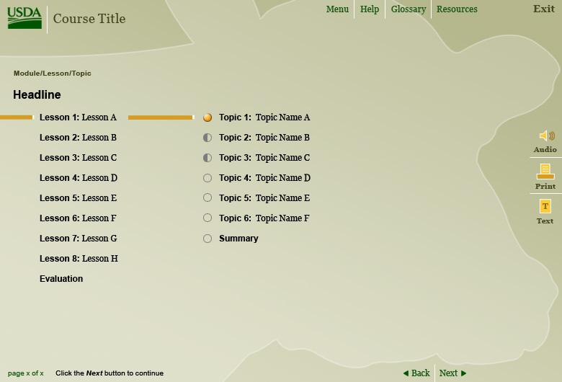
Figure 3: Menu Template

Introduction Screen
The Introduction Screen consists of one or more screens to be used to start each course. It includes:
- A customizable welcome screen
- Standard instructions on using the navigation features in the template, including a link to an animation explaining the template
- Basic "Help" information (in the form of FAQ questions)
- A “sniffer” page that will allow the user to check whether their current operating environment has the necessary programs and plug-ins in order to view the course.
NOTE: The sniffer page will not be able to detect the JRE, but will be able to detect other browser settings and plug-ins.

Content Screens
Content screens include the following screen types:
- Text-only screen
- Content with Portrait Graphic on Right/Left
- Content with Landscape Graphic on the Top/Bottom
- Content with Portrait Flash Window on the Right/Left
- Content with Landscape Flash Window on the Top/Bottom
- Full Screen Flash Window
The breadcrumb in all content screens reads, as appropriate, Module Title, Lesson Title and Topic Title.

Text-only screen
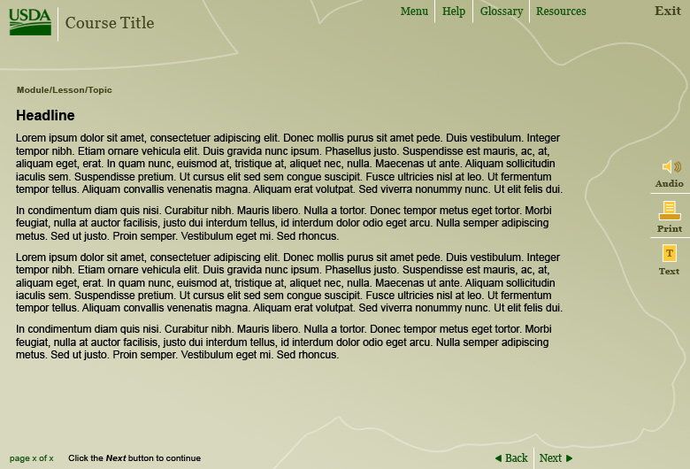
Figure 4: Text Only Screen
The text-only screen, as shown in Figure 4 (above), is the basic content screen for the course. These screens are fixed in size and do not allow the user to scroll.

Content with Portrait Graphic on Right
The Content with Portrait Graphic on the Right screen, as show in Figure 5 (below), features a graphic area on the right and a text area on the left. (A similar template is available with a portrait graphic area on the left and a text area on the right.)

Figure 5: Content Template with Portrait Graphic on Right

Content with Landscape Graphic on the Top
The Content with Landscape Graphic on the Top screen, as shown in Figure 6 (below), accommodates a landscape graphic above the content area. (A template with landscape graphic below the content area is also available.)

Figure 6: Content Template with Landscape Graphic on Top

Content screen with Right Portrait Flash Window
The Content with Portrait Flash Window on the Right screen, as shown in Figure 7 (below), has an area on the right for Flash files to play. As a best practice, the play button is built into the Flash animation, and should not be built into the template. (Similar templates, one with a Portrait Flash Window on the left, one with a Landscape Flash Window on the top of the screen and one with a Flash or animation window in the middle of the screen or full-screen, are also available.)

Figure 7: Content Template with Right Portrait Flash Window

Practice and Assessment Screens
The interactivity screens and assessment screens are similar in look and feel, but serve different purposes. The practice templates are designed for presenting a non-assessment practice question. They are not tracked by the LMS, nor are they scored. The assessment screens are designed for presenting and tracking knowledge checks within the AgLearn Learning Management System (LMS) environment. Question feedback is given after the user submits their answers. Each interactivity screen is shown in Figures 10-12 (below). Both screen types (interactivity and assessment) will have feedback pop-ups available.
NOTE: The feedback box will be positioned in the upper right hand corner, but the position can be re-programmed by developer if necessary.

Interactivity Templates
The following are types of interactivity templates:
- Matching: A set of four or more (up to 8) Text to Text or Text to Graphic Matching, using a drop down box for the answers.
- Multiple choice: A question with multiple distractors (up to five) and one correct answer.
- Multiple-multiple choice: A question with at least two correct answers (with potentially all five being correct) out of five choices.
- True/False: A question with a True/False answer. May also be used as a Yes/No question and answer as well.
NOTE: The True/False Page will look the same as the Multiple Choice interface, and use two answers.
The interactivity and assessment questions can be multi-line questions. The answers and distractors can be repositioned on the page should the developer want to do so.
The final assessment summary screen will include a JavaScript warning to caution users to finish the course by clicking on the Next button when required.
Developers can modify the template and re-arrange the answer section as needed.

Multiple-choice Interactivity Template
Figure 8 (below) shows a multiple-choice interactivity template. This template includes a single correct answer and three distractors. A similar, multiple-multiple choice template is also available. That template includes at least two (and potentially five) correct answers.
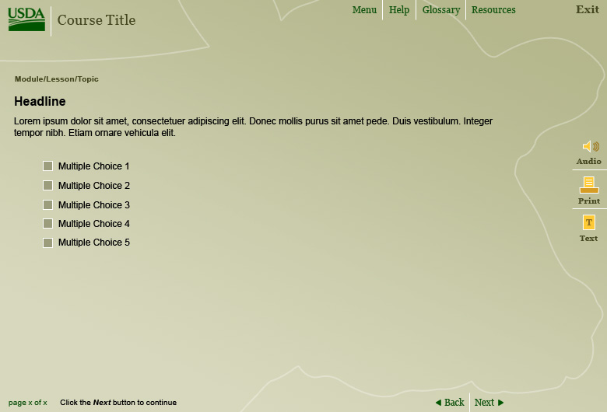
Figure 8: Multiple Choice Template

Summary Screen
The Summary screen follows the Assessment screen and displays information regarding which questions were answered correctly. At this time, the course will send information to the LMS indicating that the SCO is complete, percentage of correct responses to questions, and what score the learner achieved.

Interface Design
The interface design will be based on the look and feel of the approved template. Figure 13 (below) provides an example of what a content screen might look like with the USDA templates. Each template is available in a choice of three colors (brown, blue and green) as indicated in Figure 9 (below).

Figure 9: Interface Design

Interface Specifications
The following specifications are used in the interface design of the USDA Templates:
- Global Course Elements
- Main Menu
- Interface Components
Screens use the standards described in the following sections to ensure a consistent design concept, appearance and functionality throughout the course.

Global Interface Elements
Global elements, shown in Figure11 (below), are persistent and available to learners throughout the entire course. All of the global elements are located in the header and footer section of the interface. The header section includes:
- USDA branding/logo
- Indicator elements that identify where the learner is located in the course and the prompt text
- Print, Audio and Text Buttons
- Menu, Help, Resources and Glossary Buttons
- Course Exit Button
NOTE: Any button that is not necessary for a particular course may be de-activated by the developer.
The footer section includes:
- Page Indication (Page X of Y – labeled at the module level, not topic level)
- User Prompt
- Navigational elements (Back/Next)
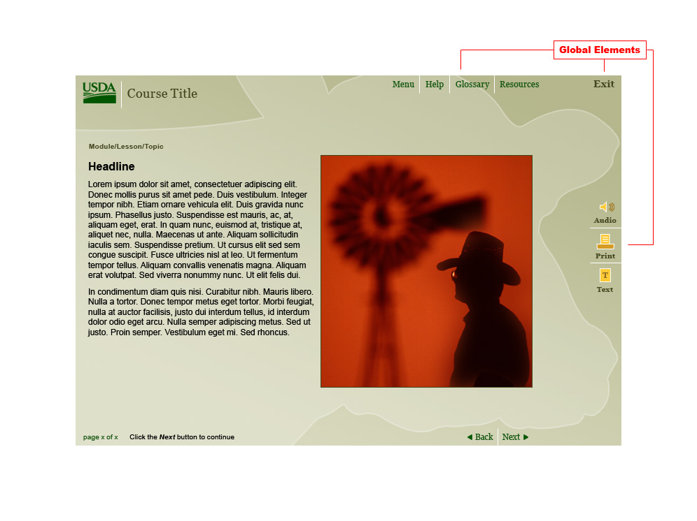
Figure 10: Global Elements shown in the Interface

Table 11: Global Element Descriptions
Element | Descriptions
Menu Button | A Menu button is provided for each Module so that learners can navigate through the SCO without returning to the LMS main menu. Learners can access the menu anytime in the SCO by clicking on the Menu button located in the upper right hand portion of the interface. Doing so will take learners to the Menu where they can navigate through the SCO and the sub-components contained within that SCO.
Help Button | The purpose of the Help section is to orient those who are new to the course with functionality and navigation. The following elements will be contained in the help section, when the student activates the HELP button:  - Computer requirements – minimum hardware, operating system, software, and plug-in requirements  - Navigation – description of each navigation button on the graphical user interface (GUI) and its function including buttons such as Help, Resources, Topic Menu, Back, and Next  - When clicked, the Help button will launch a smaller window that allows the learner to print the information and to close the window; developers can edit this window as needed.
Glossary Button | The Glossary section is an editable window that lists all the glossary terms for the current course. When clicked, the Glossary button launches a smaller window that allows the learner to print the information and close the window.
Resources Button | The purpose of the Resources section is to provide additional resource and reference information to learners. Developers can edit this window as needed. When clicked, the Resources button launches a smaller window that allows the learner to print the information and close the window.
Exit Button | The Exit button closes the current window and provides a warning prompt that warns learners that they are closing the current window and will be returned to the LMS. Functionality will be incorporated to focus on the browser window that contains the LMS.
Audio Button | The audio button allows the learner to turn the audio for the course on or off. This button is disabled if no audio is available.
Print Button | The print button allows the learner to print the current page. Typically, configuration options for how pages appear when printed are configurable within the learners’ browser.
Text Button | The text button allows the learner to see the text equivalent content of the audio on-screen, whether or not the audio is playing. Industry standards and best practices, recommend that the audio-text box be presented as a smaller, scrolling window layered slightly over the image area that the user can move, if need be. With the restricted screen space, learners are able to maximize their screen to suit their learning needs.

Interface Components
This section describes the individual sections of the interface.

Navigational Elements
Figure 11 (below) is an example of the course navigation elements (i.e., Back and Next buttons).

Figure 11: Navigational Elements shown in the Interface
The following specifications are provided for the course navigation elements shown in Table 12 (below).
Table 12: Navigation Element Descriptions
Element | Descriptions
Back | The Back button returns learners to the previous content screen. It is disabled on the first screen of content.
Next | The Next button forwards learners to the next screen of course content. At the end of each topic, the learner is forwarded to the next topic or lesson within that SCO.

Content Elements
Figure 12 (below) is an example of the course content elements.
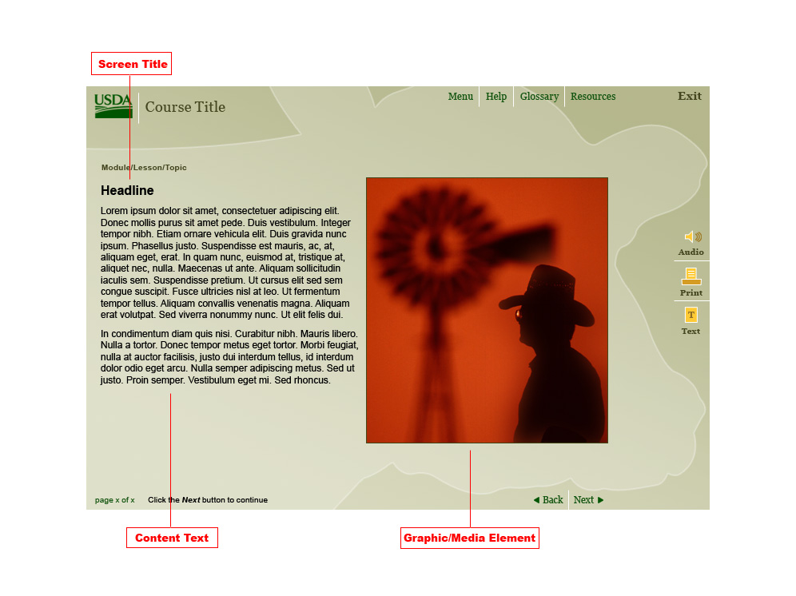
Figure 12: Content Elements in the Interface
The following specifications are provided for the content elements shown in Table 13.
Table 13: Content Elements
Element | Descriptions
Content Text | The instructional text and information that provides guidance to the learner is located in the content text section.
Screen Title | The screen title is a persistent element that provides the learner with the name of each screen.
Graphic or Media Element | Graphic or Media elements can be any visual aid that reinforces content, or stands on its own to teach a piece of information or interact with the learner. Such elements include graphics (photos/illustrations), animations, videos or interactions. For example, a graphic element might be an icon displayed on a content screen that, when selected, provides the learner with additional information to support the content.

Indicator Elements
Indicator elements provide learners with instructions and location information throughout the course. Examples of indicator elements are shown in Figure 13 (below).
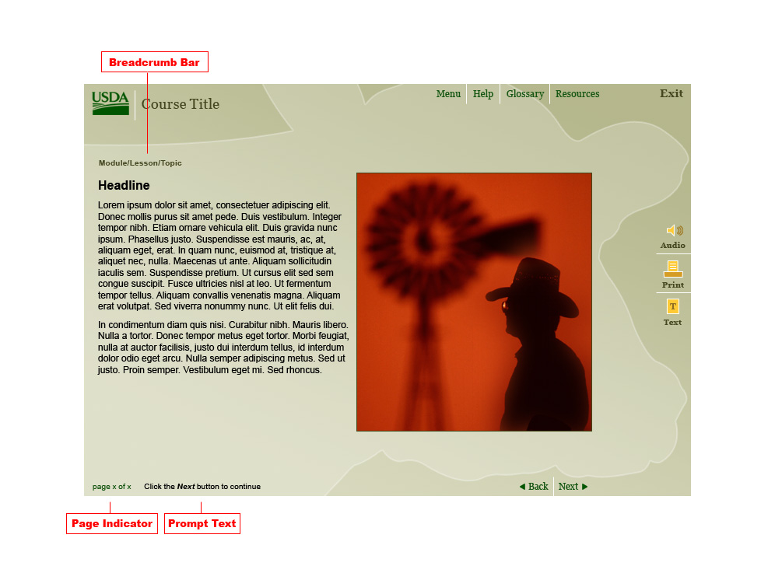
Figure 13: Indicator Elements in the Interface
Examples of indicator elements are given in Table 14.
Table 14: Examples of Indicator Elements
Element | Description
Breadcrumb Bar | The Breadcrumb Bar is located in the top banner and displays the learner’s location by providing the Module Number, Module Title and Lesson Title.
Page Indicator | The Page Indicator displays the current page number and total number of pages in the specific course component. For example, page 5 of 12.
Prompt Text | The Prompt Text displays learner instructions (e.g., “Click the Next button to proceed”).

Production and Technical Specifications
This section describes considerations for the development of online courseware specific to the USDA host and end-user environments and technical standards. It also includes a description of the USDA templates including screen types; interface specifications; and interface, navigation and content elements.

Host Platform Specifications
USDA uses Plateau 5.8 LMS. Plateau 5.8 is built within the J2EE framework and supports J2EE applications and platforms. The LMS is AICC and SCORM 2004 certified.

End-User Platform Specifications
This section describes the minimum requirements for the end-user environment in USDA. Specific software may vary among Agencies.

Operating Systems
- Windows 95, 98, NT, 2000 or XP

Hardware
Minimum requirements for personal computers at USDA include the following:
- Browsers must be Internet Explorer (IE) 6.0 or Netscape 6.2 or later
- Java must be enabled
- Javascript must be enabled
- Pop-ups must be enabled
- Cookies must be enabled
- Screen resolution must be set to 800x600 or greater
- Color depth must be 16 bit or greater
- Java VM must be Sun's 1.4.2_07 or newer and Javascriptable (Other versions of Sun's Java VM may work but are unverified.)

Software
USDA computers may have a variety of software applications installed. Courseware developers should check with the System Administrator for their Agency for specific information.

Screen Development
Screen development involves combining appropriate text, graphics, animation, audio, and video elements into an aesthetically and instructionally sound product. Considerations for screen development include the following:
- Text Layout and Appearance
- Graphics Development
- Animation Development
- Screen Appearance
- Screen Layouts
- Captivate Simulations

Text Layout and Appearance
Standards for text layout and presentation of content include the following best practices:
- Limit the amount of text on screen.
- Avoid long segments of text wherever possible. Convert full text documents or long text segments requiring more space than is available on a single screen to PDF or MS Word format.
- Use short sentences and paragraphs. Break up lengthy sentences using bullets, numbered lists, tables, and charts.
- Provide adequate white space to separate blocks of text.
- Generally, left justify basic text.
- Avoid using italics. Use bold for emphasis.
- Avoid blinking text.
Guidelines for content appearance include the following:
- Present information in a top down, left to right format.
- Display important information prominently on the screen.
- Integrate diversity appropriate to the target audience when developing content including graphics, animations, and text.

Graphic Development
Industry best practices suggest the following guidelines for producing graphics:
- Use 72 dots per inch (dpi) of detail for all images
- Develop graphics for 16-bit SVGA color environment
- Size graphics to adopted template layouts
- Ensure screen graphic artwork has a consistent look and feel
- Ensure adequate contrast between text and background colors (Accessibility/Section 508)
- Ensure key details are easily identified
- Compress graphics and save them in a .gif, .jpg, or .png format
- If color is used to convey important information, the important information should also be conveyed in an alternative manner, such as alternative text (Accessibility/Section 508)
- Title charts clearly with appropriately sized fonts
- Avoid overloading charts with small symbols or graphics
- Avoid using numerous visual cues or colors

Animation Development
Guidelines for developing animations include the following:
- Avoid blinking screen elements (Accessibility/Section 508).
- Avoid animation that moves across the screen or otherwise distracts students from the content.
- Use special effects only when required for emphasis or transition. Avoid special effects that detract from instructional content.
- Avoid timed effects. When using an animation to explain a concept, it is good practice to prompt the user to initiate the animation.
- Design animations appropriate to the target audience.
- Incorporate student interaction into animations.
- When designing clickable images, make sure areas do not overlap. Use simple clickable shapes (e.g., square, rectangle, and circle) (Accessibility/Section 508)

Programming and Development
The following defines the programming standards used to develop courseware:
Source code should be commented, showing information such as:
- Do Not Disturb areas
- Decision Points (code that needs to be modified prior to placing in production)
- Editable content areas
- Code purpose

Section 508 Requirements
In 1998, Congress amended Section 508 of the Rehabilitation Act to require that Federal agencies make their electronic and information technology accessible to people with disabilities. In general, all electronic media developed by or for the US government is required to adhere to Section 508 guidelines.
NOTE: See Appendix A for additional Section 508 guidance, including suggested best practices for implementing the standards. For additional information about accessibility and Section 508, visit the US Government’s Section 508 website at http://www.section508.gov/ or view the standard itself at http://www.access-board.gov/ 508.htm.

Evaluating Courseware for Accessibility
The following sections outline a process for evaluating content for conformance to Section 508 accessibility standards.

Evaluation During Development
Developers should use the best practices recommended previously in this document to ensure that programmed content is accessible. During development, developers should periodically test various pages containing different types of content using tools such as Bobby, LIFT, JAWS, or Window Eyes. Identifying accessibility issues early can reduce or avoid time spent later to correct content that cannot be accessed by users with disabilities or alternate browser software.

Evaluation After Development
Once content development is complete, a preliminary conformance evaluation should be conducted using semi-automatic and manual checking methods. The five-step process below is excerpted from the World Wide Web Consortium (W3C) Web Accessibility Initiative document, Evaluating Web Sites for Accessibility:
- Select a representative sampling of different kinds of pages from the Web content to be reviewed; must include all pages on which people are more likely to enter your content.
- Use a graphical user interface (GUI) browser (such as Internet Explorer, Netscape Navigator, or Opera) and examine the selection of pages to be assessed. Some of these manual checks can be performed by changing settings or preferences in the browser, some may require changes to operating system settings, and some may require additional software.
  - Turn off images, and check whether appropriate alternative text is available.
  - Turn off the sound, and make sure audio content is still available through text equivalents.
  - Use browser controls to vary font-size: verify that the font size changes on the screen accordingly; and that the page is still usable at larger font sizes.
  - Test with different screen resolution, and/or by resizing the application window to less than maximum, to verify that horizontal scrolling is not required (caution: test with different browsers, or examine code for absolute sizing, to ensure that it is a content problem not a browser problem)
  - Change the display color to gray scale (or print out page in gray scale or black and white) and observe whether the color contrast is adequate.
  - Without using the mouse, tab through the links and form controls on a page, making sure that you can access all links and form controls, and that the links clearly indicate what they lead to.
- Use a voice browser (such as JAWS) or a text browser (such as Lynx) and examine the Web site while answering these questions:
  - Is equivalent information available through the voice or text browser as is available through the GUI browser?
  - Is the information presented in a meaningful order if read serially?
- Use two general accessibility evaluation tools and note any problems indicated by the tools.
- Summarize results
  - Summarize the types of problems encountered
  - Indicate the method by which problems were identified
  - Recommend follow-up steps and ways to address any identified problems.
NOTE: Copyright © 2001-2002 W3C (MIT, INRIA, Keio), All Rights Reserved. <http://www.w3.org/Consortium/Legal/2002/copyright-documents-20021231>.

Final Verification
Once all identified accessibility problems have been addressed and corrected, the online content is ready to be tested and verified before being published to a live production environment such as the Plateau LMS.

Accessibility Assessment Tools
This section provides an overview of the available tools used by Web developers to evaluate and modify online content to meet accessibility requirements.
- AccMonitor – AccMonitor provides the ability to monitor the status of an entire Website or a subdirectory of the site. The AccMonitor console allows for inclusion or exclusion of directories or file types. Email alerts can be sent to any number of recipients. When monitoring Web files, use Accessibility (i.e., Section 508 standards or W3C guidelines) report modes for the accessibility rules chosen, Searchability Rules, Privacy Rules, or any Test Suite that was developed or is shipped with AccMonitor.
- Bobby – Bobby is a Web accessibility software tool designed to help expose and repair barriers to accessibility and encourage compliance with existing accessibility guidelines.
Bobby tests for compliance with government standards, including the U.S. Government's Section 508. It offers prioritized suggestions based on the Web Content Accessibility Guidelines provided by the World Wide Web Consortium's Web Access Initiative. Bobby allows developers to test Web pages and generate summary reports highlighting critical accessibility issues before posting content to live servers. While Bobby is not as powerful as a solution like AccMonitor or Site Valet (below) that can monitor multiple sites in real-time, it is an adequate solution for smaller site development.
- JAWS® for Windows – JAWS for Windows is a software application for the blind and visually impaired. With its internal software speech synthesizer and the computer’s sound card, information from the screen is read aloud, providing technology to access a wide variety of information, education, and job related applications.
- LIFT for Dreamweaver – LIFT for Dreamweaver is an extension for the Macromedia Dreamweaver authoring tool. LIFT allows customization of accessibility tests (i.e., Web Content Accessibility Guidelines [WCAG] Priority 1, U.S. Government Section 508) and provides continuously updated test results during editing, as well as a wizard-based repair tool that can be run in a context-sensitive mode while editing. It generates reports in HTML format or as an XML file that can be used for further processing. It incorporates heuristics for distinguishing different types of tables and images to provide appropriate suggestions for repair. LIFT is now fully integrated within Dreamweaver MX.
- Macromedia Dreamweaver MX – Dreamweaver MX includes an accessibility reports feature to check that guidelines are implemented in the various HTML files. An accessibility report can be run on a current document, selected files, a folder, or an entire site.
- Site Valet – Site Valet is a comprehensive quality assurance product for Web and Intranet sites. An online toolkit is complemented by a site maintenance program, both of which are available to the public at the Website. Site Valet can be extensively customized for corporate users. Accessibility Valet is a core Site Valet tool, designed to help ensure accessibility by analyzing markup for conformance to Web accessibility guidelines, specifically the WCAG and Section 508.
- Window-Eyes –Window-Eyes is a software application for the blind and visually impaired that converts components of the Windows operating system into synthesized speech, allowing for complete and total access to Windows based computer systems. Window-Eyes integration into Windows is seamless, providing instant access to the operating system without having the end user learn a complicated set of keystrokes.

SCORM Requirements
The Shareable Content Object Reference Model (SCORM) has been developed as part of the Advanced Distributed Learning (ADL) Initiative and is designed to be a standard to promote the reusability and interoperability of learning content. Initially designed for use in the Department of Defense, SCORM has been adopted by the majority of LMS vendors as a supported standard, which has influenced its adoption among most other government agencies as well.
The USDA AgLearn is no exception to this trend since the AgLearn’s instance of the Plateau LMS supports SCORM version 1.2 conformant content. As a result, all content developed for inclusion in the USDA AgLearn should be developed to be SCORM version 1.2 conformant.
NOTE: For additional information about SCORM version 1.2 implementation, refer to the ADL website at http://www.adlnet.org. For additional information about SCORM implementation in AgLearn, refer to the USDA Content Integration Guide.

USDA Templates and SCORM
The USDA templates were developed using SCORM version 1.2 standards, and should be forward compatible with SCORM 2004.
The templates track the following learner-specific information:
- Where the learner left off within a SCO (bookmarking)
- What the completion status is of the SCO is (e.g., not started, started, completed)
- What the learner’s score is for assessments (knowledge checks)
- Time spent in SCO

Manifest
A SCORM manifest is an extensible Markup Language (SML) description of a content object, a collection of content objects, a course (information about content objects as well as the content aggregation), or a collection of courses. For the purposes of the inclusion of content in the USDA AgLearn, a manifest should at a minimum contain the content aggregation of a course, any associated meta-data for that course, and the appropriate resource references identifying the SCOs and assets that make up the course.
The manifest file must be named imsmanifest.xml (case-sensitive) and be included with the content object files at the root of the directory containing these files. As part of the process of enabling content, a member of the AgLearn team will separate the manifest file from the rest of the content and compresss it for uploading into the AgLearn. The AgLearn’s implementation of Plateau limits the size of this file to 1MB once compressed.
NOTE: As dictated by SCORM, only resources identified in the manifest as a SCO (those resources with their scormtype attribute set to “SCO” rather than “asset”) will be able to communicate with the LMS. Developers should ensure that each resource’s scormtype attribute is set to the appropriate value for the required functionality of that resource.

Meta-Data
SCORM defines a number of meta-data elements for a variety of levels of a content package including the content aggregation itself, a SCO, an asset and data types. USDA is not currently requiring the use of a specific set of meta-data elements; however, it is expected that all mandatory meta-data elements be addressed.
Meta-data place holders have been created within the template code. Developers can tailor the meta-data to their specific course.
The following meta-data elements, at both the SCO level and the course aggregation, can be tracked as appropriate.
Table 15: Meta-Data Elements
Meta-Data
Title
Domain
Date
Version
Duration
Build Author
Description
Subject
Build Company
Developer Tool(s): (Macromedia Dreamweaver, Captivate, etc.)
File Location: (Where it will reside in Data repository
Keywords: (Optional)
Re-Use Policies: (Optional)

Tools for the Creation of SCORM Content
Third party tools are available to the developer or content creator to aid in the creation of SCORM conformant content as well as course manifests. In general, the market for tools of this nature is still fairly young. While the tools mentioned below can help in the creation of SCORM compliant content, none provides a complete, full feature-set solution.
- Macromedia Dreamweaver MX
Macromedia Dreamweaver is a web development tool that supports the inclusion of most web standards, including: HTML, JavaScript, ASP, XML, JSP, Flash, etc… This application is designed for general web-based content creation and website management. While Dreamweaver does not include any built in SCORM features, there are a number of extensions available and its features provide an excellent environment for efficient and consistent code development.
- Manifest Maker 2.0
Manifest Maker is an extension developed for Macromedia Dreamweaver that has the capability to scan a Dreamweaver site and generate XML manifest content, although only for one SCO at a time. It includes an interface for entering Meta-Data, scans directories and subdirectories for assets, and produces the applicable XML in a single manifest file.
- L5 SCORM Producer
L5 SCORM Producer is a Macromedia Dreamweaver extension for the organization and creation of manifest content. It has the capability to scan a Dreamweaver site and generate multiple manifest files for multiple SCOs. L5 SCORM Producer includes an interface for entering Meta-Data and creates a manifest for multiple SCO's; however, it does not automatically scan for assets.
- XMLSpy
XMLSpy is a robust tool for XML creation that, while not specifically SCORM focused, allows for the creation of custom meta-data entry interfaces, lending itself to being used within the realm of the SCORM.
- ADL Test Suite
The ADL Test Suite provides a means for developers to test for conformance with the SCORM when developing an LMS, a SCO, Meta-Data, and/or a Content Package. The test suite is available from the ADL website at http://www.adlnet.org.
- ADL Sample RTE
While the ADL Sample RTE (Run Time Environment) is not a full-featured LMS, it is an effective tool for the testing and validation of how a content package will function within an LMS environment. The ADL Sample RTE is available from the ADL website at http://www.adlnet.org.

Configuration Management
A recommended best practice is to establish standard configuration management practices at the beginning of the production cycle. Configuration includes designing:
- Directory naming conventions – Create and name directories in an easy to understand and easy to maintain manner.
- File naming conventions – Use standard file naming conventions.
- Back up practices – Back up files on a regular basis. Local back ups should be several times a day. Hard copy back ups (e.g., tape, CD-ROM, and DVD) should be on a weekly basis.
- Migration – Migrate courseware to appropriate servers for development testing, reviews, and final hosting.

Directory Naming Conventions
Directories containing courseware should use the following convention:
[linear order]_C[course number]M[module number*]L[lesson*]_T[topic]_[name]
NOTE: These items are only required as needed. Not all courses may have a Module and/or Lesson.
Each portion of the file name is defined below:
- Linear order – This is a two digit number included to sort various SCO folders to represent a completely linear path through the course. This eases the search for specific SCO folders during development.
- Course number – This is a two digit number that represents the course number assigned to the course. Course numbers may be assigned from a central entity to assure unique numbers.
- Module number – This is a two digit number that represents the module number. Module numbers are not applied to the course introduction, course pretest, and course posttest.
- Lesson – This is a two digit number that represents the lesson number. Lesson numbers are not applied to the course introduction, course pretest, course posttest, module tests, and module introductions.
- Topic – This is a two digit number that represents the topic number.
- Name – The name should be an abbreviation with no spaces. Topic names should be an abbreviation of the topic’s name, with initial caps and no spaces. For example, the name “How to Slice Bread” may have an abbreviated name “HowSlcBrd.”
Figure 14 (below) provides an example of naming conventions in use.
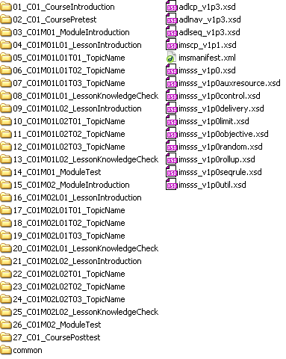
Figure 14: File Naming Conventions
NOTE: Please note the “common” directory in Figure 14. This directory should be provided with all courses to include content that is shared between SCOs. Examples may include glossary, help file or supporting .pdf files.

File Naming Conventions
A recommended best practice is to determine a standard file naming convention based on the default hierarchy for all graphic and content files. Developers should name all HTML and media files according to the established naming convention to allow for consistency and ease when developing and retrieving content.

Content files
Use the following file naming convention for content files:
C[course ID]_M[module]_L[lesson]_T[topic]_[screen].htm
Please note that spaces are not used. For ease of reading, use the underscore character (_).

Screen Numbers
Screen numbers should be three digits, with 010 as the first screen in a topic and continuing in increments of 10 (i.e., the second screen is numbered 020, the third is numbered 030, and so on). This minimizes the impact of additional content being added to the course during review or testing processes. For example, during product testing, if an additional content screen (015) is added between the first (010) and second (020) screens of a topic, the new numbering sequence for the screens would be 010, 015, 020, 030, etc.
Graphics, Flash movies, and other media should be named in a similar fashion with the addition of a letter designation after the screen number to distinguish multiple assets contained within the same screen.
C[course ID]_M[module]_ L[lesson]_T[topic]_[screen]_[a].[jpg | swf | gif]
An example of a content screen file name for screen three of the second topic in Module one, Lesson two, Topic four of course number 065 would be: C065_M01_L02_T04_030.htm.
It is worth noting that any Shareable Content Object (SCO) may later become detached from its current course and re-aggregated into a new course. At that time, the file name with its course, module, and lesson name may no longer become relevant. While this is not an ideal situation, the purpose of specifying a file-naming scheme as identified in this section is to give each file a unique identifier.

Course Migration Practices
Once completed, courseware is migrated to the appropriate servers for development testing, reviews, and final hosting. (See Section 7.0 - Content Integration and Implementation for additional information about this process.)

Content Integration and Implementation

Content Standards
The following sections provide an overview of the standards related to implementing, testing, and managing content within AgLearn.

Content Types
Within the AgLearn system, “content” can refer to any of the following types of materials:
- Online Courseware – includes web-based training (WBT), computer-based training (CBT), online exams/surveys, and the Flash and HTML files used for online training. Examples include:
- Commercial-off-the-shelf (COTS) onlines courses (e.g., NETg courses, SkillSoft courses, etc.)
- Custom online courses or exams/surveys built with an authoring tool such as Toolbook, Dreamweaver, Flash, Authorware or other similar software.
- Content that requires tracking of certain information such as a completion status, score or other information. This type of content may use the AICC or SCORM (1.2 or 2004) standards.
- Documents – common desktop application documents requiring users only to read or view the information contained within. These types of files may be stored outside of AgLearn. Examples include:
- Microsoft documents including Word, PowerPoint and Excel
- PDF (Adobe’s Portable Document Format) documents
- Flash animations or executable files
- Electronic Video files (for example, .mpg, .mpeg, or .wmv files)
- Reference Materials – used as support materials for an instructor-led class. May include materials to be used prior to class or documentation to be used by a class during or after an instructional session. These types of files are to be stored outside of AgLearn.

Content within AgLearn
Content is implemented within AgLearn as Content Objects and components.
- Content Objects – are individual modules that are grouped together to make up an entire course. For online training, Content Objects contain the information required by the AgLearn system to launch the individual modules.
- Components – refers to a course in AgLearn. For online training, components are used to provide a place where individual Content Objects can be grouped to form a course. Components also provide the ability to document information related to the design, delivery, prerequisites, collateral credit and target audience for the course.

AICC and SCORM Standards Testing
The AgLearn system, which is built on the Plateau 5.8 platform, operates with both AICC and SCORM 1.2 and SCORM 2004 compliant courseware (See Section 8.1 for additional information about SCORM.). However, these standards are only guidelines and are often interpreted differently. Therefore, online courses created based on AICC or SCORM standards should always be tested to ensure proper communication between the course and the LMS. (Depending on the specific installation and environment that runs these products, there may be some limitations and/or preferred methods for having an LMS, such as AgLearn, communicate with external courseware.)
NOTE: AgLearn does not require that courseware include SCORM or AICC elements. Content can be implemented without the use of SCORM or AICC if the Agency desires. However, if the courseware is not created to meet AICC or SCORM standards, functionality such as bookmarking, tracking course completions, or scoring surveys and exams will not be tracked in AgLearn.
All custom courseware designed to be AICC or SCORM compliant must be tested prior to configuring it onto the AgLearn system. It is the responsibility of the Agency/Course Content Owner to test all custom courseware against the appropriate AICC or SCORM standard before it is loaded and configured onto AgLearn.
Please follow the steps listed below for testing a custom AICC or SCORM course.
Table 16: Testing a Custom AICC Course
Steps | Action
1 | Create the custom online course with SCORM course structure files.
2 | Download and install the Advanced Distributed Learning (ADL) SCORM Test Suite  The Test Suite is available at: http://www.adlnet.org/index.cfm?fuseaction=SCORMDown.  Note: Be sure to download the correct version of the Test Suite for the SCORM for the course being tested (For example, if the course was built to be SCORM 1.2 compliant, use the SCORM 1.2 Test Suite).
3 | The custom online course must pass three tests in the Test Suite: Manifest, Metadata, and SCO tests.
4 | Save the log files created by the Test Suite indicating the tests have been successfully passed.
5 | Contact the USDA eLearning team for information on the current FTP site to upload the online courseware.
6 | Upload both the courseware and the log files generated by the Test Suite (The logs provide proof that the courseware is SCORM compliant.).
7 | GPE will import the course into the AgLearn Training environment to ensure it is launching and passing course status information. All custom courseware will first be tested in AgLearn’s Training environment and then in the Staging environment. After the course is successfully launched and tested in both environments and has passed its Telecommunications Impact Assessment, the eLearning team will make it available in AgLearn’s Production (LIVE) environment.

Table 17: Testing a Custom SCORM Course
Steps | Action
1 | Create the custom online course with AICC course structure files.
2 | Download and install the AICC Test Suite (http://www.aicc.org/pages.aicc_tx.htm)
3 | The custom online course must pass two tests in the Test Suite: Course Structure and AU tests.
4 | Save the log files created by the Test Suite indicating the tests have been successfully passed.
5 | Contact the USDA eLearning team for information on the current FTP site to upload the online courseware.
6 | Upload both the courseware and the log files generated by the Test Suite (The logs provide proof that the courseware is AICC compliant.).
7 | GPE will import the course into the AgLearn Training environment to ensure it is launching and passing course status information. All custom courseware will first be tested in AgLearn’s Training environment and then in the Staging environment. After the course is successfully launched and tested in both environments and has passed its Telecommunications Impact Assessment, the eLearning team will make it available in AgLearn’s Production (LIVE) environment.

NOTE: If there are any issues with the courseware, the AgLearn Team will inform the Agency of the errors identified. It will then be the responsibility of the Agency to troubleshoot and correct the courseware.

Testing and Configuration Requirements
Regardless of the communication standard being used, all custom content will need to be tested and configured on the AgLearn system. This is often an iterative process to ensure that the courseware tracks all necessary information within AgLearn, such as assessment scores, completion status, etc.
Courseware developers should plan for the time required to test Agency content on the AgLearn system. Agencies contracting the development of courseware out to a vendor should also ensure there is sufficient time included for testing.
NOTE: The AgLearn Team can aid in setting up your courseware for testing and deployment on the AgLearn site.

Vendors and Authoring Tools
Plateau has integrated with numerous content vendors. For a list of content partners, please go to Plateau’s Web site at: http://plateau.com/all/all/htm.
For information about authoring tools that integrate well with Plateau see the USDA Authoring Tools Report.

AgLearn Environment
The AgLearn environment consists of three separate areas that are specifically configured to support separate AgLearn missions. These areas include the training, staging and live (production) environments. Figure 15 (below) illustrates these three environments.
Figure15. AgLearn Enrivonment
AgLearn
TRAINING
Server

AgLearn
STAGING
Server

AgLearn
PRODUCTION
Server

AgLearn Training Server
The URL(s) for the AgLearn Training server are:
- Admin URL: http://www.training.aglearn.usda.gov/pwa/login.jsp
- Student (Tester) URL: Http://www.training.aglearn.usda.gov/pws/login.jsp

AgLearn Training Server Uses
The AgLearn Training server is used for:
- Online Content Testing
- Training Classes
- Contractors’ tests of custom online courses

Login Information
Users and Administrators have generic IDs and passwords (e.g., Training1, Training2). IDs and passwords are not tied to e-Authentication

AgLearn STAGING Server
The URL for the AgLearn Staging server is: http://www.staging.aglearn.usda.gov

AgLearn Staging Server Uses
The AgLearn Staging server is used for:
- User Acceptance Testing of Online Content and AgLearn Upgrades
- Content Staging

Login Information
Users have specially configured test accounts with USDA Level 2 credentials. IDs and passwords are integrated with USDA e-Authentication Service.

AgLearn LIVE (Production) Server
The URL for the AgLearn Live server is: http://www.aglearn.usda.gov

AgLearn Live Server Uses
The AgLearn Live server is the official USDA system for delivering, managing and tracing training for USDA employees, contractors, partners and customers.

Login Information
USDA federal employees, contractors, partners and customer accounts login with USDA Level 2 credentials. User IDs and passwords are integrated with USDA e-Authentication Service.

Online Courseware Test Procedures
The following sections describe the step-by-step process for implementing, testing, and migrating online content within the three AgLearn environments: Training, Staging and Production.

Step 1: Content Submission
The first step of the process requires the agency course owner to complete and submit a Content Submission form. The information entered into this form is critical for the accurate implementation of training content within AgLearn. The following sections provide instructions for this step as well as detailed information on the elements contained within the Content Submission Form. A Content Submission Form can be found within Appendix B of this document.
Table 18: Step 1 Procedure
Procedure | Action | Responsibility
1 | Obtain a copy of the Content Submission Form | Agency Course Owner
2 | Complete Content Submission Form | Agency Course Owner
3 | Rename Content Submission Form to include Agency Name and Date | Agency Course Owner
4 | Submit Content Submission Form to AgLearn Office | Agency Course Owner
5 | Review Content Submission Form for accuracy and completeness | AgLearn Team
6 | Coordinate additions and corrections to Content Submission Form | AgLearn Team
7 | Finalize Content Submission Form | AgLearn Team
The Content Submission Form is divided into the following three critical information areas:
- General Information
- Content Object Information
- Component Information
Table 19 defines the informational elements required for each form submitted.
Table 19: Content Submission Form Description
Form Field | Definition
General Information
USDA Agency & Contact | This is the name of the agency sponsor (i.e., their USDA agency acronym).
Who is the audience of this course? | This is the domain(s) or sub-domain(s) whose students will need to access this training (e.g., USDA for everybody, FS for only FS, AMS-CN which is a sub-domain of AMS, etc).
Does this course have a required exam? | Simple yes/no question.  Note: The answer may change how the course is implemented within AgLearn.
Vendor and/or Authoring Tool | If a vendor developed the course, the company name should be listed here along with the name of the product used to develop the course. If the course was developed internally, simply list the name of the product used in its development.
Course Owner/Manager | Provide the contact information (name, telephone number, and e-mail address) of the course owner. This may be the same person as the agency contact or could be a different person.
Content Object Information
Content Object ID | This is a critical definition field that is required within AgLearn. Although this field can be anything desired, it is required that all Content Object names follow a convention. The convention is AGENCY-OBJNAME (e.g., FSA-ICS1)
Content Object Title | This is the title of the Content Object (e.g., Lesson 1: ICS Overview)
Domain ID | This field will determine which AgLearn administrators can access the Content Object record and what functions (copy, edit, view, delete) can be performed on the Content Object record. The information entered into this field is typically the domain of the USDA agency contact or course owner/manager. However, any domain existing within AgLearn can be entered here.
Launch Method | There are several different technologies enabled within AgLearn that support launching online content. They include AICC, Document Type, Browser, or Content Player. It is probable that custom courseware provided by agencies need only the browser setting for this field.
Description | This field is for providing the description of the content contained within each Content Object.
Component Information
Component Type | This is a definition field within AgLearn that can be used during searches for components within the system. This field can be one of the following:  - Assessment (Evaluations, Surveys, etc.)  - Audio (Audio files)  - Briefing (PowerPoints, Executive Briefings, etc.)  - CD-ROM (For courses offering a CD-ROM alternative for completion. This provides the means to manually record student completions of CD-ROM courses)  - Certification (Courses that provide credit or certification for completion)  - Conference/Meeting (Meetings, Seminars, Conventions, Conferences, etc.)  - Course (Classroom Instructor-Led Training)  - Detail  - Document (Required Readings, Articles, Regulations, etc.)  - Exam (Tests, Exams, etc.)  - Shadow Assignment  - Video (Video Tapes, DVD, Video Files, etc.)  - Web-Based (Online Launchable Content)  - More times than not, custom courseware provided by agencies are classified as web-based.
Component ID | Like the Content Object ID, this is a critical definition field that is required within AgLearn. Although this field can be anything desired, it is required that all component names follow a convention. The convention is: AGENCY-COMPONENTNAME (e.g., FSA-HQ-IT).
Component Title | This is the title of the course (e.g., Introduction to Excel (XP) In-house).
Subject Area ID | This is another definition field within AgLearn that can be used during searches for components within the system. Many subject area IDs are already set up in the system. However, content submitters are expected to provide a short definition of their course subject. If one exists within the system that matches the requested subject ID, it will be used. If not, the subject area ID must be added. Examples of subject areas include Administration, Civil Rights, Communications, Desktop Computer Skills, IT Security, etc.
Domain ID | Like the Content Object Domain ID, this field will determine which AgLearn administrators can access the component record and what functions (copy, edit, view, delete) can be performed on the component record. The information entered into this field is typically the domain of the USDA agency contact or course owner/manager. However, any domain existing within AgLearn can be entered here.
Catalog | This field is critical within AgLearn because it determines which students can directly search for and add the component to their development plans. Catalogs configured within AgLearn correspond to the domains assigned to students within the system. Typically the catalog is selected based on the audience described later within this form.
Description of Component | This field is for describing the information that is provided within the course.
Component Goals | This field is for describing the goals of the course.
Required Date of Completion | This field is an optional setting. It allows course owners to set a date by which all students assigned to the course must have the course completed and listed within their learning histories.
Length | This field is for entering the number of in-seat hours required for a student to complete the course.
Course Contact | This field is for entering the e-mail information of the individual to be listed as the contact for the course. This e-mail address should be for the individual responsible for fielding questions from students participating in the course.
Audience | This field is for entering the intended audience of the course.

NOTE: The above process should be followed for each Content Object individually.

Step 2: Content Upload
The second step of the process requires the agency course owner to package up and upload the content to an FTP site for access by the AgLearn Office. This package should consist of a single zip file that contains all content files and, if required, the resultant logs from performing the SCORM and/or AICC tests, and all required SCORM manifests and/or AICC files.
NOTE: The agencies are not required to implement SCORM or AICC elements within all submitted courses.

Table 20: Step 2 Procedure
Procedure | Action | Responsibility
1 | Zip all course-related content files, manifests, and test logs into a single zip file. | Agency Course Owner
2 | FTP zip file to the AgLearn FTP site. | Agency Course Owner
3 | Inform the AgLearn Office of the file’s availability, name, and location. | Agency Course Owner
4 | Unzip files and upload to SVN content management system. | AgLearn Team
5 | Inform AgLearn host contractor files are ready for migration to the AgLearn content server. | AgLearn Team
Content zip files can be uploaded to the FTP website using the following process:
- Browse to ftp://clientftp.genphysics.com/.
- Contact the AgLearn Team to obtain the login ID and password.
- Drag and drop the content zip file into the newly opened window.

Step 3: Manifest Import and File Migration
This step in the process contains two separate tasks. The first requires the AgLearn office to import the SCORM and/or AICC manifest files into the AgLearn training environment if required by the course that is being implemented. During the manifest import, the required content objects are created within the AgLearn instance. The second step requires the AgLearn hosting contractor to migrate the content files from the SVN content management system into the AgLearn content server.
Table 21: Step 3 Procedures
Procedure | Action | Responsibility
1 | If required, perform SCORM and/or AICC import adjusting Content Object IDs, and editing the URL prepend where required. | AgLearn Team
2 | Edit the content objects to include any missing titles and descriptions. | AgLearn Team
3 | Verify correct launch method is selected. | AgLearn Team
4 | Set the Content Object ID to the correct Domain. | AgLearn Team
5 | Migrate files from the SVN content management system to the AgLearn content server. | GP

NOTE: The training instance of AgLearn is loctated at www.training.aglearn.usda.gov.

Step 4: Component Configuration
Once the content objects have been configured within the training instance, the next step is to assemble the course within a component record. This is accomplished using the following procedures.
Table 22: Step 4 Procedures
Procedure | Action | Responsibility
1 | Add new component within the training instance of AgLearn. | AgLearn Team
2 | Configure component elements. | AgLearn Team
3 | Set component Domain ID. | AgLearn Team
4 | Setup online settings within component. | AgLearn Team
5 | Add content objects to component | AgLearn Team
6 | Assign component to a catalog. | AgLearn Team

Step 5: Test Student Assignment
The training environment will be setup with 20 test user accounts to support online content testing. However, it is recommended that a maximum of 10 testers actually be selected. In addition, it is also recommended that at least one to two of these test for ADA Section 508 compliance.
The test accounts will be prepared so the test users will be able to access the course they are testing. This preparation includes clearing off old learning histories and development plans from previous uses of the test accounts. Once the accounts have been cleared and an accurate list of testers has been provided by the Agency Course Owner, each tester will be e-mailed their login information and test instructions. The procedures for this step can be found in Table 23 below.

NOTE: ADA Section 508 requires all Federal agencies that develop, procure, maintain, or use electronic and information technology to ensure such electronic and information technology allows all individuals with disabilities (whether Federal employees or members of the public) to have access to and use of that information and data comparable to that available to individuals who are not similarly disabled, unless an undue burden would be imposed on the agency. For additional information about Section 508 requirements, see Appendix A.
Table 23: Step 5 Procedures
Procedure | Action | Responsibility
1 | Develop a list of students who will test training in Staging environment. | Agency Course Owner
2 | Send contact information of desired test students to AgLearn Office. | Agency Course Owner
3 | Clear and prepare test student accounts. | AgLearn Team
4 | E-mail test account login information and test forms to Agency Course Owner. | AgLearn Team

NOTE: A test form template has been provided within Appendix B.

Step 6: Telecommunications Impact Assessment and Content Testing
During this next step, a telecommunication impact assessment is performed on the course. This assessment serves the purpose of determining if the expected number of students accessing the course will critically impact the daily operations of the USDA IT infrastructure. This includes testing the impact on available bandwidth, server connections, router transmissions, and degradations to USDA daily operations. This step is accomplished using the following procedures.
Table 24: Step 6a Procedures
Procedure | Action | Responsibility
1 | Coordinate with Telecommunications Impact Assessment testers to perform test on course within AgLearn Production. | AgLearn Team
2 | Perform periodic status checks to determine assessment status. | AgLearn Team
3 | Gather results from Impact Assessment. | AgLearn Team
4 | Review the results to determine if any issues exist. | AgLearn Team
5 | Communicate results to Agency Course Owner | AgLearn Team
In addition, during this step the content testers will test and validate the various capabilities and functionality of the content within the training environment. The initial test run should be completed in full by the test users. Any additional test iterations should focus solely on determining if issues identified during the first run have been corrected; these additional test runs should only be conducted by the test users who identified the issues within the initial test run. The procedures for this step are as follows.
Table 25: Step 6b Procedures
Procedure | Action | Responsibility
1 | E-mail test account login information, test forms, test schedule, and Agency-specific test instructions to testers. | Agency Course Owner
2 | Track and follow test progress with test population. | Agency Course Owner
3 | Immediately report critical issues to AgLearn Office. | Agency Course Owner
4 | Determine if system issues are causing course issues. | AgLearn Team
5 | Report system issues as required. | AgLearn Team

Step 7: Test Results Reporting
At the conclusion of the formal testing within the training environment, the Agency Course Owner is responsible for collecting and consolidating comments from the test users. The Agency Course Owner is also responsible for reviewing the comments to determine if any will require changes to the course prior to its migration to production. The procedures for this step are as follows.
Table 26: Step 7 Procedures
Procedure | Action | Responsibility
1 | Collect completed test forms from test users. | Agency Course Owner
2 | Review, consolidate, and edit test comments into a single test report. | Agency Course Owner
3 | Communicate all issues requiring correction to the course developer and the AgLearn office. | Agency Course Owner
4 | Review the final test report to determine if any system issues are causing course issues. | AgLearn Team
5 | Report system issues to GP as required. | AgLearn Team
6 | If required, coordinate course corrections with content developers and restart the process at Step 2. If not, proceed to step 8. | Agency Course Owner

Step 8: Course Approval
After the course has successfully passed its test in staging, the Agency Course Owner should provide approval to the AgLearn Office for its migration to production. This is accomplished using an approval form found in Appendix C and the following procedures:
Table 27: Step 8 Procedures
Procedure | Action | Responsibility
1 | Complete Course Approval Form. | Agency Course Owner
2 | E-mail completed approval form to AgLearn Office (teamaglearn@usda.gov). | Agency Course Owner

NOTE: This email must come from the approver’s email address or it will be rejected.

Step 9: Content Migration to Production
Once the online content has successfully passed the tests identified within Steps 6 and 7, and the Agency Course Owner has provided written approval to migrate their content, the course content is migrated to the AgLearn production environment for deployment into student catalogs. This step is accomplished using the following procedures.
Table 28: Step 9 Procedures
Procedure | Action | Responsibility
1 | If required, perform AICC and/or SCORM manifest import using the procedures described within Step 3 but within the production environment instead. | AgLearn Team
2 | Perform a component setup using the procedures described within Step 4 but within the production environment instead. | AgLearn Team
3 | Provide estimate for number of concurrent users to AgLearn Office | Agency Course Owner
4 | Inform the telecommunications impact assessment personnel that the course is ready for their testing. | AgLearn Team

Step 10: Course Availability Announcements
Once the course has passed its telecommunication impact assessment, the next step in this process is to make the course available to its intended audience and to communicate its availability to the appropriate student population. This is accomplished by using the following procedures.
Table 29: Step 10 Procedures
Procedure | Action | Responsibility
1 | Migrate course components to their appropriate catalogs within AgLearn. | Agency Course Owner
2 | Develop and send a training announcement e-mail to the course’s intended audience. | Agency Course Owner
3 | Provide description of course announcement to AgLearn Team if it is desired that the announcement appear within the AgLearn splash page. | Agency Course Owner
- Section 508 Guidelines and Best Practices
The information below addresses each of the standards under the Web-based Intranet and Internet Information and Applications (1194.22) section of the Section 508 Standards for Electronic and Information Technology.
A brief interpretation of each item is provided followed by suggested best practices for implementing the standard. Practical recommendations are also included for providing alternative access to Web-based and multimedia content as applicable.
SECTION 508 Standards
1. §1194.22(a) A text equivalent for every non-text element shall be provided (e.g., via “alt," "longdesc,” or in the element content).
  - Interpretation:
Images, animations, audio, and video are all examples of non-text elements. These items cannot be interpreted by assistive technology; therefore, their meaning must also be available through an accessible text description.
  - Practices:
- Include alt and title attributes for all images. Images used as list bullets, spacers, interface elements, etc., can use a blank description (“ “) whereas images that display content and have meaning should include a full description. Using a blank description for non-content orientated imagery saves the listener (of screen readers) the repetition of hearing non-essential information.
- Include a title attribute in the link tag if an image is used as a link.
- Use alt and title attributes in a dummy image to describe applets, objects, audio, or video.
- D links to accessible descriptions should be used if the required description is substantial in length.
2. §1194.22(b) Equivalent alternatives for any multimedia presentation shall be synchronized with the presentation.
- Interpretation:
A multimedia presentation appeals to both the visual and auditory senses. Text equivalents for this type of presentation must be synchronized so that the meaning of the content is not misrepresented.
- Practices:
- Synchronize text equivalents of multimedia presentations.
3. §1194.22(c) Web pages shall be designed so that all information conveyed with color is also available without color, for example from context or markup.
- Interpretation:
The use of black and red text to indicate positive and negative numbers is one example of using color to convey information. A colorblind individual might be unable to distinguish between the two text colors; therefore, text or markup should be used to clarify this information.
- Practices:
- Avoid the use of color to convey information whenever possible.
- If color is necessary, clarify via an alt tag for images or markup (e.g., italics, underline, etc.) for text.

SECTION 508 Standards
4. §1194.22(d) Documents shall be organized so they are readable without requiring an associated style sheet.
- Interpretation:
Style sheets can be used to control formatting of a Web page; however, some individuals may wish to override these style sheets in order to modify font type, size, or color, or to change background colors for easier reading. This can cause objects on screen to become misaligned or text on screen to blend into the background among other potential problems. Therefore, documents must be designed in such a way that the same meaning is conveyed and the content is readable with or without the style sheet.
- Practices:
- Verify that a Web page is viewable with or without the associated style sheet.
- Verify that text that is in a Layer does not disappear over a background or other text.
- Look for misalignment of screen elements, such as the caption for one image being moved near another image.
5. §1194.22(e) Redundant text links shall be provided for each active region of a server-side image map.
- Interpretation:
A server-side image map may not reveal the destination of a link to a user; therefore, redundant plain text links should be provided in addition to the image map.
- Practices:
- Avoid the use of server-side image maps whenever possible; instead use client side image maps.
- If server-side image maps are necessary, provide redundant plain text links.
6. §1194.22(f) Client-side image maps shall be provided instead of server-side image maps except where the regions cannot be defined with an available geometric shape.
- Interpretation:
A server-side image map may not reveal the destination of a link to a user; therefore, a client-side image map should be used in place of a server-side image map whenever possible.
- Practices:
- Avoid the use of server-side image maps using client-side image maps.
- Assign a title attribute to each image map link to indicate the purpose of that link.
7. §1194.22(g) Row and column headers shall be identified for data tables.
- Interpretation:
Some assistive technology relies on markup to define a heading and data in a data table. Headings should be indicated by markup to prevent a user from becoming lost in a table, row, and column.
- Practices
- Use the scope attributes to identify a row or column heading.
- Use the <th> tag instead of the <td> tag for column headings.
- Use the <thead> tag instead of the <tr> around the column headings row.
- Sample:
<table>
<thead>
<th scope="col" >Name</th>
<th scope="col" >Phone Number</th>
</thead>
<tr>
<td scope="row" >John Doe</td>
<td>(123) 456-7890</td>
</tr>
</table>
8. §1194.22(h) Markup shall be used to associate data cells and header cells for data tables that have two or more logical levels of row or column headers.
- Interpretation:
Tables containing more than one level of information should utilize markup to specify the category and subcategory in which the data belongs.
- Practices
- Use the id attribute to identify a row or column heading.
- To specify which row and column the data belongs, use the headers attribute.
- Sample
<th id="name">Name</th>
<th id="phone">Phone</th>
<th id="address">Address</th>
<td id="john">John Doe</td>
<td headers="john phone">(123) 456-7890</td>
<td headers="john address">123 Main St.</td>
9. §1194.22(i) Frames shall be titled with text that facilitates frame identification and navigation.
  - Interpretation:
Frames allow different components of a page to be located in separate files, such as content in one and navigation controls in another. A user might become lost in a Website while he/she searches one frame for navigation controls that actually appear in another.
  - Practices:
- Use the title attribute in each frame and assign a meaningful title.
- §1194.22(j) Pages shall be designed to avoid causing the screen to flicker with a frequency greater than two Hz and lower than 55 Hz.
  - Interpretation:
Blinking or flashing elements on a Web page, especially those that flash at a frequency between two and 55 Hz, can be a danger to some individuals with certain epileptic conditions. Effects or animations that might cause a screen to flicker between two and 55 Hz should be avoided.
  - Practices:
- Avoid animations that may cause screen flicker.
- §1194.22(k) A text-only page, with equivalent information or functionality, shall be provided to make a Web site comply with the provisions of this part, when compliance cannot be accomplished in any other way. The content of the text-only page shall be updated whenever the primary page changes.
  - Interpretation:
In the event that a Web page or element within a Web page cannot be made to comply with the above conditions, an alternative compliant page should be created. This page should be kept up to date and always reflect the content of the non-complaint page.
  - Practices:
- Use accessible alternative pages as necessary.
- §1194.22(l) When Web pages utilize scripting languages to display content, or to create interface elements, the information provided by the script shall be identified with functional text that can be read by assistive technology.
  - Interpretation:
If a scripting language is used to dynamically change the content of a screen, the changed content should be recognizable by assistive technology.
  - Practices:
- Force focus on any dynamic object on screen to focus the assistive technology on it.
- Avoid SetTimeout( ) function calls whenever necessary as this can interfere with the assistive technology’s ability to interpret the Web page.
- §1194.22(m) When a Web page requires that an applet, plug-in, or other application be present on the client system to interpret page content, the page must provide a link to a plug-in or applet that complies with 1194.21 (a) through (l).
  - Interpretation:
If the content of a Web page requires an applet or plug-in, a link to this applet or plug-in must be provided and that link must comply with the above sections regarding accessibility.
  - Practices:
- Provide a course requirements page with accessible links to any required plug-ins. Make this page available at the beginning of the course so users can access it immediately.
- For each instance of the plug-in (a Flash movie for example), the link to the plug-in download location should exist. For Internet Explorer browsers, this is done in the ‘codebase’ element in the ‘object’ tag. For Netscape browsers, this is done in the ‘pluginspage’ attribute of the ‘embed’ element.
- §1194.22(n) When electronic forms are designed to be completed online, the form shall allow people using assistive technology to access the information, field elements, and functionality required for completion and submission of the form, including all directions and cues.
  - Interpretation:
If a Web page contains a form or form objects, these objects must be accessible by a user of assistive technology. Items should be in a logical order with a rational tab order and all items should be labeled with text or markup to easily associate an item with its purpose.
  - Practices:
- Assign <label> elements to form elements.
- Ensure items appear in logical order.
- Set tab order of form items as needed but only when necessary.
- §1194.22(o) A method shall be provided that permits users to skip repetitive navigation links.
  - Interpretation:
Any page with repetitive links (e.g., navigation bars or links in a header or footer) should also contain a method to skip past these links. This would prevent a user utilizing a screen reader from having to listen to repeated links on every page of a site.
  - Practices:
- Include a hidden link prior to any repetitive links that shifts focus past the repetitive links.
- If framesets are used, embed links in individual frames to allow users to skip to a different frame.
- §1194.22(p) When a timed response is required, the user shall be alerted and given sufficient time to indicate more time is required.
  - Interpretation:
Any action that occurs after a specified amount of time with or without interaction from a user is considered a timed response, including page refreshing or redirecting. In these instances, notification should be given to the user and the option made available to request more time to complete the action. This would prevent a user from missing any relevant information on a page due to having insufficient time to review the page content.
  - Practices:
- Avoid the use of timed responses whenever possible.
- If a timed response is necessary, allow a user to request more time if needed.

- Content Submission Form
The following form must be completed before new online content can be placed on the content server and setup as a course offering in AgLearn. This information is critical since it enables students to search for your course and administrators to run reports. This information allows the eLearning team to ensure your course is delivered in the manner you expect.
Please fill out all of the information on this form and return it to the eLearning team.
General Information
USDA Agency & Contact
Who is the Audience of this course?
Does the course have a required exam? | (Yes/No)
Vendor and/or Authoring Tool
Course Owner/Manager | (Name, Telephone #, e-mail address)

Content Object Information
Content Object ID | (Follow naming convention AGENCY-OBJNAME. ie.SEC-ICS100)
Content Object Title
Domain ID | Where the object will be stored and maintained
Launch Method | (AICC, SCORM, Document, Browser, Content Player)
Description

Component Information
Component Type
Component ID | (Follow naming convention AGENCY-COMPNAME. ie.SEC-ICS100)
Component Title | (Note – this is a key field used by students to search for a course)
Subject Area ID | (Allows course to be searchable by student in Catalog > Browse)
Domain ID | (Where course resides and which Admins have access to it.)
Catalog (Key field) | (Determines which users will see the component.)
Description of component
Component Goals
Required Date of completion | (If any)
Length | (In Hours: 1.00)
Course Contact | Required
Audience

- Content Testing Form
Courseware Tester Information:
Please provide the following information so that the AgLearn Office or the Agency Course Owner is able to contact you in the event there are questions related to your test results.
Name:
Title:
Phone:
E-mail:
Title of Course Being Tested:

Test Environment Information
In addition to the information provided above, the AgLearn Office and Agency Course Owner will need the following information so the computer environment can be identified and duplicated in the event there are issues within the tested course.
Browser Version:
Operating System Version:
ADA Section 508 Software (e.g. Jaws, etc.)

To determine your browser information:
- Open your browser.
- On the Menu Bar near the top of the screen, click Help, About <browser name>.
- Enter the version information (in the format x.x) and any update information (e.g. SP2) in the space below.
To determine the operating system of your computer:
- Click the Start tab at the lower left of your screen.
- Click Settings, Control Panel, System.
- Click the General tab. The system information will be displayed. Fill in the blank below with the operating system (Windows XP, Windows 2000, Windows 98, etc.)

NOTE: After clicking Control Panel, you may see a screen inviting you to “Pick a Category”. Click Performance and Maintenance, System, General.
User Acceptance Testing:
The primary purpose behind user testing of online training in AgLearn is to ensure all of the learning features in the courseware operate correctly in the USDA environment. Trained computer professionals can test the software, but only a member of the audience for which the training was intended can guarantee the content is accurate and operates as expected.
Please follow the steps described below to test the functionality of this online learning. Fill out the accompanying form completely and note any errors or unexpected behaviors on the Exceptions Form. Do not worry about your level of computer skill, or lack thereof; this training is not designed for computer specialists and has no value if the learner has to be trained on how to take the course. As a member of the courseware’s intended audience, you will be providing the AgLearn Office and Agency Course Owner with valuable feedback.
Instructions:
- Log into the staging environment of AgLearn using the provided test account information.
- On your Development Plan, find the course being tested.
- Click on Launch Course.
Follow the instructions described in each block below and fill out the form accordingly. Use this key for completing the information in the Results box.
- Performed as Expected – The courseware completed the requested action (keyboard input, mouse click, played video and/or audio clip, etc.) properly and as expected.
- Unexpected Result – The courseware completed the requested action, but did not return an expected result (showed only a partial screen, went to an incorrect screen, scored a question/test incorrectly, performed some other action other than what you expected).
- Did Not Function – The courseware did not respond to your input.
- Error – The screen displayed an error message after receiving your input. Please transcribe the error message as fully as you can onto the Exception Form..
- Not Applicable – This courseware does not include this functionality (for example, no video or audio).
- Correct – There are no errors in the test items described.
- Incorrect – There are errors in the test items described. (Detail items on Exception Form.)
- Clearly describe the results on the Exception Form.
To determine the screen number for the Exception Form, right click on your mouse anywhere on the screen being viewed, and then left click on Properties. The URL shown on the Address line will contain a six-digit number. That is the screen number.
Test Form:
Tests | Item(s) to be Tested | Results
Test 1: Communication with AgLearn | Does the course launch properly when you click the link in your Development Plan? | - Performed as Expected  - Unexpected Result  - Did Not Function  - Error  - Not Applicable
Test 1: Communication with AgLearn | Go partway into the course, set a bookmark, and log off. Are you returned to AgLearn or another application without error? | - Performed as Expected  - Unexpected Result  - Did Not Function  - Error  - Not Applicable
Test 1: Communication with AgLearn | Re-enter the course. Were you returned to the bookmarked location? | - Performed as Expected  - Unexpected Result  - Did Not Function  - Error  - Not Applicable
Test 1: Communication with AgLearn | Was your Learning History updated on completion of the course? | - Performed as Expected  - Unexpected Result  - Did Not Function  - Error  - Not Applicable
Test 2: Navigation | Click on every link. Does the course take you where you expect to go? | - Performed as Expected  - Unexpected Result  - Did Not Function  - Error  - Not Applicable
Test 2: Navigation | Click the “Next” (or “Forward”) button; click the “Previous” (or “Back”) button. | - Performed as Expected  - Unexpected Result  - Did Not Function  - Error  - Not Applicable
Test 2: Navigation | Do the menus work as they should? | - Performed as Expected  - Unexpected Result  - Did Not Function  - Error  - Not Applicable
Test 2: Navigation | Does each screen scroll as it should? | - Performed as Expected  - Unexpected Result  - Did Not Function  - Error  - Not Applicable
Test 2: Navigation | Do the navigation buttons and/or links have a consistent appearance on each page? | - Performed as Expected  - Unexpected Result  - Did Not Function  - Error  - Not Applicable
Test 3: Screen/Page Layouts | Do the standard features (text, graphics, animations, video) align uniformly from page to page or screen to screen? | - Correct  - Incorrect
Test 3: Screen/Page Layouts | Are the colors consistent from page to page or screen to screen? | - Correct  - Incorrect
Test 3: Screen/Page Layouts | Is the spacing and alignment of paragraphs, bullets, menus, titles, glossary items, quiz questions and answers consistent? | - Correct  - Incorrect
Test 3: Screen/Page Layouts | Is there a consistent amount of space from the text (or graphic, animation, or video) to the border? | - Correct  - Incorrect
Test 4:  Screen/Page Textual Content | Do titles and topic headers appear on every screen or page? | - Correct  - Incorrect
Test 4:  Screen/Page Textual Content | Are there any incorrect quiz answers or inappropriate distractors? (For example, for the question “2+2=” the possible answers should all be numbers; “orange” would be an inappropriate distracter.) | - Correct  - Incorrect
Test 4:  Screen/Page Textual Content | Are the font sizes, types, and colors consistent for similar items from page to page and from screen to screen? (For example, do all the headings look alike? Text? Captions?) | - Correct  - Incorrect
Test 5: Textual Content Grammar | Are there errors in spelling or grammar (e.g.. sentence structure, verb tense, punctuation)? | - Correct  - Incorrect
Test 5: Textual Content Grammar | Are the style of writing and word usage consistent from page to page and from screen to screen? (Formal vs. informal style; smooth vs. abrupt; words do not have different meanings on different screens or pages.) | - Correct  - Incorrect
Test 5: Textual Content Grammar | Does the content flow logically from page to page or from screen to screen, without logical gaps or organizational disruptions? | - Correct  - Incorrect
Test 5: Textual Content Grammar | Is there any redundancy in the text? (Does not include obvious repetition for educational effect.) | - Correct  - Incorrect
Test 5: Textual Content Grammar | Are all abbreviations, acronyms, and unfamiliar terms defined the first time they are used and/or identified as “hot words” and linked to their definitions? | - Correct  - Incorrect
Test 6: Graphics and Animations | Are the animations smooth? | - Performed as Expected  - Unexpected Result  - Did Not Function  - Error  - Not Applicable
Test 6: Graphics and Animations | Do the animations run at an appropriate speed? | - Performed as Expected  - Unexpected Result  - Did Not Function  - Error  - Not Applicable
Test 6: Graphics and Animations | Do the animations load (start) relatively quickly? | - Performed as Expected  - Unexpected Result  - Did Not Function  - Error  - Not Applicable
Test 6: Graphics and Animations | Are the graphics/animations clean and clear? | - Performed as Expected  - Unexpected Result  - Did Not Function  - Error  - Not Applicable
Test 6: Graphics and Animations | Do graphics and animations appear in the appropriate place on the screen? | - Performed as Expected  - Unexpected Result  - Did Not Function  - Error  - Not Applicable
Test 6: Graphics and Animations | Are the graphics and animations of the correct size and proportion? | - Performed as Expected  - Unexpected Result  - Did Not Function  - Error  - Not Applicable
Test 6: Graphics and Animations | Are the colors of the graphics and animations appropriate? | - Performed as Expected  - Unexpected Result  - Did Not Function  - Error  - Not Applicable
Test 6: Graphics and Animations | Is the intricacy of the graphics and animations consistent? (Should have similar levels of detail for similar types of graphics or animation.) | - Performed as Expected  - Unexpected Result  - Did Not Function  - Error  - Not Applicable
Test 7: Video and Audio | Are the audio and video presentations smooth? (Correct audio with video; no audio skips, pops, or background noise; no video shifts or jitters.) | - Performed as Expected  - Unexpected Result  - Did Not Function  - Error  - Not Applicable
Test 7: Video and Audio | Do the audio and video controls function correctly? | - Performed as Expected  - Unexpected Result  - Did Not Function  - Error  - Not Applicable
Test 7: Video and Audio | Are the audio and video clips relevant to the lesson in which they are presented? | - Performed as Expected  - Unexpected Result  - Did Not Function  - Error  - Not Applicable
Test 7: Video and Audio | Do audio clips have equivalent level, tone, and background? | - Performed as Expected  - Unexpected Result  - Did Not Function  - Error  - Not Applicable
Test 7: Video and Audio | Do video and audio clips play completely and without interruption? | - Performed as Expected  - Unexpected Result  - Did Not Function  - Error  - Not Applicable
Test 7: Video and Audio | Is the audio clearly understandable, with word pronunciation and text remaining consistent throughout? | - Performed as Expected  - Unexpected Result  - Did Not Function  - Error  - Not Applicable
Test 7: Video and Audio | Is the video easy to see? | - Performed as Expected  - Unexpected Result  - Did Not Function  - Error  - Not Applicable
Test 7: Video and Audio | Are the video effects (fades, cuts, etc.) appropriate and easy to follow? | - Performed as Expected  - Unexpected Result  - Did Not Function  - Error  - Not Applicable
Test 8: Interactions and Quizzes | Did the courseware confirm correct answers; provide help, correction, or re-direction to content for incorrect answers? (May not apply to all tests or quizzes.) | - Performed as Expected  - Unexpected Result  - Did Not Function  - Error  - Not Applicable
Test 8: Interactions and Quizzes | Was your score accurate for all quizzes? | - Performed as Expected  - Unexpected Result  - Did Not Function  - Error  - Not Applicable
Test 8: Interactions and Quizzes | Did you receive the feedback you should have (i.e. if you missed a question about avocadoes, you should receive feedback about avocadoes, not football.) | - Performed as Expected  - Unexpected Result  - Did Not Function  - Error  - Not Applicable
Test 9: Glossary and Index | Was everything in proper alphabetical order? | - Correct  - Incorrect
Test 9: Glossary and Index | Were glossary definitions accurate? | - Correct  - Incorrect
Test 9: Glossary and Index | Did glossary definitions have proper spelling and grammar? | - Correct  - Incorrect
Test 9: Glossary and Index | Were the index references accurate? | - Correct  - Incorrect

Exception Form:
Please cite any problems noted in the Evaluation Form in the spaces below. Be as thorough and complete as you can.
To determine the screen number, right click your mouse anywhere on the screen being noted, and then left click on Properties. The URL shown on the Address line will contain a six-digit number. That is the screen number.

Test | Instruction Number | Screen Number | Comments

- Course Approval Form
USDA AgLearn Component Approval

I hereby certify that the following instructional material has been tested and accepted for inclusion in AgLearn’s production environment and made available to the intended audience as specified by USDA policy.

Component ID
Component Title
Revision Date
Revision Number

____________________________________________ ________________________
Signature Agency

____________________________________________________________________
Printed Name

____________________________________________ ________________________
Title Date

